**Roll No…………….. Total No. of Pages:……**

**Linux System Administration**

**Time allowed: 90 Minutes Max. Marks: 40**

**General Instructions:**

* **Follow the instructions given in each section.**
* **Make sure that you attempt the questions in order.**

**SECTION-A (10*1 mark=10 marks)**

***(All questions are compulsory)***

**Q1 Who founded the Linux Kernel?**

(a) Bill Gates

(b) Ben Thomas

(c) Richard Stallman

**(d) Linus Torvalds**

(e) None of the above

**Q2 How many extended partitions can exist on one drive?**

(a) 16

(b) 4

(c) 2

**(d) 1**

(e) None of the above

**Q3 IP address is a**

(a) Static address

(b) Dynamic address

**(c) Both (a) and (b)**

(d) None

**Q4 The location of some system configuration and system administrator executable files, is:**

(a) /home

(b) /proc

(c) /var

**(d) /sbin**

(e) None of the above

**Q5 By default, one can mount**

(**a) CDs onto your device as root**

(b) Floppy disk onto your device as root

(c) Pen drive

(d) Magnetic tapes

**Q6 The agency that sits between the user and the LINUX system is called the**

(a) logic

**(b) shell**

(c) .profile

(d) .exec

(e) None of the above

**Q7 Which is the earliest and most widely used shell that came with the Linux system?**

(a) C shell

(b) Korn shell

**(c) Bourne shell**

(d) Smith Shell

(e) None of the above

**Q8 In Bourne shell, which file sets the Linux environment for the user when the logs into his**

**HOME directory.**

(a) .exec

(b) .last login

**(c) .profile**

(d) .mbox

(e) None of the above

**Q9 The seventh field of /etc/password is**

(a) password

(b) login

**(c) shell**

(d) home

(e) None of the above

**Q10 The Linux file system stores a date in physical blocks of**

(a) 1,024 bytes

**(b) 512 bytes**

(c) 2,048 bytes

(d) 256 bytes

(e) None of the a

**SECTION-B (5*2 mark=10 marks)**

***(All questions are compulsory)***

**Q11 Which of the following is not the component of LINUX?**

**(a) CPU**

(b) Kernel

(c) Shell

(d) Utilities

**Q12 What hardware architectures are not supported by Red Hat?**

(a) SPARC

(b) A

(c) Alpha

(d) Macintosh

**(e) All of the above**

**Q13 How can you add Aman, a new user, to your system?**

**(a) Using useradd**

(b) Using adduser

(c) Using linuxconf

(d) All of the above

(e) None of the above

**Q14 How many primary partitions can exist on one drive?**

(a) 16

**(b) 4**

(c) 2

(d) 1

(e) None of the above

**Q15 How do the user gets the help about the command “cp”?**

(a) help cp

**(b) man cp**

(c) cd ?

**SECTION-C() (4x5 marks=20 marks)**

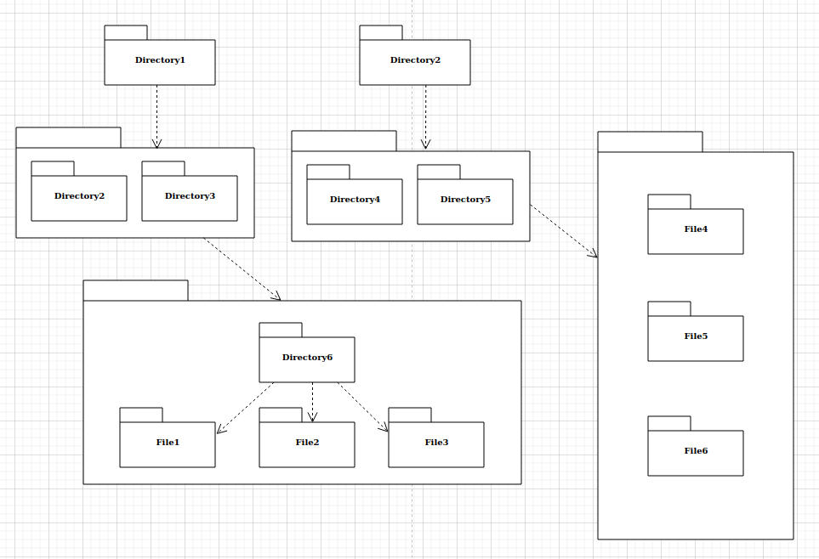

**Q16 Write answer to perform following operations as per above diagram**

* **Create files and directory as per diagram**
* **Print File6 content on console/terminal**

**Ans -**

**>su**

**#mkdir –p Directory1/{Directory2,Directory3,Directory6}**

**#mkdir –p Directory2/{Directory4,Directory5}**

**#cd /Directory1/Directory6**

**#touch File1 File2 File3**

**#cd /Directory2**

**#touch File4 File5 File6**

**#cat > File6**

**#cat file6**

**Q17 Write answer to perform following operations as per above diagram**

* **Read 3 lines of beginning of File2**
* **Merge File1 and File4 content in File3**

**Ans -**

**>su**

**#cd /Directory1/Directory6**

**#cat > File2**

**#head –n 3 File2**

**#cat /Directory1/Directory6/File1 /Directory2/File4 > /Directory1/Directory6/File3**

**Q18 Write answer to perform following operations as per above diagram**

* **Read 3 lines of bottom of File2**
* **Search File5 location**

**Ans -**

**>su**

**#tail –n 3 /Directory1/Directory6/File2**

**#find . -name "File5*"**

**Q19 Write answer to perform following operations**

* **Display directory file types from root**
* **Display regular file types from root**

**Ans -**

**>su**

**#ls -l /* |grep ^-**

**#ls -l /* |grep ^d**