**Roll No…………….. Total No. of Pages:……**

**Linux System Administration**

**Time allowed: 90 Minutes Max. Marks: 40**

**General Instructions:**

* **Follow the instructions given in each section.**
* **Make sure that you attempt the questions in order.**

**SECTION-A (10*1 mark=10 marks)**

***(All questions are compulsory)***

Q1 How can you navigate to the parent directory in Linux using the command line?

**A) Use the 'cd ..' command**

B) Use the 'cd /' command

C) Use the 'cd ~' command

D) Use the 'cd -' command

Q2 How can you copy a file in Linux?

**A. touch**

B. cp

C. mkdir

D. mv

Q3 What is dual booting?

A. A method to boot two operating systems on separate hard drives

**B. A method to boot two operating systems on the same hard drive**

C. A method to boot two operating systems through a network

D. A method to boot two operating systems on different partitions

Q4 What does the 'fdisk' command do in a Linux system?

A. Fixes a disk

B. Formats a disk

**C. Modifies the partition table of a hard drive**

D. Creates a file system

Q5 What is the command to change a user password in Linux?

A. cpwd

**B. chpwd**

C. passwd

D. changepw

Q6 Which command can be used to display the last 10 lines of a file in a terminal in Linux?

**A. tail**

B. cat

C. more

D. head

Q7 What does the redirection symbol ">" do in the terminal in Linux?

A. Display the contents of a file

B. Display the first 10 lines of a file

**C. Write the output of a command to a file**

D. Display the last 10 lines of a file

Q8 What is the command used to change the group of a file in a terminal in Linux?

**A. chgrp**

B. chown

C. chmod

D. chfile

Q9 What is the default file editor in the terminal in Linux?

A. nano

B. pico

**C. vi**

D. gedit

Q10. What is the "awk" command used for in the terminal in Linux?

A. To extract specific columns from a file

**B. To process and analyze text data**

C. To search for a pattern in a file

D. To sort a file

**SECTION-B (5*2 mark=10 marks)**

***(All questions are compulsory)***

Q11 What is the difference between less and more commands in Linux?

A. The “less” command shows the first five lines of a file, while the “more” command shows the last five lines of a file.

B. "more" allows for more advanced navigation and searching within a file, while "less" simply displays the contents of the file one page at a time.

**C. "less" allows for more advanced navigation and searching within a file, while "more" simply displays the contents of the file one page at a time.**

A. Both allow for more advanced navigation and searching within a file. "more" displays all the content of the file while “less” does not.

Q12 How do you change the ownership of a file in Linux using the 'chown' command?

A.To change the ownership of a file in Linux, use the 'chown' command followed by the new owner's username and the file's name. For example: "chown file_name new_owner".

B. To change the ownership of a file in Linux, use the 'chowner' command followed by the new owner's username and the file's name. For example: "chowner new_owner file_name".

C. To change the ownership of a file in Linux, use the 'chowner' command followed by the new owner's username and the file's name. For example: "chowner file_name new_owner".

**D. To change the ownership of a file in Linux, use the 'chown' command followed by the new owner's username and the file's name. For example: "chown new_owner file_name".**

Q13. Can you explain what redirection is in the context of the command line? Select the best option.

A. Redirection is the process of redirecting the output of a command to a file. It allows you to capture output of a command.

B. Redirection is the process of redirecting the output of a command to another command. It allows you to manipulate the output of a command.

C.Redirection is the process of redirecting the output of a file to a file. It allows you to capture the output of a command.

**D. Redirection is the process of redirecting the output of a command to a file or to another command. It allows you to capture or manipulate the output of a command.**

Q15 How do you monitor the currently logged-in users in Linux?

A.To monitor the currently logged-in users in Linux, use the 'who' command. This command shows the username in the terminal of the last log-out of all the currently logged out users.

**B. To monitor the currently logged-in users in Linux, use the 'who' command. This command shows the username, terminal, date, and time of the last login of all the currently logged-in users.**

C. To monitor the currently logged-in users in Linux, use the 'who' command. This command shows the username, terminal, date, and time of all users.

D. To monitor the currently logged-in users in Linux, use the 'who' command. This command shows the username, terminal, date, time and last 1 digit of password of the last login of all the currently logged-in users.

Q15 How would you change the permissions of a file called "file1" to be read and executed only by the owner?

A. chmod 704 file1

**B. chmod 700 file1**

C.chmod 710 file1

D. chmod 777 file1

**SECTION-C() (4x5 marks=20 marks)**

Q.16. i.What is the "sudo" command in Linux, and what is it used for?

ii. How would you change the password for a user account called "chitrang"?

iii.you are currently in the /home/user directory. How would you extract the contents of a compressed archive called "docs.tar.gz"? “docs.tar.gz” is present inside the /home/user directory.

**ans.**

**i. The "sudo" command in Linux is used for executing commands with elevated privileges as a superuser. For example, sudo apt-get update will run the "apt-get update" command with superuser privileges.**

**ii. passwd chitrang**

**iii. tar -xvzf ~/docs.tar.gz**

Q.17 i. How would I create an empty file called "file.txt"?

ii. How would you remove a non-empty directory and its contents called "non_empty_dir" present inside the ‘~’ directory ?

iii. How would you copy the contents of a directory "src_dir" to a new location "dst_dir"?both are present inside your current directory.

**ans.**

**i.touch ~/file.txt**

**ii. rm -r ~/non_empty_dir**

**iii.cp -r ./src_dir ./dst_dir**

Q.18. i. You are currently in the /home/user directory.How can you change the permissions of a file named "file.txt" to allow read and write access for the owner and read-only access for everyone else? ”file.txt” is present inside “user/Documents”.

ii. How would you duplicate lines in a file called "file.txt"?

iii. you are currently inside the root directory. How do you remove the file "file.txt"?

**ans:**

**i.chmod 644 ~/Documents/file.txt**

**2.sort ~/file.txt | uniq**

**3.rm ~/Documents/file.txt**

Q.19. You have given a system having the following scenario. “subjects” is present inside the /home/user directory.

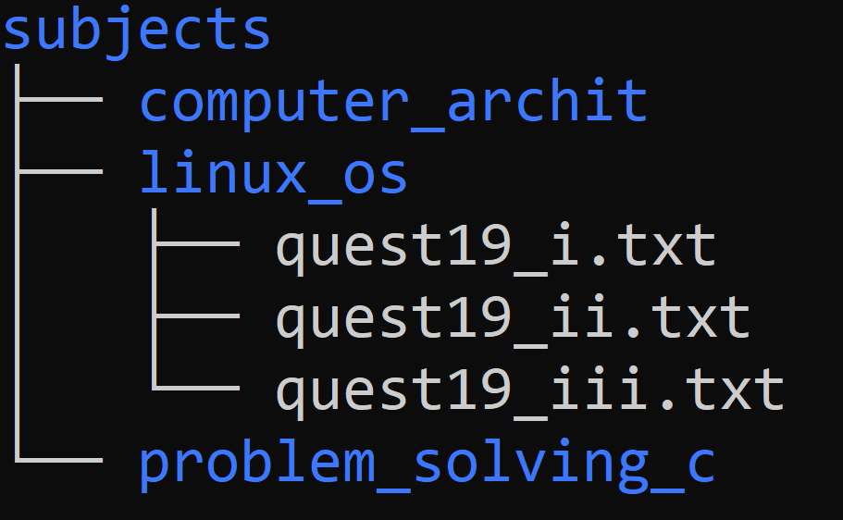

Perform the following task on the given system.

i. Create a file name containing your name and the last four digits of your roll number.(Example: “chitrang_9011”) . The file should be present inside the “linux_os” directory.

ii. You are currently in the /home/user directory. The difference between vi and vim editor is present inside question19_ii.txt. How can you print the content of this file?

iii. You are currently in question19_ii directory which should be the output of the following command: ls question19_ii.txt.

**Ans.**

**i.touch ~/subjects/chitrang_9011.txt**

**ii. cat ~/subjects/linux_os/quest19_ii.txt**

**iii."vi" is a classic text editor in Linux, while "vim" is an enhanced version of "vi" that includes many additional features and capabilities. "vim" is generally used for more advanced editing tasks, while "vi" is still useful for simple editing tasks.**