**Roll No…………….. Total No. of Pages:……**

**Linux System Administration**

**Time allowed: 90 Minutes Max. Marks: 40**

**General Instructions:**

* **Follow the instructions given in each section.**
* **Make sure that you attempt the questions in order.**

**SECTION-A (10*1 mark=10 marks)**

***(All questions are compulsory)***

1. What is a popular Linux distribution?

A) Fedora

B) Ubuntu

C) Red Hat Enterprise Linux

D) All of the above

Answer: D) All of the above

2. What is the Linux architecture made up of?

A) Shell, kernel, and utilities

B) GUI, command line, and drivers

C) Libraries, file system, and networking

D) All of the above

Answer: A) Shell, kernel, and utilities

3. What is virtual memory in Linux?

A) An area of memory used for temporary storage

B) A portion of a hard disk used as RAM

C) An area of memory used to store files

D) A portion of a hard disk used to store backups

Answer: B) A portion of a hard disk used as RAM

4. What is swap space in Linux?

A) An area of memory used for temporary storage

B) A portion of a hard disk used as RAM

C) An area of memory used to store files

D) A portion of a hard disk used to store backups

Answer: A) An area of memory used for temporary storage

5. What is the file system structure of Linux?

A) Hierarchical

B) Flat

C) Network-based

D) None of the above

Answer: A) Hierarchical

6. What is the boot process of Linux?

A) Power on, BIOS, boot loader, kernel, init process

B) Power on, BIOS, operating system, init process

C) Power on, boot loader, BIOS, operating system, init process

D) Power on, BIOS, operating system, boot loader, init process

Answer: A) Power on, BIOS, boot loader, kernel, init process

7. What is partitioning in Linux?

A) Dividing a hard disk into smaller sections

B) Combining smaller sections of a hard disk

C) Deleting a section of a hard disk

D) None of the above

Answer: A) Dividing a hard disk into smaller sections

8. What is an absolute path in Linux?

A) A path relative to the root directory

B) A path relative to the current directory

C) A path relative to the home directory

D) A path relative to the boot directory

Answer: A) A path relative to the root directory

9. What is a relative path in Linux?

A) A path relative to the root directory

B) A path relative to the current directory

C) A path relative to the home directory

D) A path relative to the boot directory

Answer: B) A path relative to the current directory

10. What are the types of files in Linux?

A) Executable, text, binary, and symbolic link

B) Audio, video, image, and document

C) System, hidden, configuration, and backup

D) All of the above

Answer: A) Executable, text, binary, and symbolic link

**SECTION-B (5*2 mark=10 marks)**

***(All questions are compulsory)***

11. What does the command "cut" in Linux do?

A) Counts the number of characters in a file

B) Extracts columns from a file

C) Searches for a pattern in a file

D) Compares two files

Answer: B) Extracts columns from a file

12. What does the command "awk" in Linux do?

A) Compresses files

B) Processes and analyzes text data

C) Searches for a pattern in a file

D) Counts the number of characters in a file

Answer: B) Processes and analyzes text data

13. What does the command "grep" in Linux do?

A) Extracts columns from a file

B) Processes and analyzes text data

C) Searches for a pattern in a file

D) Counts the number of characters in a file

Answer: C) Searches for a pattern in a file

14. What does the command "sort" in Linux do?

A) Compares two files

B) Sorts the contents of a file

C) Searches for a pattern in a file

D) Counts the number of characters in a file

Answer: B) Sorts the contents of a file

15. What does the command "wc" in Linux do?

A) Compresses files

B) Counts the number of lines, words, and characters in a file

C) Searches for a pattern in a file

D) Sorts the contents of a file

Answer: B) Counts the number of lines, words, and characters in a file

**SECTION-C() (4x5 marks=20 marks)**

Q16

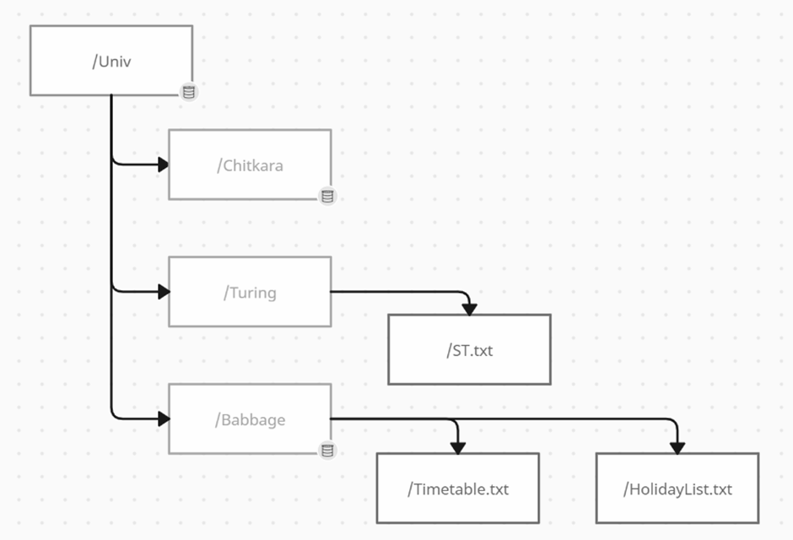

Create following directories as per the diagram.

Create following files as per the diagram. Also insert text “Timetable2023” in Timetable file

Ans-

mkdir -p /Univ/Chitkara

mkdir -p /Univ/Turing

mkdir -p /Univ/Babbage

cd /Univ/Turing

touch ST.txt

cd /Univ/Babbage

touch Timetable.txt HolidayList.txt

cat > Timetable.txt

cat Timetable.txt

Q17. Write answer to perform following operations as per above diagram

· Read 10 lines of beginning of file ST

· Rename file Timetable to Timetable23

Ans –

cd /Univ/Turing

head ST.txt

cd /Univ/Babbage

mv Timetable Timetable23

Q 18. Write answer to perform following operations as per above diagram

· Read last lines of file HolidayList

· Search ST file location

Ans -

tail /Univ/Babbage/HolidayList

find . -name "ST*"

Q19. Sanjeev wants to add new user “StudentABC” and change the password again for the same user “StudentABC”. Give the appropriate command to perform the actions.

Ans –

sudo adduser StudentABC

sudo passwd -l StudentABC