**Roll No…………….. Total No. of Pages:……**

**ST-2 (SET-I)**

**4th SEMESTER 2022-23**

**22CS002- Linux System Administration**

**Time allowed: 90 Minutes Max. Marks: 40**

**General Instructions:**

* **Follow the instructions given in each section.**
* **Make sure that you attempt the questions in order.**

**SECTION-A (10*1 mark=10 marks)**

***(All questions are compulsory)***

Q1 Which of the following commands is used to view the file 24 lines at a time?

(a) pg

(b) 1p

(c) cat

(d) /p

Q2 What are mandatory parts in the function declaration?

a) **return type, function name**

b) return type, function name, parameters

c) parameters, function name

d) parameters, variables

Q3 The complexity of Binary search algorithm is _________

a) O(n)

b) O(log)

c) O(n2)

d) **O(n log n)**

Q4 What will happen in the following C++ code snippet?

int a = 100, b = 200;

int *p = &a, *q = &b;

p = q;

a) b is assigned to a

b) **p now points to b**

c) a is assigned to b

d) q now points to a

Q5 Which of the following is the correct difference between cin and scanf()?

a) both are the same

b) **cin is a stream object whereas scanf() is a function**

c) scanf() is a stream object whereas cin is a function

d) cin is used for printing whereas scanf() is used for reading input

Q6 Which of the following is a correct identifier in C++?

a) **VAR_1234**

b) $var_name

c) 7VARNAME

d) 7var_name

Q7 What are mandatory parts in the function declaration?

a) **return type, function name**

b) return type, function name, parameters

c) parameters, function name

d) parameters, variables

Q8 The complexity of Binary search algorithm is _________

a) O(n)

b) O(log)

c) O(n2)

d) **O(n log n)**

Q9 What will happen in the following C++ code snippet?

int a = 100, b = 200;

int *p = &a, *q = &b;

p = q;

a) b is assigned to a

b) **p now points to b**

c) a is assigned to b

d) q now points to a

Q10 Which of the following is the correct difference between cin and scanf()?

a) both are the same

b) **cin is a stream object whereas scanf() is a function**

c) scanf() is a stream object whereas cin is a function

d) cin is used for printing whereas scanf() is used for reading input

**SECTION-B (5*2 mark=10 marks)**

***(All questions are compulsory)***

Q11 What will be the output of the following C++ code?

#include <iostream>

#include <string>

#include <algorithm>

using namespace std;

int main()

{

string s = "spaces in text";

s.erase(remove(s.begin(), s.end(), ' ' ), s.end() ) ;

cout << s << endl;

}

a) **spacesintext**

b) spaces in text

c) spaces

d) spaces in

Q12 What will be the output of the following C++ code?

#include <iostream>

using namespace std;

int fun(int = 0, int = 0);

int main() {

cout << fun(5);

return 0;

}

int fun(int x, int y){

return (x + y);

}

a) -5

b) 0

c) 10

d) **5**

Q13 What is the time complexity of following code:

int a = 0, i = N;

while (i > 0)

{

a += i;

i /= 2;

}

A. O(N)

B. O(Sqrt(N))

C. O(N / 2)

D. **O(log N)**

Q14 What will be the output of the following C++ code?

#include <iostream>

using namespace std;

int main() {

char *ptr; char Str[] = "abcdefg";

ptr = Str;

ptr += 5;

cout << ptr;

return 0;

}

a) **fg**

b) cdef

c) defg

d) abcd

Q15 What will be the output of the following C++ code?

#include <iostream>

using namespace std;

int main() {

int array[] = {0, 2, 4, 6, 7, 5, 3};

int n, result = 0;

for (n = 0; n < 8; n++)

{

result += array[n];

}

cout << result;

return 0;

}

a) 25

b) 26

c) **27**

d) 21

**SECTION-C() (4x5 marks=20 marks)**

Q16 Following files and directories as mentioned below are already created. Perform the below mentioned task

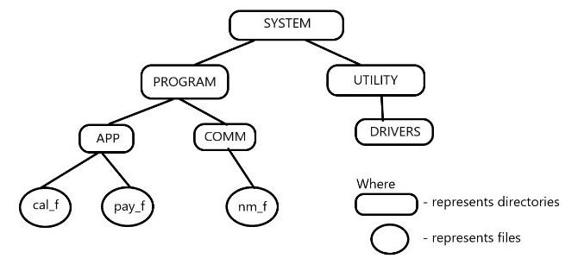

mkdir -p SYSTEM/PROGRAM/APP

mkdir SYSTEM/PROGRAM/COMM

mkdir -p SYSTEM/UTILITY/DRIVERS

touch SYSTEM/PROGRAM/APP/cal_f

touch SYSTEM/PROGRAM/APP/pay_f

touch SYSTEM/PROGRAM/COMM/nm_f

(i)       Copy the “cal_f” file and COMM directory to the “UTILITY” directory. (2 Mark)

cp –r SYSTEM/PROGRAM/COMM SYSTEM/PROGRAM/APP/cal_f SYSTEM/UTILITY/

(ii)      Move “pay_f” to the “DRIVERS” directory and rename it to paid_f. (2 Mark)

mv SYSTEM/PROGRAM/APP/pay_f SYSTEM/UTILITY/DRIVERS/paid_f

(iii)      Remove “APP” directory. (1 Mark)

rm –rf SYSTEM/PROGRAM/APP

There is directory named content has some files. Write the suitable commands for the following operations: Create a Gzip compressed archive file **data.tar.gz** and exclude all the .doc file

**Do Not verbose the compressed tar file content.**

mkdir content

cd content

touch sysdata{1..5}{6..9}.txt sysdata{1..5}{6..9}.doc

cd content

tar -czf data.tar.gz --exclude=’*.doc’ *

Create directory structure consists of guide/chapter/magazine.txt and guide/book

Create a hard link of the file (magazine.txt) in the book directory as link_magazine.txt

mkdir -p guide/chapter

mkdir -p guide/book

touch guide/chapter/magazine.txt

ln guide/chapter/magazine.txt guide/book/link_magazine.txt

cd $curr

cd guide/book

if [ -f link_magazine.txt ]

then

echo "Hardlink link_magazine.txt created Successfully"

fi