**Roll No…………….. Total No. of Pages:……**

**Linux System Administration**

**Time allowed: 90 Minutes Max. Marks: 40**

**General Instructions:**

* **Follow the instructions given in each section.**
* **Make sure that you attempt the questions in order.**

**SECTION-A (10*1 mark=10 marks)**

***(All questions are compulsory)***

Q1 What is the history behind the Linux operating system?

A. Linux was created by Microsoft in the 1980s.

**B. Linux was created by Linus Torvalds in 1991 as a free, open-source alternative to Unix**.

C. Linux was created by Apple in the 1990s.

D. Linux was created by Google in the 2000s.

Q2 What is the role of the Shell in Linux?

A. GUI component

**B. Interpreter between the user and the kernel**

C. File Manager

D. Internet browser

Q3 How can you see hidden files in the current directory using the 'ls' command?

**A) Use the 'ls -a' command**

B) Use the 'ls -l' command

C) Use the 'ls -h' command

D) Use the 'ls -r' command

Q4 What is the first stage in the boot process?

A. Booting

B. Loading the operating system

C. POST (Power-On Self Test)

**D. BIOS (Basic Input/Output System)**

Q5 What is the default file type in the Linux file system?

**A. Regular file**

B. System file

C. Directory file

D. Executable file

Q6 What command can be used to display the contents of a file page by page in a terminal in Linux?

**A. less**

B. cat

C. more

D. head

Q7 What does the redirection symbol "<" do in Linux?

A. Display the contents of a file

B. Append the output of a command to a file

C. Write the output of a command to a file

**D. Take content as an Input**

Q8 What is the command used to change file permissions in a terminal in Linux?

**A. chmod**

B. chown

C. chgrp

D. chfile

Q9 What is another popular text editor in terminal in Linux besides vi and vim?

**A. nano**

B. pico

C. gedit

D. emacs

Q10 What is the "sed" command used for in the terminal in Linux?

A. To sort a file

B. To search for a pattern in a file

**C. To edit a file in a non-interactive way**

D. To count the number of lines in a file

**SECTION-B (5*2 mark=10 marks)**

***(All questions are compulsory)***

Q11 What is the difference between 'head' and 'tail' commands in Linux?

A. The 'head' command shows the first five lines of a file, while the 'tail' command shows the last five lines of a file.

B. The 'head' command shows the first five lines of a file in reverse order, while the 'tail' command shows the last five lines of a file in reverse order.

**C. The 'head' command shows the first ten lines of a file, while the 'tail' command shows the last ten lines of a file.**

D. The 'head' command shows the first ten lines of a file in sorted order, while the 'tail' command shows the last ten lines of a file in sorted order.

Q12 How do you change the ownership of a file in Linux using the 'chown' command?

A.To change the ownership of a file in Linux, use the 'chown' command followed by the new owner's username and the file's name. For example: "chown file_name new_owner".

B. To change the ownership of a file in Linux, use the 'chowner' command followed by the new owner's username and the file's name. For example: "chowner new_owner file_name".

C. To change the ownership of a file in Linux, use the 'chowner' command followed by the new owner's username and the file's name. For example: "chowner file_name new_owner".

**D. To change the ownership of a file in Linux, use the 'chown' command followed by the new owner's username and the file's name. For example: "chown new_owner file_name".**

Q13 You have a file named "numbers.txt" and you want to sort the contents in ascending order. Which command would you use?

A. awk numbers.txt

B. sort | grep numbers.txt

**C. sort numbers.txt**

D. sort -l numbers.txt

Q14 You want to combine two files named "file1.txt" and "file2.txt" into a single new file named "combined.txt". Which command would you use?

A. cat file1.txt file2.txt >> combined.txt

B. cat file1.txt > file2.txt > combined.txt

C. cat file2.txt file1.txt > combined.txt

**D. cat file1.txt file2.txt > combined.txt**

Q15 You have a file named "report.txt" and you want to replace all occurrences of the word "old" with the word "new" in the file. Which command would you use?

A. sed 's/g/new/old' report.txt

**B. sed 's/old/new/g' report.txt**

C. sed 'g/old/new/s' report.txt

D. sed 's/new/old/g' report.txt

**SECTION-C() (4x5 marks=20 marks)**

Q.16. How would you accomplish the following task?

i. You are currently in the "/home/user" directory and you want a directory “log” inside a directory “var”. “var” "/home/user" inside "/home/user" directory .

ii. You want to search for all files in the "/var/log" directory that have the ".log" extension.

iii.You want to change the permissions of a directory "log" to allow read and execute permissions for all users.

**ans. i. mkdir var**

**cd var**

**mkdir log**

**ii. find /var/log -name "*.log"**

**iii. chmod 755 /var/log**

Q.17. How would you accomplish the following task?

i. A file called "filelist.txt” is present inside your current directory. You want to redirect the output of the "ls" command to filelist.txt.

ii. Open a file called "file.txt" in the "/var/log" directory using the "vi" editor.

iii. Write 3 commands used to enter the insert mode from the command mode with their short description in vi editor.

**ans.**

**i.ls > filelist.txt**

**ii. vi file.txt**

**iii. i : is used to insert the text in the current position. I : It is used to insert the text in the starting of the line. o: is used to insert the text in the next line.**

Q.18. i. How would you find all instances of the word "error" in a file "filelist.txt". filelist.txt is present inside your current directory.

ii.How would you sort the contents of a file "filelist.txt" in ascending order, and save the output to a new file "sorted_filelist.txt"?

iii. display the last 10 lines of a file "filelist.txt"?

**Ans:**

**i. grep error file1.txt**

**2.sort filelist.txt > sorted_filelist.txt**

**3. tail -n 10 filelist.txt**

Q.19. You have given a system having the following scenario. “_test” is present inside the /home/user directory.

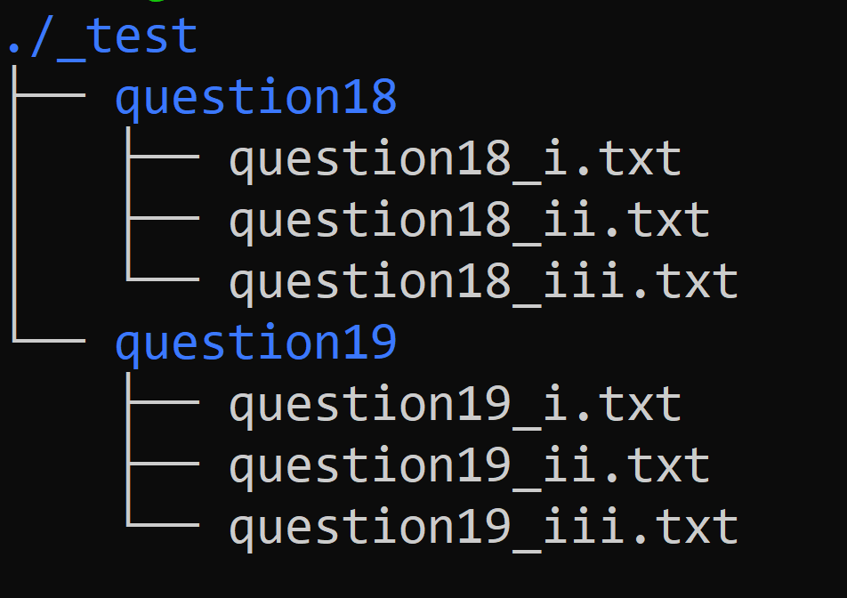

Perform the following task on the given system.

i. Create a file name containing your name and the last four digits of your roll number.(Example: “chitrang_9011”) . The file should be present inside the “_test” directory.

ii. You are currently in the /home/user directory. The difference between less and more commands is present inside question19_ii.txt. How can you print the content of this file?

iii. You are currently in question19_ii directory which should be the output of the following command: ls question19_ii.txt.

**Ans.**

**i.touch ./_test/chitrang_9011.txt**

**ii. cat ./_test/question19/question19_ii.txt**

**iii."less" allows for more advanced navigation and searching within a file, while "more" simply displays the contents of the file one page at a time.**