**Roll No…………….. Total No. of Pages:……**

**Linux System Administration**

**Time allowed: 90 Minutes Max. Marks: 40**

**General Instructions:**

* **Follow the instructions given in each section.**
* **Make sure that you attempt the questions in order.**

**SECTION-A (10*1 mark=10 marks)**

***(All questions are compulsory)***

Q1 What is the basic structure of the Linux file system?

**A. Tree structure**

B. Linear structure

C. Network structure

D. Star structure

Q2 How can you access the configuration settings in Linux?

**A. Through terminal commands**

B. Through GUI

C. Through Registry editor

D. Through Control Panel

Q3 What is the difference between an absolute path and a relative path?

**A. An absolute path always starts from the root directory**

B. A relative path starts from the current working directory

C. An absolute path never changes

D. A relative path always starts from the root directory

Q4 What is the purpose of partitioning a hard drive?

A. To create multiple virtual machines

**B. To divide a single physical hard drive into multiple logical drives**

C. To increase the speed of the hard drive

D. To decrease the size of the hard drive

Q5 What is the command used to search for a specific file in Linux?

A. rm

B. cp

**C. find**

D. locate

Q6 Which command can be used to display the first 10 lines of a file in terminal in Linux?

**A. head**

B. cat

C. less

D. more

Q7 What does the redirection symbol ">>" do in the terminal in Linux?

A. Display the contents of a file

B. Append the first 10 lines of a file

**C. Append the output of a command to a file**

D. Append the last 10 lines of a file

Q8 What is the command used to change the owner of a file in terminal in Linux?

**A. chown**

B. chmod

C. chgrp

D. chfile

Q9 What is the difference between the vi and vim editors in terminal in Linux?

A. vi is graphical while vim is text-based

B. vi is outdated while vim is updated

**C. vi is basic while vim has more features**

D. vi is faster while vim is slower

Q10 What is the command used to extract specific columns from a file in a terminal in Linux?

**A. cut**

B. awk

C. grep

D. sort

**SECTION-B (5*2 mark=10 marks)**

***(All questions are compulsory)***

Q11 What is the purpose of the 'cut' command in Linux?

**A. The 'cut' command is used to extract columns or fields from a text file or standard input.**

B. The 'cut' command is used to extract only the columns from a text file or standard input.

C. The 'cut' command is used to extract only the fields from a text file or standard input.

D. The 'cut' command is used to delete the whole columns or fields from a text file or standard input.

Q12 What is the difference between 'grep' and 'egrep' in Linux?

A. The 'grep' command is used to search for a specific pattern in a text file. The 'egrep' command is used to search for a specific file or a directory.

B. The 'egrep' command is used to search for a specific pattern in a text file. The 'grep' command is an extended version of 'grep' that allows the use of more advanced regular expressions.

**C. The 'grep' command is used to search for a specific pattern in a text file. The 'egrep' command is an extended version of 'grep' that allows the use of more advanced regular expressions.**

D. The 'grep' command is used to search for a specific pattern in a text file. The 'egrep' command is used to do the same operation but with limitations.

Q13. How do you compare two files in Linux using the 'diff' command?

A. To compare two files in Linux, use the 'differ' command followed by the two file names. For example: "differ file1 file2".

B. To compare two files in Linux, use the 'diff' command followed by the two file names. For example: "diff file1 > file2".

C. To compare two files in Linux, use the 'differ’' command followed by the two file names. For example: "diff file1 | file2".

**D. To compare two files in Linux, use the 'diff' command followed by the two file names. For example: "diff file1 file2".**

Q14 How do you compress a file in Linux using the 'tar' command?

**A. To compress a file in Linux, use the 'tar' command followed by the options to create a tar archive and compress it using gzip compression. For example: "tar -czvf file_name.tar.gz file_name".**

B. To compress a file in Linux, use the 'tar' command followed by the options to create a tar archive and compress it using gzip compression. For example: "tar file_name.tar.gz -czvf file_name".

C. To compress a file in Linux, use the 'tar' command followed by the options to create a tar archive and compress it using gzip compression. For example: "tar -czvf file_name file_name.tar.gz".

D. Tar command can’t be used to compress files.

Q15 How do you monitor the currently logged-in users in Linux?

A.To monitor the currently logged-in users in Linux, use the 'who' command. This command shows the username in the terminal of the last log-out of all the currently logged out users.

**B. To monitor the currently logged-in users in Linux, use the 'who' command. This command shows the username, terminal, date, and time of the last login of all the currently logged-in users.**

C. To monitor the currently logged-in users in Linux, use the 'who' command. This command shows the username, terminal, date, and time of all users.

D. To monitor the currently logged-in users in Linux, use the 'who' command. This command shows the username, terminal, date, time and last 1 digit of password of the last login of all the currently logged-in users.

**SECTION-C() (4x5 marks=20 marks)**

Q.16. How would you accomplish the following task?

i. You are currently in the "/home/user" directory. How do you create a file called "notes.txt" in the directory "Documents"?

ii. How do you copy the file "notes.txt" to "notes_backup.txt"?Both files should be present inside the same directory.

iii.you are currently inside the root directory. How do you remove the file "notes_backup.txt"?

**ans.**

**i. touch ~/Documents/notes.txt**

**ii. cp ~/Documents/notes.txt ~/Documents/notes_backup.txt**

**iii. rm ~/Documents/notes_backup.txt**

Q.17. What command would you use to change the permissions on a file called "notes.txt" so that the owner can read, write, and execute it, while others can only read it?

ii. How would you change the owner of a file called "notes.txt" to the user "chitrang"?

iii. How would you use the "sed" command to replace all instances of the word "old" with the word "new" in a file called "notes.txt"?

**ans.**

**i.chmod 744 ~/notes.txt**

**ii. chown chitrang~/notes.txt**

**iii.sed 's/old/new/g' ~/notes.txt**

Q.18.i. What command would you use to extract the 2nd field of a file called "data.txt"?

ii.How would you use the "grep" command to search for lines in a file called "data.txt" that contain the word "error"?

iii. How would you use the "uniq" command to remove duplicate lines in a file called "data.txt"?

**ans:**

**i. cut -d "," -f 2 ~/data.txt**

**2.grep "error" ~/data.txt**

**3. sort ~/data.txt | uniq**

Q.19. You have given a system having the following scenario. “linux_os” is present inside the /home/user directory.

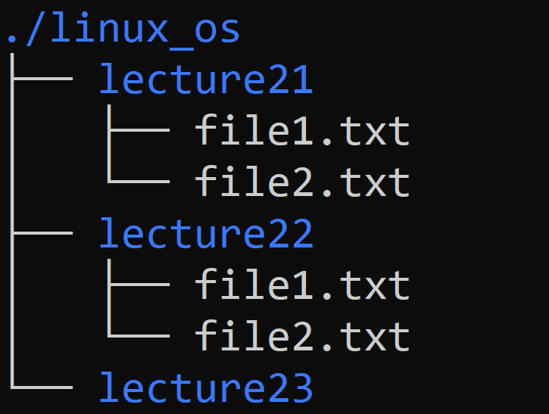

Perform the following task on the given system.

i. Create a file name containing your name and the last four digits of your roll number.(Example: “chitrang_9011”) . The file should be present inside the “linux_os” directory.

ii. You are currently in the /home/user directory. You want to save the description about the “wc” command inside a new file “wc_desc”.This new file must be present inside “lecture23”. How can you create and put content inside a wc_desc file?

iii. You are currently in question19_ii directory which should be the output of the following command: ls question19_ii.txt.

**ans.**

**i.touch ./linux_os/chitrang_9011.txt**

**ii. cat > ./linux_os/lecture23/**

**iii.The "wc" command in Linux is used for counting the number of lines, words, and characters in a file. it prints the number of lines, number of words,number of characters along with the file name.**