LABORATORY MANUAL
COMPUTER NETWORKS

Regulation | 2021 (Volume 11 – CSE, Updated 2025)
School | School of Computing
Course Category | Professional Core
Total Experiments | 15
Recommended Tool | Cisco Packet Tracer

Prepared by
Dr. Anirudha Anil Gaikwad
Assistant Professor
SRM Institute of Science and Technology,Delhi-NCR Campus, Delhi- Meerut Road, Modinagar, Ghaziabad (U.P.) - 201204

Table of Contents
Course Information 3
Part A — Networking Commands (Windows 11 & Ubuntu 26.04 LTS) ……………………………………………4
Part B — Study of Networking Cables …………………………………………………………………………………….…….10
Part C — Study of Networking Devices ………………………………………………………………………………….……..16
Part D — Which Device Uses Which Cable? ……………………………………………………………………………….…20
List of Experiments 21
Experiments
Experiment 1: Study of Network Devices and Peer-to-Peer Communication 22
Experiment 2: Implementation of Network Topologies 24
Experiment 3: Router Configuration — Creating Passwords and Configuring Interfaces 27
Experiment 4: IP Addressing and Subnetting using VLSM 29
Experiment 5: Design and Implementation of Static and Default Routing 31
Experiment 6: Configuration of Network Address Translation (NAT) 34
Experiment 7: Implementation of RIP Version 1 36
Experiment 8: Implementation of RIP Version 2 38
Experiment 9: Implementation of Single Area OSPF 40
Experiment 10: Implementation of Multi Area OSPF 42
Experiment 11: Configuration of Point-to-Point Protocol (PPP) 44
Experiment 12: Configuration of High-Level Data Link Control (HDLC) 46
Experiment 13: Implementation of Border Gateway Protocol (BGP) 48
Experiment 14: Implementation of EIGRP 50
Experiment 15: Configuration of Telnet for Remote Router Access 52

Course Information

Course Learning Rationale (CLR)
- CLR-1: Define the layered network architecture.
- CLR-2: Produce knowledge in IP addressing.
- CLR-3: Identify suitable routing algorithms based on geographical location of the devices.
- CLR-4: Apply the concept of Error detection to identify the errors in data.
- CLR-5: Explore reliable and unreliable protocols.

Course Outcomes (CO)
- CO-1: Apply the knowledge of communication.
- CO-2: Construct the network using addressing schemes.
- CO-3: Design and implement the various Routing Protocols.
- CO-4: Identify and correct the errors in transmission.
- CO-5: Analyze the services provided by Transport and Application layers.

Textbooks and Learning Resources
- Behrouz A. Forouzan, "Data Communication and Networking", 5th ed., 2010.
- Bhushan Trivedi, "Data Communication and Networks", 2016.
- William Stallings, "Data and Computer Communications", 9th ed., 2010.
- Todd Lammle, "CCNA Study Guide", 7th ed., 2011.

General Instructions to Students
- Install the latest version of Cisco Packet Tracer on your personal system before attending the laboratory session.
- Read the Aim and Theory of the experiment thoroughly before starting the implementation.
- Design the given network topology carefully and label all IP addresses as instructed.
- Save configuration files (running-config to startup-config) at the end of each experiment.
- Record all outputs, routing tables and verification screenshots in the observation note/record book.
- Attempt the Viva-Voce questions given at the end of every experiment for self-assessment.

Part A — Networking Commands
Command-line tools are the fastest and most precise way to inspect, configure and troubleshoot a network connection. This section presents the essential networking commands available on Windows 11 and Ubuntu 26.04 LTS, organized by function, with syntax, purpose, and sample terminal output.

Sample Output — Windows 11 Command Prompt
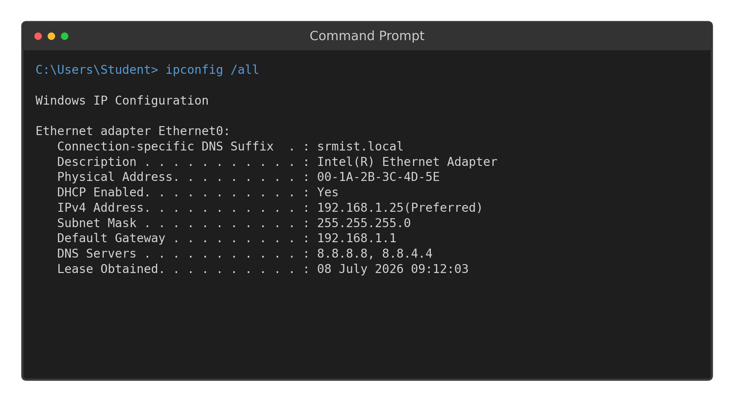
Fig A.1: Output of ipconfig /all on Windows 11
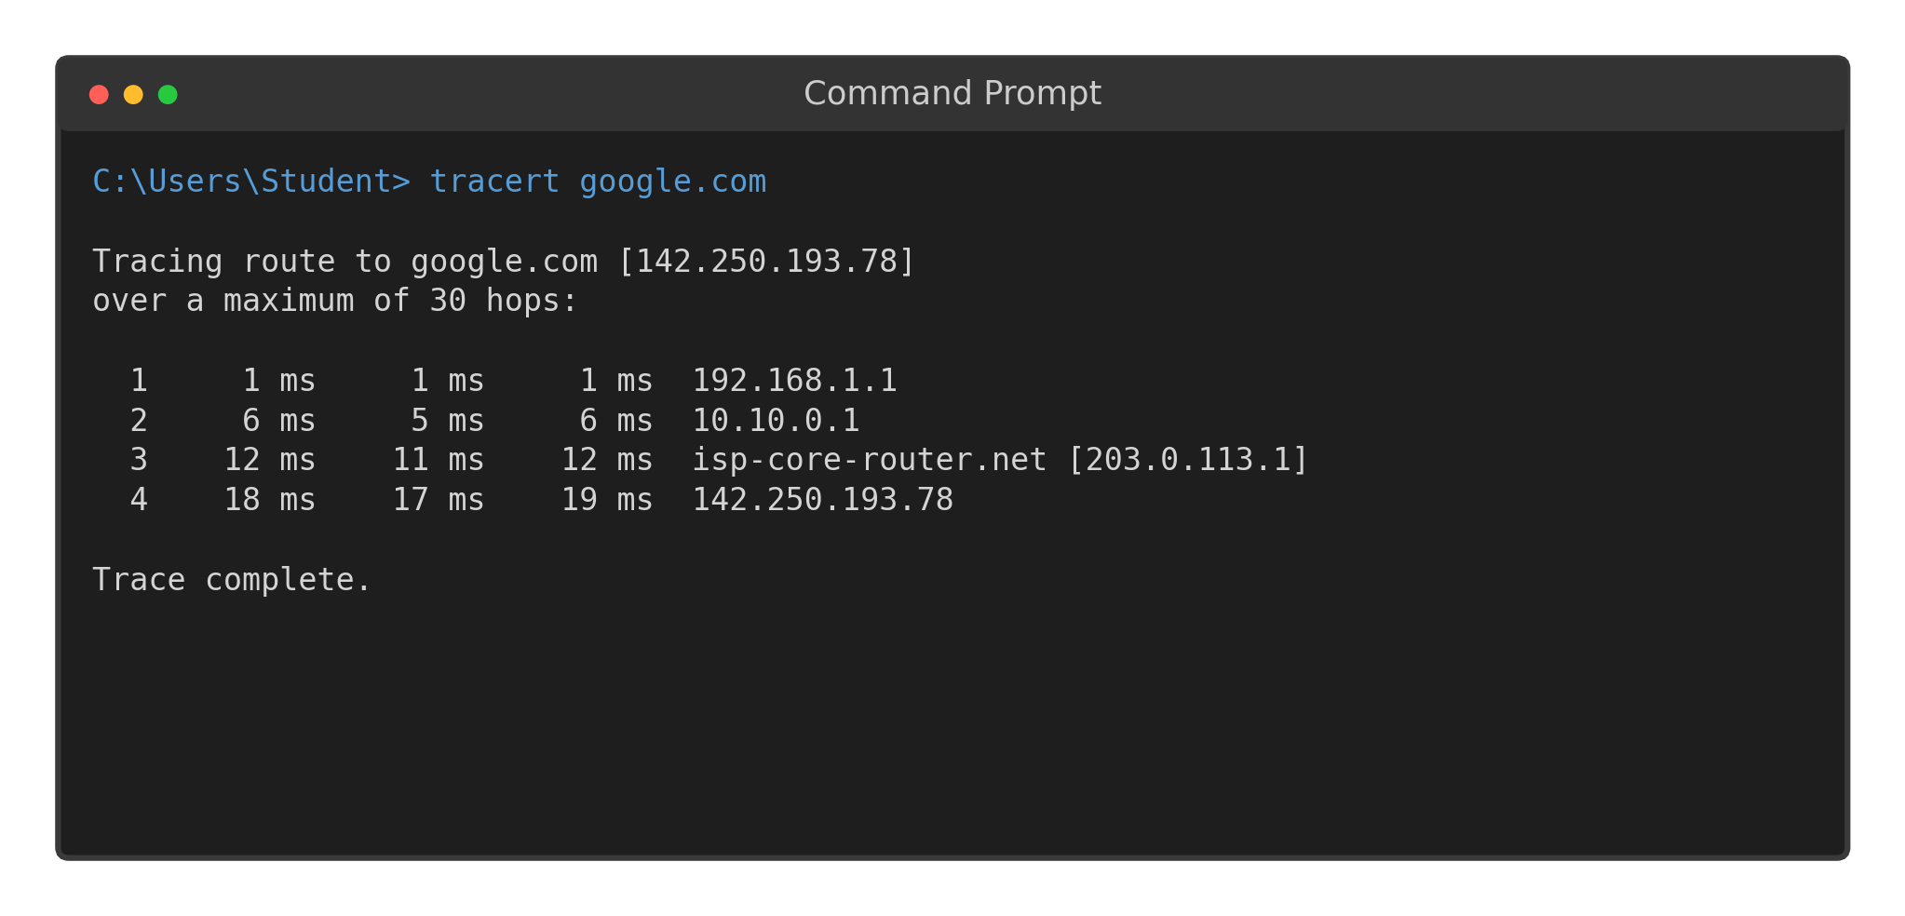
Fig A.2: Output of tracert on Windows 11

Sample Output — Ubuntu 26.04 LTS Terminal
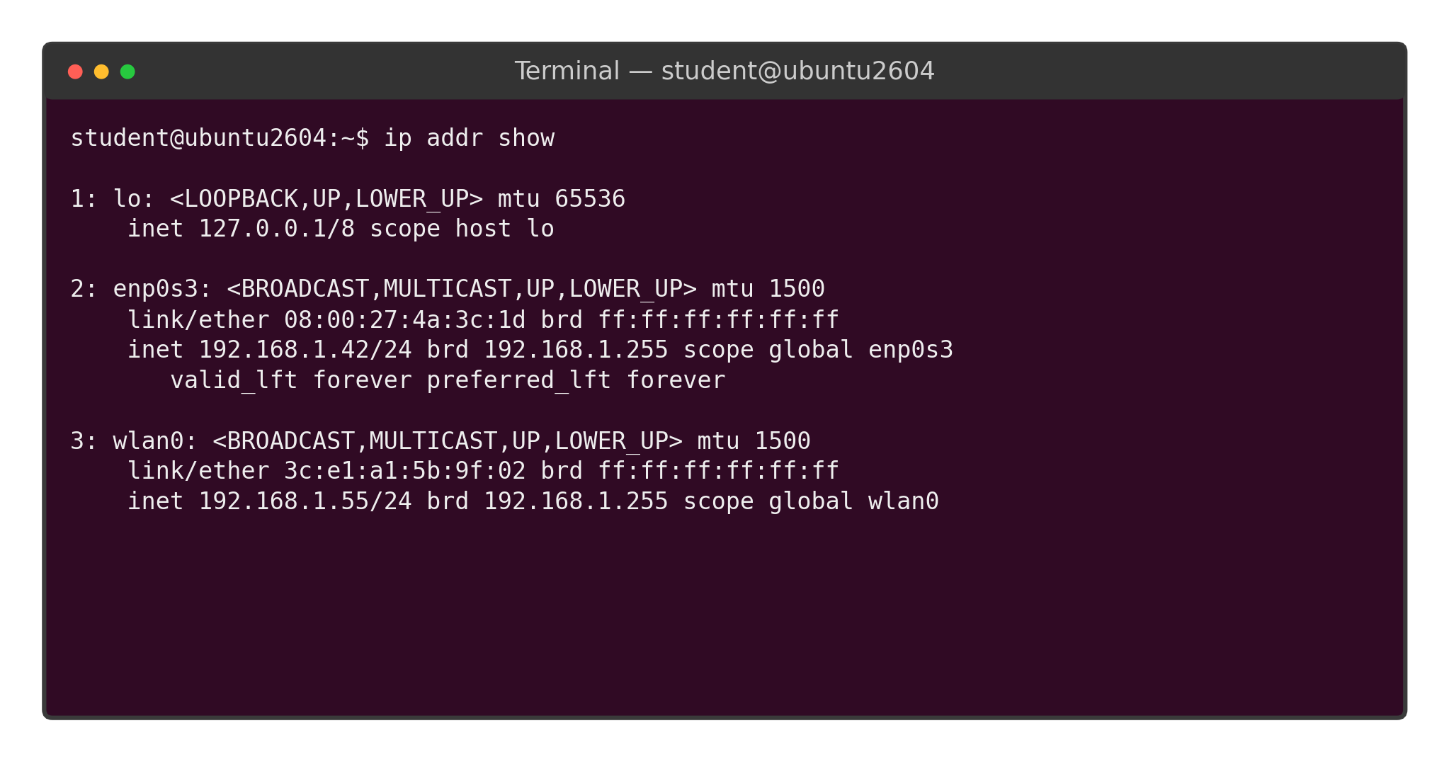
Fig A.3: Output of ip addr show on Ubuntu 26.04 LTS
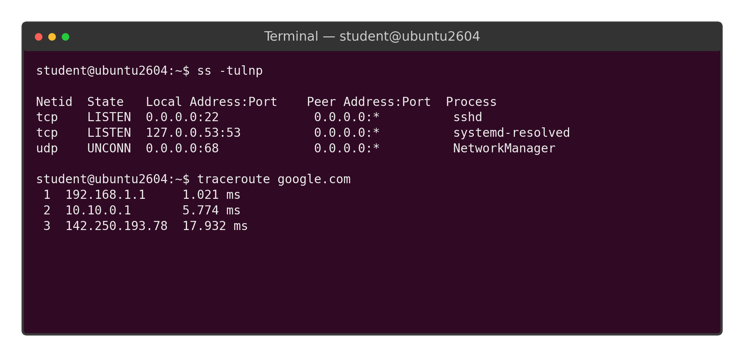
Fig A.4: Output of ss -tulnp and traceroute on Ubuntu 26.04 LTS

1. IP Configuration & Interface Information
These commands display or manage the IP configuration (IP address, subnet mask, gateway, MAC address) of the network interfaces on a machine.
Command | OS | Purpose | Example Syntax
ipconfig | Windows | Displays a summary of IP configuration for all adapters. | ipconfig
ipconfig /all | Windows | Displays detailed configuration — MAC address, DHCP status, DNS servers, lease times. | ipconfig /all
ipconfig /release & /renew | Windows | Releases and requests a new DHCP-assigned IP address. | ipconfig /release  ipconfig /renew
ipconfig /flushdns | Windows | Clears the local DNS resolver cache. | ipconfig /flushdns
Get-NetIPAddress | Windows (PowerShell) | Lists all configured IP addresses in object form (scriptable). | Get-NetIPAddress
ip addr show (ip a) | Ubuntu 26.04 | Displays IP addresses and state of all interfaces (replaces ifconfig). | ip addr show  ip a
ip -br a | Ubuntu 26.04 | Displays a brief, tabular summary of interface addresses. | ip -br a
nmcli device show | Ubuntu 26.04 | Displays detailed connection info via NetworkManager. | nmcli device show enp0s3
hostname -I | Ubuntu 26.04 | Quickly prints just the machine's IP address(es). | hostname -I
ifconfig | Ubuntu 26.04 (legacy) | Older utility (net-tools package) to view/configure interfaces; largely superseded by the ip command. | ifconfig enp0s3

2. Connectivity & Reachability Testing
These commands test whether a remote host is reachable and measure the path/latency to it, using ICMP echo requests.
Command | OS | Purpose | Example Syntax
ping | Both | Sends ICMP Echo Request packets to test reachability and measure round-trip time. | ping 8.8.8.8 (Win: 4 packets by default)  ping -c 4 8.8.8.8 (Linux: -c limits count)
tracert | Windows | Traces the hop-by-hop route to a destination using incrementing TTL values. | tracert google.com
traceroute | Ubuntu 26.04 | Linux equivalent of tracert; traces the route to a destination. | traceroute google.com
pathping | Windows | Combines ping and tracert — computes packet loss statistics at each hop over time. | pathping google.com
mtr | Ubuntu 26.04 | 'My Traceroute' — a continuously updating combination of ping and traceroute. | mtr google.com
Test-NetConnection | Windows (PowerShell) | Tests connectivity to a host and optional TCP port in one command. | Test-NetConnection google.com -Port 443

3. DNS Lookup & Name Resolution
These commands query DNS servers to resolve domain names to IP addresses and vice versa.
Command | OS | Purpose | Example Syntax
nslookup | Both | Queries the DNS server to resolve a domain name to its IP address (and vice versa). | nslookup www.srmist.edu.in
Resolve-DnsName | Windows (PowerShell) | PowerShell-native DNS resolution with structured output. | Resolve-DnsName www.srmist.edu.in
dig | Ubuntu 26.04 | Detailed DNS lookup tool showing full query/response records — preferred by administrators. | dig www.srmist.edu.in
host | Ubuntu 26.04 | A simple, concise DNS lookup utility. | host www.srmist.edu.in

4. Routing Table
These commands display the routing table that the operating system uses to forward outgoing packets.
Command | OS | Purpose | Example Syntax
route print | Windows | Displays the IPv4/IPv6 routing table. | route print
Get-NetRoute | Windows (PowerShell) | PowerShell-native cmdlet to list routes in object form. | Get-NetRoute
ip route show | Ubuntu 26.04 | Displays the kernel IP routing table. | ip route show
route -n | Ubuntu 26.04 (legacy) | Displays the routing table numerically (no DNS lookups), from net-tools. | route -n

5. Active Connections & Listening Ports
These commands list current TCP/UDP connections and which process is using each port — essential for troubleshooting and security auditing.
Command | OS | Purpose | Example Syntax
netstat -an | Windows | Lists all active connections and listening ports, numerically. | netstat -an
netstat -ano | Windows | Same as above but also shows the owning Process ID (PID). | netstat -ano
Get-NetTCPConnection | Windows (PowerShell) | PowerShell-native listing of TCP connections. | Get-NetTCPConnection
ss -tulnp | Ubuntu 26.04 | Modern replacement for netstat — lists TCP/UDP listening sockets with process names. | ss -tulnp
netstat -tulnp | Ubuntu 26.04 (legacy) | Older net-tools equivalent of ss -tulnp. | netstat -tulnp

6. ARP / Neighbor Table
These commands display the Address Resolution Protocol (ARP) cache mapping IP addresses to MAC addresses on the local network.
Command | OS | Purpose | Example Syntax
arp -a | Both | Displays the current ARP cache (IP-to-MAC address mappings). | arp -a
ip neigh show | Ubuntu 26.04 | Modern equivalent of arp -a, showing the neighbor (ARP/NDP) table. | ip neigh show

7. Wireless Network Commands
These commands inspect and manage Wi-Fi interfaces, scan for nearby networks, and view signal information.
Command | OS | Purpose | Example Syntax
netsh wlan show interfaces | Windows | Displays current Wi-Fi connection details (SSID, signal, channel). | netsh wlan show interfaces
netsh wlan show networks | Windows | Lists nearby available Wi-Fi networks. | netsh wlan show networks
nmcli device wifi list | Ubuntu 26.04 | Lists nearby Wi-Fi networks using NetworkManager. | nmcli device wifi list
nmcli device wifi connect | Ubuntu 26.04 | Connects to a specified Wi-Fi network from the command line. | nmcli device wifi connect "SSID" password "pass"
iw dev wlan0 link | Ubuntu 26.04 | Shows detailed low-level info about the current wireless link. | iw dev wlan0 link

8. Remote Access
These commands establish remote command-line sessions to another networked device.
Command | OS | Purpose | Example Syntax
ssh user@host | Both | Opens a Secure Shell (encrypted) remote session — built into Windows 11 (OpenSSH client) and Ubuntu by default. | ssh student@192.168.1.10
telnet host | Both (optional feature) | Opens an unencrypted remote terminal session on TCP port 23; must be enabled as an optional feature on Windows 11. | telnet 192.168.1.1
scp / sftp | Both | Securely copies files to/from a remote host over SSH. | scp file.txt student@192.168.1.10:/home/student/

9. Firewall Management
These commands view or control the built-in host-based firewall.
Command | OS | Purpose | Example Syntax
netsh advfirewall show allprofiles | Windows | Shows the status of the Domain, Private and Public firewall profiles. | netsh advfirewall show allprofiles
Get-NetFirewallProfile | Windows (PowerShell) | PowerShell-native cmdlet to inspect firewall profile state. | Get-NetFirewallProfile
ufw status verbose | Ubuntu 26.04 | Shows the status and active rules of the Uncomplicated Firewall. | sudo ufw status verbose
ufw allow / deny | Ubuntu 26.04 | Adds a rule to allow or deny traffic on a given port/service. | sudo ufw allow 22/tcp

10. Miscellaneous System & Diagnostic Commands
General-purpose commands useful during network troubleshooting and lab exercises.
Command | OS | Purpose | Example Syntax
hostname | Both | Displays the computer's network host name. | hostname
whoami | Both | Displays the currently logged-in user. | whoami
systeminfo | Windows | Displays detailed OS, hardware and network configuration summary. | systeminfo
uname -a | Ubuntu 26.04 | Displays kernel name, version, and system architecture. | uname -a
lsb_release -a | Ubuntu 26.04 | Displays the Ubuntu distribution version details (e.g., 26.04 LTS). | lsb_release -a
curl / wget | Both (curl native on Win11; wget on Ubuntu) | Fetches content from a URL over HTTP/HTTPS/FTP from the command line. | curl https://example.com  wget https://example.com/file.iso
tcpdump | Ubuntu 26.04 | Captures and displays live packet traffic on an interface (requires sudo). | sudo tcpdump -i enp0s3 -c 20
nmap | Both (installed separately) | Scans a host or network for open ports and running services. | nmap -sV 192.168.1.0/24

Windows ↔ Linux Command Equivalence — Quick Reference
The following table maps common networking tasks to their corresponding command on each operating system, for quick cross-reference.
Task | Windows 11 | Ubuntu 26.04 LTS
View IP configuration | ipconfig / ipconfig /all | ip addr show / ip a
Test reachability | ping | ping (use -c to limit count)
Trace network path | tracert | traceroute / mtr
DNS lookup | nslookup | dig / host
View routing table | route print | ip route show
View active connections | netstat -an / -ano | ss -tulnp
View ARP cache | arp -a | ip neigh show
Manage Wi-Fi | netsh wlan show ... | nmcli device wifi ...
Remote login | ssh (OpenSSH client) | ssh
Firewall status | netsh advfirewall show allprofiles | sudo ufw status verbose
Kernel / OS version | systeminfo | uname -a / lsb_release -a

Part B — Study of Networking Cables
The physical cabling of a network directly determines its achievable speed, distance and immunity to interference. This section studies the construction, connectors, technical parameters, and appropriate use-case of each major cable type used in wired networking.

RJ-45 Connector and Pin Numbering
The RJ-45 (Registered Jack 45) connector is the standard 8-position, 8-contact (8P8C) plug used to terminate twisted-pair cabling. Pins are numbered 1 to 8 from left to right when viewed with the retention clip facing downward and the cable entering from the bottom.
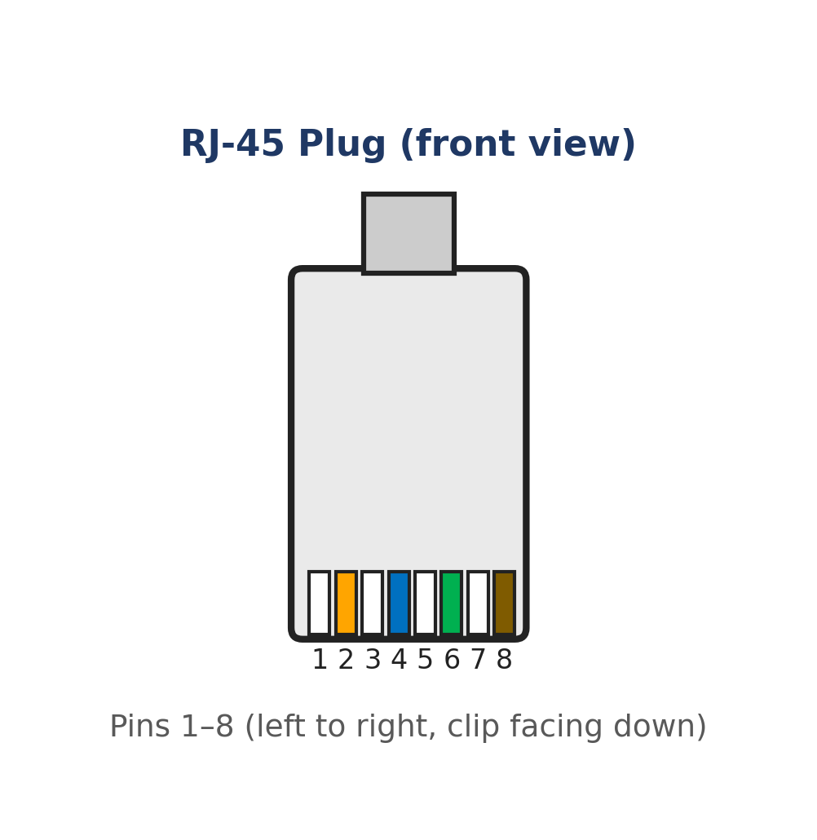
Fig B.1: RJ-45 Plug — Front View with Pin Numbering

T568A and T568B Wiring Standards
Twisted-pair cables are terminated according to one of two standardized color-code/pin arrangements — T568A or T568B — issued under TIA/EIA-568. Both are electrically equivalent; the choice matters only in ensuring both ends of a given cable use the same (or intentionally different, for a cross-over) standard.
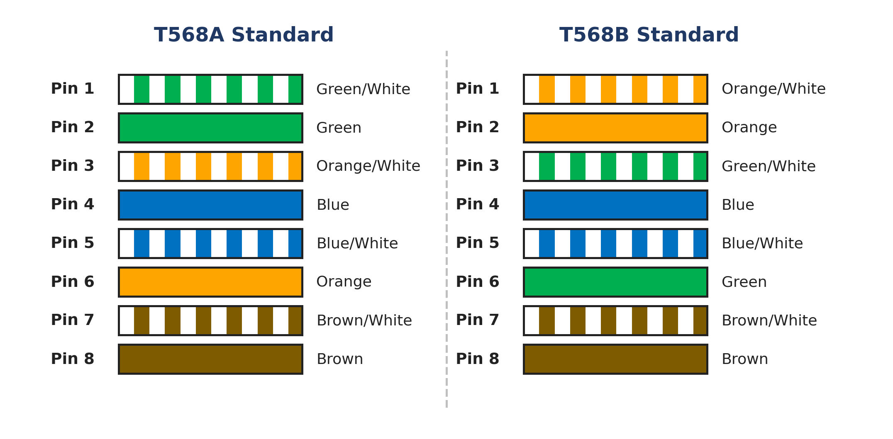
Fig B.2: T568A vs T568B Pin-to-Color Wiring Standards

Straight-Through vs Cross-Over Cable
A straight-through cable uses the same wiring standard (T568B, typically) on both ends, so each pin connects to the identical pin number at the far end — used to connect unlike devices. A cross-over cable uses T568A on one end and T568B on the other, swapping the transmit and receive pairs (pins 1↔3 and 2↔6) — used to connect like devices directly. Most modern NICs and switches support Auto-MDI/MDI-X, automatically detecting and correcting the wiring, making the distinction less critical in current equipment.
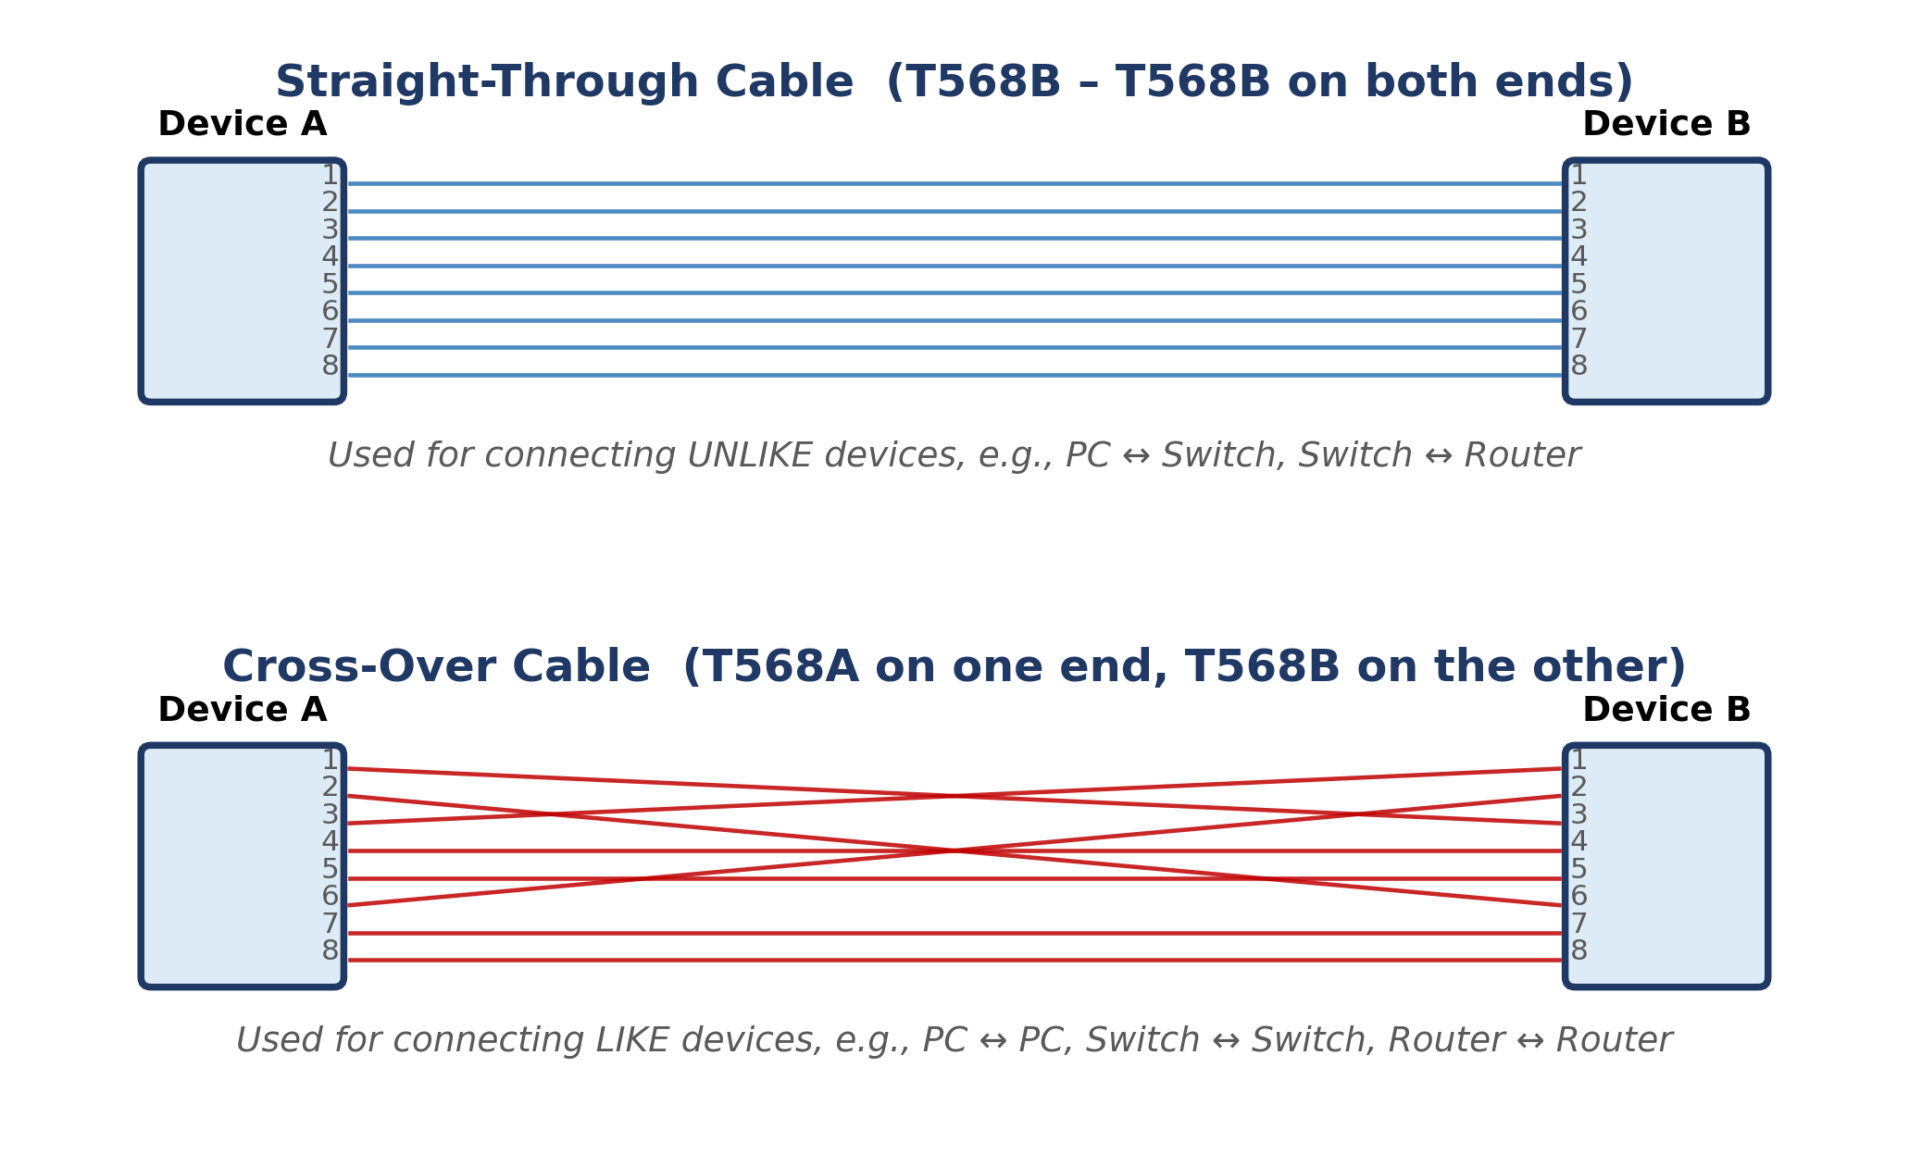
Fig B.3: Straight-Through Cable vs Cross-Over Cable — Pin Mapping

B.1 Unshielded Twisted Pair (UTP) — Cat5e
UTP cable consists of four pairs of insulated copper conductors twisted around each other, enclosed in a flexible PVC jacket. Twisting each pair at a different rate cancels out electromagnetic interference (crosstalk) between adjacent pairs, without requiring a metallic shield.
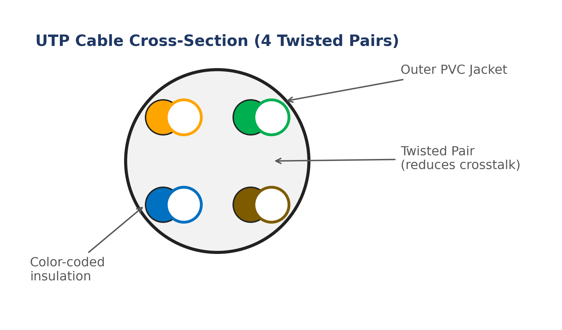
Fig: UTP Cable Cross-Section — 4 Twisted Pairs, Color-Coded
Parameter | Specification
Standard | TIA/EIA-568 (Category 5e)
Max. Data Rate | 1 Gbps (1000BASE-T)
Max. Bandwidth | 100 MHz
Max. Segment Length | 100 metres
Connector | RJ-45 (8P8C)
Typical Use | Desktop-to-switch LAN cabling, general office/campus networks

B.2 Unshielded Twisted Pair (UTP) — Cat6 / Cat6a
Cat6 tightens the twist rate further and adds a central plastic separator (spline) between pairs to reduce crosstalk, supporting Gigabit Ethernet reliably and 10-Gigabit Ethernet over short distances. Cat6a (Augmented) uses thicker conductors and tighter shielding of individual pairs to support 10 Gbps over the full 100 m distance.
Parameter | Specification
Standard | TIA/EIA-568 (Category 6 / 6a)
Max. Data Rate | 1 Gbps (Cat6, 100 m) / 10 Gbps (Cat6, ≤55 m) / 10 Gbps (Cat6a, 100 m)
Max. Bandwidth | 250 MHz (Cat6) / 500 MHz (Cat6a)
Max. Segment Length | 100 metres
Connector | RJ-45 (8P8C)
Typical Use | Modern LAN backbones, server-room cabling, 10 GbE links

B.3 Shielded Twisted Pair (STP) / Cat7
STP adds a foil or braided shield around each pair (and often an overall shield) to give superior immunity from external electromagnetic interference, at the cost of a thicker, less flexible, and more expensive cable that requires proper grounding of the shield at both ends.
Parameter | Specification
Standard | ISO/IEC 11801 (Category 7)
Max. Data Rate | 10 Gbps and above
Max. Bandwidth | 600 MHz
Max. Segment Length | 100 metres
Connector | GG45 or TERA (backward-compatible with RJ-45 at reduced rating)
Typical Use | High-EMI industrial environments, data centres requiring maximum noise immunity

B.4 Coaxial Cable
Coaxial cable has a single central copper conductor surrounded by an insulating dielectric layer, a braided/foil metallic shield, and an outer PVC jacket. The shield provides excellent noise immunity and was historically used for early bus-topology Ethernet (10BASE2/10BASE5); today it is mainly used for cable television and broadband internet distribution.
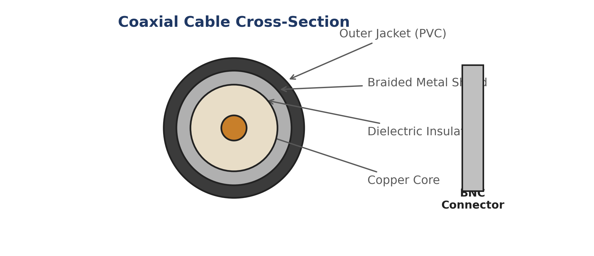
Fig: Coaxial Cable Cross-Section and BNC Connector
Parameter | Specification
Common Types | RG-6 (broadband/cable TV), RG-59 (older CCTV/video)
Max. Data Rate | Up to several hundred Mbps (DOCSIS cable broadband)
Max. Segment Length | Several hundred metres (with amplifiers for longer runs)
Connector | BNC or F-Type connector
Typical Use | Cable/broadband internet (ISP to cable modem), CCTV, television distribution

B.5 Fiber-Optic Cable — Multi-Mode
Fiber-optic cable transmits data as pulses of light through a glass or plastic core, making it completely immune to electromagnetic interference and capable of very high bandwidth over long distances. Multi-mode fiber has a larger core (50 or 62.5 µm) that allows multiple light paths (modes), typically driven by inexpensive LED or VCSEL sources, but is limited to shorter distances due to modal dispersion.
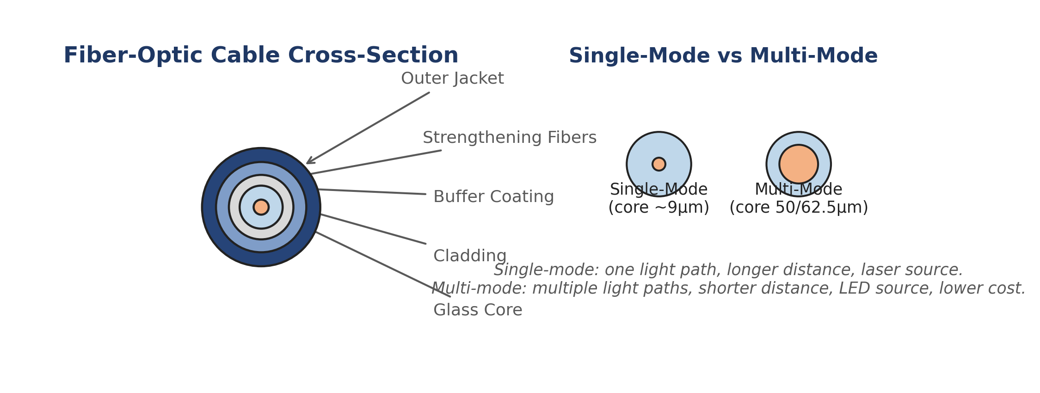
Fig: Fiber-Optic Cable Cross-Section and Single-Mode vs Multi-Mode Comparison
Parameter | Specification
Standard | OM3 / OM4 / OM5 (multi-mode)
Core Diameter | 50 µm or 62.5 µm
Max. Data Rate | 10–100 Gbps
Max. Segment Length | 300–550 metres (10GbE, depending on grade)
Connector | LC, SC, or ST
Typical Use | Data-centre and intra-building backbone links (short/medium reach, lower cost than single-mode)

B.6 Fiber-Optic Cable — Single-Mode
Single-mode fiber has a very narrow core (about 9 µm) that allows only a single light path, virtually eliminating modal dispersion. It is driven by a precise laser source and supports extremely long transmission distances (tens of kilometres) with minimal signal loss, at a higher equipment cost than multi-mode.
Parameter | Specification
Standard | OS1 / OS2 (single-mode)
Core Diameter | ~9 µm
Max. Data Rate | 10–400+ Gbps
Max. Segment Length | Up to 40+ km (with appropriate optics)
Connector | LC, SC
Typical Use | Long-haul ISP/telecom backbones, campus-to-campus links, FTTH (Fiber-to-the-Home)

B.7 Console (Rollover) Cable
A rollover cable is a flat 8-conductor cable in which the wire on pin 1 at one end connects to pin 8 at the other end, pin 2 to pin 7, and so on (the pinout is 'rolled over'). It connects a PC's serial/USB port (via an RJ-45-to-DB-9 or RJ-45-to-USB adapter) to a router or switch's console port for out-of-band CLI configuration, independent of the network being configured.
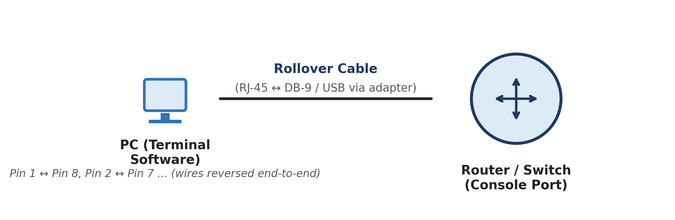
Fig: Console Cable Connecting a PC to a Router/Switch Console Port
Parameter | Specification
Wiring | Pin 1↔8, 2↔7, 3↔6, 4↔5 (reversed end-to-end)
Connector (device end) | RJ-45
Connector (PC end) | DB-9 serial (legacy) or USB-A/USB-C via adapter
Typical Speed | 9600 bps (default console baud rate)
Typical Use | Initial/out-of-band configuration of routers and switches via a terminal emulator (e.g., PuTTY, Tera Term)

B.8 Serial WAN Cable (V.35 / RS-232)
Serial cables connect routers over WAN links in lab/simulation environments, typically with a DTE (Data Terminal Equipment) end at the router and a DCE (Data Circuit-terminating Equipment) end that provides clocking, commonly simulating a connection through a CSU/DSU to a leased line or WAN cloud.
Parameter | Specification
Standard | V.35 / RS-232 / RS-449 (varies by equipment)
Connector | DB-60 or Smart Serial
Max. Data Rate | Up to 8 Mbps (V.35 typical)
Typical Use | Router-to-router WAN simulation labs, leased-line connections to a CSU/DSU

Part C — Study of Networking Devices
Networking devices operate at different layers of the OSI model and serve distinct purposes — from simply regenerating a signal to intelligently routing traffic between entirely different networks. Understanding each device's layer of operation, function, and appropriate cabling is essential to designing and troubleshooting real networks.

OSI Layer to Device Mapping
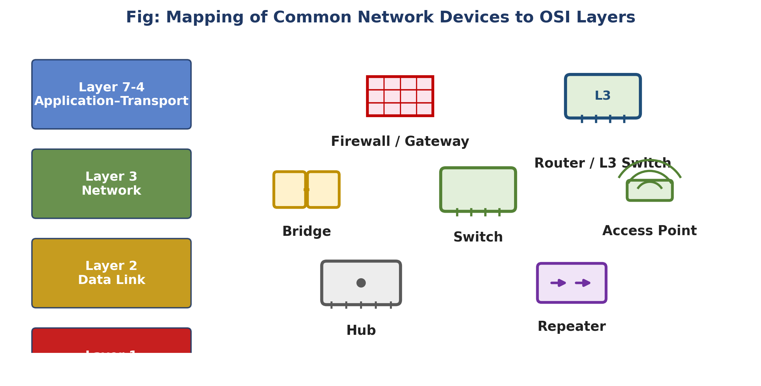
Fig C.1: Mapping of Common Network Devices to OSI Layers

Common Device Gallery
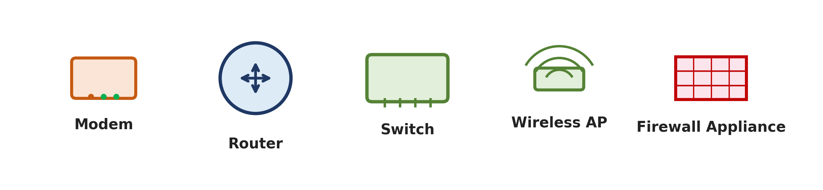
Fig C.2: Modem, Router, Switch, Wireless AP and Firewall Appliance

C.1 Network Interface Card (NIC)
The NIC is the hardware component that physically connects a computer to a network medium and provides the globally unique 48-bit MAC (Media Access Control) address used for Layer 2 addressing. It converts data between the parallel format used inside the computer and the serial format used on the network medium.
Attribute | Detail
OSI Layer | Layer 1 – Physical (with Layer 2 addressing)
Cable(s) Typically Used | UTP (RJ-45) for wired NICs; radio waves (no cable) for wireless NICs
Typical Speeds | 100 Mbps / 1 Gbps / 2.5 Gbps / 10 Gbps
Addressing | 48-bit MAC address, burned into hardware

C.2 Repeater
A repeater regenerates and amplifies a weak or degraded electrical/optical signal so it can travel further without loss of data integrity, extending the maximum cabling distance of a network segment. It operates purely on the physical signal and has no awareness of frames or addresses.
Attribute | Detail
OSI Layer | Layer 1 – Physical
Cable(s) Typically Used | UTP or Fiber (matches the segment being extended)
OSI Layer | 1 (Physical)
Function | Signal regeneration/amplification only
Collision Domain | Does not separate collision domains — merges them

C.3 Hub
A hub is a multi-port repeater — any signal received on one port is electrically repeated out to every other port. It has no intelligence to read MAC addresses, so all connected devices share a single collision domain and a single bandwidth pool, making hubs obsolete in modern networks (replaced by switches).
Attribute | Detail
OSI Layer | Layer 1 – Physical
Cable(s) Typically Used | UTP (Straight-through, RJ-45) from each end device to the hub
OSI Layer | 1 (Physical)
Collision Domain | Single, shared across all ports
Typical Ports | 4 / 8 / 16 / 24
Status | Legacy — rarely used in modern networks

C.4 Bridge
A bridge connects two network segments and intelligently forwards frames only when necessary, by learning which MAC addresses reside on which segment and filtering traffic that does not need to cross the bridge — thereby dividing a network into separate collision domains while keeping it a single broadcast domain.
Attribute | Detail
OSI Layer | Layer 2 – Data Link
Cable(s) Typically Used | UTP (RJ-45) connecting each segment to the bridge
OSI Layer | 2 (Data Link)
Collision Domains | Separates collision domains (one per port)
Broadcast Domain | Single (forwards broadcasts to all segments)
Typical Ports | 2 (classic bridge)

C.5 Switch
A switch is a multi-port bridge: it learns the MAC address(es) reachable on every port and forwards each frame only out of the port leading to its destination, giving every port its own dedicated collision domain and full-duplex bandwidth. Modern switches are the standard device for wired LAN connectivity.
Attribute | Detail
OSI Layer | Layer 2 – Data Link (Layer 3 for multilayer switches)
Cable(s) Typically Used | UTP Straight-through (Cat5e/6/6a, RJ-45) to end devices; Fiber (SC/LC) for uplinks between switches over longer distances
OSI Layer | 2 (Data Link); Layer 3 for multilayer/L3 switches
Collision Domain | One per port (full-duplex, effectively none)
Broadcast Domain | Single, unless configured with VLANs
Typical Ports | 8 / 24 / 48
Switching Speed | 1 Gbps – 100 Gbps per port depending on model

C.6 Wireless Access Point (AP)
An access point bridges wireless (Wi-Fi, IEEE 802.11) client devices to a wired Ethernet network, converting radio-frequency signals to and from Ethernet frames. Multiple APs with the same SSID can provide roaming coverage across a building or campus.
Attribute | Detail
OSI Layer | Layer 1/2 – Physical & Data Link
Cable(s) Typically Used | UTP Straight-through (RJ-45), often carrying Power-over-Ethernet (PoE) to the AP
OSI Layer | 1–2 (Physical/Data Link)
Standard | IEEE 802.11 (Wi-Fi 5 / Wi-Fi 6 / Wi-Fi 6E)
Power | Usually PoE (802.3af/at) via the Ethernet cable
Typical Range | 30–100 m indoors (varies with obstacles)

C.7 Router
A router forwards packets between different networks (different IP subnets) based on their destination IP address, using a routing table built manually (static routing) or through dynamic routing protocols (RIP, OSPF, EIGRP, BGP). A router is the boundary device between a LAN and a WAN/the Internet, and separates both collision domains and broadcast domains.
Attribute | Detail
OSI Layer | Layer 3 – Network
Cable(s) Typically Used | UTP (RJ-45) for LAN interfaces; Serial (V.35/RS-232) or Fiber for WAN links; Crossover/Auto-MDIX UTP for router-to-router Ethernet links
OSI Layer | 3 (Network)
Broadcast Domain | Separates broadcast domains (one per interface)
Routing | Static and/or Dynamic (RIP, OSPF, EIGRP, BGP)
Typical Interfaces | GigabitEthernet, FastEthernet, Serial

C.8 Gateway
A gateway is a broader term for any device that connects two dissimilar networks — potentially translating between entirely different protocol stacks (not just IP-to-IP routing). A home 'router' is technically also acting as a default gateway for LAN devices to reach the Internet.
Attribute | Detail
OSI Layer | All Layers (1–7, as required)
Cable(s) Typically Used | Varies by the two networks being connected — UTP, Coax, Fiber, or wireless
OSI Layer | Can operate at any/all layers depending on translation required
Typical Use | Default gateway (LAN↔Internet), VoIP gateway (analog↔digital), protocol gateway

C.9 Modem
A modem (modulator-demodulator) converts digital data from a computer/router into an analog or modulated signal suitable for transmission over telephone lines, cable TV lines, or fiber, and demodulates the signal back into digital data on reception. Common types include DSL modems, cable modems, and fiber ONTs (Optical Network Terminals).
Attribute | Detail
OSI Layer | Layer 1 – Physical
Cable(s) Typically Used | RJ-11 (DSL/telephone), RG-6 Coaxial (cable broadband), or Single-Mode Fiber with SC/LC connector (FTTH/ONT)
OSI Layer | 1 (Physical)
Types | DSL Modem, Cable Modem (DOCSIS), Fiber ONT
Typical Speeds | Up to several hundred Mbps (cable) / 1 Gbps+ (fiber)

C.10 Firewall (Dedicated Appliance)
A firewall inspects and filters incoming and outgoing network traffic according to a defined set of security rules, based on IP addresses and ports (traditional/stateful firewalls) or full application-layer content (Next-Generation Firewalls). It is typically deployed at the network perimeter, between the internal LAN and the router/Internet connection.
Attribute | Detail
OSI Layer | Layer 3/4 (and Layer 7 for next-gen firewalls)
Cable(s) Typically Used | UTP (RJ-45) or Fiber, matching the LAN/WAN interfaces it is placed between
OSI Layer | 3/4 (stateful); up to 7 for NGFW/application-aware firewalls
Function | Access control, stateful inspection, intrusion prevention (NGFW)
Placement | Network perimeter, between LAN and WAN/Internet edge router

Part D — Which Device Uses Which Cable?
This consolidated matrix maps common network connection scenarios to the correct cable type and connector, serving as a quick reference when cabling or troubleshooting a network in the laboratory or the field.
Connection Scenario | Cable Type | Connector | Notes
PC ↔ Switch / Hub | Straight-through UTP (Cat5e/6) | RJ-45 | Standard LAN access-layer connection
Switch ↔ Switch | Crossover UTP (or straight-through with Auto-MDIX) | RJ-45 | Modern NICs/switches auto-detect and adjust (Auto-MDIX), so either cable typically works
Switch ↔ Router | Straight-through UTP (Cat5e/6) | RJ-45 | Router LAN interface to switch access/uplink port
Router ↔ Router (Ethernet) | Crossover UTP (or straight-through with Auto-MDIX) | RJ-45 | Direct Ethernet link between two routers' LAN interfaces
Router ↔ Router (Serial WAN) | Serial DTE/DCE cable | DB-60 / Smart Serial | WAN simulation in labs; DCE end supplies the clock rate
PC ↔ Router/Switch Console Port | Rollover (Console) cable | RJ-45 to DB-9/USB | Out-of-band CLI configuration access
PC ↔ PC (Direct) | Crossover UTP | RJ-45 | Simple peer-to-peer link without an intermediary device
Switch/Router ↔ Access Point | Straight-through UTP with PoE | RJ-45 | Powers and connects the AP over a single cable
Cable Modem ↔ ISP | Coaxial (RG-6) | F-Type | Last-mile connection for cable broadband
DSL Modem ↔ ISP (telephone exchange) | Twisted-pair telephone cable | RJ-11 | Last-mile connection for DSL broadband
ONT/Fiber Modem ↔ ISP | Single-Mode Fiber | SC / LC | Last-mile connection for Fiber-to-the-Home (FTTH)
Building-to-Building / Data-Centre Backbone | Single-Mode or Multi-Mode Fiber | SC / LC | Long-distance, high-bandwidth, EMI-immune backbone links
Firewall ↔ Edge Router / Internal Switch | Straight-through UTP or Fiber (per link speed) | RJ-45 / SC / LC | Perimeter security placement between LAN and WAN edge

List of Experiments
Ex. No. | Title of the Experiment | Unit | Page
1 | Study of Network Devices and Peer-to-Peer Communication | Unit 1 | 22
2 | Implementation of Network Topologies | Unit 1 | 24
3 | Router Configuration — Creating Passwords and Configuring Interfaces | Unit 1 | 27
4 | IP Addressing and Subnetting using VLSM | Unit 2 | 29
5 | Design and Implementation of Static and Default Routing | Unit 2 | 31
6 | Configuration of Network Address Translation (NAT) | Unit 2 | 34
7 | Implementation of RIP Version 1 | Unit 3 | 36
8 | Implementation of RIP Version 2 | Unit 3 | 38
9 | Implementation of Single Area OSPF | Unit 3 | 40
10 | Implementation of Multi Area OSPF | Unit 4 | 42
11 | Configuration of Point-to-Point Protocol (PPP) | Unit 4 | 44
12 | Configuration of High-Level Data Link Control (HDLC) | Unit 4 | 46
13 | Implementation of Border Gateway Protocol (BGP) | Unit 5 | 48
14 | Implementation of EIGRP | Unit 5 | 50
15 | Configuration of Telnet for Remote Router Access | Unit 5 | 52

Experiment 1

Study of Network Devices and Peer-to-Peer Communication

Aim
To study the basic networking devices used in Cisco Packet Tracer and establish a peer-to-peer (P2P) connection between two end devices, and verify connectivity using the ping command.

Software / Equipment Required
- Cisco Packet Tracer software
- 2 PC (End Devices)
- Copper Cross-Over Cable

Theory
A computer network is an interconnection of two or more computing devices that enables the exchange of data and sharing of resources. Cisco Packet Tracer is a network simulation tool that allows students to design, configure, and troubleshoot networks without physical hardware.
The commonly used end devices are PCs, laptops, servers and printers, while intermediary devices include hubs, switches and routers, which are responsible for forwarding data between end devices. A Network Interface Card (NIC) provides the physical connection point and a unique MAC address for each device on the network.
A Peer-to-Peer (P2P) network is the simplest form of a network in which two devices are connected directly, without any intermediary device, and both devices can act as client and server simultaneously. Two computers with Ethernet NICs are connected using a copper cross-over cable so that the transmit pin of one device aligns with the receive pin of the other.

Network Diagram
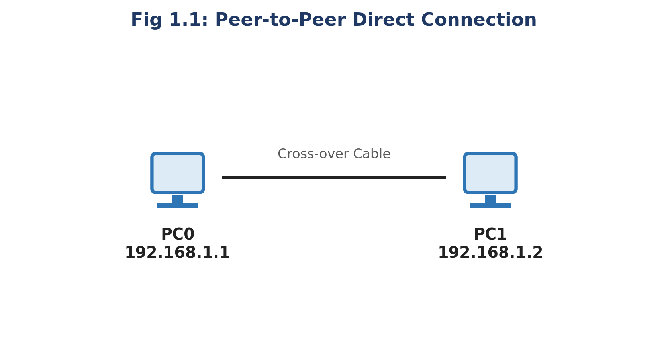
Fig 1.1: Peer-to-Peer Direct Connection between PC0 and PC1

Procedure
- Open Cisco Packet Tracer and place two PC icons (PC0 and PC1) on the workspace from the End Devices category.
- Select the Connections category and choose the Copper Cross-Over cable.
- Click PC0, choose the FastEthernet0 port, then click PC1 and choose its FastEthernet0 port to complete the physical link (the link turns green once both interfaces are up).
- Click PC0 → Desktop → IP Configuration, and assign IP Address 192.168.1.1 with Subnet Mask 255.255.255.0.
- Click PC1 → Desktop → IP Configuration, and assign IP Address 192.168.1.2 with Subnet Mask 255.255.255.0.
- Open the Command Prompt on PC0 (Desktop → Command Prompt) and execute: ping 192.168.1.2
- Observe the reply messages confirming successful delivery of ICMP echo request/reply packets between the two hosts.

Result / Verification
- The link status indicator between PC0 and PC1 must be green on both ends.
- The command ping 192.168.1.2 executed on PC0 must return: Reply from 192.168.1.2: bytes=32 time<1ms TTL=128, with 0% packet loss.
Result: The objective of Experiment 1 — "Study of Network Devices and Peer-to-Peer Communication" — was successfully achieved and verified in Cisco Packet Tracer.

Viva-Voce Questions
- What is the difference between a straight-through cable and a cross-over cable?
- Why can two PCs not be connected directly using a straight-through cable?
- What is the purpose of the ping command and which protocol does it use?

Experiment 2

Implementation of Network Topologies

Aim
To design and implement Bus, Star, Ring, Mesh and Tree network topologies in Cisco Packet Tracer and study their structural characteristics.

Software / Equipment Required
- Cisco Packet Tracer software
- PCs, Hub/Switch, Copper Straight-through and Cross-over cables

Theory
Network topology refers to the arrangement of nodes and links in a network. The choice of topology affects cost, reliability, scalability and ease of troubleshooting.
Bus topology: all devices are attached to a single shared communication backbone (the bus). It is inexpensive to install but a break in the backbone disables the entire network, and performance degrades as more devices are added.
Star topology: every device is connected to a central device such as a hub or switch. It is easy to install and manage, and failure of one node link does not affect others; however, failure of the central device brings down the entire network.
Ring topology: each device is connected to exactly two neighbouring devices, forming a closed loop, and data travels in one (or both) direction around the ring. It provides orderly access but a single broken link can disrupt communication unless a dual ring is used.
Mesh topology: every device is connected to every other device through a dedicated point-to-point link, providing very high redundancy and reliability at the cost of extensive cabling.
Tree topology: a hierarchical combination of star networks connected via a central 'root' device; it is scalable and easy to expand, but the root and higher-level switches are critical points of failure.

Network Diagram
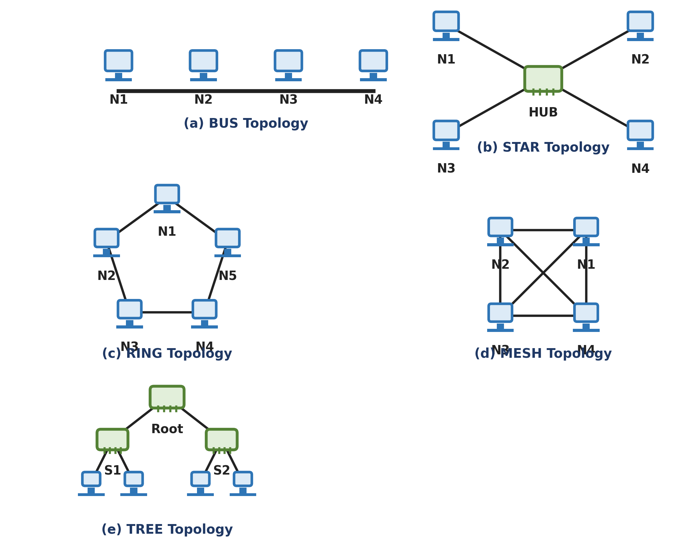
Fig 2.1: Bus, Star, Ring, Mesh and Tree Topologies

Procedure
- For each topology, place the required number of end devices and intermediary devices (hub/switch) on the workspace as per the corresponding diagram.
- Connect the devices using appropriate cables: straight-through cable between a PC and a switch, cross-over cable between two like devices (PC–PC, switch–switch).
- Assign IP addresses from the same subnet (e.g., 192.168.1.0/24) to all end devices in each topology.
- Verify all links show a green (connected) status.
- Test connectivity between different pairs of end devices using the ping command and record the results.
- Simulate a link/device failure (delete one cable or one device) and observe which stations lose connectivity, to compare the fault-tolerance of each topology.

Numerical Example — Number of Links Required
For a Mesh topology with n nodes, every node connects to every other node, so the total number of dedicated links required is:
Number of links = n(n − 1) / 2
For n = 5 nodes: Links = 5(5 − 1)/2 = 5 × 4 / 2 = 10 links.
In contrast, a Star topology with the same 5 nodes requires only n = 5 links (one per node to the central switch), and a Ring or Bus topology requires only n = 5 and (n − 1) = 4 links respectively — illustrating why Mesh, though highly reliable, does not scale well for large n.

Result / Verification
- All configured end devices in each topology must successfully ping one another.
- On simulating a single link failure, only the Star, Ring (single loop) and Bus topologies should show a loss of connectivity for the affected node(s)/network, while the Mesh topology should continue to deliver packets via an alternate path.
Result: The objective of Experiment 2 — "Implementation of Network Topologies" — was successfully achieved and verified in Cisco Packet Tracer.

Viva-Voce Questions
- Which topology offers the highest fault tolerance and why?
- Why is Star topology the most commonly used topology in modern LANs?
- What is a hybrid topology? Give one real-world example.

Experiment 3

Router Configuration — Creating Passwords and Configuring Interfaces

Aim
To perform the basic configuration of a Cisco router — setting the hostname, securing access using console and enable passwords, and configuring an interface with an IP address.

Software / Equipment Required
- Cisco Packet Tracer software
- 1 Router (e.g., 2911)
- 1 PC for console access

Theory
A Cisco router's Command Line Interface (CLI) is organized into hierarchical modes: User EXEC mode (limited monitoring commands, prompt Router>), Privileged EXEC mode (full monitoring/debug commands, prompt Router#), Global Configuration mode (device-wide settings, prompt Router(config)#), and Interface Configuration mode (per-interface settings, prompt Router(config-if)#).
Passwords secure different access points: the console password restricts direct physical/console access, the enable/enable-secret password restricts entry into Privileged EXEC mode, and the vty (virtual terminal) password restricts remote Telnet/SSH access.
Each router interface must be assigned an IP address belonging to the subnet of the network segment it connects to, and must be enabled using the no shutdown command, since all interfaces are administratively down by default.

Network Diagram
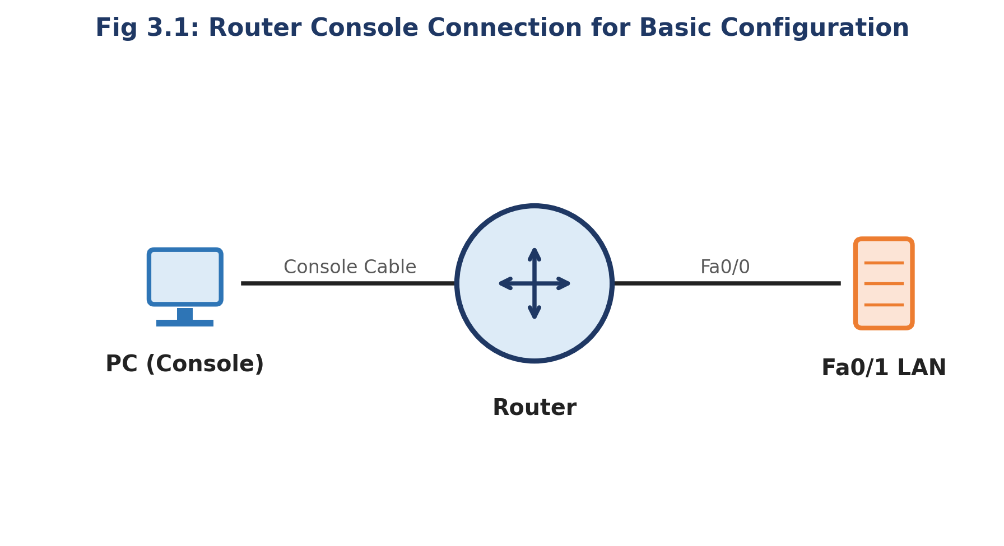
Fig 3.1: Router Console Connection for Basic Configuration

Procedure
- Connect a PC to the router's console port using a console cable and open a Terminal session.
- Enter Privileged EXEC mode and then Global Configuration mode using the commands below.
- Set the router hostname, configure the enable secret password, configure the console line password, and configure the vty lines for remote access.
- Enter interface configuration mode for GigabitEthernet0/0, assign an IP address and subnet mask, and enable the interface.
- Save the configuration to NVRAM so it persists after a reboot.

Configuration Commands
Command Sequence
Router> enable
Router# configure terminal
Router(config)# hostname R1
R1(config)# enable secret class
R1(config)# line console 0
R1(config-line)# password cisco
R1(config-line)# login
R1(config-line)# exit
R1(config)# line vty 0 4
R1(config-line)# password cisco
R1(config-line)# login
R1(config-line)# exit
R1(config)# interface GigabitEthernet0/0
R1(config-if)# ip address 192.168.1.1 255.255.255.0
R1(config-if)# no shutdown
R1(config-if)# exit
R1(config)# exit
R1# copy running-config startup-config

Result / Verification
- The command show running-config should display the hostname R1, the encrypted enable secret, and the configured passwords under line console 0 and line vty 0 4.
- The command show ip interface brief should show GigabitEthernet0/0 with IP address 192.168.1.1 and status up/up.
Result: The objective of Experiment 3 — "Router Configuration — Creating Passwords and Configuring Interfaces" — was successfully achieved and verified in Cisco Packet Tracer.

Viva-Voce Questions
- What is the difference between the enable password and the enable secret command?
- Why must the no shutdown command be issued on every router interface?
- What is the purpose of vty lines on a router?

Experiment 4

IP Addressing and Subnetting using VLSM

Aim
To understand classful and classless IP addressing and to design an efficient IP addressing scheme for a given network using Variable Length Subnet Masking (VLSM).

Software / Equipment Required
- Cisco Packet Tracer software
- Routers, Switches, PCs
- Calculator / manual binary computation

Theory
An IPv4 address is a 32-bit number divided into a network portion and a host portion, conventionally written in dotted-decimal notation (e.g., 192.168.1.1). Classful addressing divides addresses into Class A, B, C, D and E, each with a fixed-length default subnet mask, which often wastes large numbers of host addresses.
Classless Inter-Domain Routing (CIDR) removes the class boundaries and represents the network portion using a prefix length (e.g., /24), allowing subnet masks of any length and far more efficient address allocation.
Variable Length Subnet Masking (VLSM) extends subnetting by allowing each subnet within an organization to use a different subnet mask sized to its actual host requirement, instead of a single fixed mask for the entire network — this is often called 'subnetting a subnet' and minimizes address wastage.

Network Diagram

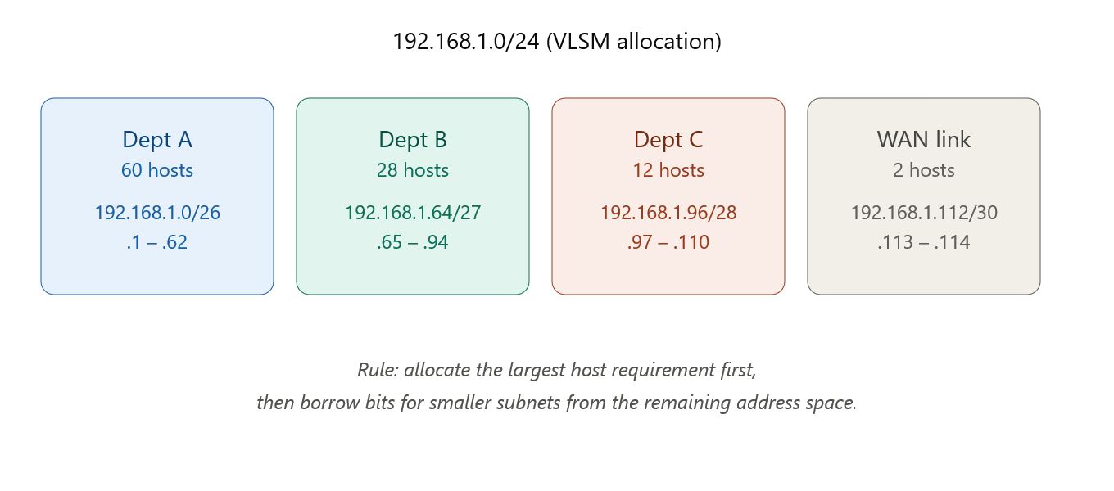
Fig 4.1: VLSM Allocation of 192.168.1.0/24 Among Four Departments

Procedure
- List the host requirements of each department/segment in descending order (largest requirement first).
- For each requirement, determine the number of host bits (h) needed such that 2^h − 2 ≥ required hosts.
- Assign the subnet mask as /(32 − h), compute the network address, the usable host range, and the broadcast address.
- Move to the next available network address after the previous block's broadcast address and repeat for the next department.
- Configure the computed IP addresses on the routers/PCs in Packet Tracer and verify reachability within each subnet using ping.

Numerical Example — VLSM Calculation for 192.168.1.0/24
Given address block: 192.168.1.0/24 (256 total addresses). Requirements: Dept A = 60 hosts, Dept B = 28 hosts, Dept C = 12 hosts, WAN link = 2 hosts.
Dept A (60 hosts): need 2^h − 2 ≥ 60 → h = 6 (2^6 − 2 = 62). Mask = /26 (255.255.255.192). Subnet: 192.168.1.0/26, Host range: 192.168.1.1 – 192.168.1.62, Broadcast: 192.168.1.63.
Dept B (28 hosts): need 2^h − 2 ≥ 28 → h = 5 (2^5 − 2 = 30). Mask = /27 (255.255.255.224). Subnet: 192.168.1.64/27, Host range: 192.168.1.65 – 192.168.1.94, Broadcast: 192.168.1.95.
Dept C (12 hosts): need 2^h − 2 ≥ 12 → h = 4 (2^4 − 2 = 14). Mask = /28 (255.255.255.240). Subnet: 192.168.1.96/28, Host range: 192.168.1.97 – 192.168.1.110, Broadcast: 192.168.1.111.
WAN Link (2 hosts): need 2^h − 2 ≥ 2 → h = 2 (2^2 − 2 = 2). Mask = /30 (255.255.255.252). Subnet: 192.168.1.112/30, Host range: 192.168.1.113 – 192.168.1.114, Broadcast: 192.168.1.115.
Remaining unused address space from 192.168.1.116 to 192.168.1.255 (140 addresses) is preserved for future expansion.

Result / Verification
- The sum of all allocated host addresses and broadcast/network addresses in each block must not overlap with any other block.
- Devices configured within the same VLSM subnet must successfully ping each other; devices across different subnets must communicate only through a router.
Result: The objective of Experiment 4 — "IP Addressing and Subnetting using VLSM" — was successfully achieved and verified in Cisco Packet Tracer.

Viva-Voce Questions
- Why is VLSM more efficient than Fixed Length Subnet Masking (FLSM)?
- What is the formula to calculate the number of usable hosts in a subnet?
- Differentiate between a network address, a broadcast address and a usable host address.

Experiment 5

Design and Implementation of Static and Default Routing

Aim
To configure static routes and a default route between routers so that hosts on different networks can communicate with each other and with unspecified external destinations.

Software / Equipment Required
- Cisco Packet Tracer software
- 2 Routers
- 2 PCs
- Serial and Copper cables

Theory
Routing is the process by which a router forwards packets toward their destination network. Static routing requires the network administrator to manually configure each route in the routing table using the ip route command; it does not adapt automatically to topology changes but consumes no CPU/bandwidth for route computation and is highly predictable, making it suitable for small or stub networks.
A default route (also called the 'gateway of last resort') is a special static route, written as ip route 0.0.0.0 0.0.0.0 <next-hop>, that matches any destination network not explicitly present in the routing table — it is typically configured on a stub router that connects to a single upstream router or to the Internet.
Static routes have an Administrative Distance (AD) of 1, making them more trusted (preferred) than routes learned from any dynamic routing protocol, unless a more specific match exists in the routing table (longest-prefix-match rule).

Network Diagram
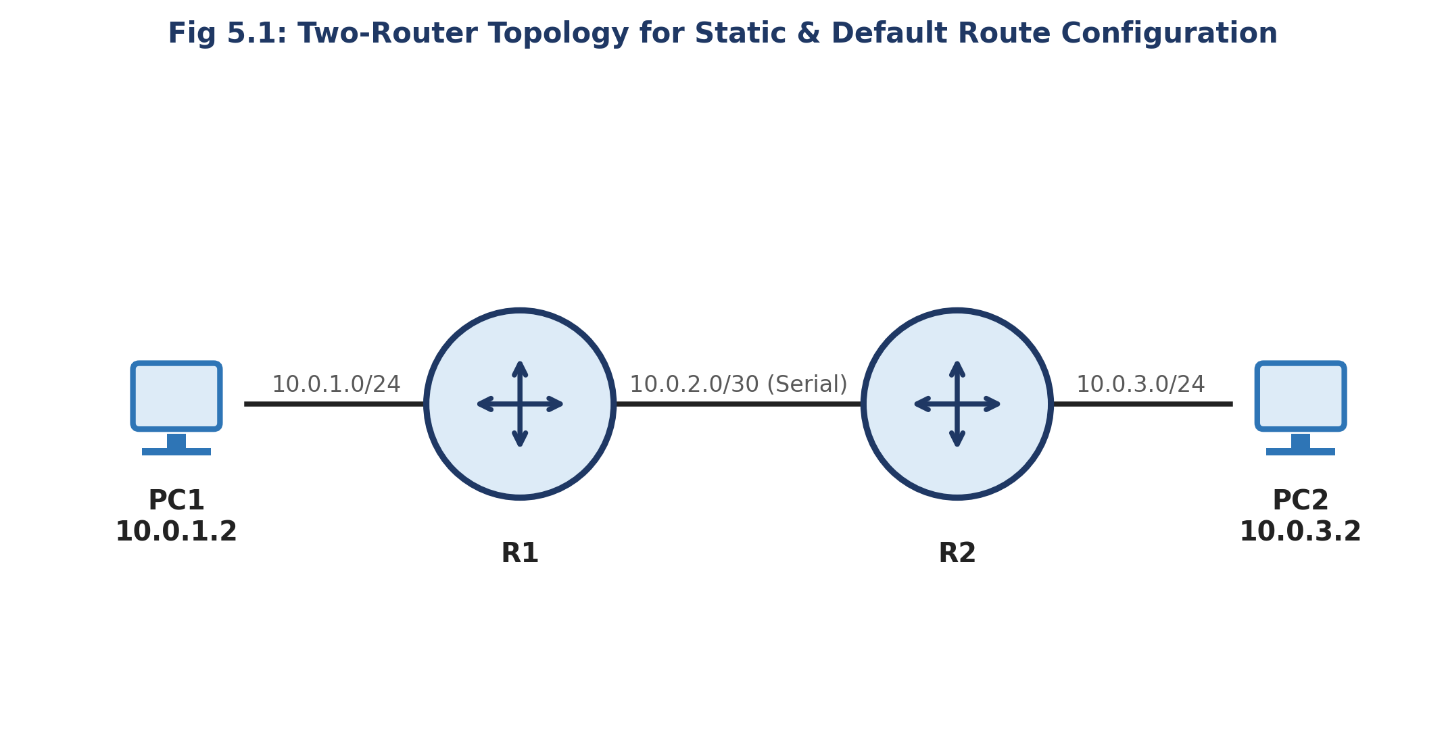
Fig 5.1: Two-Router Topology for Static and Default Route Configuration

Procedure
- Build the topology: PC1 — R1 — (Serial link) — R2 — PC2, with distinct IP subnets on each segment as shown in the diagram.
- Configure the LAN and serial interfaces of R1 and R2 with appropriate IP addresses and clock rate (on the DCE end of the serial link).
- On R1, configure a static route to reach PC2's network via R2's serial interface address.
- On R2, configure a static route (or a default route) to reach PC1's network via R1's serial interface address.
- Verify end-to-end connectivity using ping from PC1 to PC2 and examine the routing table on each router.

Configuration Commands
R1 Configuration
R1(config)# interface GigabitEthernet0/0
R1(config-if)# ip address 10.0.1.1 255.255.255.0
R1(config-if)# no shutdown
R1(config-if)# exit
R1(config)# interface Serial0/0/0
R1(config-if)# ip address 10.0.2.1 255.255.255.252
R1(config-if)# clock rate 64000
R1(config-if)# no shutdown
R1(config-if)# exit
R1(config)# ip route 10.0.3.0 255.255.255.0 10.0.2.2
R2 Configuration
R2(config)# interface GigabitEthernet0/0
R2(config-if)# ip address 10.0.3.1 255.255.255.0
R2(config-if)# no shutdown
R2(config-if)# exit
R2(config)# interface Serial0/0/0
R2(config-if)# ip address 10.0.2.2 255.255.255.252
R2(config-if)# no shutdown
R2(config-if)# exit
R2(config)# ip route 0.0.0.0 0.0.0.0 10.0.2.1

Numerical Note — Administrative Distance
Administrative Distance (AD) represents the trustworthiness of a routing information source; a lower value is preferred. Directly connected route: AD = 0. Static route: AD = 1. EIGRP (internal): AD = 90. OSPF: AD = 110. RIP: AD = 120.
Since the static route's AD (1) is lower than any dynamic protocol's AD, if both a static route and a dynamic route to the same destination exist, the router installs the static route in its routing table.

Result / Verification
- show ip route on R1 must display a route to 10.0.3.0/24 marked with 'S' (static).
- show ip route on R2 must display a default route (S* 0.0.0.0/0) via 10.0.2.1.
- ping from PC1 (10.0.1.2) to PC2 (10.0.3.2) must succeed with 0% packet loss.
Result: The objective of Experiment 5 — "Design and Implementation of Static and Default Routing" — was successfully achieved and verified in Cisco Packet Tracer.

Viva-Voce Questions
- What is the syntax of the ip route command and what does each parameter represent?
- When would you prefer a default route over an explicit static route?
- What is the administrative distance of a static route, and why is it lower than dynamic routing protocols?

Experiment 6

Configuration of Network Address Translation (NAT)

Aim
To configure NAT overload (PAT) on a router so that multiple private hosts on an internal LAN can access an external/public network using a single public IP address.

Software / Equipment Required
- Cisco Packet Tracer software
- 1 Router (NAT-enabled)
- 2 PCs
- 1 Server (representing the Internet)

Theory
Network Address Translation (NAT) is the process of mapping private (internal) IP addresses to public (external) IP addresses, conserving the limited pool of public IPv4 addresses and adding a layer of address-hiding security.
Static NAT provides a permanent one-to-one mapping between a private and a public address. Dynamic NAT maps a private address to any available address from a pool of public addresses, on a first-come basis. NAT Overload, also called Port Address Translation (PAT), maps many private addresses to a single public address by additionally distinguishing sessions using unique source port numbers.
RFC 1918 reserves the private address ranges 10.0.0.0/8, 172.16.0.0/12 and 192.168.0.0/16 for internal use; these addresses are not routable on the public Internet and must be translated by a NAT-enabled router at the network boundary.

Network Diagram
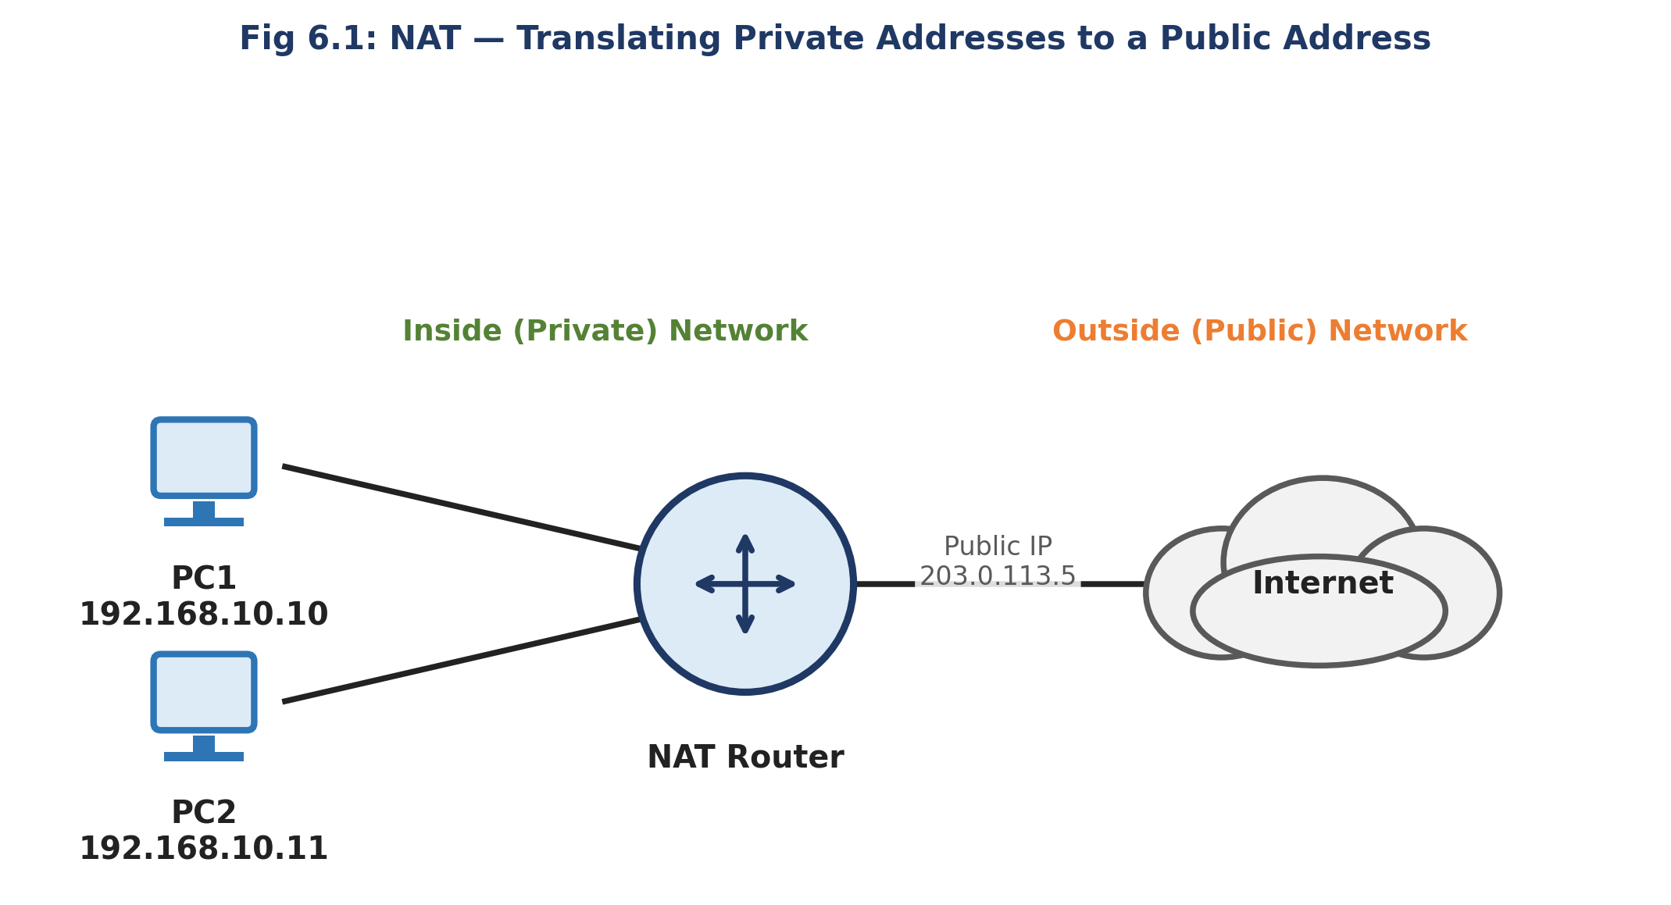
Fig 6.1: NAT — Translating Private Addresses to a Single Public Address

Procedure
- Configure the inside LAN interface and the outside (public-facing) interface of the router with their respective IP addresses.
- Mark the LAN-facing interface as ip nat inside and the public-facing interface as ip nat outside.
- Define an access-list that identifies the private source addresses eligible for translation.
- Bind the access-list to the outside interface using NAT overload, so all matching internal hosts share the single public IP address of the outside interface.
- Verify translation by generating traffic from an inside PC toward the outside server and inspecting the NAT translation table.

Configuration Commands
NAT Router Configuration
Router(config)# interface GigabitEthernet0/0
Router(config-if)# ip address 192.168.10.1 255.255.255.0
Router(config-if)# ip nat inside
Router(config-if)# exit
Router(config)# interface GigabitEthernet0/1
Router(config-if)# ip address 203.0.113.5 255.255.255.0
Router(config-if)# ip nat outside
Router(config-if)# exit
Router(config)# access-list 1 permit 192.168.10.0 0.0.0.255
Router(config)# ip nat inside source list 1 interface GigabitEthernet0/1 overload

Numerical Illustration — PAT Session Table
Inside Local 192.168.10.10:1500 → Inside Global 203.0.113.5:40001 (session to outside server).
Inside Local 192.168.10.11:1500 → Inside Global 203.0.113.5:40002 (a second host using the SAME inside-local port 1500 is still distinguished uniquely by a different translated port number).
This demonstrates how PAT allows thousands of internal hosts to share one public IPv4 address using the 16-bit TCP/UDP port space (up to 65,536 concurrent sessions per public IP).

Result / Verification
- The command show ip nat translations must list the Inside Local ↔ Inside Global address/port mappings for each active session.
- The command show ip nat statistics must show the total number of active translations and hits.
Result: The objective of Experiment 6 — "Configuration of Network Address Translation (NAT)" — was successfully achieved and verified in Cisco Packet Tracer.

Viva-Voce Questions
- Differentiate between Static NAT, Dynamic NAT and PAT (NAT Overload).
- Why is NAT overload also referred to as 'many-to-one' translation?
- What are Inside Local, Inside Global, Outside Local and Outside Global addresses?

Experiment 7

Implementation of RIP Version 1

Aim
To configure the Routing Information Protocol version 1 (RIPv1) on a multi-router network and study its distance-vector route computation.

Software / Equipment Required
- Cisco Packet Tracer software
- 3 Routers
- PCs
- Serial/Copper cables

Theory
RIP is a classical Distance Vector routing protocol that uses hop count as its only metric, with a maximum usable value of 15 hops (16 is considered infinite/unreachable), which limits it to small networks.
RIPv1 is a classful protocol — it does not carry subnet mask information in its updates, and therefore cannot support VLSM or discontiguous subnets. Routing updates are broadcast (to 255.255.255.255) every 30 seconds by default.
Each router builds its routing table by exchanging its entire routing table with directly connected neighbours, and gradually converges as routers learn about farther networks (the classic 'routing by rumour' behaviour of distance-vector protocols).

Network Diagram
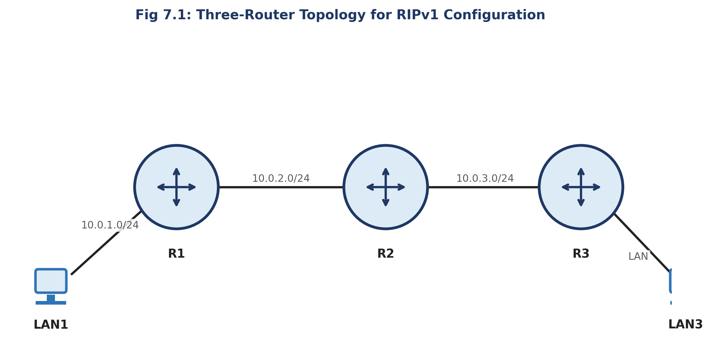
Fig 7.1: Three-Router Topology for RIPv1 Configuration

Procedure
- Configure IP addresses on all router interfaces as per the topology.
- On each router, enter router configuration mode for RIP and advertise all directly connected classful networks using the network command.
- Allow sufficient time for the protocol to converge across all three routers.
- Examine the routing table on each router to confirm that routes learned via RIP appear with the code 'R' and the correct hop-count metric.
- Test end-to-end connectivity between hosts on LAN1 and LAN3 using ping and traceroute.

Configuration Commands
RIPv1 Configuration (repeat network statements on R2, R3 as applicable)
R1(config)# router rip
R1(config-router)# network 10.0.0.0
R1(config-router)# exit
R2(config)# router rip
R2(config-router)# network 10.0.0.0
R3(config)# router rip
R3(config-router)# network 10.0.0.0

Numerical Example — RIP Hop-Count Metric
In the topology LAN1—R1—R2—R3—LAN3, R1 is directly connected to LAN1 (hop count = 0 from R1's perspective).
R2 learns of LAN1 from R1 with hop count = 0 + 1 = 1. R3 learns of LAN1 from R2 with hop count = 1 + 1 = 2.
Similarly, R1 learns of LAN3 (directly connected to R3) with a hop count of 2, via R2. If a fourth router were added in series, the hop count would increase to 3, and so on, until the maximum of 15 hops is reached, beyond which RIP considers the network unreachable.

Result / Verification
- show ip route rip on each router should list remote networks with an 'R' code and the correct hop count in the format [120/<hopcount>].
- show ip protocols should confirm RIP version 1 is active with the correct networks being advertised.
Result: The objective of Experiment 7 — "Implementation of RIP Version 1" — was successfully achieved and verified in Cisco Packet Tracer.

Viva-Voce Questions
- Why is RIP called a Distance Vector routing protocol?
- What is the maximum hop count supported by RIP, and what does a hop count of 16 signify?
- Why can RIPv1 not be used in a network with VLSM-based subnetting?

Experiment 8

Implementation of RIP Version 2

Aim
To configure RIP version 2 (RIPv2) on a multi-router VLSM-based network and compare its features with RIPv1.

Software / Equipment Required
- Cisco Packet Tracer software
- 3 Routers
- PCs configured with VLSM subnets

Theory
RIPv2 is an enhancement over RIPv1 that carries the subnet mask in its route updates, making it a classless routing protocol capable of supporting VLSM and discontiguous networks.
RIPv2 sends its updates as multicast packets to the reserved address 224.0.0.9, instead of broadcasting them to the entire subnet, reducing unnecessary processing load on non-RIP devices.
RIPv2 also supports simple plain-text and MD5 authentication of routing updates, and by default performs automatic summarization at classful network boundaries, which must usually be disabled using no auto-summary in VLSM environments to prevent incorrect route aggregation.

Network Diagram
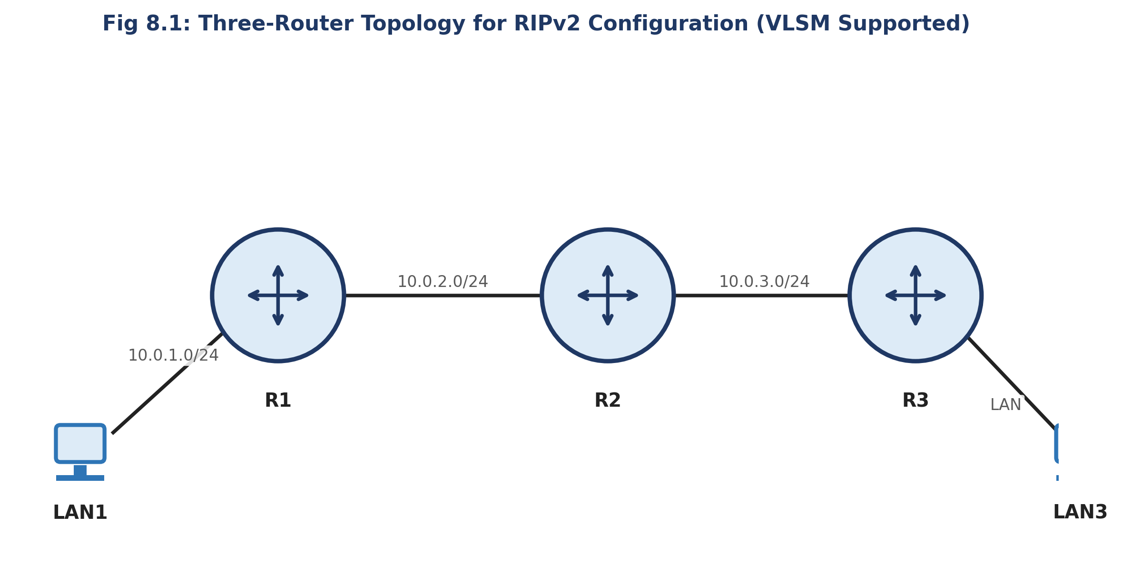
Fig 8.1: Three-Router Topology for RIPv2 Configuration (VLSM Supported)

Procedure
- Configure router interfaces with VLSM-based IP addressing (subnets of differing prefix lengths) as designed in Lab 4.
- Enable RIP on each router and explicitly set the version to 2 using the version 2 command.
- Disable automatic summarization using no auto-summary so that individual VLSM subnets are advertised correctly.
- Advertise the connected major networks using the network command under router rip.
- Verify convergence and inspect the routing table for the correctly advertised subnet masks.

Configuration Commands
RIPv2 Configuration (repeat on all routers)
R1(config)# router rip
R1(config-router)# version 2
R1(config-router)# no auto-summary
R1(config-router)# network 10.0.0.0
R1(config-router)# exit

Comparison — RIPv1 vs RIPv2
Update type: RIPv1 = Broadcast (255.255.255.255); RIPv2 = Multicast (224.0.0.9).
Addressing support: RIPv1 = Classful only; RIPv2 = Classless (VLSM/CIDR supported).
Authentication: RIPv1 = Not supported; RIPv2 = Plain-text and MD5 supported.
Subnet mask in update: RIPv1 = Not included; RIPv2 = Included with every route entry.

Result / Verification
- show ip protocols must confirm 'Routing Protocol is rip' with 'Sending updates every 30 seconds' and version 2.
- show ip route must correctly reflect the exact VLSM subnet masks of remote networks, not summarized classful boundaries.
Result: The objective of Experiment 8 — "Implementation of RIP Version 2" — was successfully achieved and verified in Cisco Packet Tracer.

Viva-Voce Questions
- Why does RIPv2 need the no auto-summary command in a VLSM network?
- What multicast address does RIPv2 use to send its updates?
- List two limitations that still remain in RIPv2 despite the enhancements over RIPv1.

Experiment 9

Implementation of Single Area OSPF

Aim
To configure Open Shortest Path First (OSPF) routing protocol within a single area (Area 0) and study its link-state operation and cost-based metric.

Software / Equipment Required
- Cisco Packet Tracer software
- 4 Routers
- PCs

Theory
OSPF is an open-standard Link-State routing protocol that uses Dijkstra's Shortest Path First (SPF) algorithm to build a complete topological map (Link-State Database) of the network, from which each router independently calculates the shortest path to every destination.
Unlike RIP's hop count, OSPF's metric is cost, which is inversely proportional to interface bandwidth: Cost = Reference Bandwidth / Interface Bandwidth. The default reference bandwidth is 100 Mbps, and the total path cost is the sum of costs of all outgoing interfaces along the path.
In a single-area design, all routers belong to Area 0 (the backbone area). OSPF routers exchange Hello packets (default every 10 seconds on broadcast/point-to-point networks) to discover neighbours, elect a Designated Router (DR) and Backup Designated Router (BDR) on multi-access segments, and then synchronize their Link-State Databases.

Network Diagram
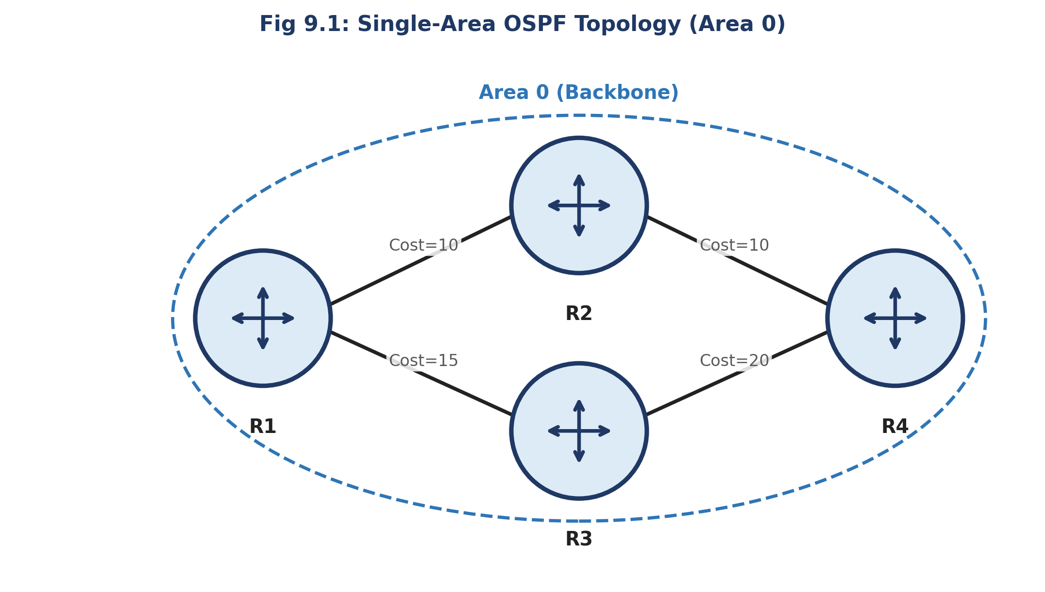
Fig 9.1: Single-Area OSPF Topology (Area 0)

Procedure
- Configure IP addresses on all router interfaces as per the topology, using appropriate bandwidths on serial links.
- Enable OSPF process 1 on each router and advertise each connected network using the network <address> <wildcard-mask> area 0 command.
- Allow the routers to form full neighbour adjacencies and synchronize the Link-State Database.
- Examine the OSPF neighbour table and the computed shortest paths in the routing table.
- Verify end-to-end reachability between hosts attached to different routers.

Configuration Commands
OSPF Configuration (repeat on R1–R4 with respective networks)
R1(config)# router ospf 1
R1(config-router)# network 10.0.1.0 0.0.0.255 area 0
R1(config-router)# network 10.0.12.0 0.0.0.3 area 0
R1(config-router)# exit

Numerical Example — OSPF Cost Calculation
OSPF Cost = Reference Bandwidth (100,000 kbps) / Interface Bandwidth (kbps).
For a FastEthernet interface (100,000 kbps): Cost = 100,000 / 100,000 = 1.
For an Ethernet interface (10,000 kbps): Cost = 100,000 / 10,000 = 10.
For a T1 Serial link (1,544 kbps): Cost = 100,000 / 1,544 ≈ 64 (rounded down to the nearest integer).
If a route from R1 to a destination passes through one Ethernet link (cost 10) and one T1 serial link (cost 64), the total OSPF path cost = 10 + 64 = 74. OSPF will always prefer the path with the lowest total cost.

Result / Verification
- show ip ospf neighbor must list all directly connected OSPF neighbours in the FULL state.
- show ip route ospf must list remote networks with the 'O' code and the computed cost, e.g., [110/74].
Result: The objective of Experiment 9 — "Implementation of Single Area OSPF" — was successfully achieved and verified in Cisco Packet Tracer.

Viva-Voce Questions
- Why is OSPF called a Link-State protocol and how does it differ from Distance Vector protocols like RIP?
- How is the OSPF cost metric calculated, and how can it be manipulated on an interface?
- What are the roles of the Designated Router (DR) and Backup Designated Router (BDR)?

Experiment 10

Implementation of Multi Area OSPF

Aim
To design and configure OSPF across multiple areas (Area 0, Area 1 and Area 2) using Area Border Routers, and understand the benefits of hierarchical OSPF design.

Software / Equipment Required
- Cisco Packet Tracer software
- 4 Routers (R2 and R3 configured as ABRs)
- PCs

Theory
As an OSPF network grows, running all routers in a single area increases the size of the Link-State Database and the frequency of SPF recalculation, consuming excessive CPU and memory. OSPF addresses this by dividing the network into multiple areas.
Area 0 (the backbone area) is mandatory and all other areas must connect to it, either directly or via a virtual link. An Area Border Router (ABR) has interfaces in two or more areas (typically Area 0 and one non-backbone area) and summarizes/filters routing information between them.
This hierarchical design reduces the size of the Link-State Database within each area, localizes the impact of topology changes (an SPF recalculation in Area 1 does not require Area 2 routers to recompute their entire SPF tree), and improves overall scalability.

Network Diagram
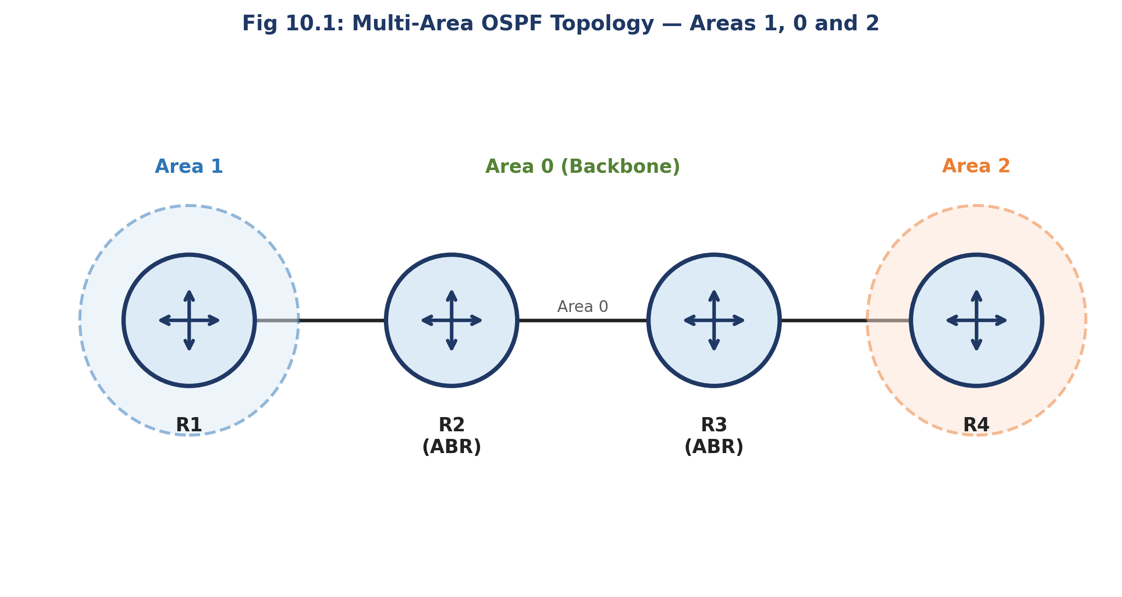
Fig 10.1: Multi-Area OSPF Topology — Areas 1, 0 and 2

Procedure
- Assign R1 to Area 1, R2 and R3 as Area Border Routers connecting Area 1–Area 0 and Area 0–Area 2 respectively, and R4 to Area 2.
- On each router, enable OSPF and advertise each interface's network under the correct area number using the network command.
- Ensure the ABRs (R2, R3) have at least one interface configured in Area 0 in addition to their non-backbone area.
- Verify that neighbour adjacencies form correctly within each area and that inter-area routes are learned by routers in different areas.
- Examine the OSPF database and routing table to distinguish Intra-area (O) and Inter-area (O IA) routes.

Configuration Commands
Sample ABR (R2) Configuration
R2(config)# router ospf 1
R2(config-router)# network 10.0.1.0 0.0.0.255 area 1
R2(config-router)# network 10.0.12.0 0.0.0.3 area 0
R2(config-router)# exit

Route Type Codes in Multi-Area OSPF
O — Intra-area route (destination network lies within the same OSPF area as the router).
O IA — Inter-area route (destination network lies in a different OSPF area, learned via an ABR).
O E1 / O E2 — External Type 1 / Type 2 routes (redistributed from another routing protocol, e.g., via an ASBR).

Result / Verification
- show ip ospf interface brief must show R2 and R3 with interfaces active in two different areas.
- show ip route on R1 (Area 1) must show the Area 2 networks tagged as O IA, confirming successful inter-area route propagation.
Result: The objective of Experiment 10 — "Implementation of Multi Area OSPF" — was successfully achieved and verified in Cisco Packet Tracer.

Viva-Voce Questions
- Why is Area 0 mandatory in a multi-area OSPF design?
- What is the role of an Area Border Router (ABR)?
- What is the difference between an intra-area route (O) and an inter-area route (O IA)?

Experiment 11

Configuration of Point-to-Point Protocol (PPP)

Aim
To configure PPP encapsulation with CHAP authentication on a serial WAN link between two routers.

Software / Equipment Required
- Cisco Packet Tracer software
- 2 Routers
- Serial DCE/DTE cable

Theory
The Point-to-Point Protocol (PPP) is a Data Link layer WAN protocol used to establish a direct connection between two nodes, commonly over serial and dial-up links. PPP is built on two key sub-protocols: the Link Control Protocol (LCP), which establishes, configures and tests the data-link connection, and the Network Control Protocols (NCPs), which configure different network-layer protocols (e.g., IPCP for IPv4) running over the link.
PPP supports optional authentication using PAP (Password Authentication Protocol), which sends credentials in clear text during a two-way handshake, or CHAP (Challenge Handshake Authentication Protocol), which uses a three-way handshake and an MD5 hash of a shared secret, never sending the password itself across the link — making CHAP significantly more secure than PAP.
PPP also supports features such as multilink (combining several physical links into one logical link) and error detection.

Network Diagram
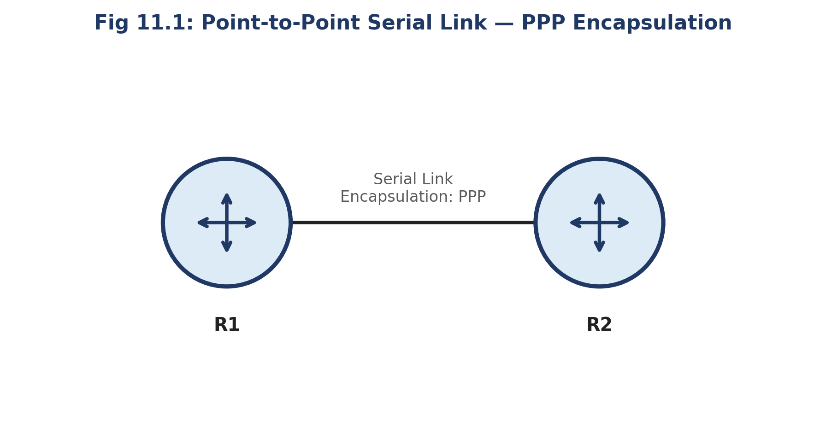
Fig 11.1: Point-to-Point Serial Link with PPP Encapsulation

Procedure
- Connect R1 and R2 via a serial interface and assign IP addresses from the same subnet to both serial interfaces.
- Configure a matching username/password pair on both routers for CHAP authentication.
- Set the encapsulation type on the serial interface of both routers to ppp.
- Enable CHAP authentication on the PPP link on both routers.
- Verify that the link comes up and authentication succeeds using the show interfaces serial command.

Configuration Commands
R1 Configuration
R1(config)# username R2 password cisco123
R1(config)# interface Serial0/0/0
R1(config-if)# ip address 172.16.1.1 255.255.255.252
R1(config-if)# encapsulation ppp
R1(config-if)# ppp authentication chap
R1(config-if)# no shutdown
R2 Configuration
R2(config)# username R1 password cisco123
R2(config)# interface Serial0/0/0
R2(config-if)# ip address 172.16.1.2 255.255.255.252
R2(config-if)# encapsulation ppp
R2(config-if)# ppp authentication chap
R2(config-if)# no shutdown

Result / Verification
- show interfaces serial0/0/0 must display 'Encapsulation PPP' and line/protocol status 'up, line protocol is up'.
- If the CHAP username/password is mismatched on one side, the protocol status should show 'down' with authentication failure messages in the debug ppp authentication output.
Result: The objective of Experiment 11 — "Configuration of Point-to-Point Protocol (PPP)" — was successfully achieved and verified in Cisco Packet Tracer.

Viva-Voce Questions
- What are the two sub-protocols that make up PPP, and what does each do?
- Why is CHAP considered more secure than PAP?
- What command is used to change the serial interface encapsulation to PPP?

Experiment 12

Configuration of High-Level Data Link Control (HDLC)

Aim
To study the HDLC frame format and configure Cisco HDLC encapsulation on a point-to-point serial link between two routers.

Software / Equipment Required
- Cisco Packet Tracer software
- 2 Routers
- Serial DCE/DTE cable

Theory
High-Level Data Link Control (HDLC) is a bit-oriented Data Link layer protocol used for point-to-point and multipoint communication over synchronous serial links. Cisco routers use a proprietary variant of HDLC as the default encapsulation on serial interfaces, which adds a Type field to identify the encapsulated network-layer protocol, making it incompatible with non-Cisco HDLC implementations.
The standard HDLC frame consists of the following fields: Flag (01111110, marks the start/end of the frame), Address (identifies the destination station in multipoint links), Control (specifies the frame type — Information, Supervisory, or Unnumbered — and carries sequence numbers for flow/error control), Data (the encapsulated payload), and FCS (Frame Check Sequence, a CRC used for error detection).
Because Cisco HDLC is proprietary, a serial link between a Cisco router and a router from another vendor typically requires PPP encapsulation instead of HDLC to ensure interoperability.

Network Diagram
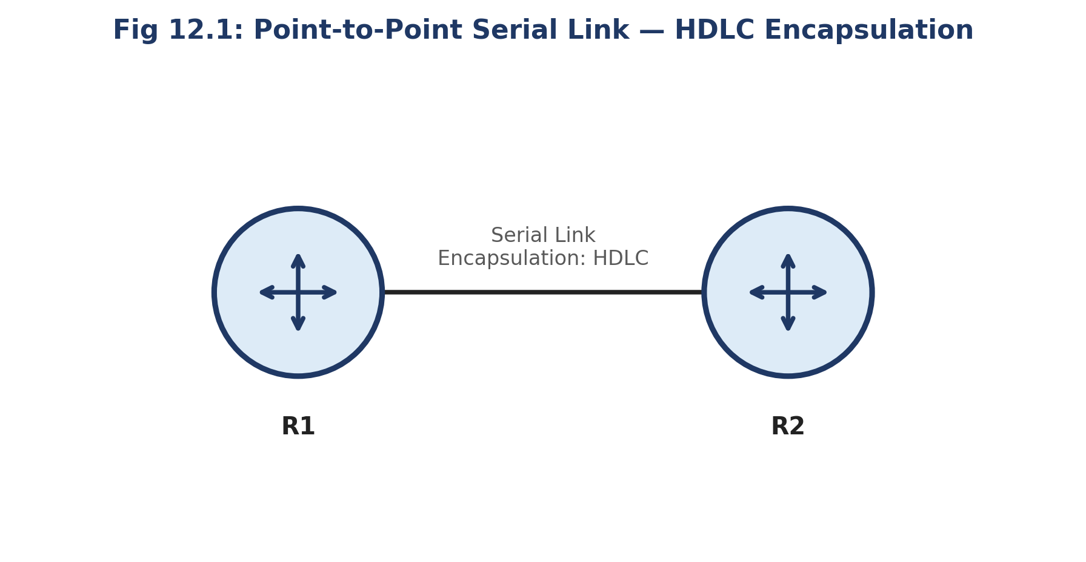
Fig 12.1: Point-to-Point Serial Link with HDLC Encapsulation

Procedure
- Connect R1 and R2 via a serial interface and assign IP addresses from the same subnet.
- On the DCE end of the link, configure the clock rate.
- Explicitly set the encapsulation type on both serial interfaces to hdlc (this is also the factory default on Cisco serial interfaces).
- Enable the interfaces using no shutdown and verify the link status.
- Use the show interfaces serial command to confirm HDLC encapsulation and test connectivity using ping.

Configuration Commands
R1 and R2 Configuration
R1(config)# interface Serial0/0/0
R1(config-if)# ip address 172.16.2.1 255.255.255.252
R1(config-if)# encapsulation hdlc
R1(config-if)# clock rate 64000
R1(config-if)# no shutdown

R2(config)# interface Serial0/0/0
R2(config-if)# ip address 172.16.2.2 255.255.255.252
R2(config-if)# encapsulation hdlc
R2(config-if)# no shutdown

HDLC Frame Format
Flag (8 bits) | Address (8 bits) | Control (8/16 bits) | Data (variable) | FCS (16/32 bits) | Flag (8 bits)
The FCS field commonly uses a 16-bit CRC (CRC-CCITT), which can detect all single and double bit errors, all odd numbers of bit errors, and any burst error of length less than or equal to 16 bits — providing robust error detection for the frame.

Result / Verification
- show interfaces serial0/0/0 must display 'Encapsulation HDLC' with line and protocol status 'up'.
- ping between the two routers' serial interface addresses must succeed with 0% loss.
Result: The objective of Experiment 12 — "Configuration of High-Level Data Link Control (HDLC)" — was successfully achieved and verified in Cisco Packet Tracer.

Viva-Voce Questions
- List the fields of a standard HDLC frame and the purpose of each field.
- Why is Cisco HDLC not compatible with equipment from other vendors?
- What is the default encapsulation on a Cisco router's serial interface?

Experiment 13

Implementation of Border Gateway Protocol (BGP)

Aim
To configure external BGP (eBGP) peering between two routers belonging to different Autonomous Systems and exchange routing information between them.

Software / Equipment Required
- Cisco Packet Tracer software
- 2 Routers (R1 in AS 100, R2 in AS 200)
- Serial cable

Theory
The Border Gateway Protocol (BGP) is the standard Exterior Gateway Protocol (EGP) used to exchange routing information between different Autonomous Systems (AS) on the Internet, and is classified as a Path-Vector protocol — routes carry the complete list of AS numbers (AS-PATH) they have traversed, which is used both for loop prevention and path selection.
eBGP (External BGP) peering is established between routers in two different Autonomous Systems, typically directly connected, while iBGP (Internal BGP) peering is established between routers within the same AS to propagate externally learned routes internally.
BGP uses several path attributes to select the best route among multiple alternatives, including AS-PATH (shorter is preferred), Next-Hop, Local Preference, and MED (Multi-Exit Discriminator), making its route-selection process considerably more policy-driven than interior gateway protocols like OSPF or EIGRP.

Network Diagram
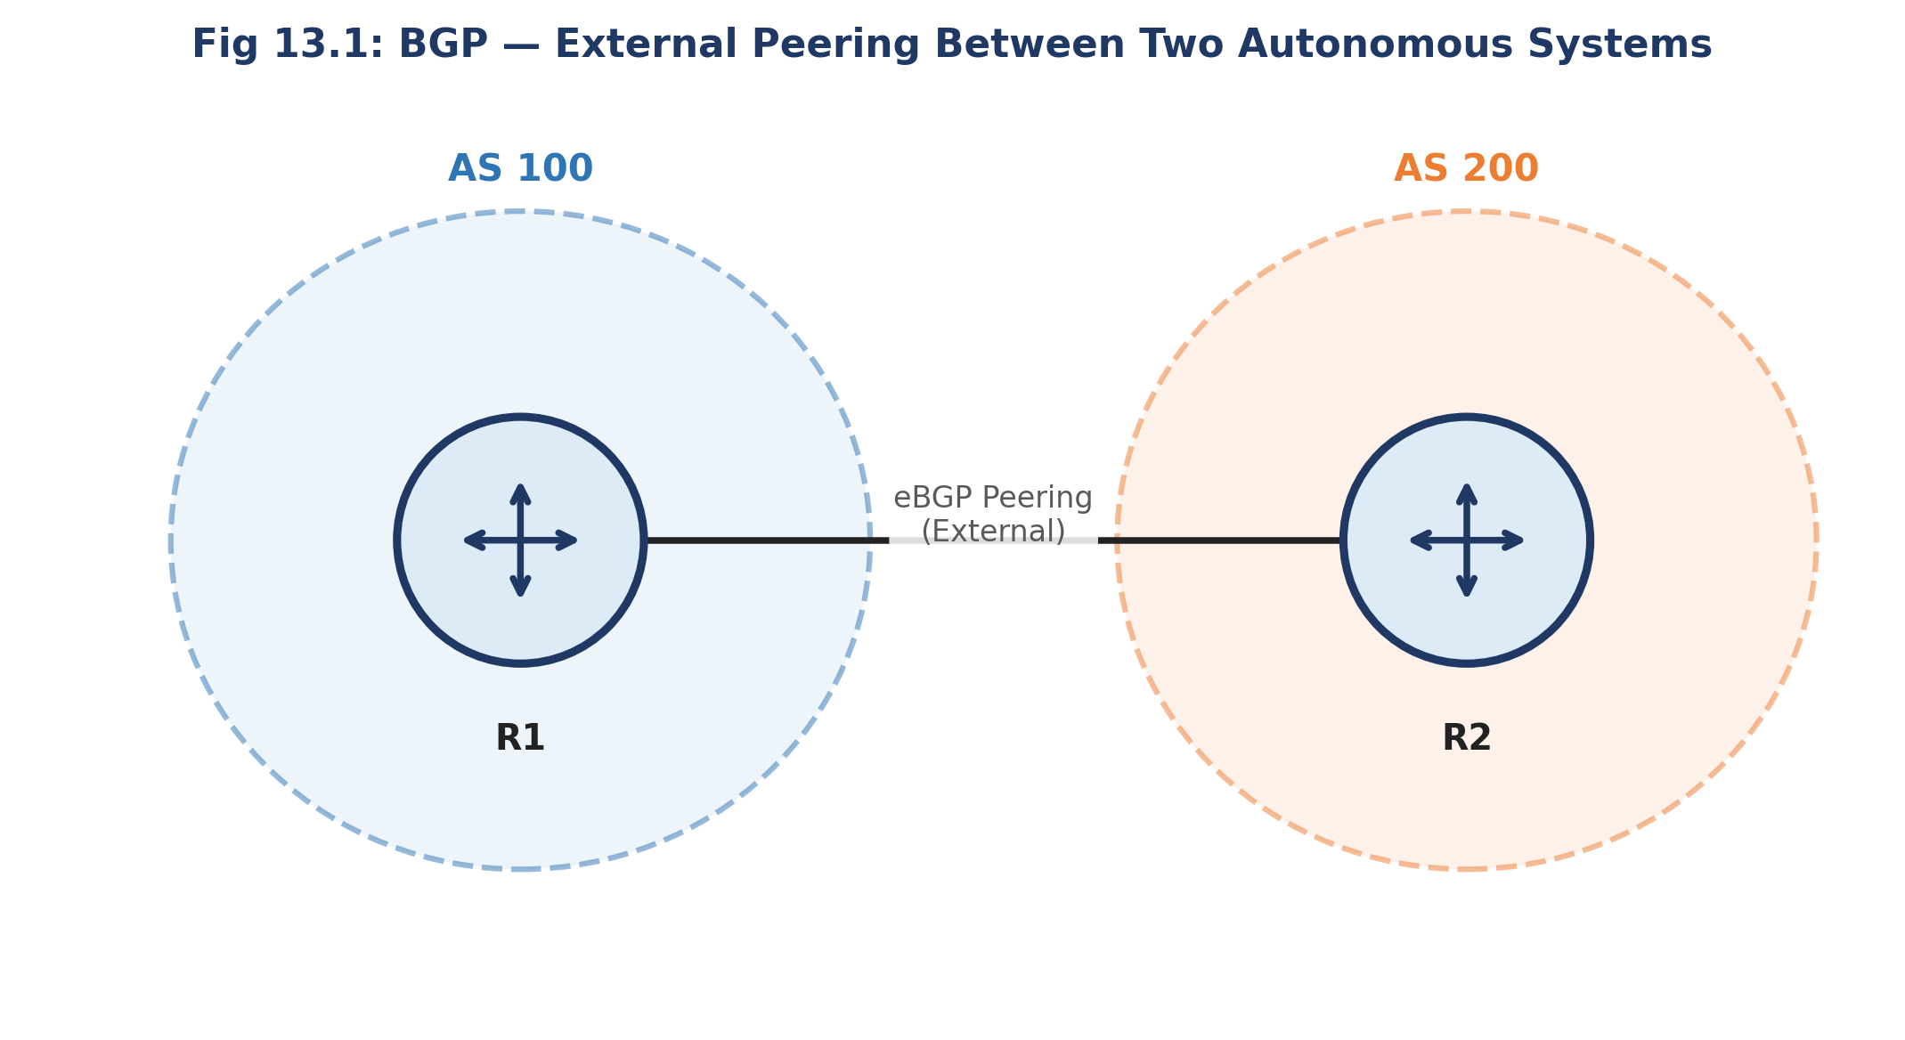
Fig 13.1: eBGP Peering Between Two Autonomous Systems

Procedure
- Assign R1 to Autonomous System 100 and R2 to Autonomous System 200, and connect their serial interfaces on a common subnet.
- On R1, start the BGP process with its own AS number and define an eBGP neighbour statement pointing to R2's IP address and AS number.
- On R2, start the BGP process with its own AS number and define the corresponding eBGP neighbour statement pointing to R1.
- Advertise each router's local networks into BGP using the network command under router bgp.
- Verify the eBGP session establishes and that each router learns the other AS's advertised networks.

Configuration Commands
R1 (AS 100) Configuration
R1(config)# router bgp 100
R1(config-router)# neighbor 172.20.1.2 remote-as 200
R1(config-router)# network 192.168.1.0 mask 255.255.255.0
R2 (AS 200) Configuration
R2(config)# router bgp 200
R2(config-router)# neighbor 172.20.1.1 remote-as 100
R2(config-router)# network 192.168.2.0 mask 255.255.255.0

AS-PATH Loop Prevention Example
Suppose a route to network 192.168.1.0/24 is advertised from AS 100 to AS 200, and AS 200 in turn attempts to advertise it further to AS 300, which peers back with AS 100.
The route received at AS 100 would show AS-PATH = [200, 100] since it was advertised by AS 200 which had appended AS 100's own path. Because AS 100 sees its own AS number already present in the AS-PATH, it rejects the route — this simple mechanism prevents routing loops between Autonomous Systems without requiring any additional protocol.

Result / Verification
- show ip bgp summary must list the neighbour's IP address with State/PfxRcd showing a numeric value (established), not 'Idle' or 'Active'.
- show ip bgp must list the remote AS's advertised network with the correct AS-PATH.
Result: The objective of Experiment 13 — "Implementation of Border Gateway Protocol (BGP)" — was successfully achieved and verified in Cisco Packet Tracer.

Viva-Voce Questions
- What is the difference between eBGP and iBGP?
- Why is BGP called a Path-Vector protocol?
- Name any two BGP path attributes used in the best-path selection process.

Experiment 14

Implementation of EIGRP

Aim
To configure the Enhanced Interior Gateway Routing Protocol (EIGRP) on a multi-router network and study its composite metric and DUAL convergence algorithm.

Software / Equipment Required
- Cisco Packet Tracer software
- 3 Routers
- PCs

Theory
EIGRP is a Cisco-proprietary Advanced Distance Vector (hybrid) routing protocol that combines the fast convergence and loop-freedom properties of link-state protocols with the simplicity of distance-vector protocols. It uses the Diffusing Update Algorithm (DUAL) to guarantee loop-free paths and near-instant convergence by pre-computing backup ('feasible successor') routes.
Unlike RIP's simple hop count or OSPF's bandwidth-only cost, EIGRP computes a composite metric using a formula based on Bandwidth, Delay, Reliability and Load (by default only Bandwidth and Delay are used), giving it a much finer ability to distinguish between paths of similar hop count but differing quality.
EIGRP sends incremental, partial updates only when a topology change occurs (rather than periodic full-table updates), which conserves bandwidth, and supports unequal-cost load balancing across multiple paths — a capability not available in RIP or OSPF.

Network Diagram
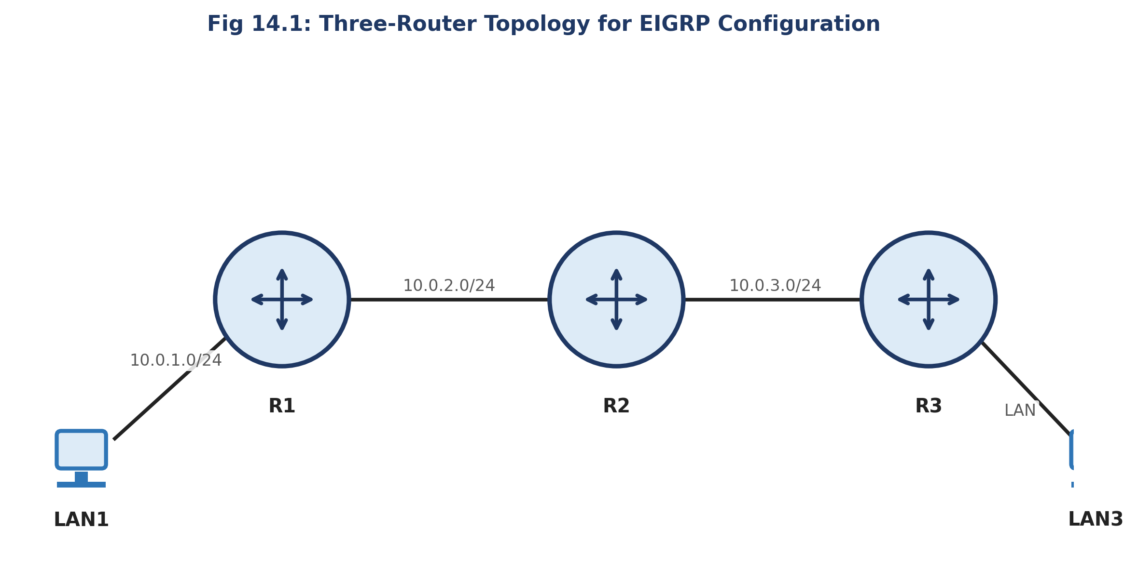
Fig 14.1: Three-Router Topology for EIGRP Configuration

Procedure
- Configure IP addresses on all router interfaces as per the topology.
- Enable the EIGRP process on each router using a common Autonomous System number and advertise directly connected networks using the network command.
- Disable automatic summarization using no auto-summary if the network uses discontiguous or VLSM subnets.
- Allow the DUAL algorithm to converge and form neighbour relationships across all three routers.
- Inspect the EIGRP topology table and routing table, and verify connectivity between LAN1 and LAN3.

Configuration Commands
EIGRP Configuration (repeat on R1, R2, R3)
R1(config)# router eigrp 10
R1(config-router)# no auto-summary
R1(config-router)# network 10.0.1.0 0.0.0.255
R1(config-router)# network 10.0.12.0 0.0.0.3
R1(config-router)# exit

Numerical Example — EIGRP Composite Metric (Simplified)
Simplified EIGRP metric formula (default K1=K3=1, others 0): Metric = 256 × [ (10^7 / Minimum Bandwidth in kbps) + (Sum of Delays in tens of microseconds) ].
Consider a path with a minimum bandwidth of 1544 kbps (T1 link) and cumulative delay of 2100 (in tens of µs, i.e., 21,000 µs total).
Bandwidth term = 10^7 / 1544 ≈ 6476.7 → truncated to 6476. Delay term = 2100.
Metric = 256 × (6476 + 2100) = 256 × 8576 = 2,195,456.
EIGRP compares this composite metric — not simple hop count — across all candidate paths and, via DUAL, installs the path with the lowest metric as the successor route while retaining any loop-free feasible successor as an instantly available backup.

Result / Verification
- show ip eigrp neighbors must list all directly connected EIGRP neighbours with valid Hold times.
- show ip route eigrp must list remote networks with the 'D' code and the computed composite metric, e.g., [90/2195456].
Result: The objective of Experiment 14 — "Implementation of EIGRP" — was successfully achieved and verified in Cisco Packet Tracer.

Viva-Voce Questions
- What algorithm does EIGRP use to guarantee loop-free, fast convergence?
- What is a Feasible Successor in EIGRP?
- Name the four components (K-values) that can contribute to the EIGRP composite metric.

Experiment 15

Configuration of Telnet for Remote Router Access

Aim
To configure a router for remote access using Telnet and verify remote login from a client PC.

Software / Equipment Required
- Cisco Packet Tracer software
- 1 Router
- 1 PC (Telnet client)

Theory
Telnet is an Application-layer protocol that provides a virtual terminal session allowing a user to remotely log in and execute commands on a networked device (such as a router or switch) as though working at its local console. Telnet operates over TCP port 23.
A key limitation of Telnet is that all data, including usernames and passwords, is transmitted in clear text, making it vulnerable to eavesdropping on the network path; for this reason modern networks generally prefer SSH (Secure Shell), which encrypts the entire session, over Telnet.
On a Cisco device, remote Telnet access is enabled by configuring a password (and, optionally, a username/password pair with local authentication) on the vty (virtual teletype) lines, and setting transport input telnet (or 'all') to permit the Telnet protocol on those lines.

Network Diagram
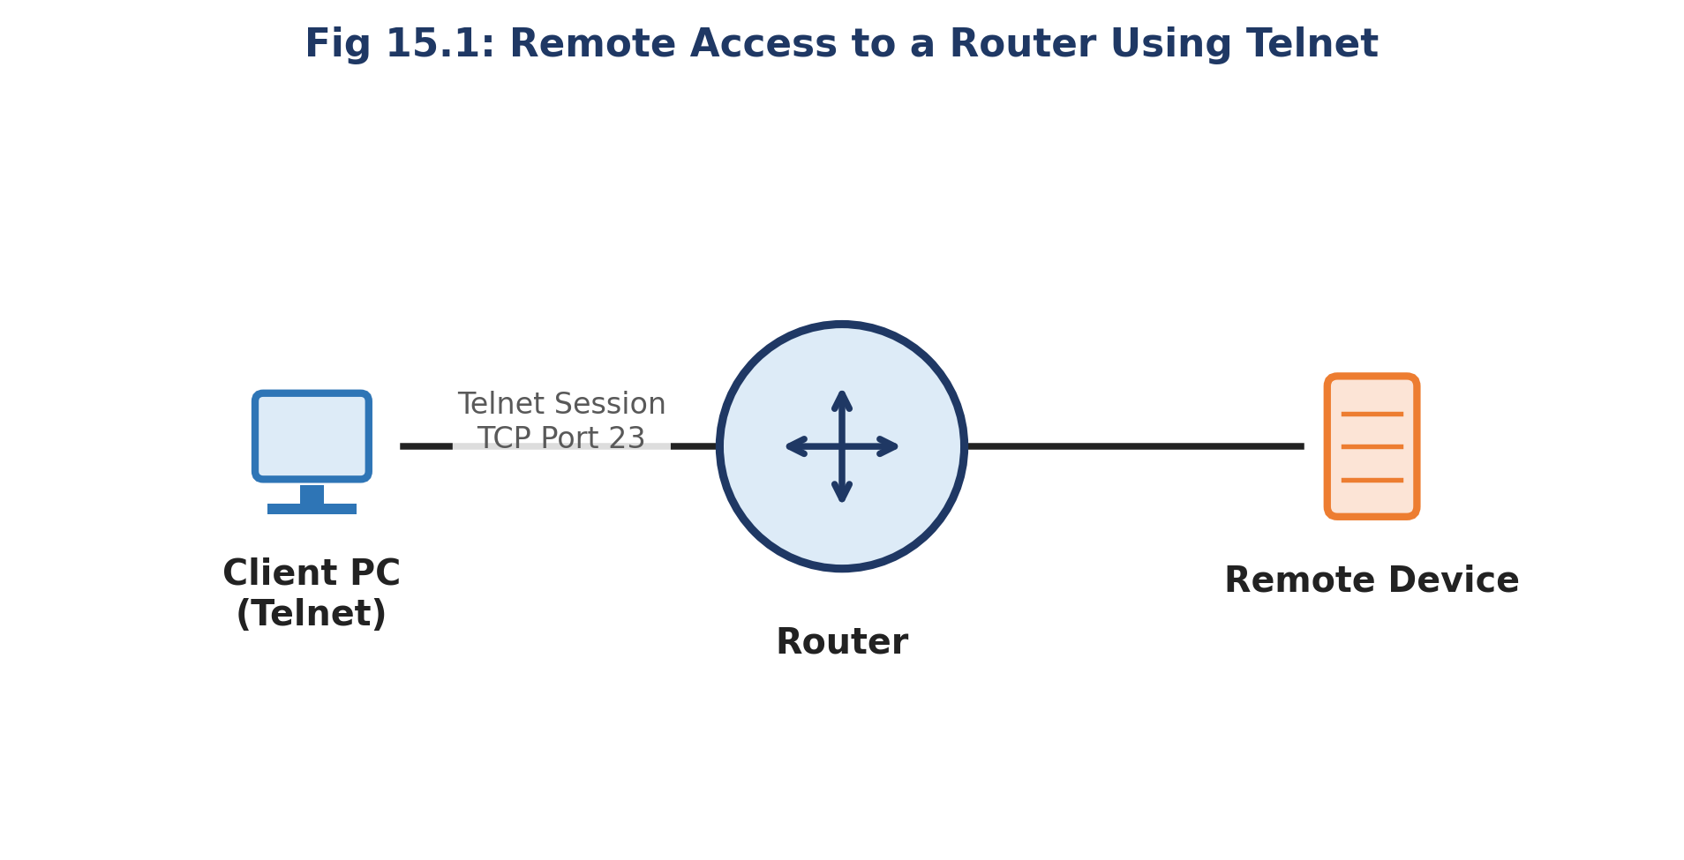
Fig 15.1: Remote Access to a Router Using Telnet

Procedure
- Configure the router's LAN interface with an IP address reachable from the client PC, and set an enable secret password.
- Configure the vty 0 4 lines with a login password (or a username/password with login local) and permit Telnet as the transport input.
- From the client PC's command prompt, initiate a Telnet session to the router's IP address.
- Enter the configured password when prompted, and verify that the router prompt (Router>) appears on the client terminal.
- Execute a few basic show commands remotely to confirm full remote CLI access, then exit the session using the exit or logout command.

Configuration Commands
Router Telnet Configuration
Router(config)# enable secret class
Router(config)# line vty 0 4
Router(config-line)# password cisco
Router(config-line)# login
Router(config-line)# transport input telnet
Router(config-line)# exit
Client PC — Initiating Telnet Session
C:\> telnet 192.168.1.1
Password: cisco
Router> enable
Password: class
Router# show ip interface brief

Result / Verification
- The client PC must successfully establish a Telnet session and receive the router's CLI prompt (Router>) after entering the correct vty password.
- show sessions and show users on the router should list the active incoming Telnet connection and its source address.
Result: The objective of Experiment 15 — "Configuration of Telnet for Remote Router Access" — was successfully achieved and verified in Cisco Packet Tracer.

Viva-Voce Questions
- Which TCP port number does Telnet use by default?
- Why is Telnet considered insecure compared to SSH?
- What command enables/permits Telnet access on a router's vty lines?

