**Assignment 1**

**Attempt all questions, each question carries 5 marks, there is no negative marking.  
Upload your answer file with your name in repository “/Assignment1” location.**

**Q.1) How user can push files on github?**

1. First create a new repository.

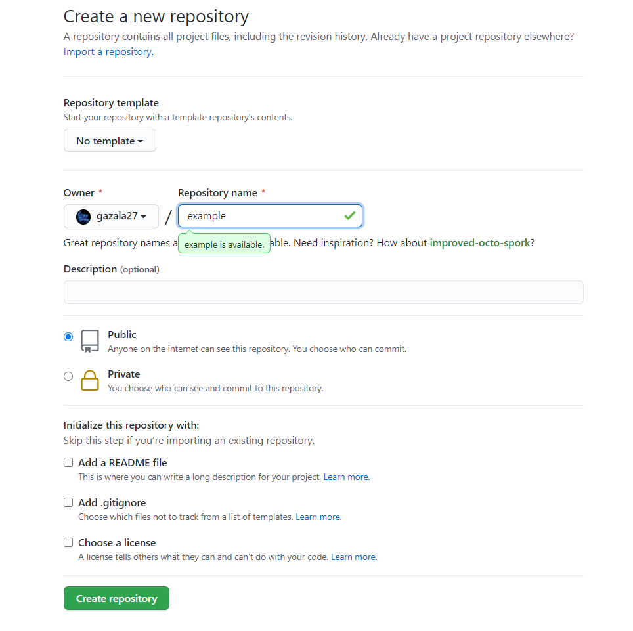

1. Open a powershell
2. And move to command prompt by writing cmd

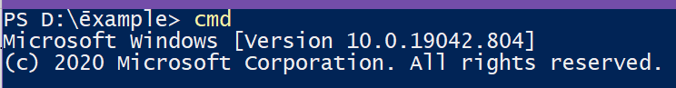

1. Copy your remote repository URL from github

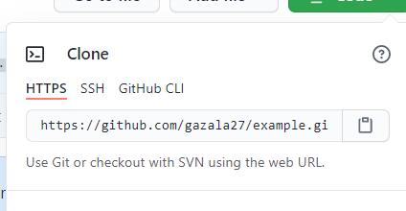

1. And paste it on your cmd

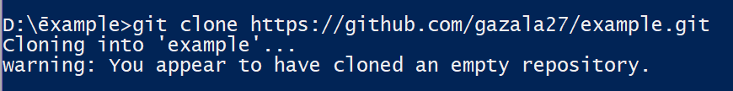

1. Move to folder where you want to commit.
2. And write command git add . to add files.
3. And git commit -m “comment” to show status.

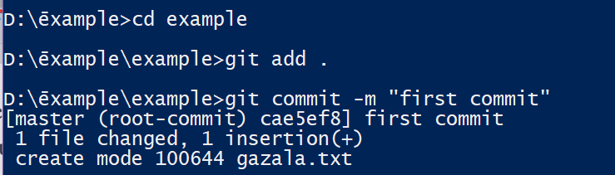

1. To push wite git push to push files.

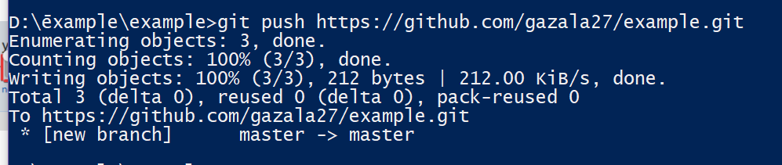

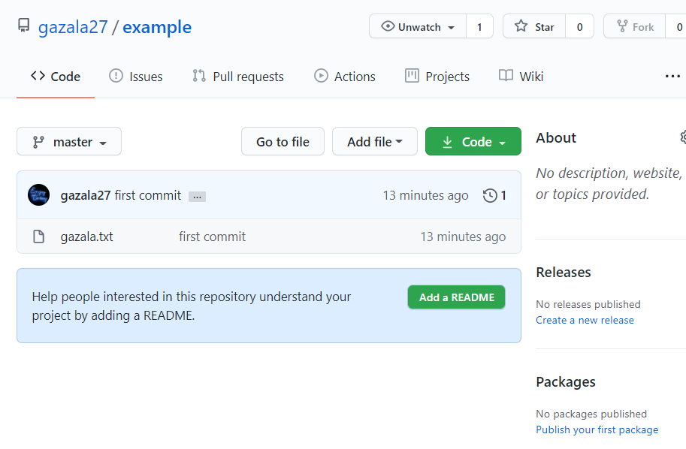

**Q.2) Which command are used to check GIT Version?**

1. git - -version command is used to check GIT Version .

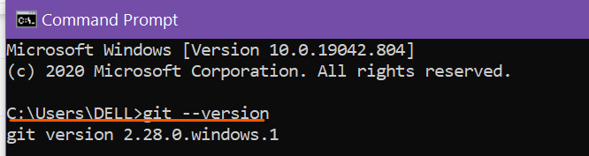

**Q.3) How you can collaborate with others in github?**

1. First open your **repository.**
2. Click on setting button.

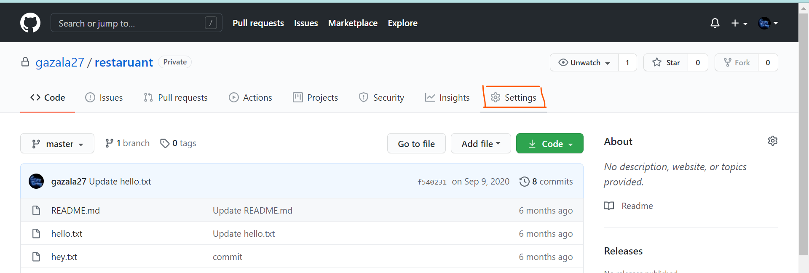

1. After Clicking on setting button go to manage access and enter your password

And then enter.

1. After that click on Invite Collaborators.
2. Write username of collaborator and then invite them.

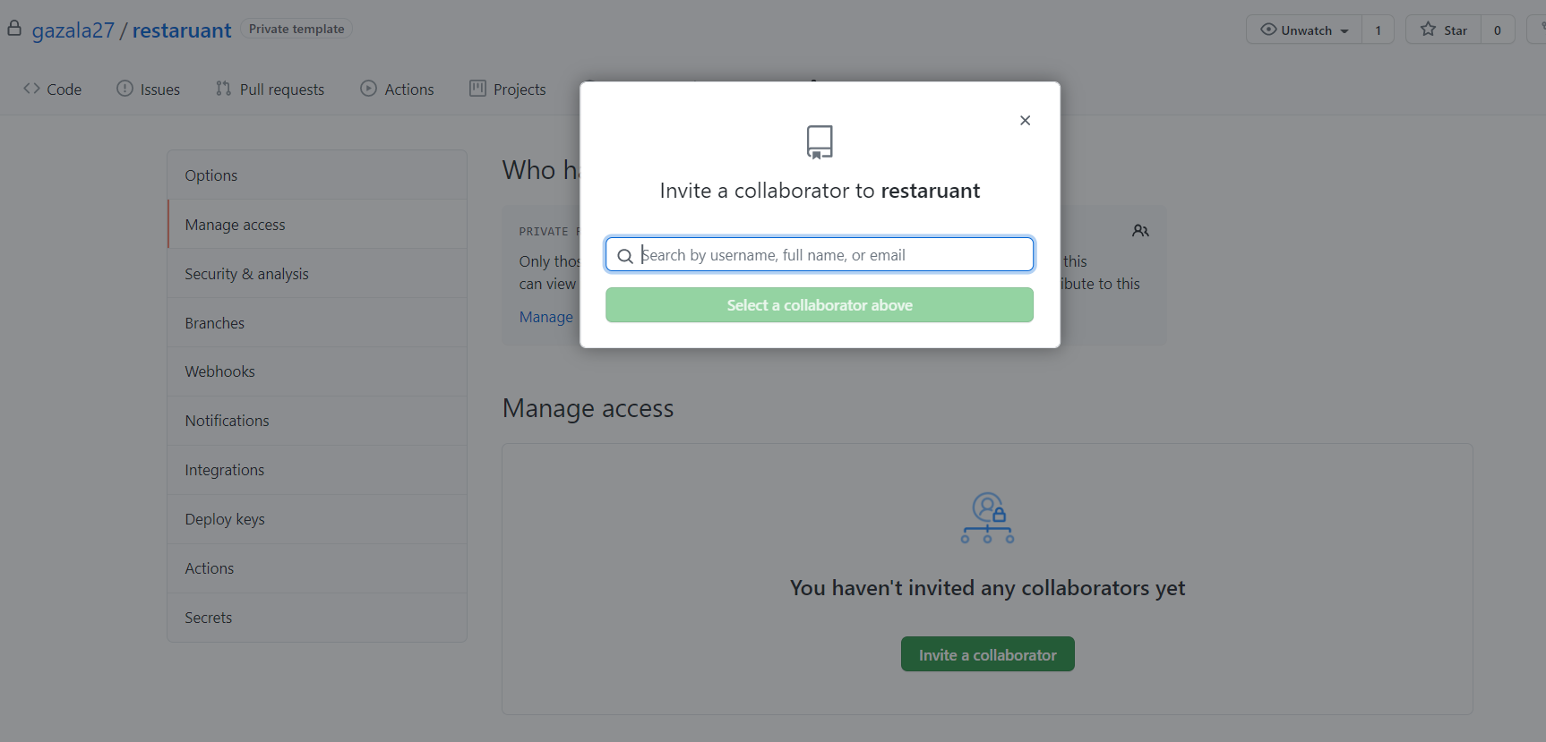

**Q.4) How you can push updates on your repository?**

While pushing updates on the repository use following commands:

1. Go to the location of working directory where we have to add or update the files in the local repository on your system. Then use following command.

git add .

1. then, make a local commit by.

git commit -m "your commit message"

1. once you make your local commit, you can then push it to your remote GitHub fork.

git push origin master

But if you want to pull your changes from the forked repository in github

To make your source code pulled by original fork, you have to send a pull request to the project owner.

1. Go to the web page of your forked project on GitHub.
2. Hit the pull request button on the top right of page
3. Select the commits that you want to submit by change commits button.
4. Write some description of your changes, comments, or etc.
5. Send pull request and wait for the owner reply.

**Q.5) What is alternative of github & what is Full form of GIT?**

Gitlab,Bitbucket is the alternative of GitHub.

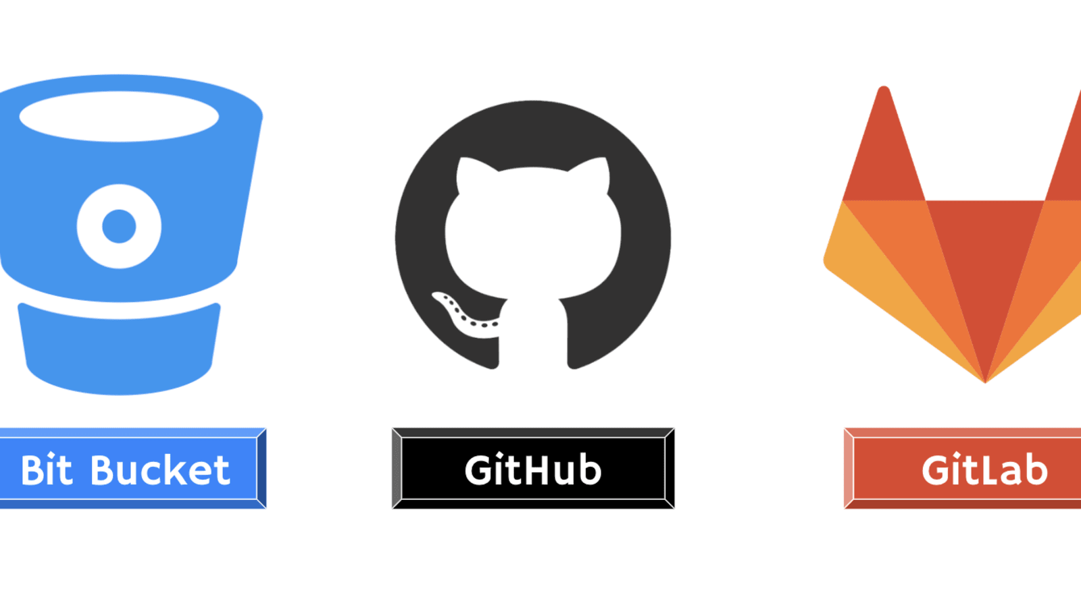

**GitHub** is a code hosting platform for version control and collaboration. It lets you and others work together on projects from anywhere.

**Git** is software for tracking changes in any set of files, usually used for coordinating work among **programmers** collaboratively developing source code during software development.