**Assignment 1**

**Q.1) How user can push files on GitHub?**

1. Answer: In your project, initialize a Git repository:

$ git init

1. Check the status of which files and folders are new or have been edited:

$ git status

1. Tell Git to start tracking your files and folders:

$ git add .

If you want to track a single folder or file, use its name:

$ git add app/  
 $ git add config/routes.rb

1. Verify that everything was committed correctly:

$ git status

1. Save the changes you made, with a message describing what changed:

$ git commit -m "Initial commit"

1. On GitHub, create a new repository with a short, memorable name: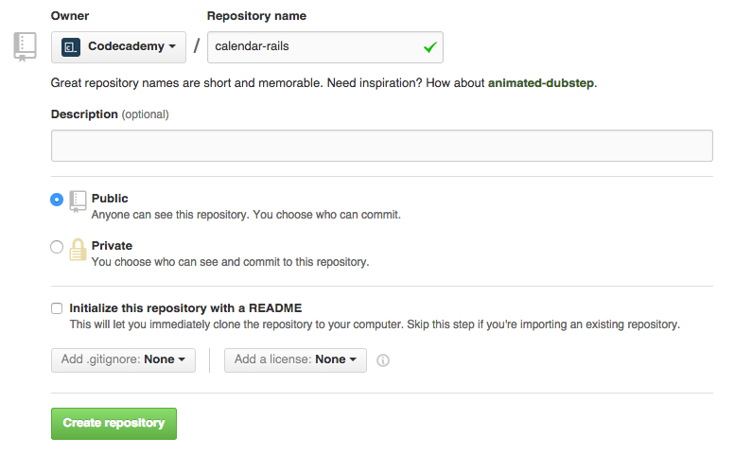
2. After creating a repository, copy the git commands under the “…or push an existing repository from the command line”, and paste them into the terminal. These commands will add a remote repository, and then push your local repository to the remote repository.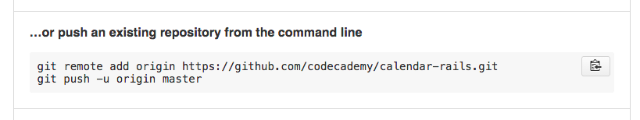

**Q.2) Which command are used to check GIT Version?**

Answer: You can check your current version of Git by running the git --version command in a terminal (Linux, Mac OS X) or command prompt (Windows). The versions of Git supported by Crucible.

git --version

C:\Users\rageb\Desktop\Django Internship\Django-Internship_3March2021>git --version

git version 2.30.1.windows.1

If you don't see a supported version of Git, you'll need to either upgrade Git or perform a fresh install.

**Q.3) How you can collaborate with others in GitHub?**

Answer:

1. First open your **repository.**
2. Click on setting button.

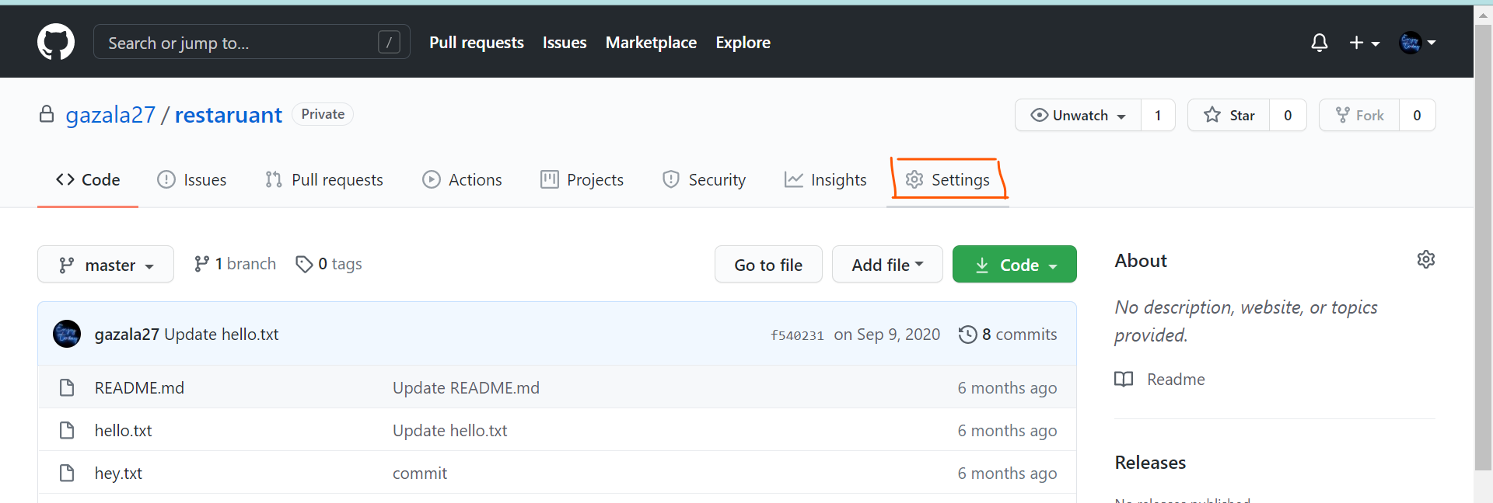

1. After Clicking on setting button go to manage access and enter your password

And then enter.

1. After that click on Invite Collaborators.
2. Write username of collaborator and then invite them.

**Q.4) How you can push updates on your repository?**

Answer: While pushing updates on the repository use following commands:

1. Go to the location of working directory where we have to add or update the files in the local repository on your system. Then use following command.

git add .

1. then, make a local commit by.

git commit -m "your commit message"

1. once you make your local commit, you can then push it to your remote GitHub fork.

git push origin master

But if you want to pull your changes from the forked repository in GitHub

To make your source code pulled by original fork, you have to send a pull request to the project owner.

1. Go to the web page of your forked project on GitHub.
2. Hit the pull request button on the top right of page
3. Select the commits that you want to submit by change commits button.
4. Write some description of your changes, comments, or etc.
5. Send pull request and wait for the owner reply.

**Q.5) What is alternative of GitHub & what is Full form of GIT?**

Answer:

### 1) Bitbucket

Bitbucket is version control tool developed by Atlassian. It is more than just Git code management. Bitbucket is one of the best alternatives to GitHub which allows the team to plan projects, collaborate on code, test, and deploy.

**Features:**

* Free unlimited private repositories
* Best-in-class Trello & Jira integration
* Allows you to build quality software with code review
* Helps you to secure your workflow

### Bitbucket lets you build, test and deploy with integrated CI/CDCD2)

2) Gitbucket

[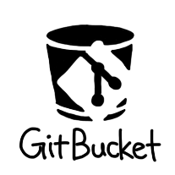](https://www.guru99.com/images/1/120718_0548_13BestGithu4.png)

Gitbucket is a high extensibility open-source tool for hosting source code for the software development process. It offers a set of tools and feature which allows developers to easily manage project code.

**Features:**

* Repository Viewer
* Pull Request
* Issue tracker
* Documentation, and wiki
* Offers plugin system to extend its core features