**Name:** Snehlata Mitkale

**Assignment 1**

Q.1) How user can push files on github?

Ans:

1. Creating a new repository in gitgub.

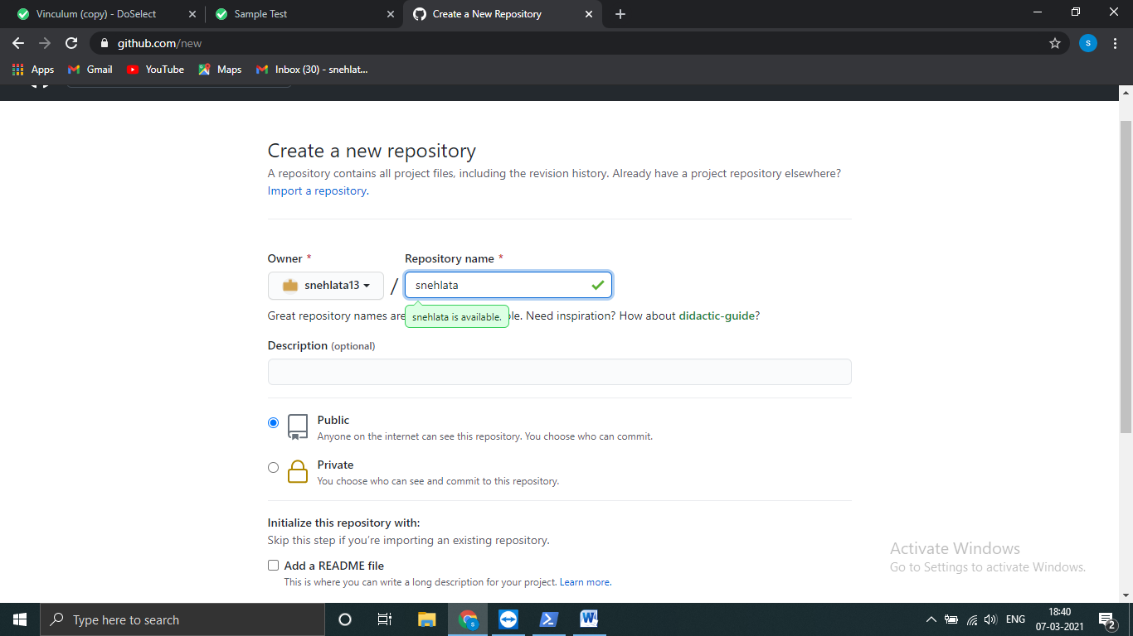

1. Open powershell and move to cmd promt.

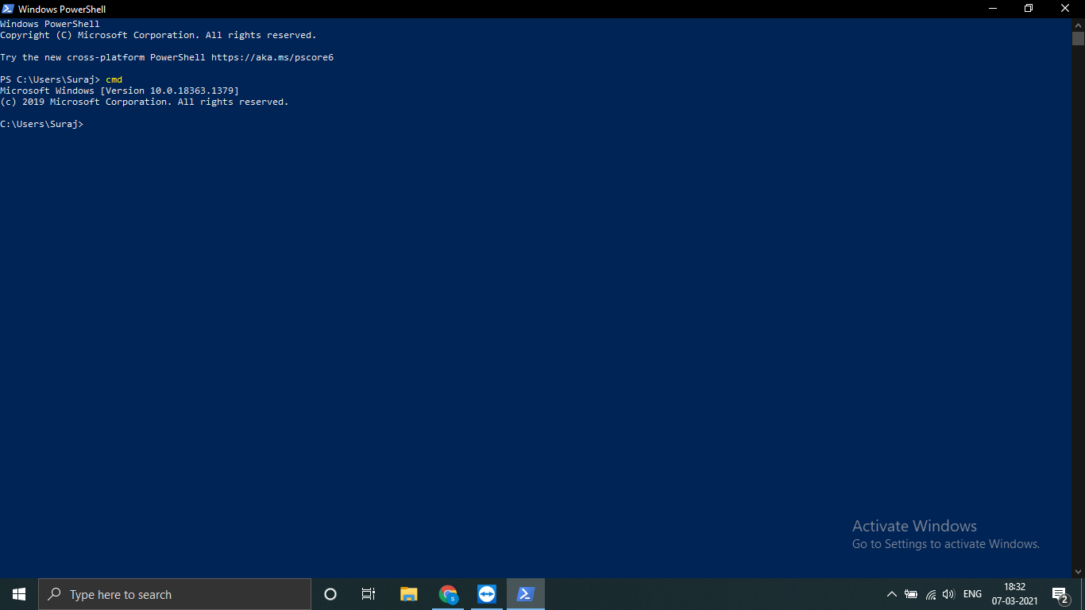

1. Now go to github and copy your remote repository URL

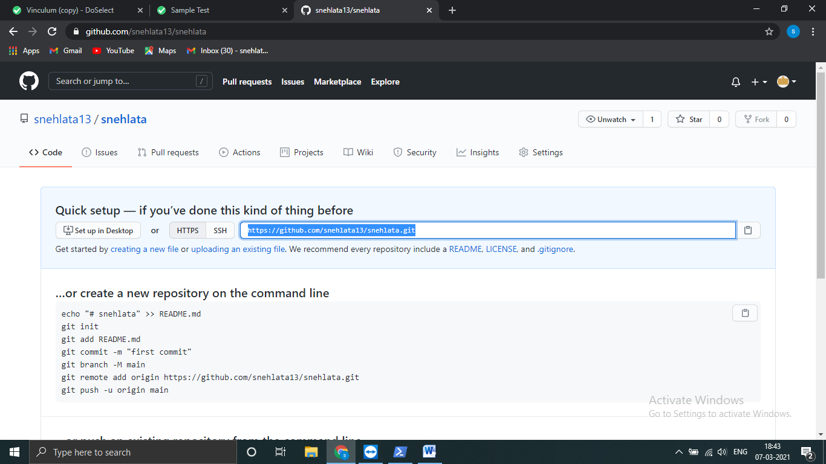

1. Now paste it on your cmd with git clone.

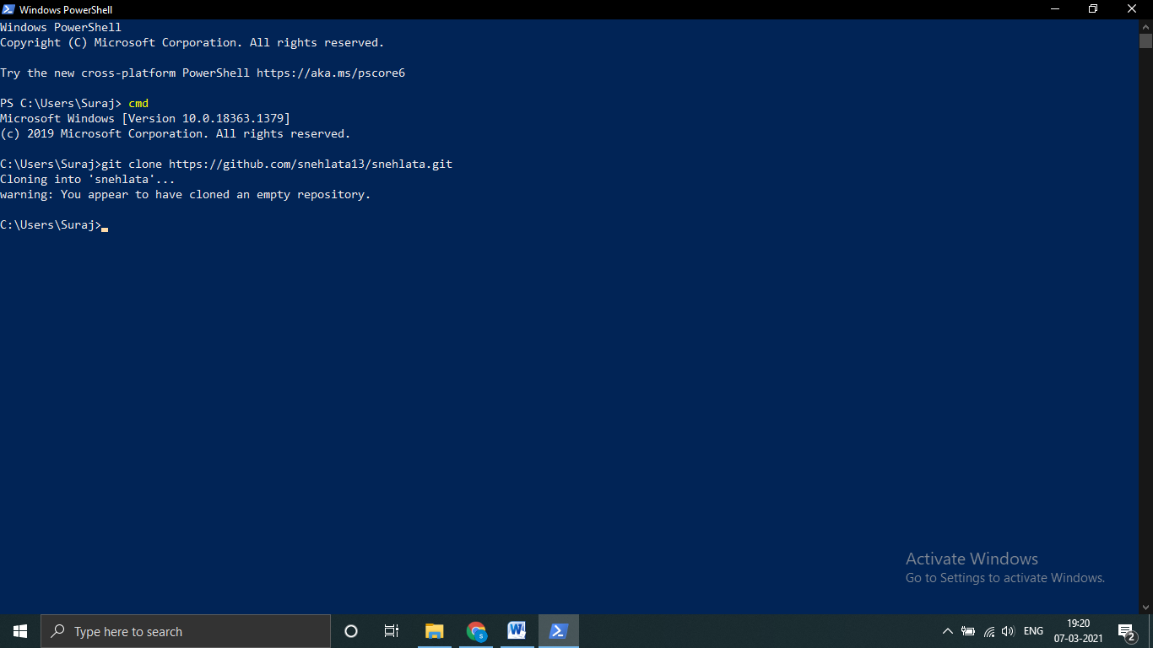

1. Go to folder where you want to commit.
2. Then write command git add. To add files.
3. And git commit .m “comment” to show status.

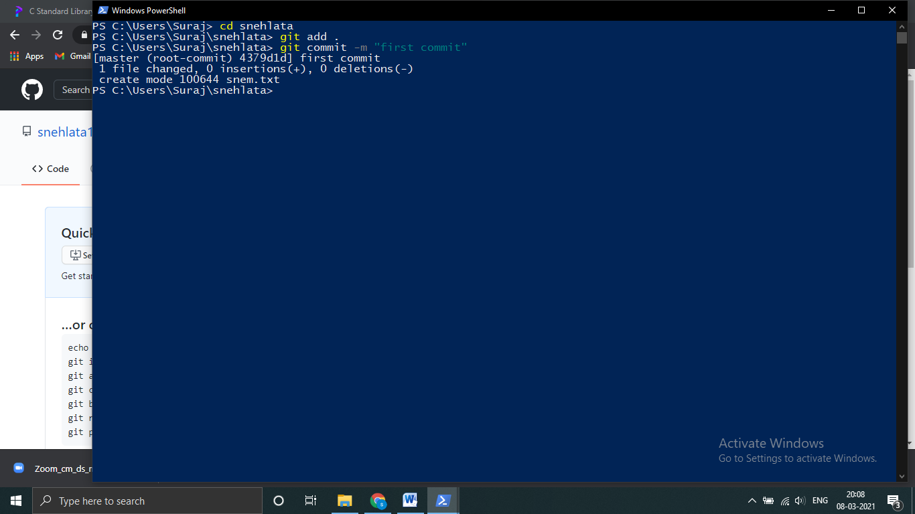

1. For push write git push to push file.

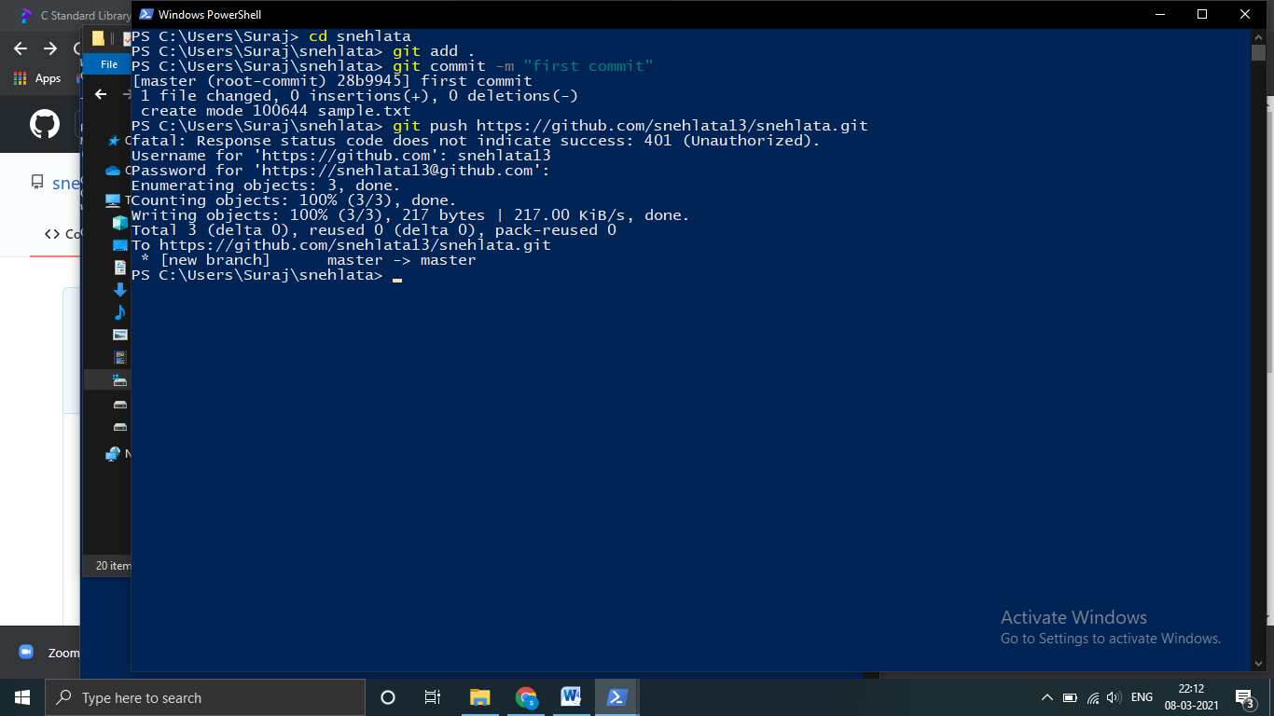

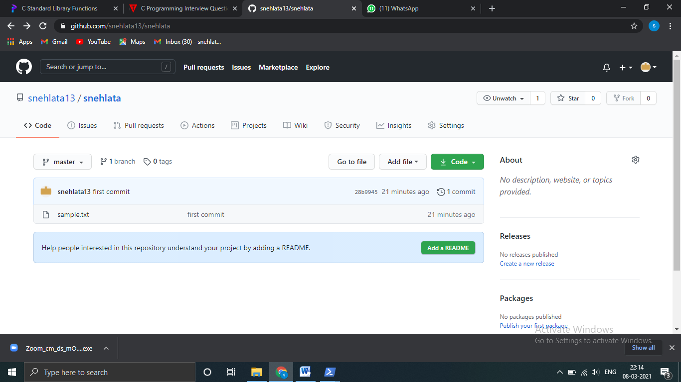

Q.2) Which command are used to check GIT Version?

Ans: To check your current version of Git by running the git --version command in a terminal or command prompt .

Like= C:\Users\Suraj>git version

git version 2.30.1.windows.1

Q.3) How you can collaborate with others in github?

Ans:

a)open your repository

b)Then click to setting button



c)Then go to manage access.

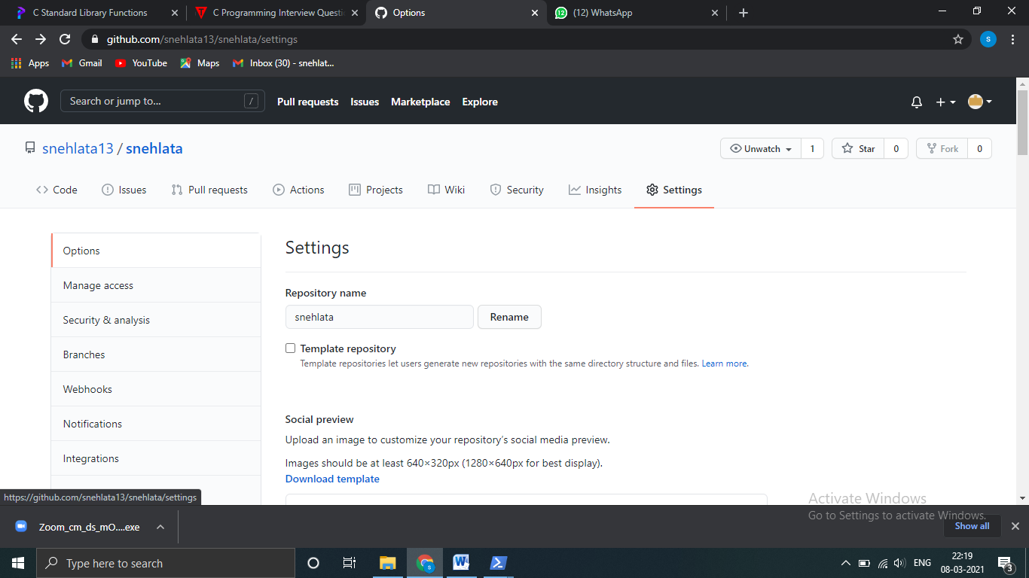

d)After that click on invite collaborators. Write username of collaborator and then invite them.

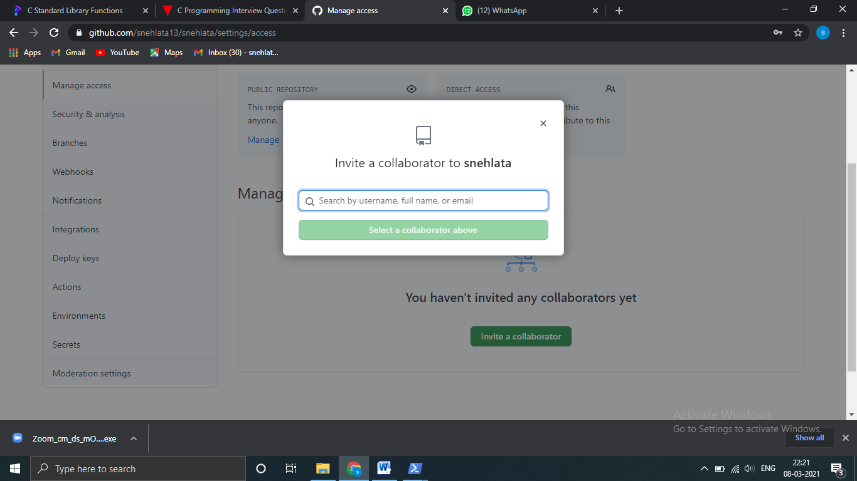

Q.4) How you can push updates on your repository?

Ans: a) At the command line, make sure you've changed into the repository directory.

b) Enter git push at the command line to push your commits from your local repository to Bitbucket. To be specific about exactly where you're pushing, enter git push <remote_server> <branch_name>.

c) If prompted for authentication, enter your Bitbucket username and password.

Q.5) What is alternative of github & what is Full form of GIT?

Answer: There are so many alternative options for github.

1. **Gitlab** is the number one choice to replace github. Gitlab is an open source software. Gitlab provide hosted server as well but it cost money.
2. **BitBucket** is a version control repository hosting service from Atlassian. It is tightly integrated with other Atlassian project management tools .

Open source projects with more than five members can still use BitBucket for free.

1. **AWS CodeCommit** is a similar alternative to Google Cloud Source Repositories.
2. **Launchpad** is a software collaboration platform from Canonical, the parent company of Ubuntu. Launchpad has been extensively used by Canonical and projects around Ubuntu.

The long form of GIT is **Global information tracker.**