**Sobiya_Khan_Assignment 1**

**Attempt all questions, each question carries 5 marks, there is no negative marking.  
Upload your answer file with your name in repository “/Assignment1” location.**

Q.1) How user can push files on github?

Answer 🡪

**Git PUSH**

The git push command is used to transfer or push the commit, which is made on a local branch in your computer to a remote repository like GitHub. The command used for pushing to GitHub is given below.  
***git push 'remote_name' 'branch_name'***

**Using Command line to PUSH to GitHub**

**1. Creating a new repository.**

**2. Open your Git Bash.**

**3. Create your local project in your desktop directed towards a current working directory.**

**4. Initialize the git repository**

**5. Add the file to the new local repository.**

**6. Commit the files staged in your local repository by writing a commit message.**

**7. Copy your remote repository's URL from GitHub.**

**8. Add the URL copied, which is your remote repository to where your local content from your repository is pushed.**

**9. Push the code in your local repository to GitHub**

**10. View your files in your repository hosted on GitHub.**

Q.2) Which command are used to check GIT Version?

Answer🡪

You can check your current version of Git by running the git --version command in a terminal (Linux, macOS) or command prompt (Windows).

**For example:**

git --version

git version 2.7.4

Q.3) How you can collaborate with others in github?

Answer🡪

Step 1: Initialize a New Project

Step 2: Setup Your Team

Step 3: Collaborating

Step 4: Rinse, Repeat

Q.4) How you can push updates on your repository?

Answer🡪

Once you make changes to your files and commit to your local repository, you'll need to push them to the remote Bitbucket Cloud repository so that other people can see them too

**Push to a Git repository**

At the command line, make sure you've changed into the repository directory.

Enter git push at the command line to push your commits from your local repository to Bitbucket. To be specific about exactly where you're pushing, enter git push <remote_server> <branch_name>. This command specifies you're pushing to:

* + remote_server — the name of the remote server. In most cases, origin indicates that you're pushing to Bitbucket.
  + branch_name — the repository branch where you made your changes and want to push them. A branch allows you do work on a set of code for your repository separate from the main codebase.

If prompted for authentication, enter your Bitbucket username and password.

In this example, origin is the remote server and master is the branch where you're pushing:

$ git push origin master   
Password:  
Counting objects: 6, done.  
Delta compression using up to 4 threads.  
Compressing objects: 100% (3/3), done.  
Writing objects: 100% (4/4), 23.98 KiB, done.  
Total 4 (delta 0), reused 0 (delta 0)  
remote: bb/acl: alui is allowed. accepted payload.  
To https://alui@staging.bitbucket.org/alui/alui-git-fork.git  
   0ad86b3..395d3c2  master -> master

Open your Bitbucket repository in your browser. The **Commits** tab shows your most recent commits.

Q.5) What is alternative of github & what is Full form of GIT?

Answer🡪

**GitHub** is a code hosting platform for version control and collaboration. It lets you and others work together on projects from anywhere. This tutorial teaches you **GitHub** essentials like repositories, branches, commits, and Pull Requests.

**Best GitHub alternatives**

### 1. GitLab

[GitLab](https://about.gitlab.com/) is the number one choice to replace GitHub. It is the closest to GitHub in terms of use and feel. Best of all, GitLab is an open source software. You can download and install it on your own server.

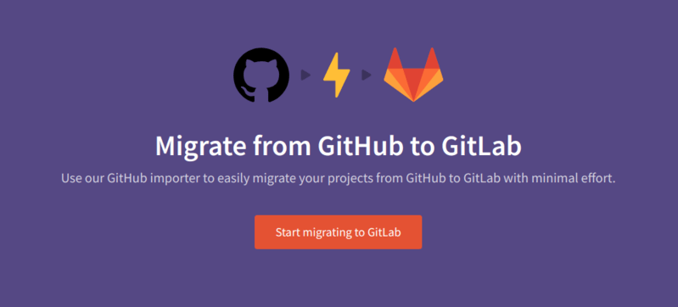

### 2. BitBucket

[BitBucket](https://bitbucket.org/product) is a version control repository hosting service from Atlassian. It is tightly integrated with other Atlassian project management tools like Jira, HipChat, and Confluence. This makes it a preferred choice for big enterprises. 

### 3. SourceForge

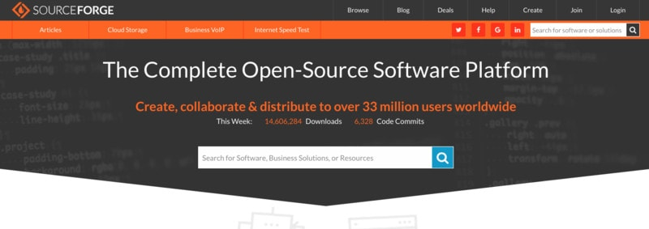

[SourceForge](https://sourceforge.net/) is another big name on this list of GitHub alternatives.

SourceForge has been popular among open source projects. Many Linux distributions and projects provide their downloads through SourceForge. It enables developers to create open source projects by providing all the necessary tools.

### 4. Launchpad

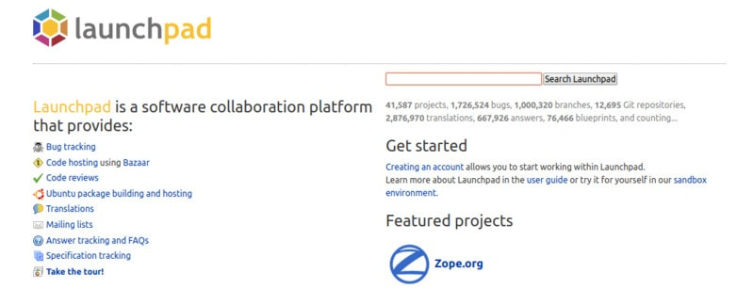

[Launchpad](https://launchpad.net/) is a software collaboration platform from [Canonical](https://www.canonical.com/), the parent company of Ubuntu. Launchpad has been extensively used by Canonical and projects around Ubuntu. It has been instrumental in providing the PPA and bug tracking for Ubuntu related projects.

### 5. Google Cloud Source Repositories

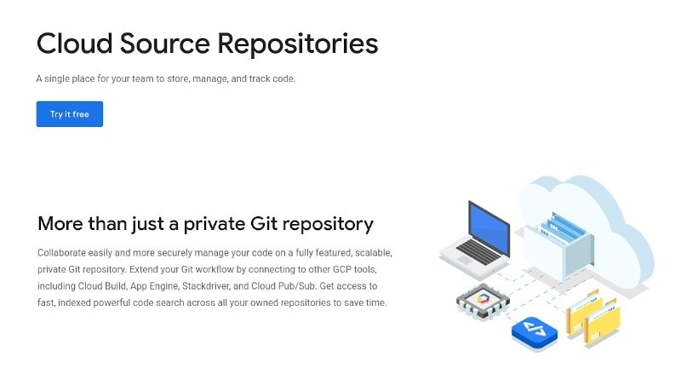

[Google Cloud Source Repositories](https://cloud.google.com/source-repositories) can be a good alternative for private repositories. You can get started for free with a limit of 5 users and 50 GB storage. To start with, you get a 12-months trial period.

And the list goes on…….

GIT full form is “**Global information Tracker**” git is a free service to store your programme online anyone can edit on that programme.