Assignment-1

1) How user can push files on GitHub?

a) First create a new repository.

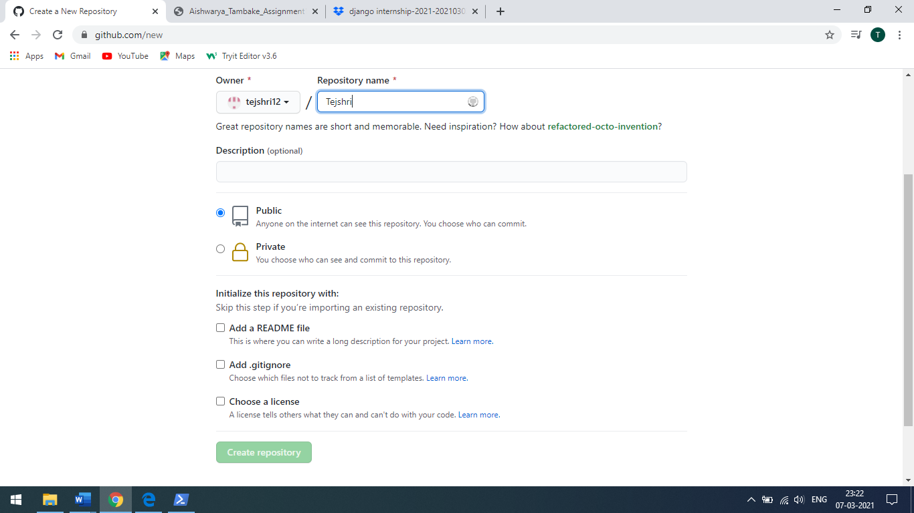

b) Open a PowerShell.

c) Move to command prompt by writing cmd.

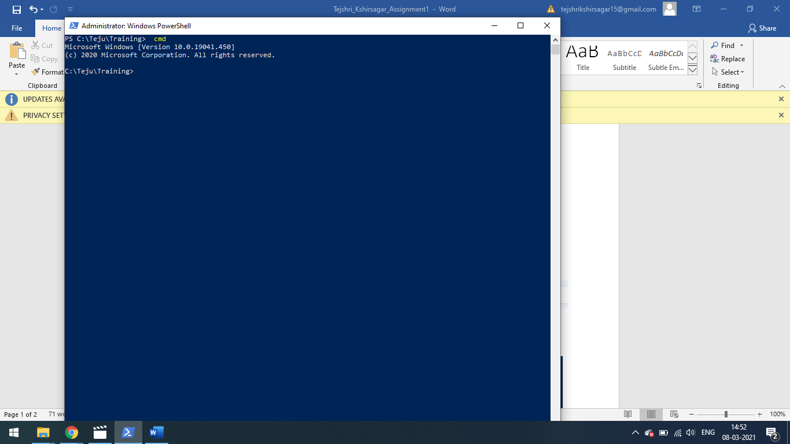

d) Now copy your remote repository URL from GitHub.

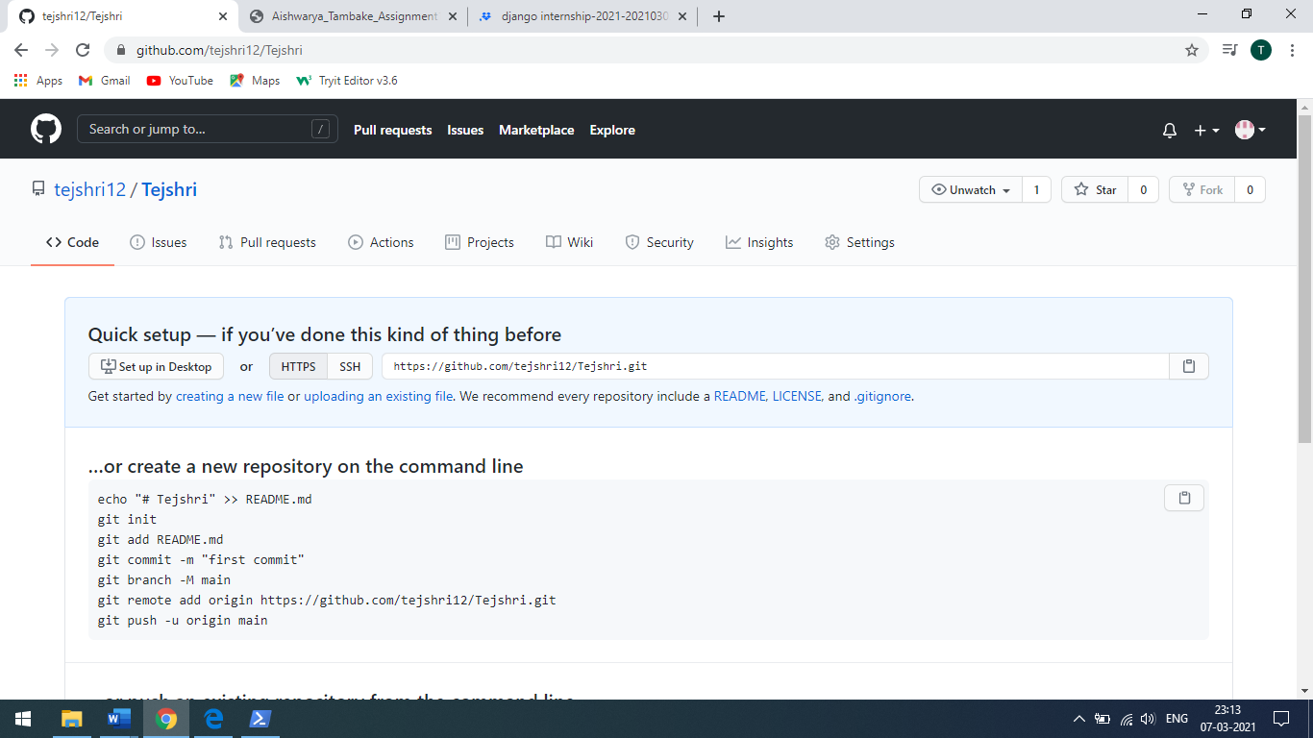

e) And paste it on your cmd

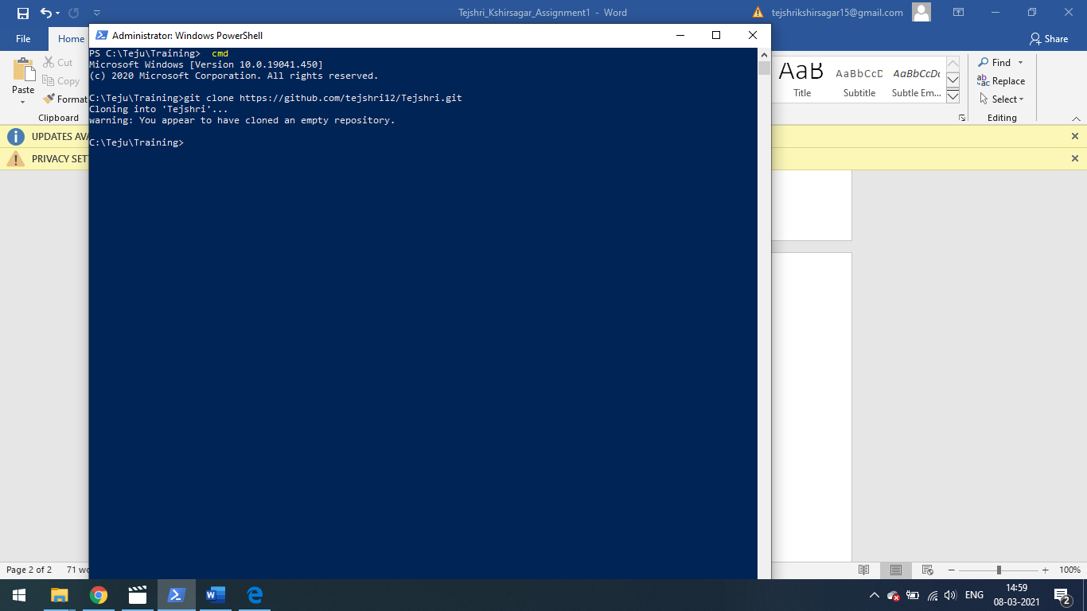

f) Move to folder where you want to commit.

g) And write command git add . to add files.

h) And git commit -m “comment” to show status.

i) To push write git push to push files.

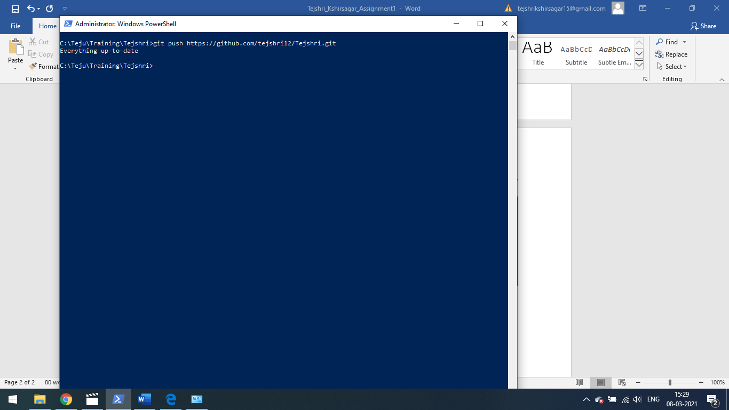

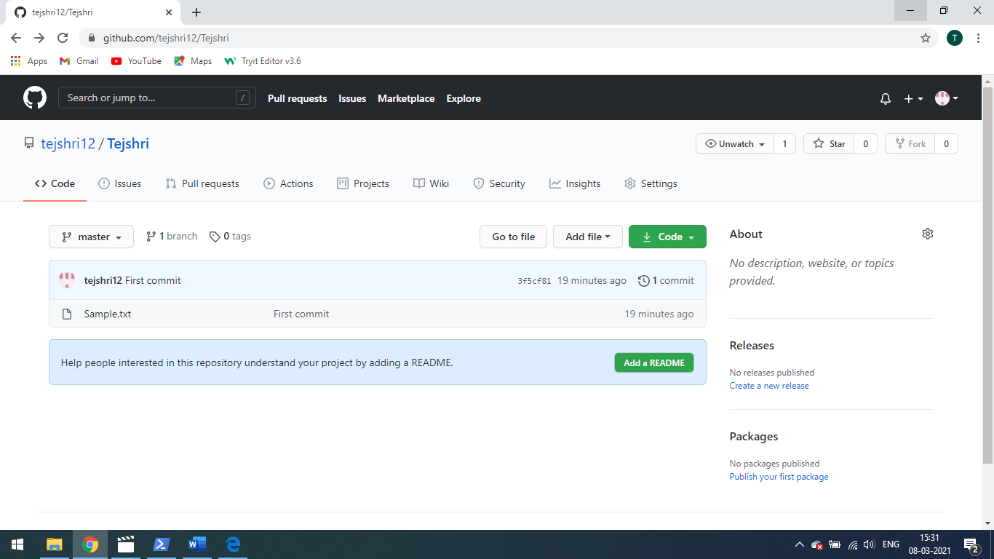

2) Which commands are used to check GIT Version?

a) git --version command is used to check GIT Version.

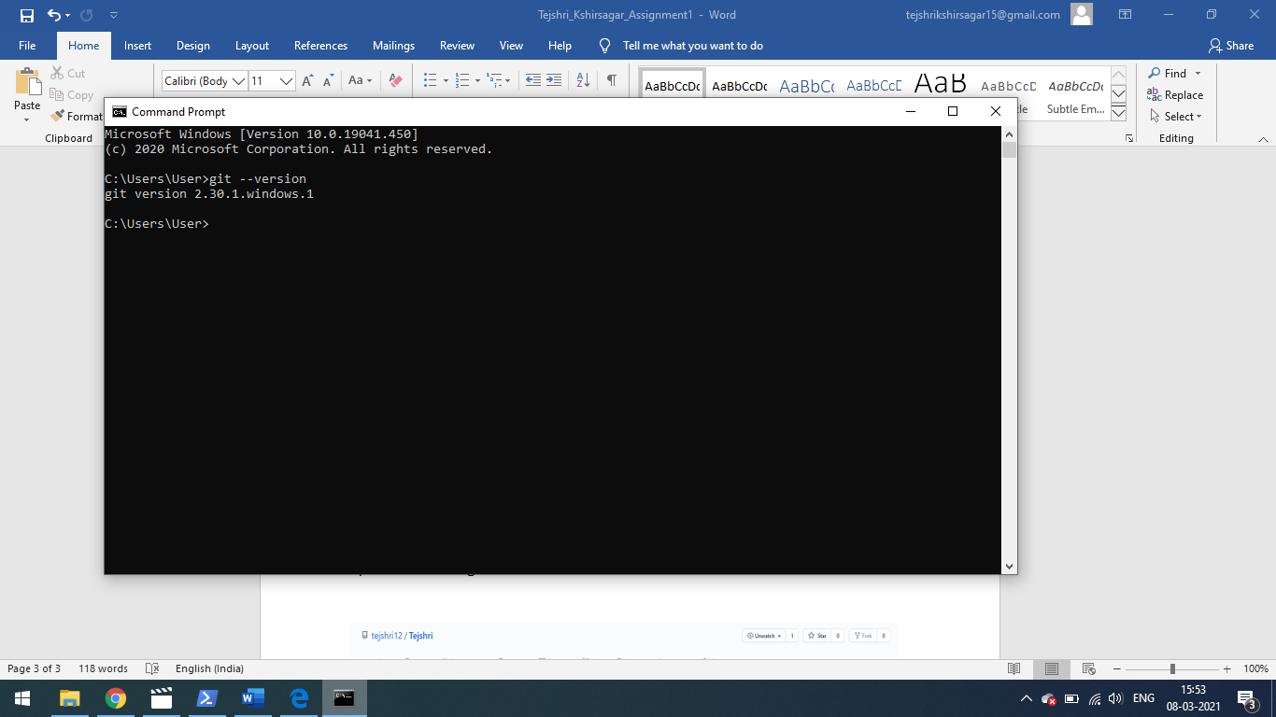

3) How can you collaborate with others in GitHub?

a) Open your repository.

b) Click on setting button.

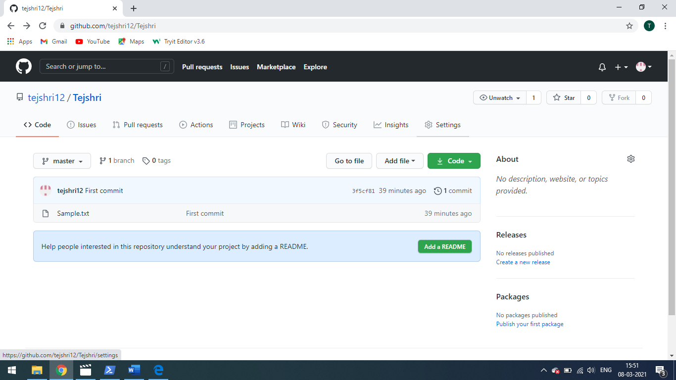

c) After clicking on settings go to Manage access.

d) After that click on Invite a collaborator. Write user name of collaborator and then invite them.

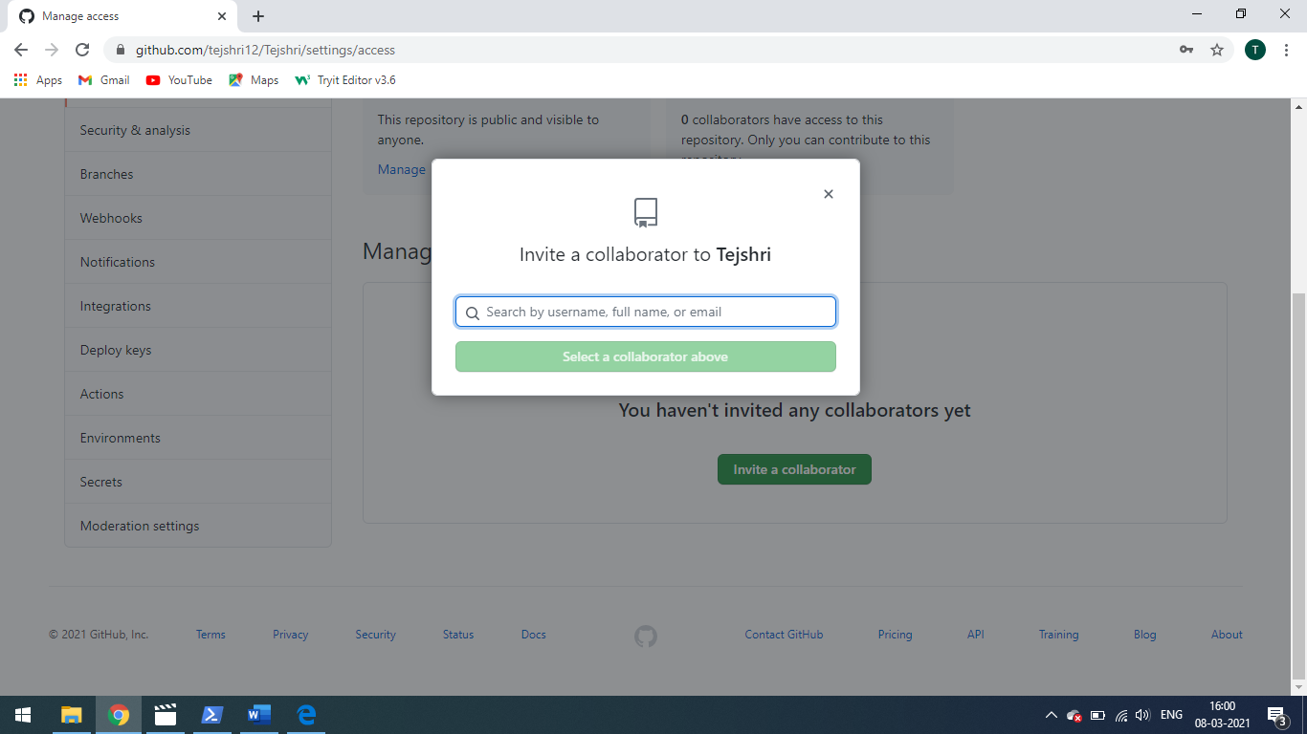

4) How you can push updates on your repository?

While pushing updates on the repository use following commands:

1. Go to the location of working directory where we have to add or update the files in the local repository on your system. Then use following command.

git add .

1. Then make a local commit.

git commit -m “message”

1. Once you make your local commit, you can then push it to your remote GitHub fork.

Git push origin master

But if you want to pull your changes from the forked repository in GitHub.

To make your source code pulled by original fork, you have to send a pull request to the project owner.

1. Go to the webpage of your forked project on GitHub.
2. Hit the pull request button on the top right of page.
3. Select the commits that you want to submit by change commits button.
4. Write some description of your changes, comments, or etc.
5. Send pull request and wait for the owner reply.

5) What is the alternative of GitHub and what is full form of GIT?

Bitbucket is the alternative of GitHub.

The Full Form of GIT is Global Information Tracker.