1st

from datetime import datetime

now = datetime.now() # current date and time

date_time = now.strftime("%d/%m/%Y")

print("date and time:",date_time)

year = now.strftime("%Y")

print("year:", year)

month = now.strftime("%m")

print("month:", month)

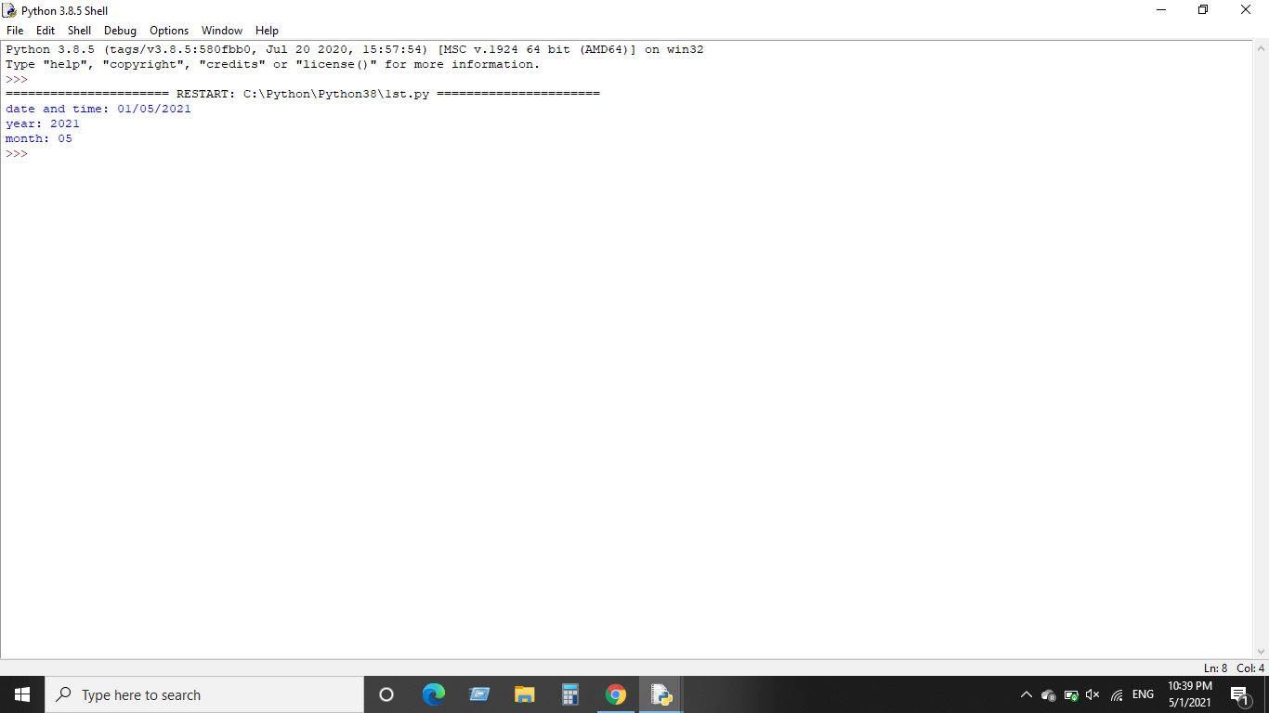

2nd

#string to tuple

string = "abc"

string_tuple = (string,)

print("String to Tuple : ",string_tuple)

#list to tuple

my_list = [1,2,3,4,5]

list_tuple = tuple(my_list)

print("list to Tuple : ",list_tuple)

#set to tuple

my_set = {1,"apple",109,'grapes'}

set_tuple = tuple(my_set)

print("Set to Tuple : ",set_tuple)

#dictionary to tuple

dict = { sobiya: 1, 'afrah': 39, 'afreen': 2, 'huma': 20 }

dic_tuple = zip(dict.keys(), dict.values())

dic_tuple = tuple(dic_tuple)

print("Dictionary to Tuple :",dic_tuple)

print()

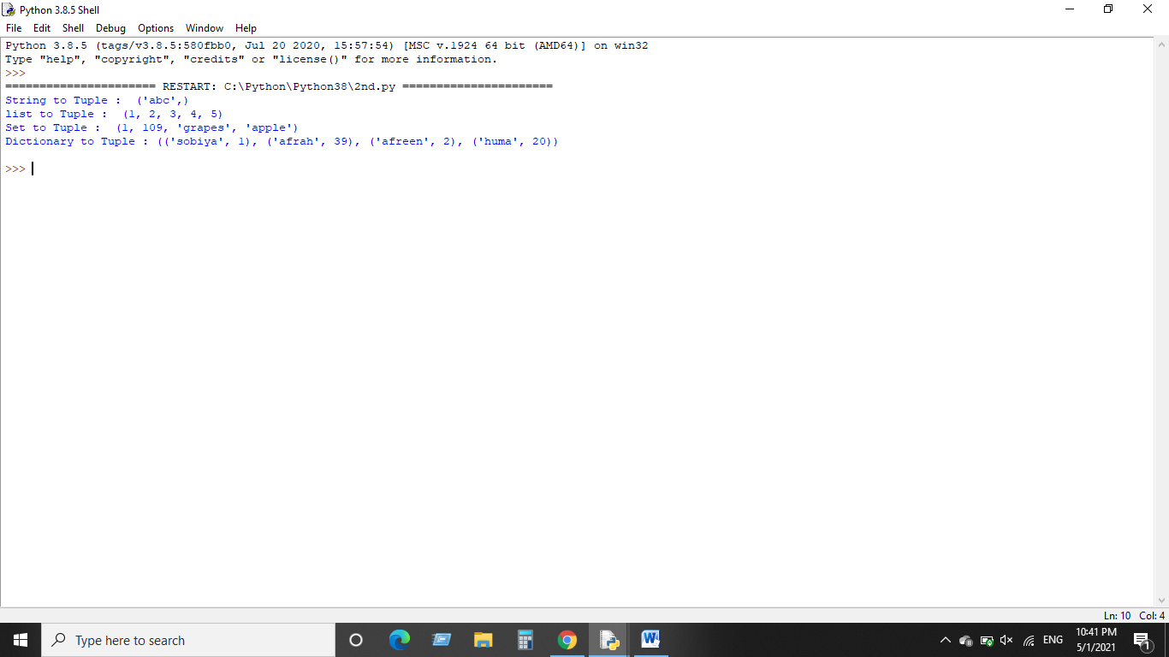

Create database

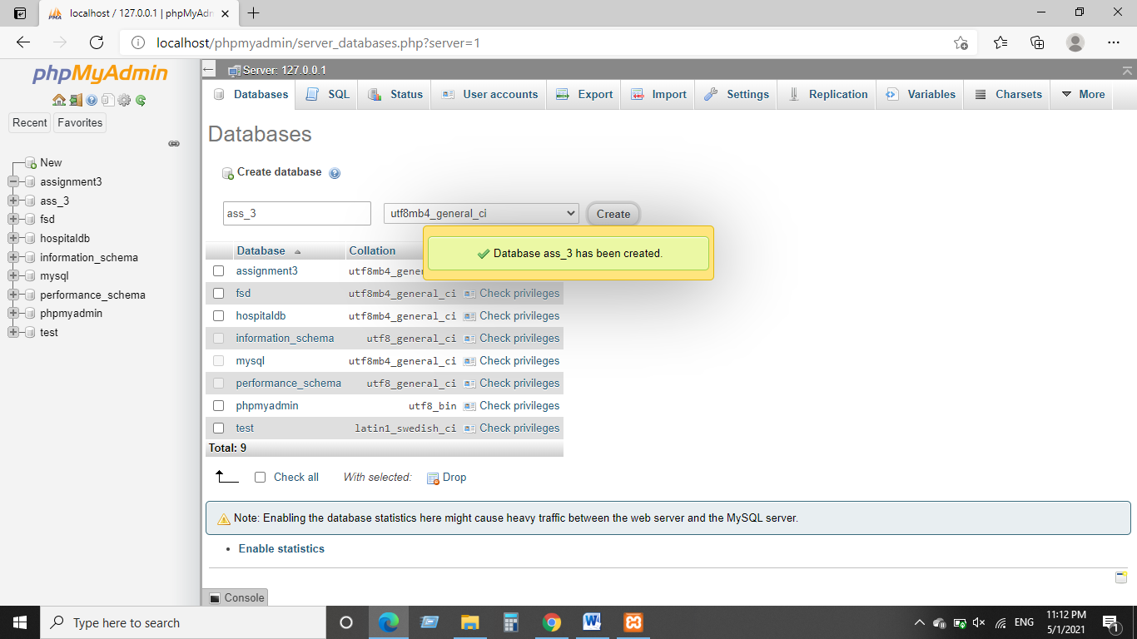

Create table

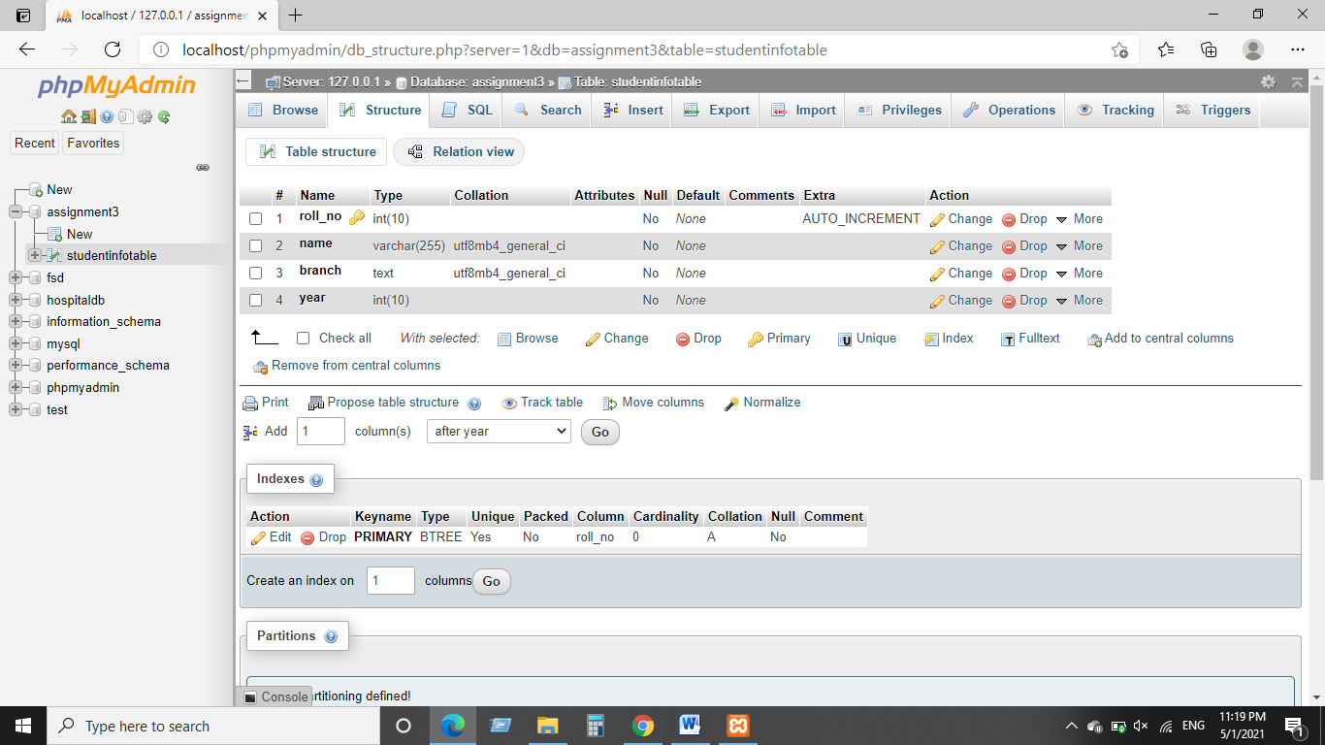

Delete Row

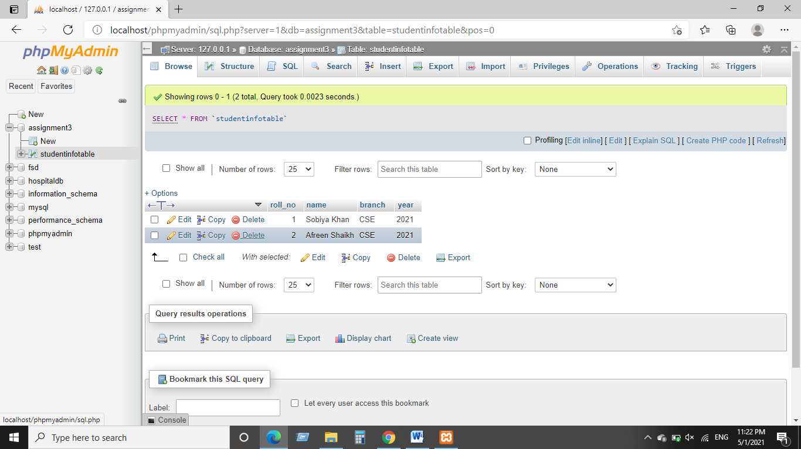

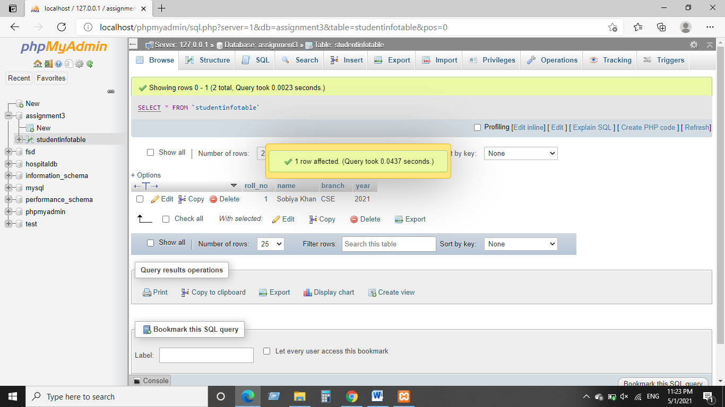

Insert into Table

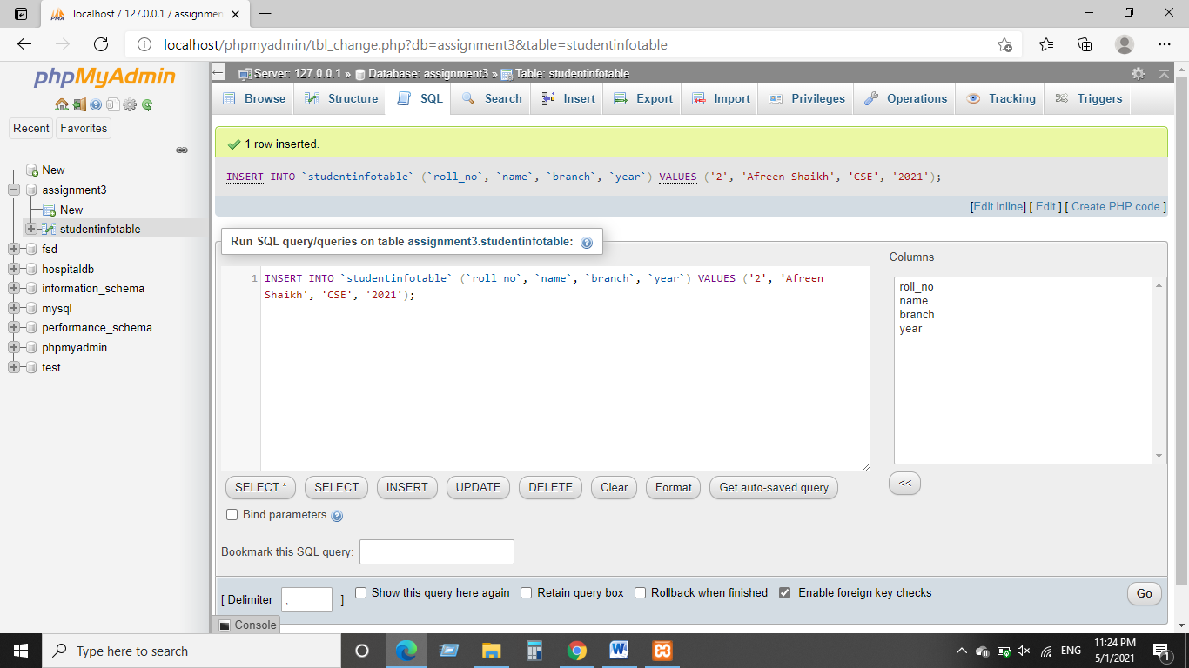

Show Data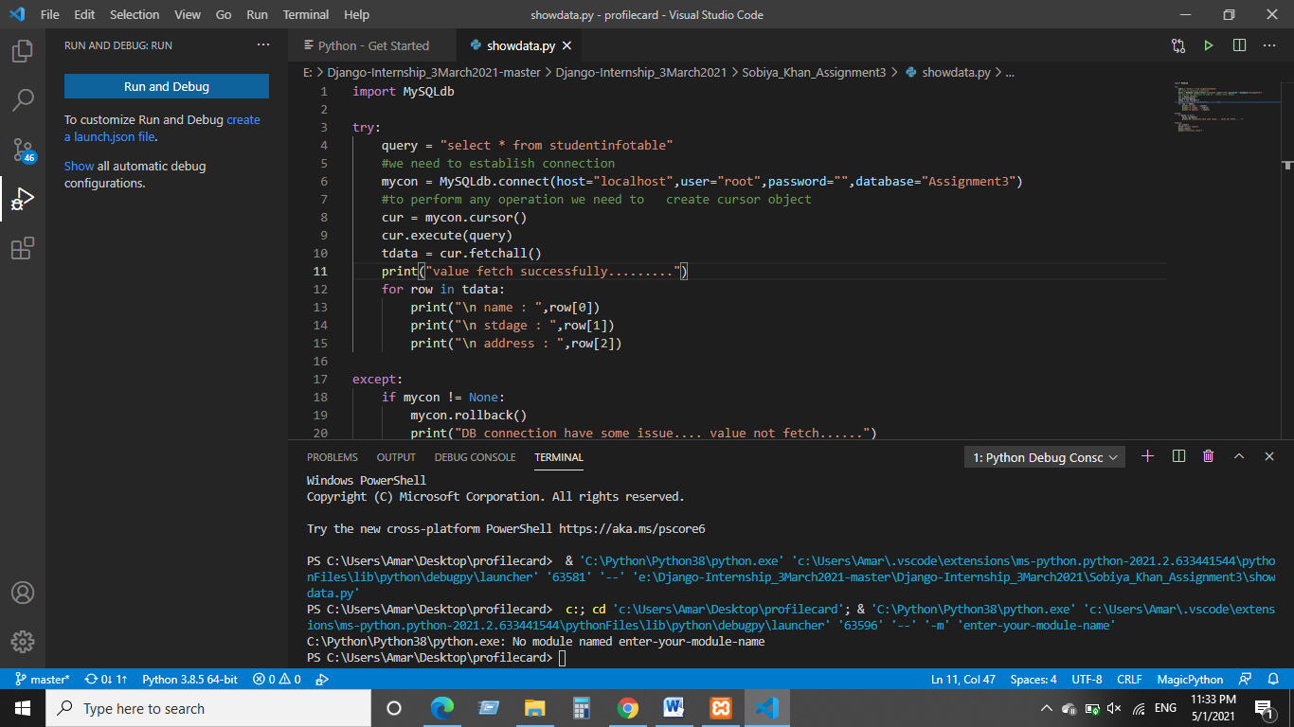

Update Value

