COL774 Assignment – 2

**Anirudha Kulkarni**

**2019CS50421**

Code running instructions:

1. All codes are arranged in respective folders

2. Each question contains a asset folder where all plots/GIFs will be stored

3. Each code is in a python file and the parameters are written in the very first line of each function which can be changed

4. Data sets need to be put in a directory in submission directory with name “data” which can be passed as an argument if not

5. python files can be run with `python q1.py`

**Q2: Naïve Bayes**

**a) Naïve Bayes with Laplace smoothing and logarithms:**

Train accuracy: 51.038

Test accuracy: 0.6595714285714286

**b) Random predictions, Majority Predictions:**

Random Train: 0.20118

Random Test: 0.1985

Majority Train: 0.51864

Majority Test: 0.6607857142857143

**d) Removal of stopwords, stemming**

Some New reviews are getting classified correctly and similarly new reviews are getting classified incorrectly. Overall accuracy increases slightly.

Train accuracy: 0.519

Test accuracy: 0.661

F1 Score

[0.00000000e+00 0.00000000e+00 0.00000000e+00 6.43086817e-04

7.95784946e-01]

Macro F1 Score

0.15928560661065586

[[ 0 0 0 0 2529]

[ 0 0 0 1 2637]

[ 0 0 0 3 5631]

[ 0 0 0 19 13248]

[ 0 0 0 1 25931]]

**e) Feature engineering:**

**i. Bingram**

Train accuracy: 0.86476

Test accuracy: 0.661428

F1 Score

[0. 0. 0. 0.02234637 0.79742404]

Macro F1 Score

0.16395408162649344

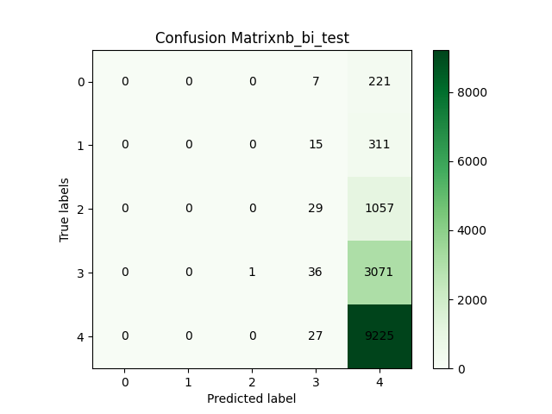

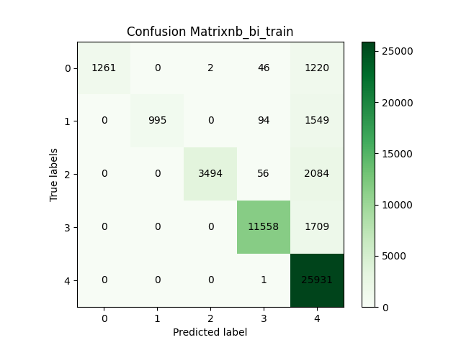

**ii. 3-gram**

F1 Score

[0. 0. 0. 0.02291731 0.7973195 ]

Macro F1 Score

0.16404736206961418

Training accuracy: 0.86528

Testing accuracy: 0.6612142857142858

**iii. Lemmatization**

F1 Score

[0.00000000e+00 0.00000000e+00 0.00000000e+00 6.43086817e-04

7.95784946e-01]

Macro F1 Score

0.15928560661065586

Training accuracy: 0.51878

Testing accuracy: 0.6607857142857143

**iv. TF-IDF**

Test accuracy: 0.66086

Macro F1 score : 0.16079297464750816

Among all feature engineering 2-gram fits training data most accurately but performs average on test data. 3-gram performs the best on test data. TF-IDF performs similar to majority predictions. Lemmatization reduces the accuracy when done with stemming. Without stemming and only lemmatization also reduces the accuracy.

**f) F1- score:** Done in each part

**F1 score is better parameter as it takes the false positive and false negative into account. Will be critical where false positive and false negative matter. Ex- classifying terrorist as non-terrorist or important mail as spam.**

**g) With summary removal of stopwords, stemming**

Confusion Matrix

[[ 8 4 2 16 198]

[ 2 0 12 33 279]

[ 1 0 23 125 937]

[ 1 0 4 186 2917]

[ 1 0 0 122 9129]]

F1 Score

[0.06639004 0. 0.04081633 0.10362117 0.80389222]

Macro F1 Score

0.202943950701937

Summaries are generally short conclusion by a human which is more accurate than ML model. Hence accuracy is more than review text

**Q2: SVM**

**a) Binary classification:**

Dual problem with noise:

CVXOPT Format:

Max can be converted to min using negative sign,

**i) Linear Kernel:**

**Finding P,q,G,h,A,b:**

q­­ T = [-1, -1, -1, …, -1]

A = YT

b = [0]

Pi, j = y(i) y(j)x(j)Tx(j)

h T = [0, 0, …, 0, C, C, …, C]

The condition $0≤α_{i}≤C$ is modelled using G. First m rows cover the $0≤α_{i}$ part and second m rows cover $α_{i}≤C$

Parameters:

d=1, threshold = 0.0001, C=1.0

**Support vectors:** Indices of support vectors are saved in a file *support_vector_linear.txt*.

Weight = stored in the file

bias = 0.795

nSV = 95

Validation accuracy: 100%

Test accuracy: 98.89%

Computational cost: 8.87 seconds

Confusion Matrix Train:

2000 0

0 2000

Confusion Matrix test:

1012 20

5 1130

**ii) Gaussian Kernel:**

Everything same as linear kernel except P

Pi, j = y(i) y(j) K(x(j), x(j))

W is given by,

b is given by,

Parameters:

d=1, threshold = 0.0001, Gamma = 0.05, C=1.0

**Support vectors:** Indices of support vectors are saved in a file *support_vector_linear.txt*.

nSV = 867

Validation accuracy: 99.825%

Test accuracy: 95.846%

Computational cost: 28.100 sec

**iii) LIBSVM:**

|  |  |  |  |  |
| --- | --- | --- | --- | --- |
|  | Linear | | Gaussian | |
|  | CVXPOT | LIBSVM | CVXPOT | LIBSVM |
| Validation accuracy | 100% | 100% | 99.825% | 99.975% |
| Test accuracy | 98.84% | 99.03% | 95.846% | 99.58% |
| nSV | 158 | 158 | 845 | 847 |
| Bias | 1.377 | -1.219 | -- | 0.890 |
| Computational cost | 37.28 | 0.50 | 28.100 | 1.988 |

**a) Multi-class classification:**

**i) CVXOPT:**

Total training time: 1198.8615338802338

Prediction Time: 3 Hrs

Multiclass LIBSVM Training accuracy: 0.99765

Multiclass LIBSVM Test accuracy: 0.9494

Total nSV: 9866

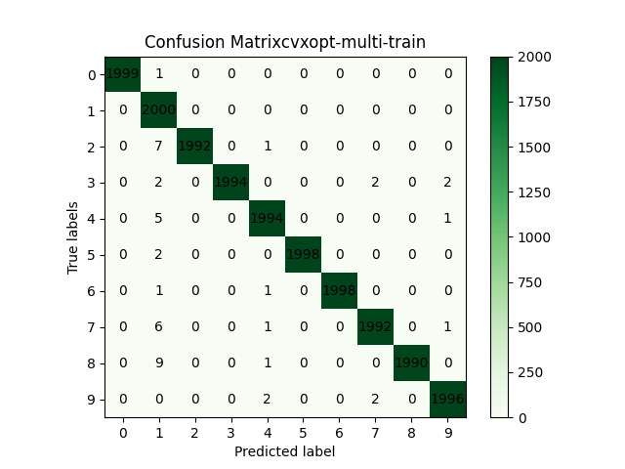

**ii) LIBSVM:**

Training time: 170.986590385437

Total nSV: 10493

Train accuracy: 99.92% (19984/20000) (classification)

Test Accuracy: 97.23% (9723/10000) (classification)

**iii) Confusion matrices:**

Missed train examples:



Missed test examples:



Miss-classified digits:

Most miss-classified are (7,2), (2,7), (8,3), (2,8), (9,4), (9,8), (9,4), (5,6), (6,0), (7,9)

Most of the results are intuitive as these are confusing to humans too.

Cross validation accuracy

|  |  |  |  |  |  |
| --- | --- | --- | --- | --- | --- |
|  | C=0.00001 | C=0.001 | C=1 | C=5 | C=10 |
| K1 | 9.325 | 9.325 | 97.125 | 97.2 | 97.2 |
| K2 | 17.075 | 17.075 | 97.25 | 97.45 | 97.45 |
| K3 | 9.275 | 9.275 | 97.625 | 97.65 | 97.65 |
| K4 | 16.525 | 16.525 | 97.05 | 97.125 | 97.125 |
| K5 | 9.275 | 9.275 | 97.1 | 97.175 | 97.175 |
| Average | 12.295 | 13.05 | 97.23 | 97.32 | 97.32 |

Test accuracy

|  |  |  |
| --- | --- | --- |
| C | Test accuracy | Validation accuracy |
| 0.00001 | 12 | 12.295 |
| 0.001 | 72.1 | 13.05 |
| 1 | 97.23 | 97.23 |
| 5 | 97.29 | 97.32 |
| 10 | 97.29 | 97.32 |

Optimal parameters: 1,5,10

Low C leads to less weight to error and model is soft SVM hence underfitting

High C leads to more weight to error and hence overfitting with hard SVM