Method 1

|  |  |  |
| --- | --- | --- |
| Parameter | Graph | Time |
| 4 |  | 118.805 |
| 7 |  | 76.1824 |
| 10 |  | 59.0122 |
| 20 |  | 37.0357 |
| 30 |  | 30.1309 |
| 40 |  | 26.636 |
| 100 |  | 21.9822 |

Observations:

Parameter vs time taken:

Parameter vs “error”:

Notion of error:

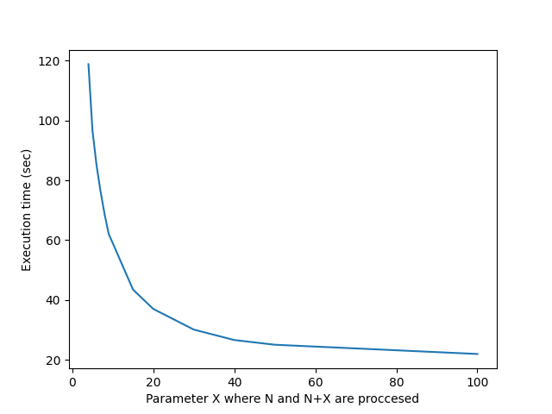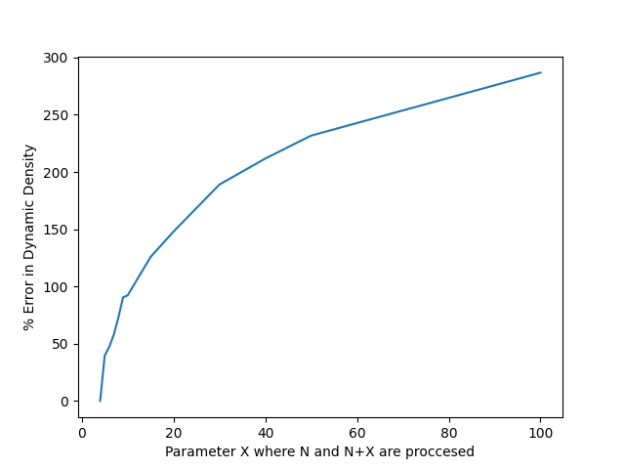

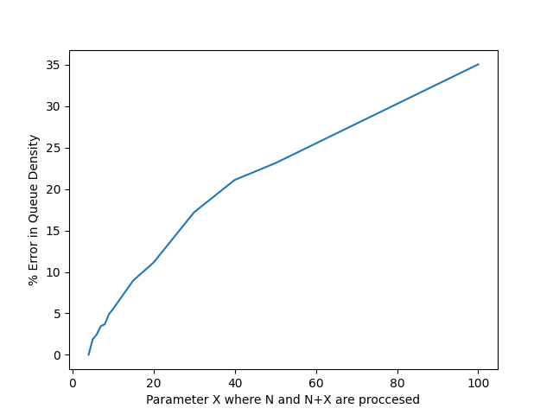

Method 2:

|  |  |  |
| --- | --- | --- |
| Resolution | Graph | Time |
| 1920 x 1080 |  | 56.6293 |
| 1000 x 1000 |  | 29.1401 |
| 700 x 700 |  | 22.7988 |
| 400 x 400 |  | 20.3674 |
| 200 x 200 |  | 17.2196 |

Observations:

Parameter vs time taken:

Parameter vs “error”:

Notion of error:

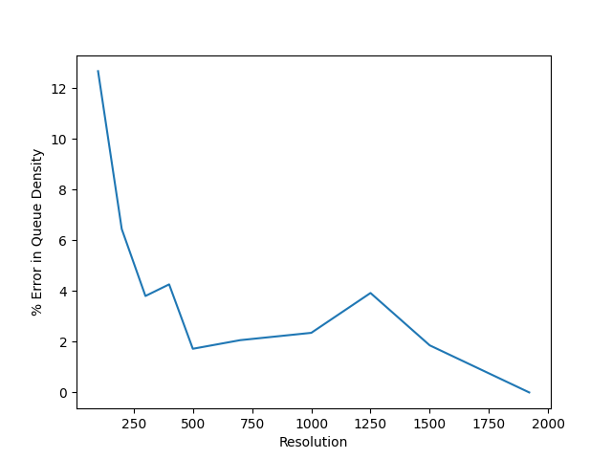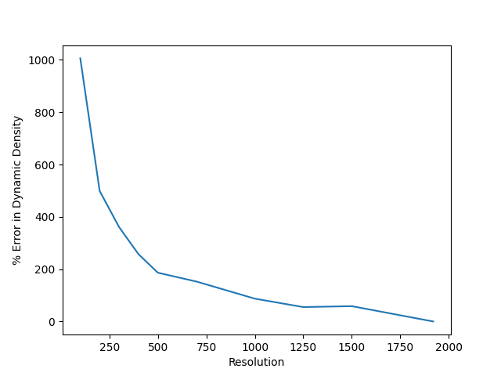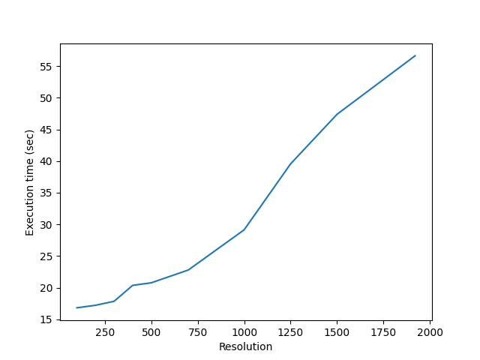

Method 4:

|  |  |  |
| --- | --- | --- |
| Number of threads | Graph | Time |
| Without threads |  | 96.5218 |
| 1 |  | 97.1115 |
| 2 |  | 71.1798 |
| 3 |  | 72.9062 |
| 5 |  | 102.761 |
| 7 |  | 134.66 |

Observations:

Parameter vs time taken:

Parameter vs “error”:

Notion of error:

