
LAIRABOOST
Google Play Store - Complete Setup Guide
Just follow each step. All text is ready to copy-paste.

A. Checklist Items (Dashboard)
These items are on your Dashboard. Click each one and fill in as described below.

A1. Ads
- Click "Ads"
- Select: "Yes, my app contains ads"
- Save

A2. Content Rating
- Click "Content rating"
- Click "Start questionnaire"
- Email: enter your email
- Category: Select "Utility, Productivity, Communication, or Other"
- Answer "No" to ALL questions (violence, sexual content, etc.)
- Click "Save" then "Calculate rating"
- You should get "Everyone" or "Rated for 3+" rating

A3. Target Audience
- Click "Target audience"
- Target age group: Select "18 and over" ONLY
- IMPORTANT: Do NOT select any age group under 18
- Save

A4. Data Safety
This is the longest section. Follow carefully:
- Click "Data safety"
- "Does your app collect or share user data?" → Yes
- "Is all collected data encrypted in transit?" → Yes
- "Can users request data deletion?" → Yes
- Data types collected (check these):
- Name (Account info)
- Email address (Account info)
- Phone number (Account info)
- Payment info (Financial info)
- "Is data shared with third parties?" → No
- Save and submit

A5. Government Apps
- Select "No, this is not a government app"
- Save

A6. Financial Features
- Select "No"
- Save

A7. Health
- Select "No, this is not a health app"
- Save

A8. App Category & Contact
- App category: "Shopping" or "Social"
- Contact email: Enter your email address
- Save

B. Main Store Listing
Left sidebar: Grow users > Store presence > Main store listing

B1. App Name
Copy-paste this:
Lairaboost

B2. Short Description (max 80 characters)
Copy-paste this:
#1 Social Media Growth Service - Buy followers, likes, views & more

B3. Full Description
Copy-paste everything in the gray box below:
Lairaboost is the #1 social media growth platform. Boost your presence on Instagram, TikTok, YouTube, Facebook, Twitter, Telegram and more.

Why choose Lairaboost?

Cheapest Prices - Best rates in the market. Grow your social media without breaking the bank.

Lightning Fast Delivery - Most orders start within minutes. Watch your numbers grow in real time.

Auto-Refill Guarantee - Drops happen, we refill automatically so your count stays up.

2257+ Services - Every major platform covered: Instagram, YouTube, TikTok, Twitter, Telegram & more.

Powerful API - Automate orders with our developer-friendly REST API and resell with ease.

7 Languages - Use the panel in English, Arabic, French, Spanish, German, Russian or Chinese.

38,000+ orders completed and counting!
6,500+ happy clients worldwide
24/7 customer support via WhatsApp

Create your free account and start growing today!

B4. App Icon (512x512)
Upload file: app_icon_512x512.png


B5. Feature Graphic (1024x500)
Upload file: feature_graphic_1024x500.png
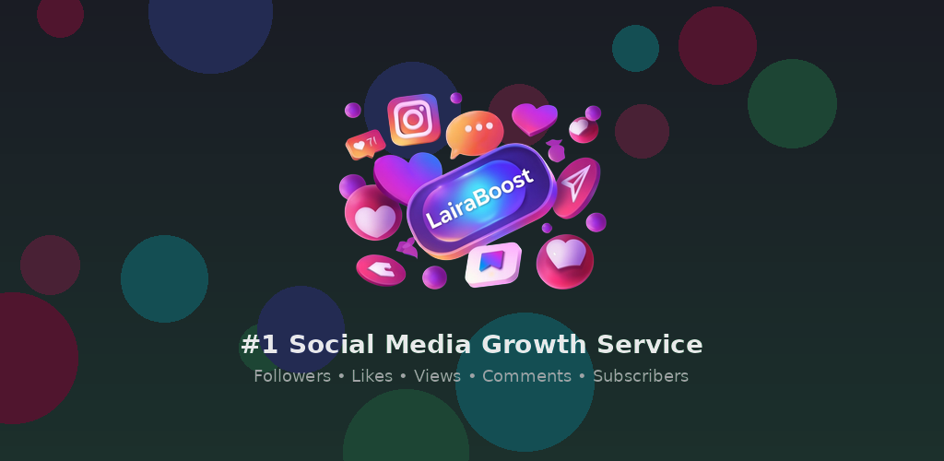

B6. Phone Screenshots (upload ALL 6)
Upload all 6 screenshot_*.png files
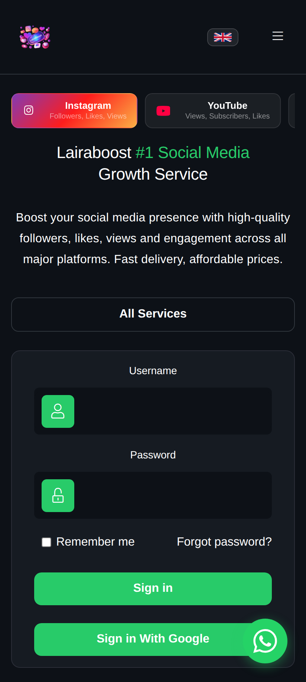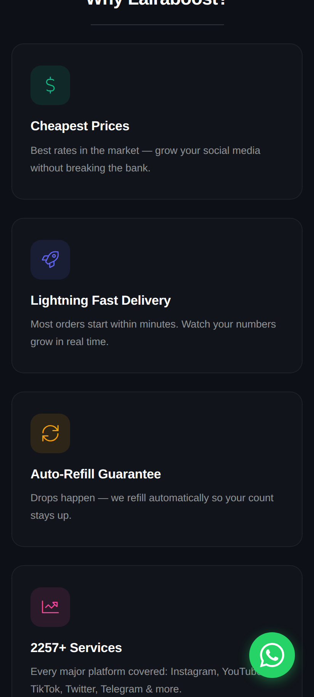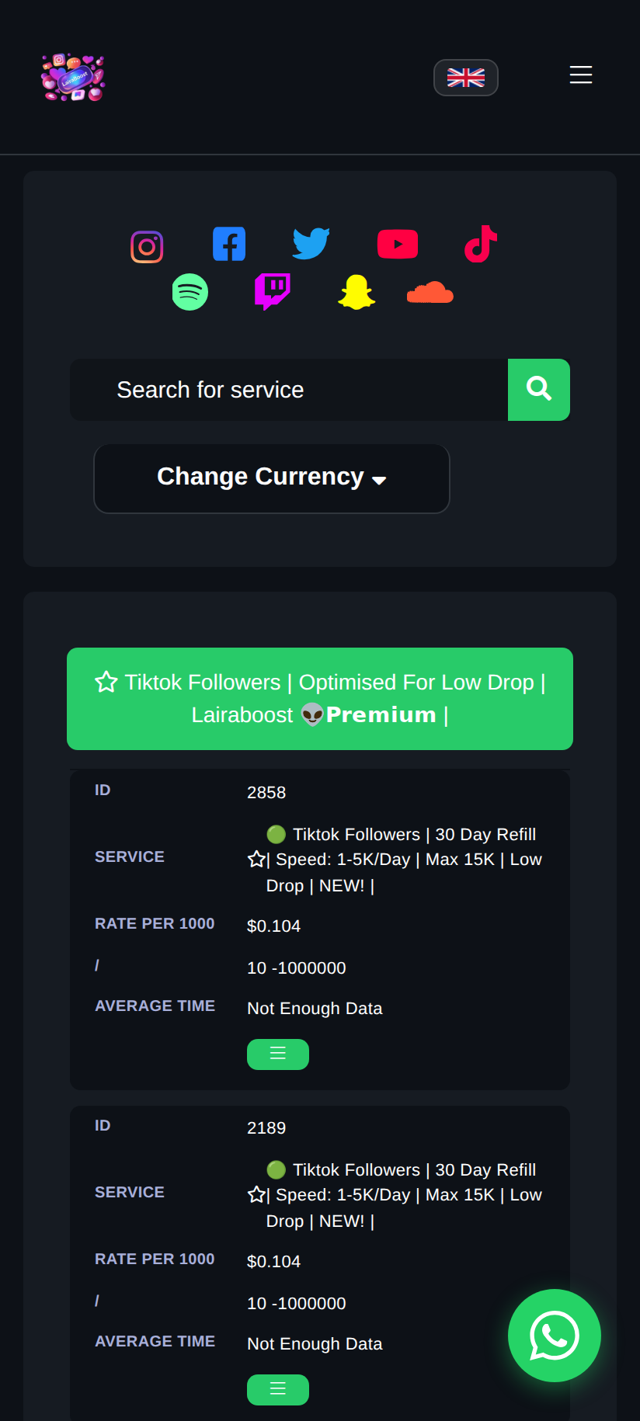
(+ 3 more screenshots in the zip)
Click "Save" at the bottom of the store listing page.

C. Upload the App (AAB File)
Left sidebar: Test and release > Production
File to upload: Lairaboost.aab (3.1 MB)
Download from:
https://github.com/anirudhatalmale6-alt/lairaboost-mobile-app/raw/main/Lairaboost.aab

Steps:
- Click "Production" in the left sidebar
- Click "Create new release"
- Under "App bundles", click "Upload" and select Lairaboost.aab
- Release name: 1.0.0 (should auto-fill)
- Release notes: Type "Initial release of Lairaboost mobile app"
- Click "Review release"
- Click "Start rollout to Production"
After submission, Google will review your app. This usually takes 1-3 days. You'll get an email when it's approved!

D. Download All Files
All files are on GitHub. Click each link to download:
ZIP (all files): https://github.com/anirudhatalmale6-alt/lairaboost-mobile-app/archive/refs/heads/main.zip
Or download individually from: https://github.com/anirudhatalmale6-alt/lairaboost-mobile-app
That's it! Your app will be live on Google Play within 1-3 days.

