STUDENT PORTAL

A MAJOR PROJECT
Submitted in partial fulfillment of the requirement for the award of the Degree of

BACHELOR OF ENGINEERING
IN
COMPUTER SCIENCE & ENGINEERING
SUBMITTED TO


Rajiv Gandhi Proudyogiki Vishwavidyalaya, Bhopal(M.P.)
SUBMITTED BY
Anirudh Bhardwaj (0176CS161016)
Namrisha Gupta (0176CS161057)
Lakshmi Narain College of Technology Excellence, Bhopal (M.P.), India

UNDER THE SUPERVISION OF

Harendra Singh
Asst. Professor, Department of Computer Science & Engineering
Lakshmi Narain College of Technology Excellence, Bhopal (M.P.), India



Department of Computer Science & Engineering
Lakshmi Narain College of Technology Excellence, Bhopal(M.P.)
Session: 2019-2020

(Approved by AICTE, New Delhi & Affiliated to RGPV, Bhopal)
Kalchuri Nagar, Raisen Road, Bhopal (M.P.)
Email: lnctebhopal@lnctgroup.in, Website: www.lnctgroup.in
Phone: +91-7553985300, 7553985301, 7553985302, 7553985303

CANDIDATE’S DECLARATION
I, Namrisha Gupta and Anirudh Bhardwaj, student of Bachelor of Engineering, Computer Science & Engineering, Lakshmi Narain College of Technology Excellence, Bhopal hereby declare that the work presented in the dissertation entitled “Student Portal” is outcome of my own bona-fide work, which is correct to the best of my knowledge and this work has been carried out taking care of Engineering Ethics. The work presented does not infringe any previous work and has not been submitted to any University for the award of any degree / diploma.

The dissertation entitled “Student Portal” being submitted by “Namrisha Gupta” (0176CS161057) and “Anirudh Bhardwaj” (0176CS161016) has been examined by us and is hereby approved for the award of degree “Bachelor of Engineering in Computer Science & Engineering”, for which it has been submitted. It is understood that by this approval the undersigned do not necessarily endorse or approve any statement made, opinion expressed or conclusion drawn therein, but approve the dissertation only for the purpose for which it has been submitted.

(Approved by AICTE, New Delhi & Affiliated to RGPV, Bhopal)
Kalchuri Nagar, Raisen Road, Bhopal (M.P.)
Email: lnctebhopal@lnctgroup.in, Website: www.lnctgroup.in
Phone: +91-7553985300, 7553985301, 7553985302, 7553985303

ACKNOWLEDGEMENT

At the outset, we would like to link to thank the Almighty who made all the things possible. Writing this project report would not have been possible without the support of several people whom we need to wholeheartedly thank. A special thank of ours goes to “Dr. Megha Kamble ” Prof.& Head, Department of Computer Science and Engineering ,LNCTE ,Bhopal who helped us in completing the research and exchanged his interesting ideas thoughts and made this research easy accurate .
We are equally grateful to Dr.V.K. Sahu, principal, LNCTE for providing all the necessary resources to carry out this project work. We would like to thank all staff members of CSE, L.N.C.T.E. and friends, for their moral and psychological support.
We will be failing in our duty if we don’t acknowledge the authors whose work has been consulted by us during the project work

Namrisha Gupta (0176CS161057)
Anirudh Bhardwaj (0176CS161016)

ABSTRACT

IMPROVED STUDENT PORTAL (ISP) deals with the maintenance of university, college, faculty, student information with in the university. ISP is an automation system, which is used to store the college, faculty, student, courses and information of a college.
Starting from registration of a new student in the college, it maintains all the details regarding the attendance and marks of the students. The project deals with retrieval of information through an INTRANET based campus wide portal. It collects related information from all the departments of an organization and maintains files, which are used to generate reports in various forms to measure individual and overall performance of the students.
Development process of the system starts with System analysis. System analysis involves creating a formal model of the problem to be solved by understanding requirements.
Keywords: JAVA Tool Box

CONTENTS

Topic Name |  |  |  |  |  |  |  | Page No.
CERTIFICATE |  |  |  | …………………………………….. |  |  |  | 2
DECLARATION |  |  |  | …………………………………….. |  |  |  | 4
ABSTRACT |  |  |  | …………………………………….. |  |  |  | 8
INTRODUCTION |  |  |  | …………………………………….. |  |  |  | 9
PURPOSE OF THE SYSTEM |  |  | …………………………………….. |  |  |  | 10
INTRODUCTION TO .NET  FRAMEWORK |  |  |  | …………………………………….. |  |  |  | 12
PROPOSED APPROCH |  |  |  | …………………………………….. |  |  |  | 24
DATA FLOW DAIGRAM |  | …………………………………….. |  |  |  | 28
E-R DAIGRAM |  | …………………………………….. |  |  |  | 33
TESTING |  | ----------------------------------------- |  |  |  | 35
CONCLUSION |  |  |  | …………………………………….. |  |  |  | 47
LIMITATIONS | …………………………………….. |  |  |  | 49
FUTUR IMPROVEMENT | …………………………………….. |  |  |  | 50
BIBLIOGRAPHY |  |  |  | …………………………………….. |  |  |  | 51

INTRODUCTION

After analyzing the requirements of the task to be performed, the next step is to analyze the problem and understand its context. The first activity in the phase is studying the existing system and other is to understand the requirements and domain of the new system. Both the activities are equally important, but the first activity serves as a basis of giving the functional specifications and then successful design of the proposed system. Understanding the properties and requirements of a new system is more difficult and requires creative thinking and understanding of existing running system is also difficult, improper understanding of present system can lead diversion from solution.

PURPOSE OF THE SYSTEM
UNIVERSITY MANAGEMENT SYSTEM [UMS] deals with the maintenance of university, college,facultie, student information with in the university. This project of UMS involved the automation of student information that can be implemented in different college managements
The project deals with retrieval of information through an INTRANET based campus wide portal. It collects related information from all the departments of an organization and maintains files, which are used to generate reports in various forms to measure individual and overall performance of the students.

FEATURES

The project is identified by the merits of the system offered to the user. The merits of this project are as follows: -
- It’s a web-enabled project.
- This project offers user to enter the data through simple and interactive forms. This is very helpful for the client to enter the desired information through so much simplicity.
- The user is mainly more concerned about the validity of the data, whatever he is entering. There are checks on every stages of any new creation, data entry or updation so that the user cannot enter the invalid data, which can create problems at later date.
- Sometimes the user finds in the later stages of using project that he needs to update some of the information that he entered earlier. There are options for him by which he can update the records. Moreover there is restriction for his that he cannot change the primary data field. This keeps the validity of the data to longer extent.
- User is provided the option of monitoring the records he entered earlier. He can see the desired records with the variety of options provided by him.
- From every part of the project the user is provided with the links through framing so that he can go from one option of the project to other as per the requirement. This is bound to be simple and very friendly as per the user is concerned. That is, we can sat that the project is user friendly which is one of the primary concerns of any good project.
- Data storage and retrieval will become faster and easier to maintain because data is stored in a systematic manner and in a single database.
- Decision making process would be greatly enhanced because of faster processing of information since data collection from information available on computer takes much less time then manual system.
- Allocating of sample results becomes much faster because at a time the user can see the records of last years.
- Easier and faster data transfer through latest technology associated with the computer and communication.

INTRODUCTION TO .NET FRAMEWORK

The Microsoft .NET Framework is a software technology that is available with several Microsoft Windows operating systems. It includes a large library of pre-coded solutions to common programming problems and a virtual machine that manages the execution of programs written specifically for the framework. The .NET Framework is a key Microsoft offering and is intended to be used by most new applications created for the Windows platform.
The pre-coded solutions that form the framework's Base Class Library cover a large range of programming needs in a number of areas, including user interface, data access, database connectivity, cryptography, web application development, numeric algorithms, and network communications. The class library is used by programmers, who combine it with their own code to produce applications.

Programs written for the .NET Framework execute in a software environment that manages the program's runtime requirements. Also part of the .NET Framework, this runtime environment is known as the Common Language Runtime (CLR). The CLR provides the appearance of an application virtual machine so that programmers need not consider the capabilities of the specific CPU that will execute the program. The CLR also provides other important services such as security, memory management, and exception handling. The class library and the CLR together compose the .NET Framework.

Principal design features

Interoperability

Because interaction between new and older applications is commonly required, the .NET Framework provides means to access functionality that is implemented in programs that execute outside the .NET environment. Access to COM components is provided in the System.Runtime.InteropServices and System.EnterpriseServices namespaces of the framework; access to other functionality is provided using the P/Invoke feature.

Common Runtime Engine

The Common Language Runtime (CLR) is the virtual machine component of the .NET framework. All .NET programs execute under the supervision of the CLR, guaranteeing certain properties and behaviors in the areas of memory management, security, and exception handling.

Base Class Library

The Base Class Library (BCL), part of the Framework Class Library (FCL), is a library of functionality available to all languages using the .NET Framework. The BCL provides classes which encapsulate a number of common functions, including file reading and writing, graphic rendering, database interaction and XML document manipulation.
Simplified Deployment
Installation of computer software must be carefully managed to ensure that it does not interfere with previously installed software, and that it conforms to security requirements. The .NET framework includes design features and tools that help address these requirements.

Security

The design is meant to address some of the vulnerabilities, such as buffer overflows, that have been exploited by malicious software. Additionally, .NET provides a common security model for all applications.

Portability

The design of the .NET Framework allows it to theoretically be platform agnostic, and thus cross-platform compatible. That is, a program written to use the framework should run without change on any type of system for which the framework is implemented. Microsoft's commercial implementations of the framework cover Windows, Windows CE, and the Xbox 360.
In addition, Microsoft submits the specifications for the Common Language Infrastructure (which includes the core class libraries, Common Type System, and the Common Intermediate Language), the C# language, and the C++/CLI language to both ECMA and the ISO, making them available as open standards. This makes it possible for third parties to create compatible implementations of the framework and its languages on other platforms.

Architecture

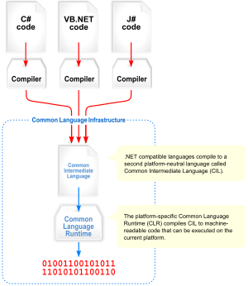
Visual overview of the Common Language Infrastructure (CLI)
Common Language Infrastructure

The core aspects of the .NET framework lie within the Common Language Infrastructure, or CLI. The purpose of the CLI is to provide a language-neutral platform for application development and execution, including functions for exception handling, garbage collection, security, and interoperability. Microsoft's implementation of the CLI is called the Common Language Runtime or CLR.

Assemblies

The intermediate CIL code is housed in .NET assemblies. As mandated by specification, assemblies are stored in the Portable Executable (PE) format, common on the Windows platform for all DLL and EXE files. The assembly consists of one or more files, one of which must contain the manifest, which has the metadata for the assembly. The complete name of an assembly (not to be confused with the filename on disk) contains its simple text name, version number, culture, and public key token. The public key token is a unique hash generated when the assembly is compiled, thus two assemblies with the same public key token are guaranteed to be identical from the point of view of the framework. A private key can also be specified known only to the creator of the assembly and can be used for strong naming and to guarantee that the assembly is from the same author when a new version of the assembly is compiled (required to add an assembly to the Global Assembly Cache).

Metadata

All CLI is self-describing through .NET metadata. The CLR checks the metadata to ensure that the correct method is called. Metadata is usually generated by language compilers but developers can create their own metadata through custom attributes. Metadata contains information about the assembly, and is also used to implement the reflective programming capabilities of .NET Framework.

Security

.NET has its own security mechanism with two general features: Code Access Security (CAS), and validation and verification. Code Access Security is based on evidence that is associated with a specific assembly. Typically the evidence is the source of the assembly (whether it is installed on the local machine or has been downloaded from the intranet or Internet).
Code Access Security uses evidence to determine the permissions granted to the code. Other code can demand that calling code is granted a specified permission.
The demand causes the CLR to perform a call stack walk: every assembly of each method in the call stack is checked for the required permission; if any assembly is not granted the permission a security exception is thrown.
When an assembly is loaded the CLR performs various tests. Two such tests are validation and verification. During validation the CLR checks that the assembly contains valid metadata and CIL, and whether the internal tables are correct. Verification is not so exact. The verification mechanism checks to see if the code does anything that is 'unsafe'. The algorithm used is quite conservative; hence occasionally code that is 'safe' does not pass. Unsafe code will only be executed if the assembly has the 'skip verification' permission, which generally means code that is installed on the local machine.
.NET Framework uses appdomains as a mechanism for isolating code running in a process. Appdomains can be created and code loaded into or unloaded from them independent of other appdomains. This helps increase the fault tolerance of the application, as faults or crashes in one appdomain do not affect rest of the application. Appdomains can also be configured independently with different security privileges. This can help increase the security of the application by isolating potentially unsafe code. The developer, however, has to split the application into sub domains; it is not done by the CLR.
Class library
Namespaces in the BCL
System
System. CodeDom
System. Collections
System. Diagnostics
System. Globalization
System. IO
System. Resources
System. Text
System.Text.RegularExpressions

The Base Class Library (BCL) includes a small subset of the entire class library and is the core set of classes that serve as the basic API of the Common Language Runtime. The classes in mscorlib.dll and some of the classes in System.dll and System.core.dll are considered to be a part of the BCL. The BCL classes are available in both .NET Framework as well as its alternative implementations including .NET Compact Framework, Microsoft Silver light and Mono.
The Framework Class Library (FCL) is a superset of the BCL classes and refers to the entire class library that ships with .NET Framework. It includes an expanded set of libraries, including Win Forms, ADO.NET, ASP.NET, Language Integrated Query, Windows Presentation Foundation, Windows Communication Foundation among others. The FCL is much larger in scope than standard libraries for languages like C++, and comparable in scope to the standard libraries of Java.

ANALYSIS MODEL

The model that is basically being followed is the WATER FALL MODEL, which states that the phases are organized in a linear order. First of all the feasibility study is done. Once that part is over the requirement analysis and project planning begins. The design starts after the requirement analysis is complete and the coding begins after the design is complete. Once the programming is completed, the testing is done. In this model the sequence of activities performed in a software development project are: -
- Requirement Analysis
- Project Planning
- System design
- Detail design
- Coding
- Unit testing
- System integration & testing

Here the linear ordering of these activities is critical. End of the phase and the output of one phase is the input of other phase. The output of each phase is to be consistent with the overall requirement of the system. Some of the qualities of spiral model are also incorporated like after the people concerned with the project review completion of each of the phase the work done.
WATER FALL MODEL was being chosen because all requirements were known beforehand and the objective of our software development is the computerization/automation of an already existing manual working system.

Communicated Requirements

Requirements Specification

Design Specification

Executable Software Modules

Integrated Software Product

Delivered Software Product

Changed Requirements

Requirements Engineering
Design
Programming
Integration
Delivery
Maintenance

Product
Product

Input

Output

Process

Fig 2.2: Water Fall Model

FEASIBILITY STUDY

Preliminary investigation examine project feasibility, the likelihood the system will be useful to the organization. The main objective of the feasibility study is to test the Technical, Operational and Economical feasibility for adding new modules and debugging old running system. All system is feasible if they are unlimited resources and infinite time. There are aspects in the feasibility study portion of the preliminary investigation:
- Technical Feasibility
- Operational Feasibility
- Economical Feasibility

TECHNICAL FEASIBILITY

Technical Feasibility centers on the existing computer system hardware, software, etc. and to some extent how it can support the proposed addition. This involves financial considerations to accommodate technical enhancements. Technical support is also a reason for the success of the project. The techniques needed for the system should be available and it must be reasonable to use. Technical Feasibility is mainly concerned with the study of function, performance, and constraints that may affect the ability to achieve the system. By conducting an efficient technical feasibility we need to ensure that the project works to solve the existing problem area.
Since the project is designed with ASP.NET with C# as Front end and SQL Server 2000 as Back end, it is easy to install in all the systems wherever needed. It is more efficient, easy and user-friendly to understand by almost everyone. Huge amount of data can be handled efficiently using SQL Server as back end. Hence this project has good technical feasibility

OPERATIONAL FEASIBILITY

People are inherently instant to change and computers have been known to facilitate change. An estimate should be made to how strong a reaction the user staff is likely to have towards the development of the computerized system.
The staff is accustomed to computerized systems. These kinds of systems are becoming more common day by day for evaluation of the software engineers. Hence,this system is operationally feasible. As this system is technically, economically and operationally feasible, this system is judged feasible.

ECONOMICAL FEASIBILITY

The role of interface design is to reconcile the differences that prevail among the software engineer’s design model, the designed system meet the end user requirement with economical way at minimal cost within the affordable price by encouraging more of proposed system. Economic feasibility is concerned with comparing the development cost with the income/benefit derived from the developed system. In this we need to derive how this project will help the management to take effective decisions.

Economic Feasibility is mainly concerned with the cost incurred in the implementation of the software. Since this project is developed using ASP.NET with C# and SQL Server which is more commonly available and even the cost involved in the installation process is not high.

Similarly it is easy to recruit persons for operating the software since almost all the people are aware of ASP.NET with C# and SQL Server. Even if we want to train the persons in these area the cost involved in training is also very less. Hence this project has good economic feasibility.

The system once developed must be used efficiently. Otherwise there is no meaning for developing the system. For this a careful study of the existing system and its drawbacks are needed. The user should be able to distinguish the existing one and proposed one, so that one must be able to appreciate the characteristics of the proposed system, the manual one is not highly reliable and also is considerably fast. The proposed system is efficient, reliable and also quickly responding.

S/w and H/w requirements
- Environment:
- Servers:
Operating System Server: - Microsoft Windows 2000 or Higher
Data Base Server: Microsoft SQL Server 2000/2005
- Clients : Microsoft Internet Explorer,
- Tools : Microsoft Visual Studio .Net
- User Interface: ASP.NET with AJAX
- Code Behind : VC#.NET

- Requirements:

- Hardware requirements:

Number | Description
1 | PC with 2 GB hard-disk  and 256 MB RAM
- Software requirements:

Number | Description
1 | Windows 2000/ XP/ or Higher with MS-office
2. | MS-SQL server2000/2005
3. | Ms-Visual Studio .Net 2005
4. | Ms-Internet Explorer

IMPROVED STUDENT PORTAL (ISP) makes management to get the most updated information always by avoiding manual accounting process. This system has the following functional divisions.
- University Administrator
- College Administrator
- User (Students / Faculties)
- Reports
- Authentication

University Administrator has the functionality of registering new colleges and courses.
College Administrator has the rights of creating department, allocating courses to departments, creating faculties, students and allocating subjects to faculties, and modifications in the data entered by the user can also be done by the college administrator.
User of this may be faculty or students. Faculty has the facility of entering the marks and attendance of the students. Students can check their marks and attendance but there is no chance of modifications.
Reports must be generated for the existing data i.e. for attendance and marks of the students, which are used to assess the performance of the students. These reports should be viewed by the in charge and user.
Authentication: this module contains all the information about the authenticated user
User without his username and password can’t enter into the login if he is only the authenticated user then he can enter to his login.

PROPOSED APPROCH

Software design sits at the technical kernel of the software engineering process and is applied regardless of the development paradigm and area of application. Design is the first step in the development phase for any engineered product or system. The designer’s goal is to produce a model or representation of an entity that will later be built. Beginning, once system requirement have been specified and analyzed, system design is the first of the three technical activities -design, code and test that is required to build and verify software.
The importance can be stated with a single word “Quality”. Design is the place where quality is fostered in software development. Design provides us with representations of software that can assess for quality. Design is the only way that we can accurately translate a employee’s view into a finished software product or system. Software design serves as a foundation for all the software engineering steps that follow. Without a strong design we risk building an unstable system – one that will be difficult to test, one whose quality cannot be assessed until the last stage.
During design, progressive refinement of data structure, program structure, and procedural details are developed reviewed and documented. System design can be viewed from either technical or project management perspective. From the technical point of view, design is comprised of four activities – architectural design, data structure design, interface design and procedural design.

DATA FLOW DIAGRAMS
A data flow diagram is graphical tool used to describe and analyze movement of data through a system. These are the central tool and the basis from which the other components are developed. The transformation of data from input to output, through processed, may be described logically and independently of physical components associated with the system. These are known as the logical data flow diagrams. The physical data flow diagrams show the actual implements and movement of data between people, departments and workstations. A full description of a system actually consists of a set of data flow diagrams. Using two familiar notations Yourdon, Gane and Sarson notation develops the data flow diagrams. Each component in a DFD is labeled with a descriptive name. Process is further identified with a number that will be used for identification purpose. The development of DFD’S is done in several levels. Each process in lower level diagrams can be broken down into a more detailed DFD in the next level. The lop-level diagram is often called context diagram. It consists a single process bit, which plays vital role in studying the current system. The process in the context level diagram is exploded into other process at the first level DFD.
The idea behind the explosion of a process into more process is that understanding at one level of detail is exploded into greater detail at the next level. This is done until further explosion is necessary and an adequate amount of detail is described for analyst to understand the process.
Larry Constantine first developed the DFD as a way of expressing system requirements in a graphical from, this lead to the modular design.
A DFD is also known as a “bubble Chart” has the purpose of clarifying system requirements and identifying major transformations that will become programs in system design. So it is the starting point of the design to the lowest level of detail. A DFD consists of a series of bubbles joined by data flows in the system.
DFD SYMBOLS:

In the DFD, there are four symbols
- A square defines a source(originator) or destination of system data
- An arrow identifies data flow. It is the pipeline through which the information flows
- A circle or a bubble represents a process that transforms incoming data flow into outgoing data flows.
- An open rectangle is a data store, data at rest or a temporary repository of data

Process that transforms data flow.

Source or Destination of data
Data flow

Data Store

CONSTRUCTING A DFD:
Several rules of thumb are used in drawing DFD’S:
- Process should be named and numbered for an easy reference. Each name should be representative of the process.
- The direction of flow is from top to bottom and from left to right. Data traditionally flow from source to the destination although they may flow back to the source. One way to indicate this is to draw long flow line back to a source.
- An alternative way is to repeat the source symbol as a destination. Since it is used more than once in the DFD it is marked with a short diagonal.
- When a process is exploded into lower level details, they are numbered.
- The names of data stores and destinations are written in capital letters. Process and dataflow names have the first letter of each work capitalized.
A DFD typically shows the minimum contents of data store. Each data store should contain all the data elements that flow in and out.
Questionnaires should contain all the data elements that flow in and out. Missing interfaces redundancies and like is then accounted for often through interviews.

DATA FLOW
- A Data Flow has only one direction of flow between symbols. It may flow in both directions between a process and a data store to show a read before an update. The later is usually indicated however by two separate arrows since these happen at different type.
- A join in DFD means that exactly the same data comes from any of two or more different processes data store or sink to a common location.
- A data flow cannot go directly back to the same process it leads. There must be at least one other process that handles the data flow produce some other data flow returns the original data into the beginning process.
- A Data flow to a data store means update (delete or change).
- A data Flow from a data store means retrieve or use.
A data flow has a noun phrase label more than one data flow noun phrase can appear on a single arrow as long as all of the flows on the same arrow move together as one package.

Context Diagram
All the above processes together are decomposed and represented in CONTEXT DIAGRAM.

Context Level (0th level DFD)
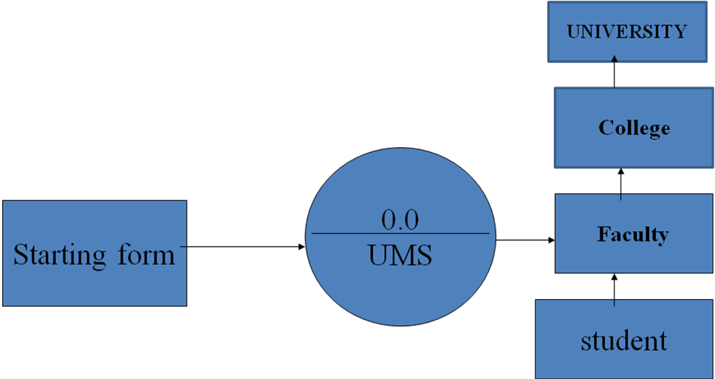

University functionalities
1st Level

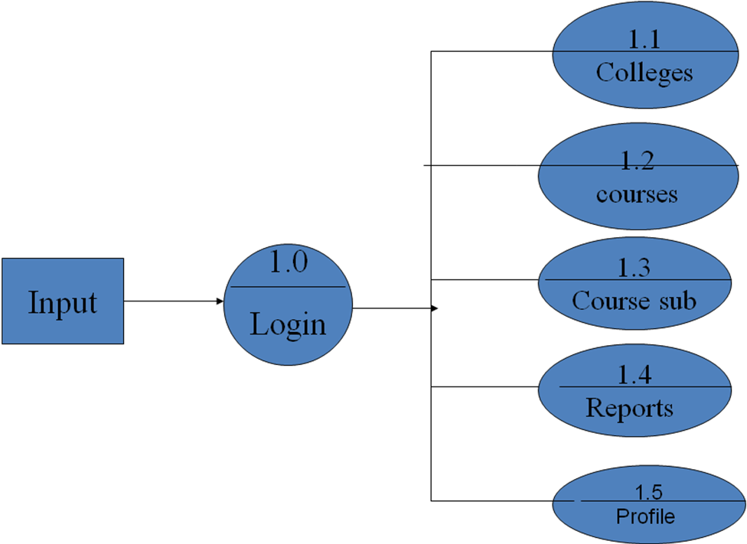

College functionalities
2ndlevel
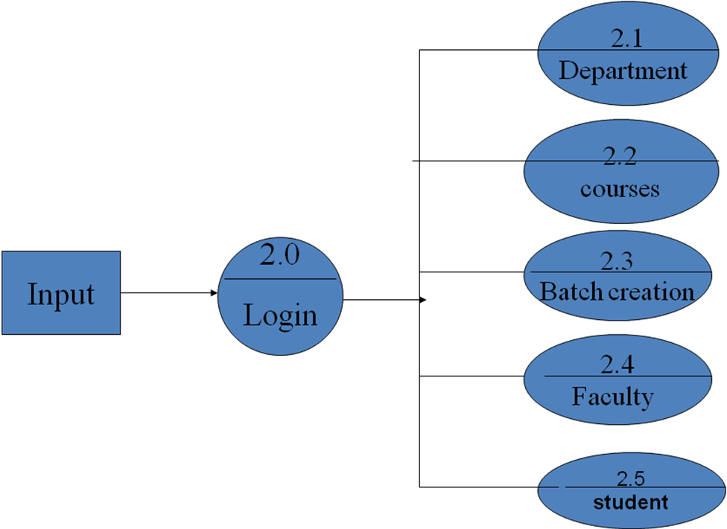

Staff functionalities
3rdlevel

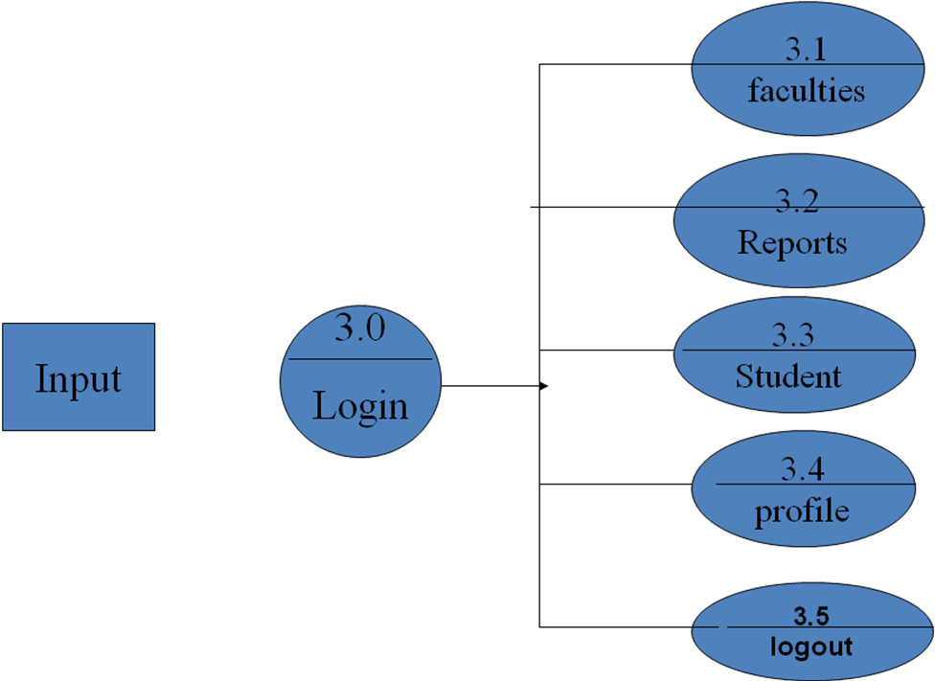

Student functionalities
4thlevel
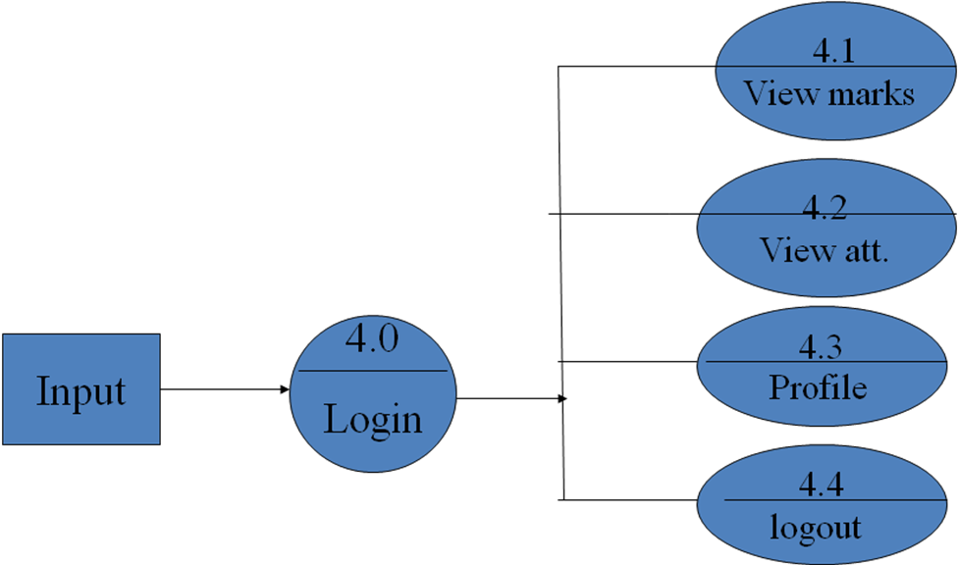

E-R DAIGRAMS

  - The relation upon the system is structure through a conceptual ER-Diagram, which not only specifics the existential entities but also the standard relations through which the system exists and the cardinalities that are necessary for the system state to continue.
  - The entity Relationship Diagram (ERD) depicts the relationship between the data objects. The ERD is the notation that is used to conduct the date modeling activity the attributes of each data object noted is the ERD can be described resign a data object descriptions.
  - The set of primary components that are identified by the ERD are
  - Data object
  - Relationships
  - Attributes
  - Various types of indicators.
The primary purpose of the ERD is to represent data objects and their relationships

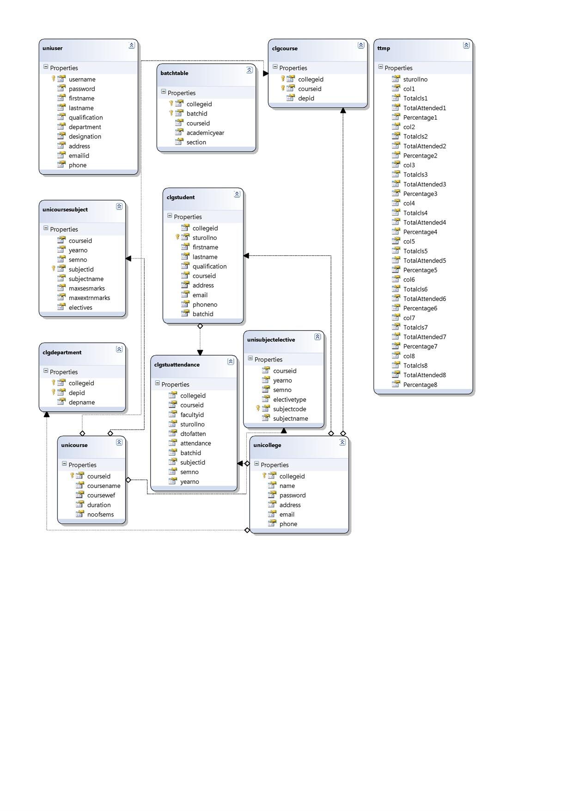

TESTING
Software testing is a critical element of software quality assurance and represents the ultimate review of specification, design and coding. In fact, testing is the one step in the software engineering process that could be viewed as destructive rather than constructive.
A strategy for software testing integrates software test case design methods into a well-planned series of steps that result in the successful construction of software. Testing is the set of activities that can be planned in advance and conducted systematically. The underlying motivation of program testing is to affirm software quality with methods that can economically and effectively apply to both strategic to both large and small-scale systems
STRATEGIC APPROACH TO SOFTWARE TESTING

The software engineering process can be viewed as a spiral. Initially system engineering defines the role of software and leads to software requirement analysis where the information domain, functions, behavior, performance, constraints and validation criteria for software are established. Moving inward along the spiral, we come to design and finally to coding. To develop computer software we spiral in along streamlines that decrease the level of abstraction on each turn.

A strategy for software testing may also be viewed in the context of the spiral. Unit testing begins at the vertex of the spiral and concentrates on each unit of the software as implemented in source code. Testing progress by moving outward along the spiral to integration testing, where the focus is on the design and the construction of the software architecture. Talking another turn on outward on the spiral we encounter validation testing where requirements established as part of software requirements analysis are validated against the software that has been constructed. Finally we arrive at system testing, where the software and other system elements are tested as a whole.

UNIT TESTING

MODULE TESTING

SUB-SYSTEM TESING

SYSTEM TESTING

ACCEPTANCE TESTING
Component Testing
Integration Testing
User Testing

UNIT TESTING

Unit testing focuses verification effort on the smallest unit of software design, the module. The unit testing we have is white box oriented and some modules the steps are conducted in parallel.

1. WHITE BOX TESTING

This type of testing ensures that
- All independent paths have been exercised at least once
- All logical decisions have been exercised on their true and false sides
- All loops are executed at their boundaries and within their operational bounds
- All internal data structures have been exercised to assure their validity.
To follow the concept of white box testing we have tested each form .we have created independently to verify that Data flow is correct, All conditions are exercised to check their validity, All loops are executed on their boundaries.

2. BASIC PATH TESTING
Established technique of flow graph with Cyclomatic complexity was used to derive test cases for all the functions. The main steps in deriving test cases were:
Use the design of the code and draw correspondent flow graph.
Determine the Cyclomatic complexity of resultant flow graph, using formula:
V(G)=E-N+2 or
V(G)=P+1 or
V(G)=Number Of Regions
Where V(G) is Cyclomatic complexity,
E is the number of edges,
N is the number of flow graph nodes,
P is the number of predicate nodes.
Determine the basis of set of linearly independent paths.

3. CONDITIONAL TESTING

In this part of the testing each of the conditions were tested to both true and false aspects. And all the resulting paths were tested. So that each path that may be generate on particular condition is traced to uncover any possible errors.

4. DATA FLOW TESTING

This type of testing selects the path of the program according to the location of definition and use of variables. This kind of testing was used only when some local variable were declared. The definition-use chain method was used in this type of testing. These were particularly useful in nested statements.

5. LOOP TESTING

In this type of testing all the loops are tested to all the limits possible. The following exercise was adopted for all loops:
All the loops were tested at their limits, just above them and just below them.
All the loops were skipped at least once.
For nested loops test the inner most loop first and then work outwards.
For concatenated loops the values of dependent loops were set with the help of connected loop.
Unstructured loops were resolved into nested loops or concatenated loops and tested as above.
Each unit has been separately tested by the development team itself and all the input have been validated.

TEST CASES
SNO | TEST CASE ID | DESCRIPTION | EXPECTED VALUE | OBSERVED VALUE | RESULT
1 | TC1 | PASSWORD NOT  GIVEN IN ADMINISTRATION  LOGIN FORM | “INVALID USERID AND PASSWORD DISPLAYED” | SAME AS EXPECTED VALUE | SUCCESS
2 | TC2 | PASSWORD  NOT GIVEEN IN COLLEGE  LOGIN FORM | “INVALID USERID AND PASSWORD IS DISPLAYED” | SAME AS EXPECTED VALUE | SUCCESS
3 | TC3 | PASSWORD IS NOT GIVEN IN STAFF LOGIN FORM | “INVALID  USERID/PASSWORD”  MESSAGE DISPLAYED | SAME AS EXPECTED VALUE | SUCCESS
4 | TC4 | PASSWORD IS NOT GIVEN IN STUDENT LOGIN FORM | “INVALID  USERID/PASSWORD”  MESSAGE DISPLAYED | SAME AS EXPECTED VALUE | SUCCESS

Test case screen1
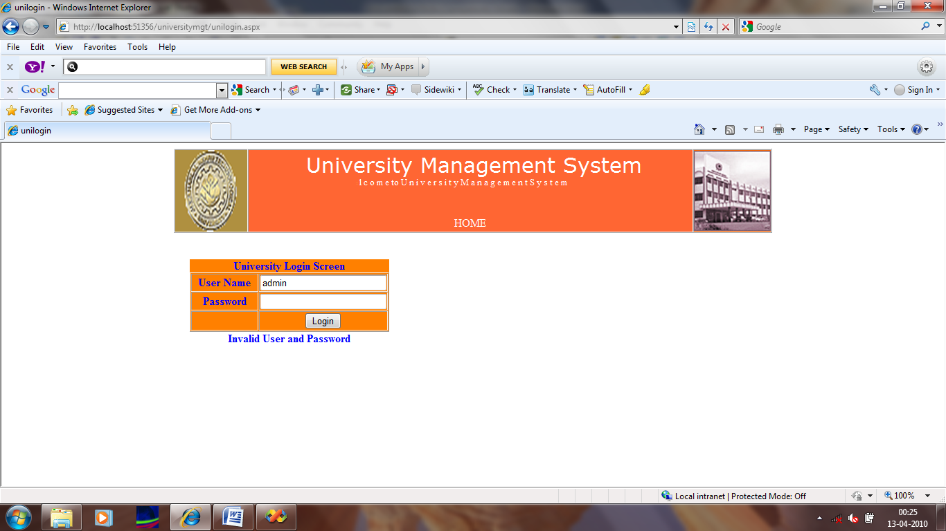

Test case screen 2
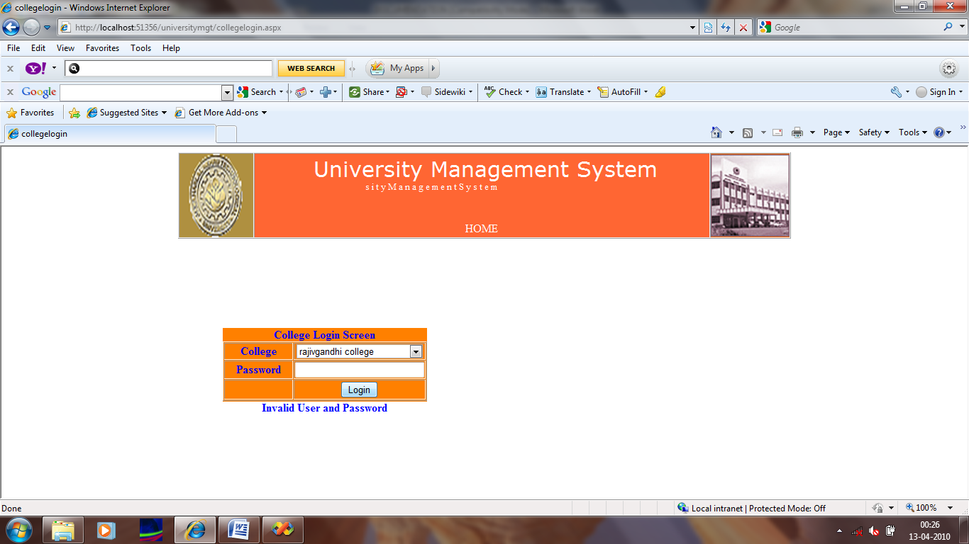

Test case screen3
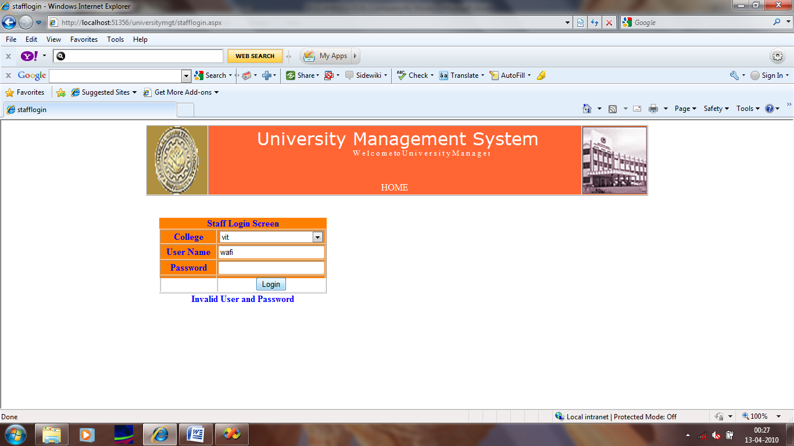

Test case screen4
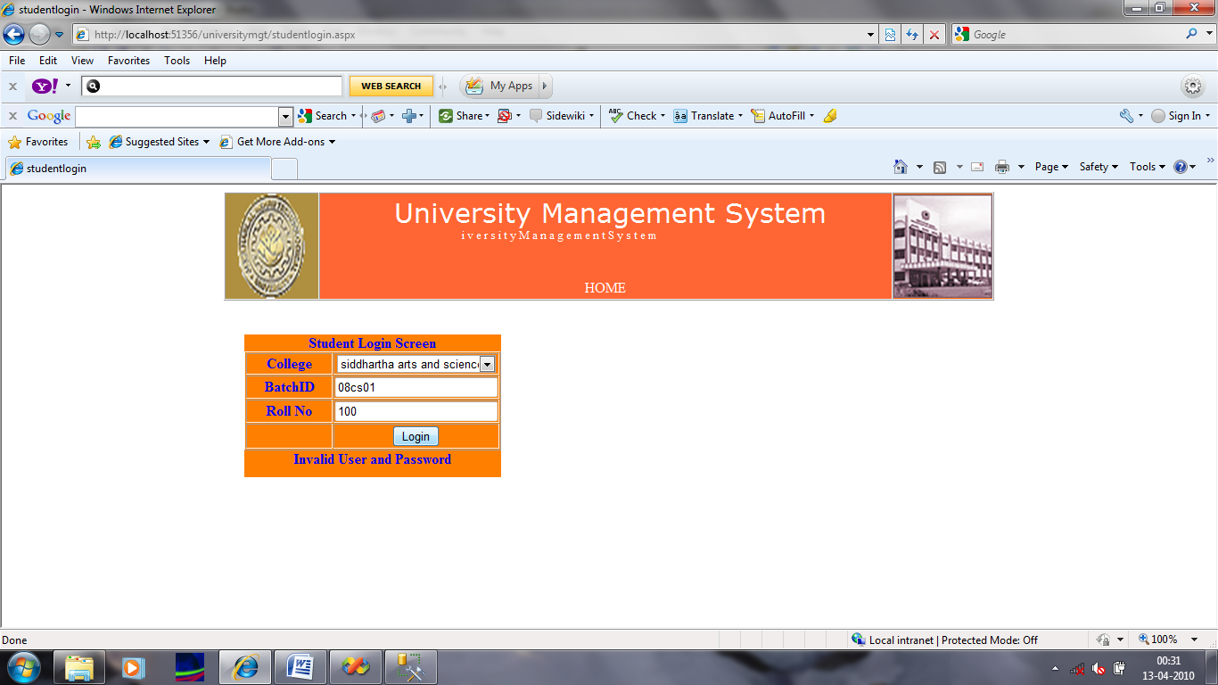

SECURITY IN SOFTWARE
System security refers to various validations on data in form of checks and controls to avoid the system from failing. It is always important to ensure that only valid data is entered and only valid operations are performed on the system. The system employees two types of checks and controls:
CLIENT SIDE VALIDATION
Various client side validations are used to ensure on the client side that only valid data is entered. Client side validation saves server time and load to handle invalid data. Some checks imposed are:
- VBScript in used to ensure those required fields are filled with suitable data only. Maximum lengths of the fields of the forms are appropriately defined.
- Forms cannot be submitted without filling up the mandatory data so that manual mistakes of submitting empty fields that are mandatory can be sorted out at the client side to save the server time and load.
- Tab-indexes are set according to the need and taking into account the ease of user while working with the system.
SERVER SIDE VALIDATION
Some checks cannot be applied at client side. Server side checks are necessary to save the system from failing and intimating the user that some invalid operation has been performed or the performed operation is restricted. Some of the server side checks imposed is:
- Server side constraint has been imposed to check for the validity of primary key and foreign key. A primary key value cannot be duplicated. Any attempt to duplicate the primary value results into a message intimating the user about those values through the forms using foreign key can be updated only of the existing foreign key values.
- User is intimating through appropriate messages about the successful operations or exceptions occurring at server side.
- Various Access Control Mechanisms have been built so that one user may not agitate upon another. Access permissions to various types of users are controlled according to the organizational structure.
- Only permitted users can log on to the system and can have access according to their category. User- name, passwords and permissions are controlled o the server side.
- Using server side validation, constraints on several restricted operations are imposed.

MAINTANACE

Maintenance the last phase in the software engineering process. As programs are developed.

A distributing trend has emerged the amount of effort and a resource expended
on software maintenance is growing. In total project development maintenances
takes 65% of effort .In software maintenance there are four .They are

- Adaptive Maintenance
- Corrective Maintenance
- Perfective Maintenance
- Preventive Maintenance

Adaptive Maintence is applied when changes in the external environment
precipitate modifications to software. I deals with adapting the software to new
environments.
Perfective Maintence incorporates enhancements that are requested by user community. It deals with updating the software according to changes in user requirements
Corrective Maintence acts to correct errors that are uncovered after the software is in use . It deals with fixing bugs in the code
Preventive Maintence improves future maintainability and reliability and provides a basis for future enhancement.It deals with updating documentation and making the software more maintainable .Tasks performed during the software engineering process define maintainability and have an important impact in the success of any maintenance approach .Reverse Engnieering and Reengineering are the tools and techniques used to maintain the project.
There are four major problems that can slow down the maintence process
- Unstructured code
- Maintence programmers having insufficient knowledge of the System
- Documentation being absent
- Out of Date , or at best insufficient
The success of the maintence phase relies on these problems being earlier in the life cycle

CONCLUSION
It has been a great pleasure for me to work on this exciting and challenging project. This project proved good for me as it provided practical knowledge of not only programming in ASP.NET and C#.Net web based application and no some extent Windows Application and SQL Server, but also about all handling procedure related with “TMPROVED STUDENT PORTAL”. It also provides knowledge about the latest technology used in developing web enabled application and client server technology that will be great demand in future. This will provide better opportunities and guidance in future in developing projects independently.

BENEFITS:
The project is identified by the merits of the system offered to the user. The merits of this project are as follows: -
- It’s a web-enabled project.

- This project offers user to enter the data through simple and interactive forms. This is very helpful for the client to enter the desired information through so much simplicity.

- The user is mainly more concerned about the validity of the data, whatever he is entering. There are checks on every stages of any new creation, data entry or updation so that the user cannot enter the invalid data, which can create problems at later date.

- Sometimes the user finds in the later stages of using project that he needs to update some of the information that he entered earlier. There are options for him by which he can update the records. Moreover there is restriction for his that he cannot change the primary data field. This keeps the validity of the data to longer extent.

- User is provided the option of monitoring the records he entered earlier. He can see the desired records with the variety of options provided by him.

- From every part of the project the user is provided with the links through framing so that he can go from one option of the project to other as per the requirement. This is bound to be simple and very friendly as per the user is concerned. That is, we can sat that the project is user friendly which is one of the primary concerns of any good project.
- Data storage and retrieval will become faster and easier to maintain because data is stored in a systematic manner and in a single database.

- Decision making process would be greatly enhanced because of faster processing of information since data collection from information available on computer takes much less time then manual system.

- Allocating of sample results becomes much faster because at a time the user can see the records of last years.

- Easier and faster data transfer through latest technology associated with the computer and communication.

- Through these features it will increase the efficiency, accuracy and transparency

LIMITATIONS:

- The size of the database increases day-by-day, increasing the load on the database back up and data maintenance activity.
- Training for simple computer operations is necessary for the users working on the system.

FUTURE IMPROVEMENT

- It can be implemented to upload files with an huge amount of size with the support of various file formats.

- This System being web-based and an undertaking of Cyber Security Division, needs to be thoroughly tested to find out any security gaps.

- A console for the data centre may be made available to allow the personnel to monitor on the sites which were cleared for hosting during a particular period.

- Moreover, it is just a beginning; further the system may be utilized in various other types of auditing operation viz. Network auditing or similar process/workflow based applications...

BIBLIOGRAPHY

FOR .NET INSTALLATION
www.support.mircosoft.com
FOR DEPLOYMENT AND PACKING ON SERVER
www.developer.com
www.15seconds.com

- FOR SQL
www.msdn.microsoft.com
- FOR ASP.NET
Asp.Net 3.5 Unleashed

www.msdn.microsoft.com/net/quickstart/aspplus/default.com
www.asp.net
www.fmexpense.com/quickstart/aspplus/default.com
www.asptoday.com
www.aspfree.com
www.4guysfromrolla.com/index.aspx

The following books were referred during the analysis and execution phase of the project
Sql the compleate reference
By Sql Press
Software engineering
By Roger.S.Pressman
Professional asp.net
By Wrox msdn By Microsoft

