Flight Management System

CLASS DIAGRAM (Scheduled-Flight Module)

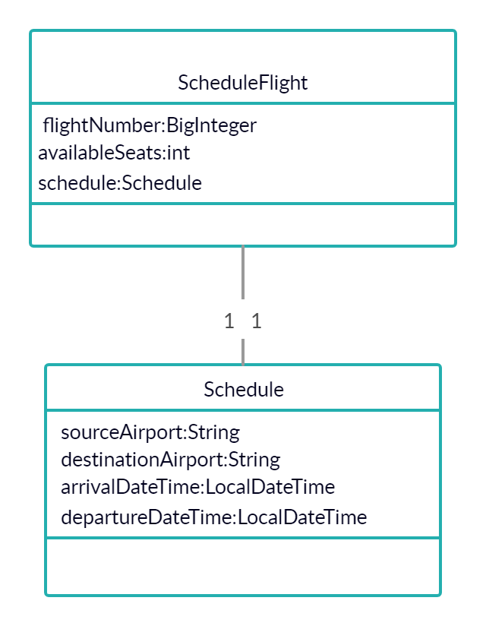

SEQUENCE DIAGRAM (Scheduled-Flight Module)

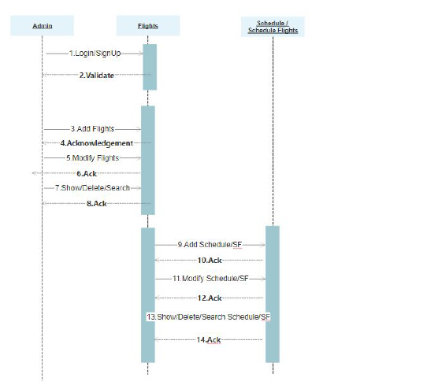

USE CASE DIAGRAM (Scheduled-Flight Module)

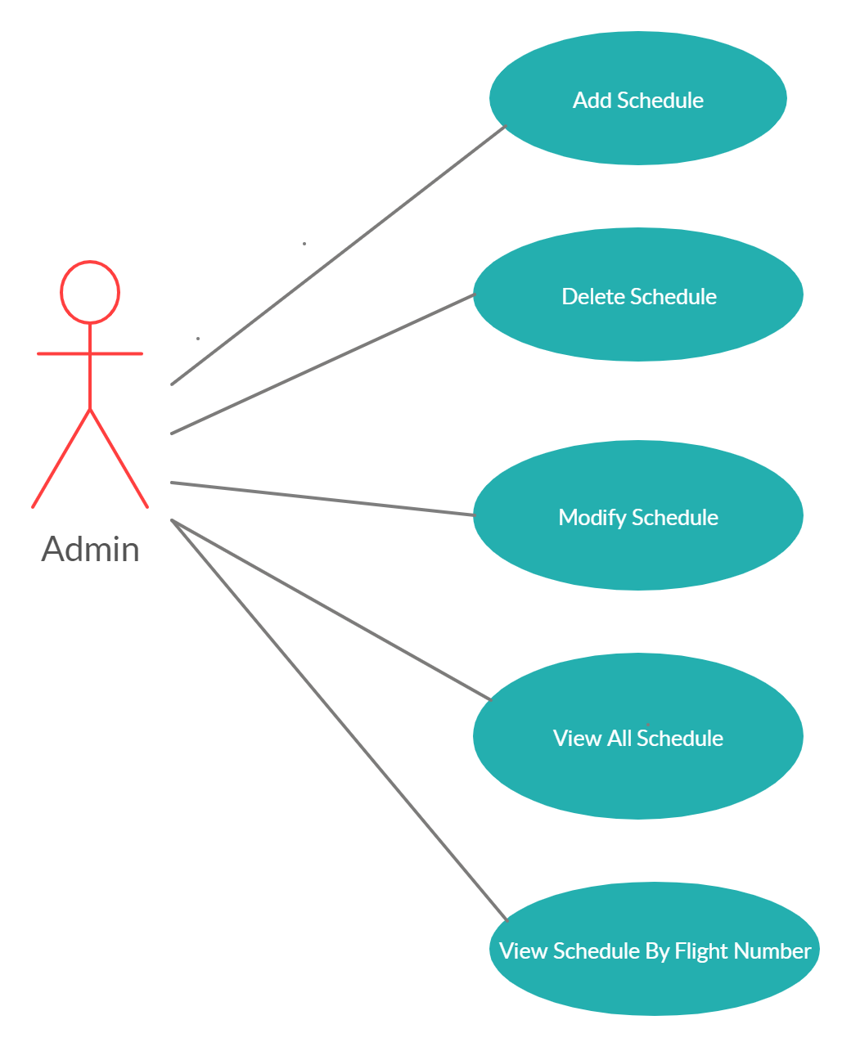

ER DIAGRAM (Scheduled-Flight Module)

