INDIAN INSTITUTE OF INFORMATION TECHNOLOGY, ALLAHABAD
(Deemed University)
(A centre of excellence in IT, established by Ministry of HRD, Govt. of India)

DBMS Lab

Project no: 27 Prof. O.P. Vyas
Title of the project
Railway reservation system

Abstract of the project

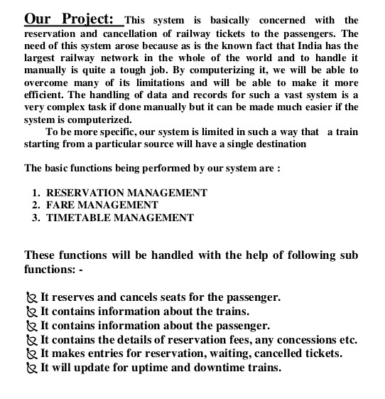

Specific Technology can be used

Oracle, Java, Swing, JDBC for Oracle Connectivity.

Project Tasks

Draw ER Diagram, Schema of each table required in Project, Normalize all table up to 3NF, Implementation Task, User Interface.

Submission

The complete project submission should contain the following:
- Design ER diagram of your project.
- All the source code necessary to compile and execute your test code.
- Can be extend Android or Web Application
(associated TA:)

