Contents

STUDENT DASHBOARD: 2

My Courses 2

? – Floating on all screens in LMS 2

My Bio-data 2

My Progress Report 3

Video Play screen 3

Test Screen 4

HR DASHBOARD 4

My Shortlisted candidates 4

My Company Profile 4

* Deliver curated content to Train, Test, consult & Track students.
  1. Videos
  2. PPTs,
  3. Pdfs
  4. Web-ex
  5. Communication channel with instructor.
  6. Access to Live testing environment (RDP to server, create own AMI)
* Testing : MCQs, Webex
* Track: Track student progress, performance, and, Tests, and Time spent on courses, Quizzes and Videos. .

# STUDENT DASHBOARD:

The login home page of LMS is called as Dashboard. This dashboard will show all the various links and menu that a student or HR will be using.

## My Courses

1. Courses that are assigned to students will be displayed here.
   1. % completed display on course box.
   2. Show courses in sequence (playlist) and unlock only when he is eligible.
   3. Descriptions about topics.
2. Display Videos within courses on topics. Two level course design.
3. Ask to request another video.
4. Link to (LMS)– so that students can start their learning.
5. Progress – show this in main screen bottom bar.
6. Feedbacks
7. One of the final courses will be “labs” (a pdf with instructions to access the server/live environment)

## ? – Floating on all screens in LMS

1. **Outward communication via direct email and notification** (next webex schedule, answers to questions, events etc) **inward & Communication** by pop ups emails to ask questions**.**
2. **Communication channel:** Payment Status – email current status and paid banking details, mode of payment, invoice etc.

## FAQs -

This page is like a blog page on technical interview questions and about courses. This section will show frequently asked questions about the subjects and courses. Eg: Eligibility criteria to get lab access.

## Knowledge Base –

**Interview Questions & Answers, courses, Technical Questions, Best practice pdfs, key notes, reference links**

## My Bio-data

1. **Candidate’s profile** – Ask him to complete the profile after login. This detailed info from profile will be used to make resume. We will create resume automatically based on student’s info that has been entered in profile to display to HR’s. Track student profile completion and display on his dashboard, ex: student profile 22% completed.....
2. **My Resume** – this link show user default resume in word format.
3. **Standard reports for students**
   1. List of courses (career path) that he is enrolled.
   2. List of courses he has completed.
   3. Report card generation.
   4. My Tests and results

## My Progress Report (graphical representation of average scores)

1. Show upcoming tests
2. Pending tests (%)
3. Completed test
   1. If passed then show (%)
   2. Failed - Retake test
   3. Time spent on courses, Quizzes and Videos.

## Video Play screen

1. Video Screen Play- Continue course from where you left off… across mobile/web (25% of entire screen)

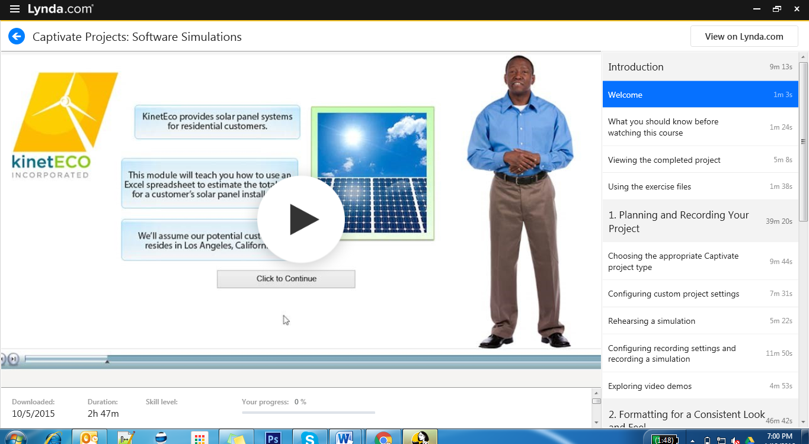

1. Show total duration of the module and duration of each topic/ video in sequence
2. Video screen should play video on itgyani.com page.
3. Course dashboard/ previous lecture/ Next lecture
4. Download video
5. Play button with speed control. Students should fast forward the playlist video to help them do a revision.

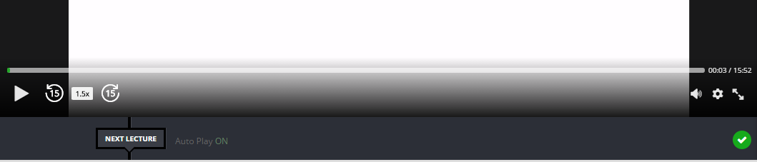

1. Slide collapsible: show playlist videos and duration with status of watched /not watched/% watched. See example as Udemy screen.
2. Video description/ Objective: It can be collapsible to show the video description, reference videos links on same topic. On completion of the course, what will student achieve? A description message area.
3. Pre-requisites: You should have: basic knowledge of the Windows operating system and some familiarity with database access techniques.
4. Topics: List of Topics for this module that student is into.
5. Reference – List reference videos and docs.

## Test Screen

1. Center of the screen displays one question and multiple choice answers displayed below.
2. Once test is submitted, user get to see the result on screen and this is captured in database to show in student’s profile.
3. For wrong answers show the right one before going to next question. Do not count marks for that.
4. Calculate and display results in last screen

# HR DASHBOARD

1. Apply filters /sort to find candidates –
   1. Option to select multiple skill sets and sex, minimum qualification required.
   2. When HR wants to see all candidates, “remove filters” button.
   3. After filter show basic info of candidate in display on top view in results like job profile, age, education, current location, progress. **Hide contact details of students.**
   4. After HR click on student show detail profile of candidate and a “shortlist” button.
2. Show graduates with qualification
3. My Shortlisted candidates
4. List of candidates.
5. Schedule interview: when HR clicks on this a request comes to Administrator.
6. “?” to talk to the systems (ask for skill sets/help/ suggestions/feedback/ call center will handle)

## My Company Profile

1. Edit Profile, designation, contact #, landline, office hours, email, and desired skill sets

# ADMIN DASH BOARD

## Manage Courses

1. Create/Edit/assign courses/ Link to test/

## Manage Test

## Manage Email

1. Reminder/ follow ups / referral programs marketing / reports/ Test scores / replies to questions

## Manage Accounts

## Manage Students

1. Courses assigned w status/ Scores/ Bio (Graduation year/ etc)

## Manage Corporate

## Manage Users

1. Student/HR/Instructor/Counselor/Placement officer/

## Analytics

* 1. Tests being retaken often’
  2. Individual performance
  3. engagement on Modules
  4. Time spent on courses, Quizzes and Videos.
  5. What HRs look for, which skills
  6. Compare students!