Anirudh Kaluri

Date: 8 March 2022

LinkedIn: https://linkedin.com/in/anirudhkaluri

Github: https://github.com/anirudhkaluri

Leet Code: <https://leetcode.com/anirudh_k97>

**PROJECT STRUCTURE DOCUMENTATION**

There are four important directories:

1) models

2) Dao

3) Services

4) Routes

**MODELS/ENTITIES/TABLES**

The models directory consists of 4 Entities with following attributes:

1) Users: #user_id, name, phone, email

2) Credentials: *user_id, password

3) PersonalContacts: *user_id, name, phone, email

4) SpamNumbers: *user_id, phone

**DATA ACCESS**

The Dao directory consists of 4 JS files.

Each file performs different Dao operations on their respective Models/tables.

1) userDao.js – Performs Dao operations on Users table

2) credentialDao.js - Performs Dao operations on Credentials table

3) contactsDao.js – Performs Dao operations on PersonalContacts table

4) spamDao.js – Performs Dao operations on SpamNumbers table

**FUNCTIONALITY**

Functionality categorized under 3 different heads.

They are implemented in Services directory.

1) Profile Functionality (/profileService)

1. Register new User
2. Login existing user
3. Logout
4. Get details of Searched result along with Email from (2a) and (2b)

* Returns above search results
* Will return Email if (i) Searched user registered (ii) Searching user in PersonalContacts of Searched user

2) Search Functionality (/searchService)

1. Search with Name:

* Returns (name, phone, spam likelihood)
* Searches on Users and PersonalContacts

1. Search with Phone Number

* Returns (name, phone, spam likelihood)
* Searches first on User. If not found searches in PersonalContacts

3) Spam Functionality (/spamService)

1. Add Spam Number

**API ENDPOINTS**

|  |  |  |  |  |
| --- | --- | --- | --- | --- |
| Functionality | END POINTS | Request Method | Request Data | Response Data |
| Register New User | /profileService/registerUser | POST | name, phone, password, email (optional) | Text |
| Login | /profileService/loginUser | POST | phone, password | Text, “userid” cookie set on the client |
| Logout | /profileService/logout | GET | - | Text, “userid” cookie cleared |
| Search With Name | /searchService/searchName/:name | GET | Request URL having name in it | JSON. Array of sorted users. |
| Search with Number | /searchService/searchPhone/:phone | GET | Request URL having phone number in it | JSON. Array of users. |
| Get user details with Email | /profileService/getUserDetails | POST | JSON body with Search result | JSON. User details along with Email. |
| Add Spam Numbers | /spamService/addNumber | POST | JSON body with spam_number | Text. |

**ROUTES**

Routes have been categorized based on functionality. (Routes Directory)

1) searchRoutes.js : for search functionality

2) userRoutes.js : for profile functionality

3) spamRoutes.js : for spam functionality

**DATA POPULATION**

Data Directory consists of populateData.js File which is executed when the app launches to populated all tables with data.

**SPAM LIKELIHOOD FORMULA**

When a number (say X) is searched for spam likelihood

1. spamHits=Number of times X marked as spam by Users
2. (spamHits/Spam table size) gives the spamming tendency relative to other spam numbers. It is scored out of 100.
3. (spamHits/Number of Users registered) gives the spamming popularity among registered users . It is scored out of 100.
4. Total scored out of 200.

**SCALABILITY/FUTURE REQUIREMENTS**

1. Spam Numbers stored along with userid of person who stores it so that users can check if they already marked a number as spam.
2. UserId used as Primary and Foreign Key instead of Phone Numbers despite Phone Numbers being unique so that User can change Phone Number in the future
3. No need to update PersonalContacts table when Phone Number changes
4. No need to update SpamNumbers table when Phone Number changes
5. Passwords stored in separate table instead of Users table because it is used only for authentication (Login and Registration)
6. Login and Logout Functionality implemented to make the project wholesome for testing(not explicitly mentioned in the document)

**SECURITY FEATURES**

1) Services work only if the user is logged in. No unauthorized access.

2) Accessing routes other than API endpoints is restricted.

3) Passwords stored in Hashed format in the database. Any leakage wont give away credentials.

**SOME SCREENSHOTS WITH POSTMAN TOOL**

These requests have been exported into instahyre.postman_collections.json

**CREATE NEW USER**

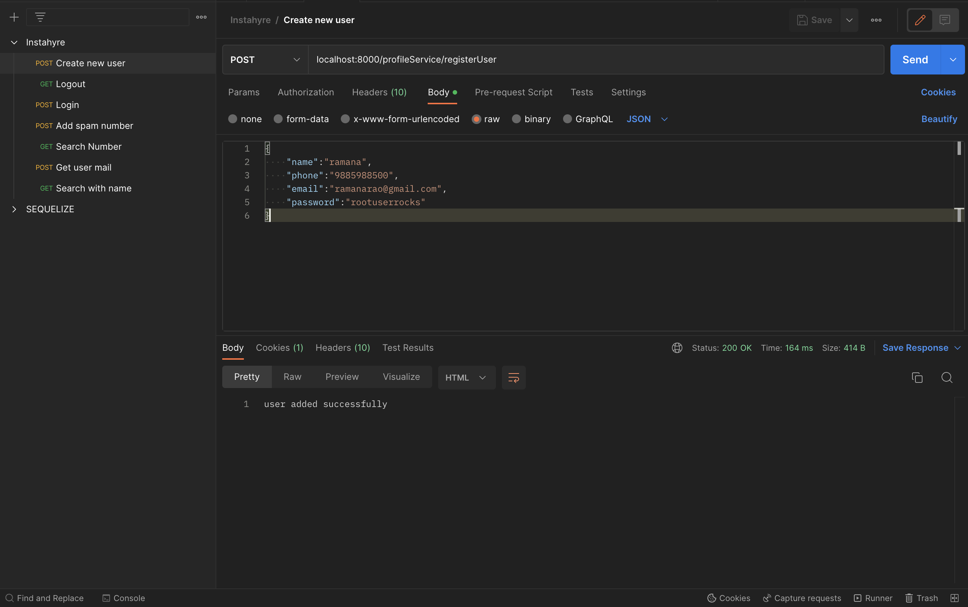

**LOGOUT**

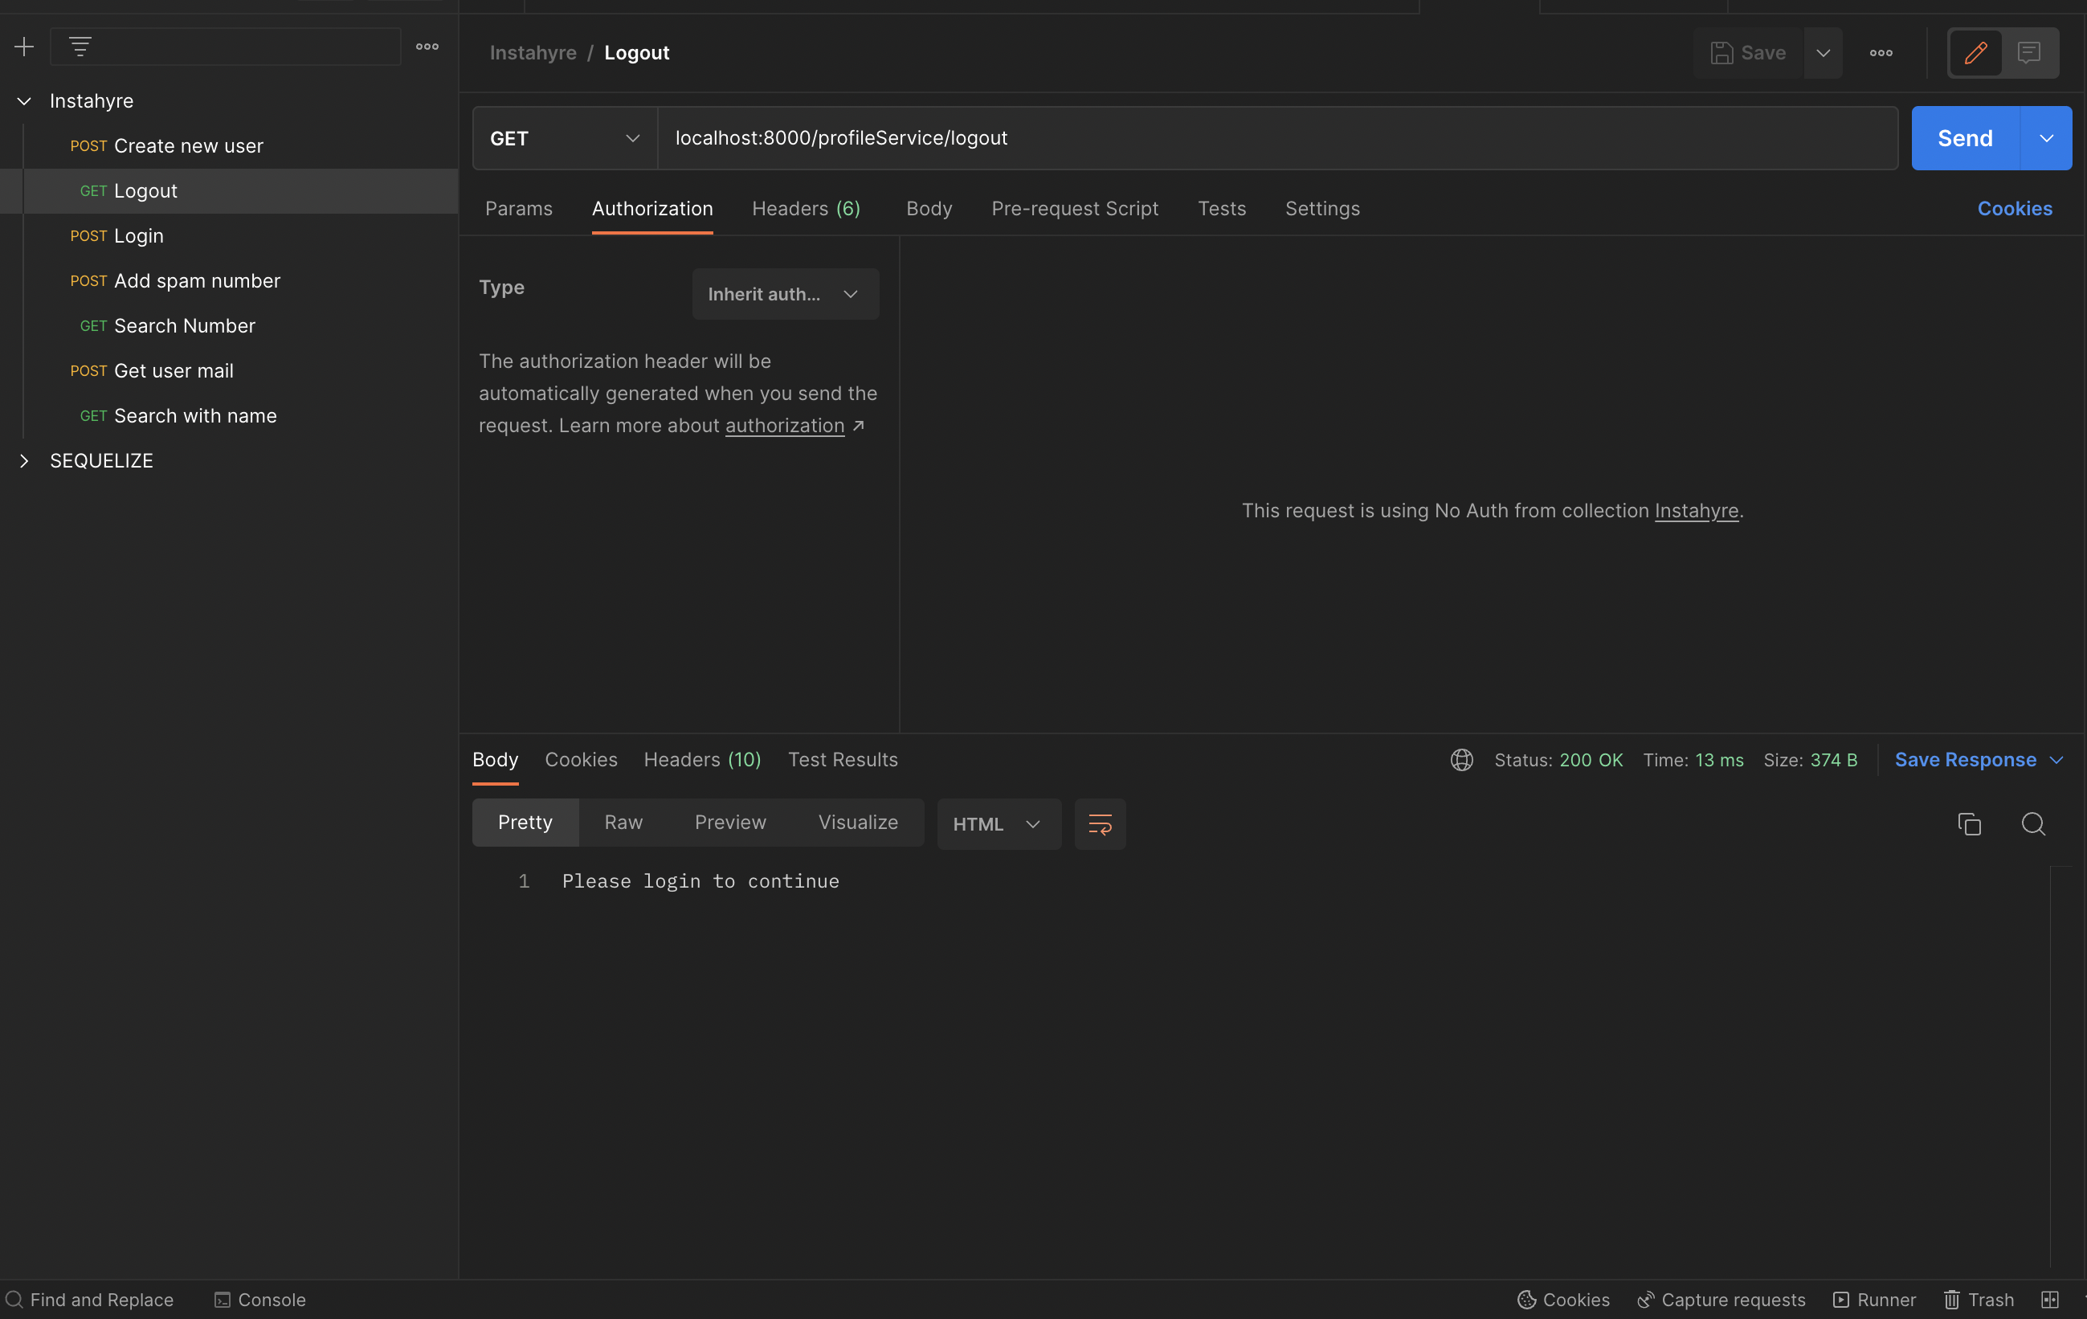

**LOGIN**

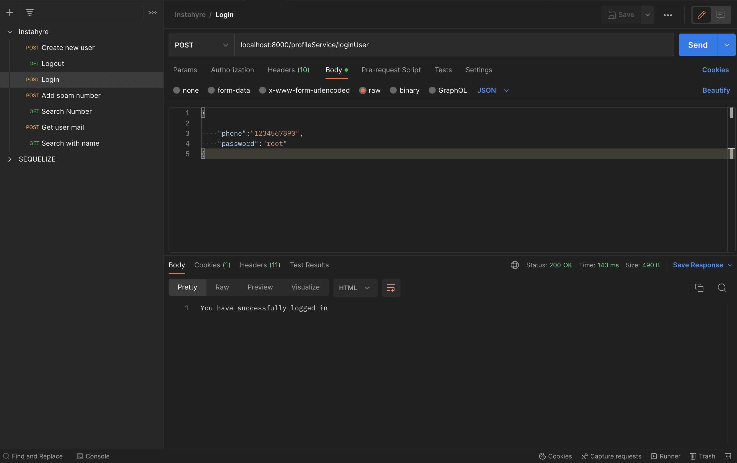

**SEARCH WITH NUMBER**

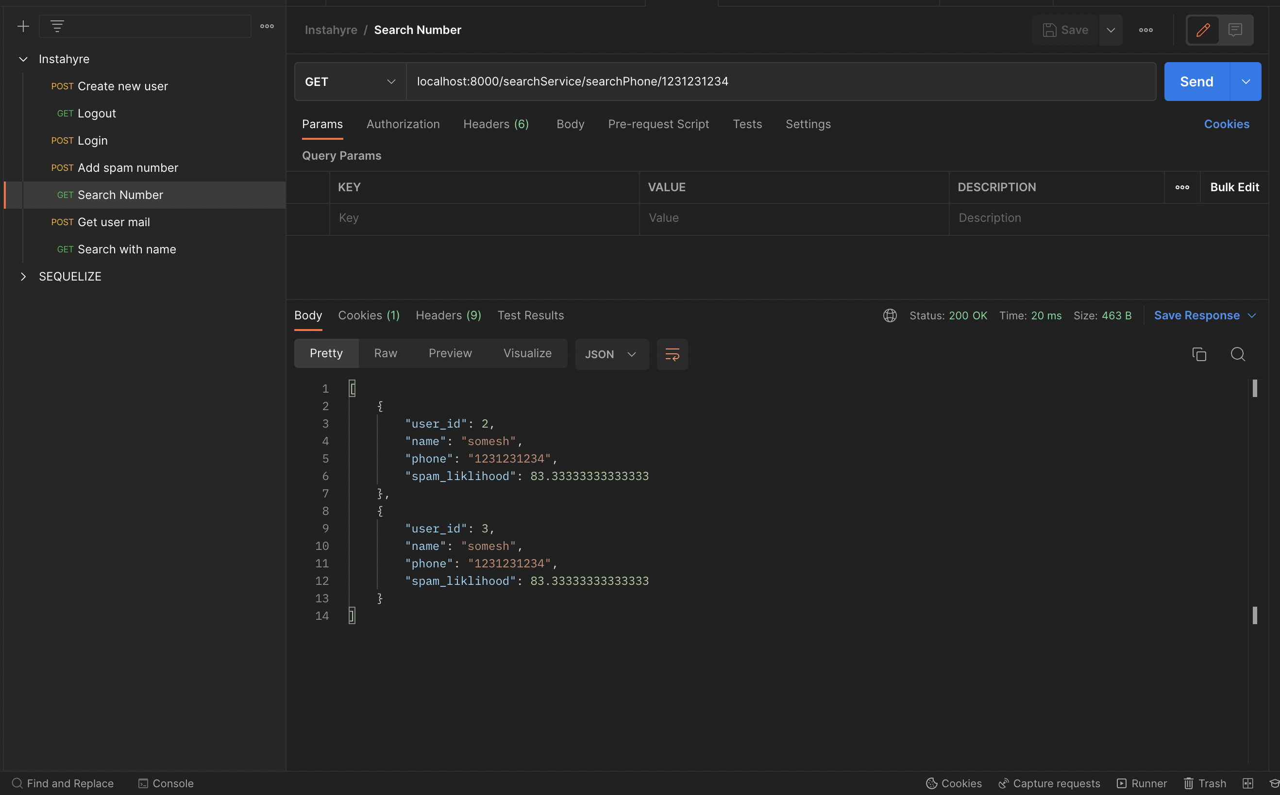

**SEARCH WITH NAME**

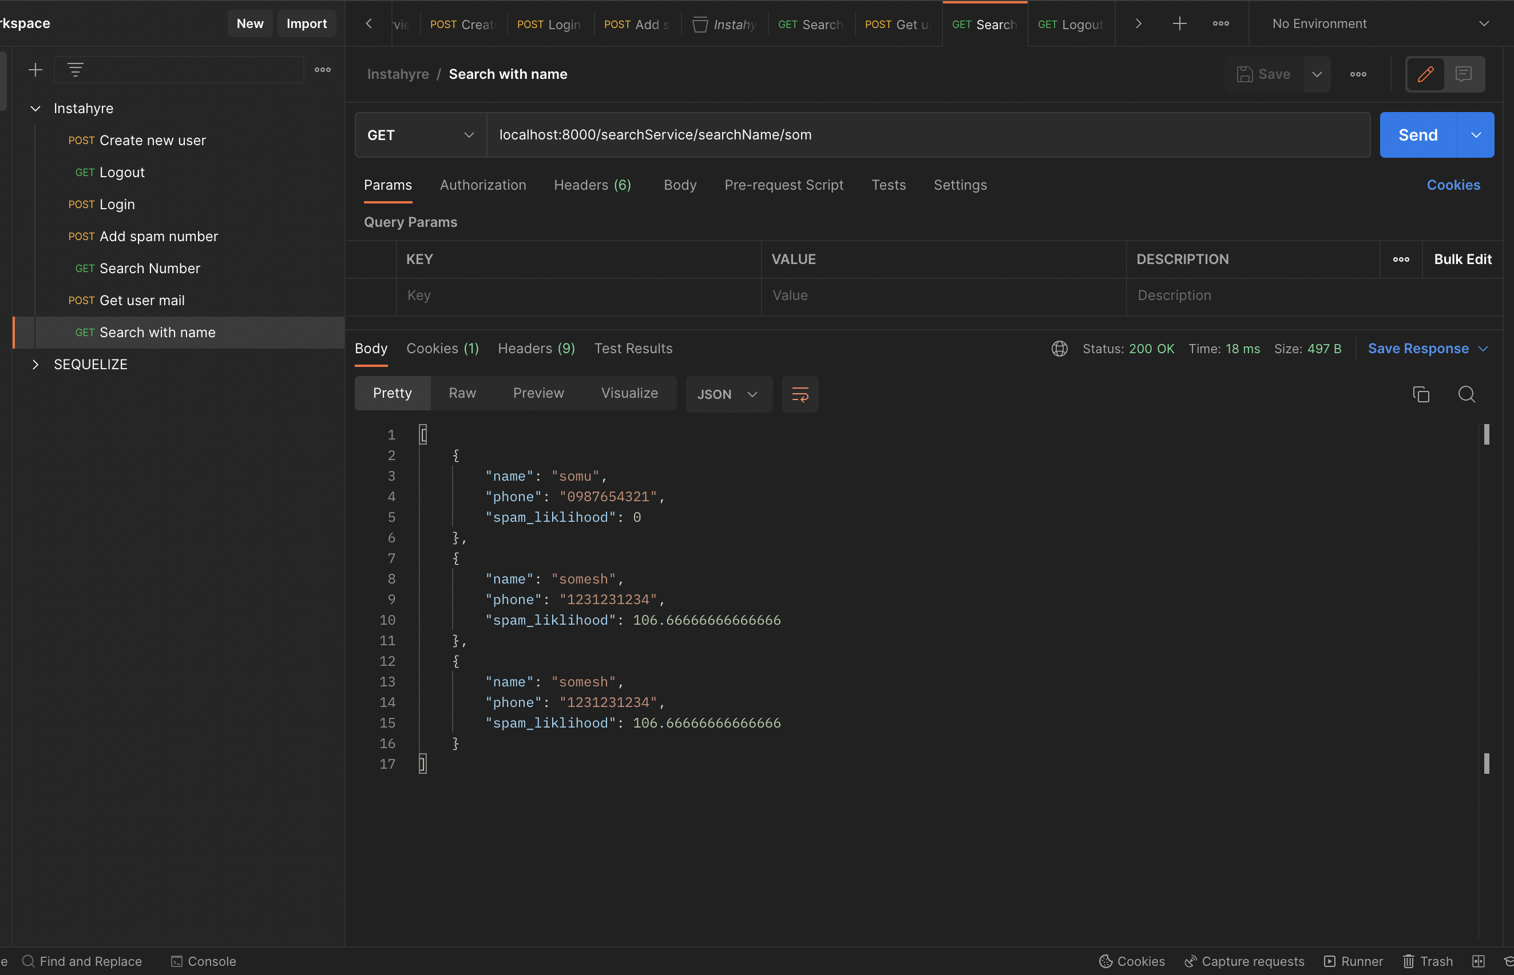

**GET USER DETAILS ALONG WITH MAILS IF POSSIBLE FROM THE SEARCH RESULT**

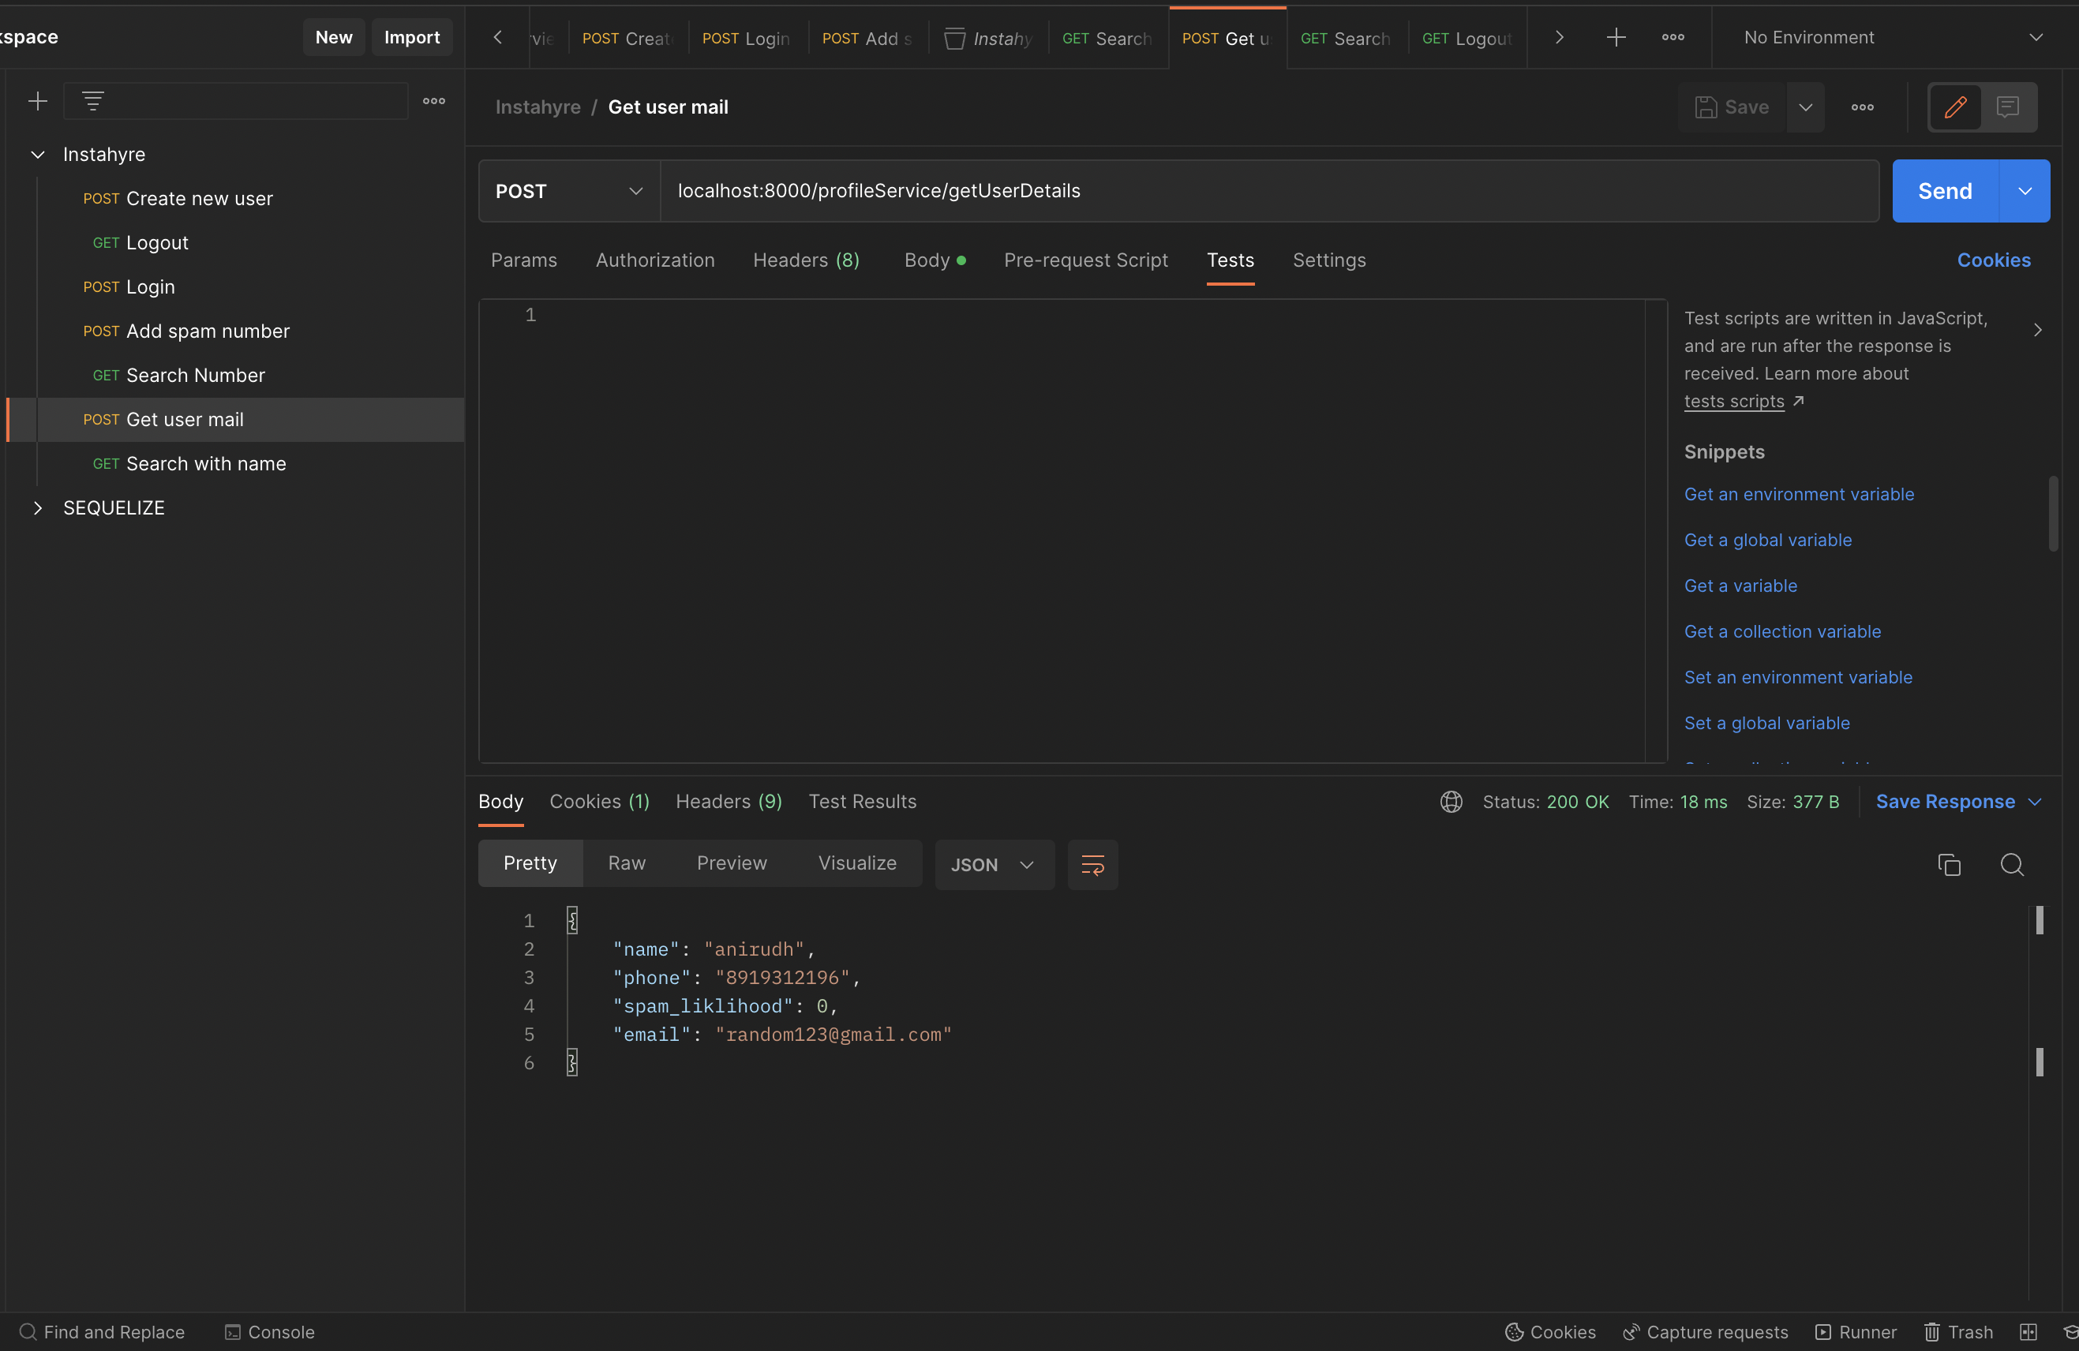

**ADD SPAM NUMBER**

