**SURANA COLLEGE**

DEPARTMENT OF COMPUTER SCIENCE

#16, SOUTH END ROAD BANGALORE



A PROJECT REPORT ON

LIFE SAVER - BLOOD BANK MANAGEMENT SYSTEM

WHICH IS A BONAFIDE WORK OF

UDAY KUMAR N [18KXSB7107]

MAHESH KUMAR M S [18KXSB7046]

Students of Bachelor of Computer Science submitted in partial fulfillment of the requirement of the award of

DEGREE IN B.C.A prescribed by BANGALORE UNIVERSITY 2020-2021

Mrs. VIDYA A Dr. A SRINIVAS

(PROJECT GUIDE) HOD (COMPUTER SCIENCE)

EXAMINER _____________ EXAMINER ______________

**SURANA COLLEGE**

DEPARTMENT OF COMPUTER SCIENCE

#16, SOUTH END ROAD BANGALORE



A PROJECT REPORT ON

LIFE SAVER - BLOOD BANK MANAGEMENT SYSTEM

WHICH IS A BONAFIDE WORK OF

UDAY KUMAR N [18KXSB7107]

MAHESH KUMAR M S [18KXSB7046]

Students of Bachelor of Computer Science submitted in partial fulfillment of the requirement of the completion of

DEGREE IN

BACHELOR OF COMPUTER APPLICATIONS

Under the Guidance of

Mrs. VIDYA. A

(Asst.Prof)

DEPARTMENT OF COMPUTER SCIENCE

INDEX

|  |  |  |
| --- | --- | --- |
| SL.NO | CONTENT | PG.NO |
| 1. | Acknowledgement | 4 |
| 2. | Project synopsis | 5 |
| 3. | Project modules | 7 |
| 4. | SRS document | 8 |
| 5. | Data dictionary | 10 |
| 6. | Data flow diagram | 12 |
| 7. | ER diagram | 15 |
| 8. | Screenshots | 17 |
| 9. | Source code | 26 |
| 10. | Test case | 57 |
| 11. | Conclusion | 58 |
| 12. | Bibliography | 59 |

ACKNOWLEDGEMENT

The development of the project has been quite challenging and is it has been sincere effort to bring this project to its completion. The successful completion of this project wouldn’t have been possible without the continuous support and encouragement of many. We make use of this opportunity to thank all those who helped us in bringing out this project. We would like to express our gratitude to Dr. Srinivas.A for granting us permission to carry out this project work at college. We sincerely thank our guide Mrs. Vidya.A and all teachers for their constant help for our project during the course of this pandemic. Our project wouldn’t have made it this far if not for the online courses and tutorials from which we have learnt so much. We also thank all our friends for their valuable suggestions and encouragement.

UDAYKUMAR N

MAHESH KUMAR M S

**PROJECT SYNOPSIS**

**PROBLEM STATEMENT:**

• Scarcity of rare blood group.

• Unavailability of blood during emergency.

• Less awareness among people about blood donation and blood transfusion.

• Deaths due to lack of blood during operations.

• The Blood Bank Management System project aims to make all the procedures automated and therefore with computer system it can be more fast and accurate.

**OBJECTIVE:**

The main objective of this application is to automate the complete operations of the blood bank. They need maintain hundreds of thousands of records. Also searching should be very faster so they can find required details instantly. The system will provide the user the option to look at the details of the existing Donor List, Blood Group and to add a new Donor. It also allows the user to modify the record. The administrator can alter all the system data. It actively encourage voluntary blood donation, motivate and maintain a well-indexed record of blood donors and educate the community on the benefits of blood donation.

**EXISTING SYSTEM:**

 • The operation of the blood bank still now is maintained in the manual system.

• The operation is tedious, time consuming and space consuming.

• It creates room for errors as the data is entered manually by the persons.

• It includes the risk of the documents being lost over years and maintenance of the records is difficult.

• The data recorded during testing or while acquiring the details of different aspects of blood bank management system is not so accurate and precise.

• Maintaining the stock of blood and the daily transactions without computerization also poses a challenge.

**PROPOSED SYSTEM:**

The proposed system (Blood Bank Management System) is designed to help the Blood Bank administrator to meet the demand of Blood by sending and/or serving the request for Blood as and when required.The proposed system gives the procedural approach of how to bridge the gap between Recipient, Donor, and Blood Banks. This Application will provide a common ground for all the three parties (i.e. Recipient, Donor, and Blood Banks)and will ensure the fulfillment of demand for Blood requested by Recipient and/or Blood Bank.

**FEASIBILITY REPORT:**

A feasibility study is a test of a system proposal according to its work ability impact on organization, ability to meet user needs and effective use of resources. The objective of a feasibility study is not to solve a problem but to acquire a sense of its scope. During the study, the problem definition is crystallized and the aspects of the problem to be included in the system are determined. After the initial investigation of the system that helped to have in-depth study of the existing system, understanding its strength and weaknesses and the requirements for the new proposed system.

**Feasibility study was done in three phases documented below:**

* **Operational feasibility**: Automation makes our life easy. The proposed system is highly user friendly and is much easily able to interact with the system. Therefore the users will readily accept the system as data entry and making queries can be easily done.
* **Economic feasibility**: Economic feasibility is the most frequently used method for evaluating the effectiveness of the candidate system. If benefits outweigh the costs, then the decision is made to design and implement the system. A cost\benefit analysis was done for the proposed system to evaluate whether it would be economically viable
* **Technical feasibility**: Technical feasibility centers on the existing computer system. (Hardware/software) and to what extent it can support the proposed addition also the organization already has sufficient high-end machines to serve the processing requirements of the proposed system. So there is no need to purchase new software as the organization has necessary software i.e. Microsoft SQL Server or hardware to support the proposed system

**MODULES :**

Admin module :

* Manage users( View and Delete the User),
* Complete access to view and alter the user details

User module :

Hospital module :

* Upload donated blood details
* Available blood units
* Update the Profile
* access the blood requests

Receiver module :

* request for blood
* Update the Profile
* Blood request status(Pending or Accepted)

**SYSTEM REQUIREMENT SPECIFICATION:**

**Hardware Requirements:**

Hardware is a set of physical components, which performs the functions of applying appropriate, predefined instructions.

The hardware requirements given here is minimal requirements for the project to run.

* Processor : Intel Pentium processor and above
* Processor Speed : 300 MHz and above
* Ram Size : 4GB or above
* Hard Drive : 32 GB or above
* Input Device : Mouse, Keyboard
* Output Device : Monitor

**Software Requirements:**

The software is a set of procedures of coded information or a program which when fed into the computer hardware enables the computer to perform the various tasks.

* Operating System : Microsoft Windows 10
* Front End : HTML, Bootstrap, PHP
* Bank End : XAMPP- sever,MYSQL
* Client side : CSS(cascading style sheet)

**Overview of Tools/Software:**

**1 XAMPP server:**

XAMPP server is a free and open source cross platform web server solution stack package developed by Apache friends,consisting mainly of the Apache HTTP server, Maria DB database, and interpreters for scripts written in the PHP and Perl programming language, XAMPP stands for that makes it extremely easy for developers to create a local web server for testing and deployment purpose.since most actual web server deployments use the same components as XAMPP, its makes transitioning from a local test server to a live sever extremely easy as well.

**2 HTML:**

HTML stands for Hyper Text Mark-up Language, which is the most widely used language on Web to develop web pages. Hypertext refers to the way in which Web pages (HTML documents) are linked together. Thus, the link available on a web-page is called Hypertext. As its name suggests, HTML is a Mark-up Language which means you use HTML to simply "mark-up" a text document with tags that tell a Web browser how to structure it to display.

**3 Bootstrap:**

Bootstrap is a free and open-source CSS framework directed at responsive, mobile-first front-end web development. It contains CSS and (optionally) JavaScript-based design templates for typography, forms, buttons, navigation, and other interface components. Bootstrap is a HTML, CSS & JS Library that focuses on simplifying the development of informative web pages. The primary purpose of adding it to a web project is to apply Bootstrap's choices of colour, size, font and layout to that project

**4 PHP:**

PHP is a intuitive,sever side scripting language it allows developers to build logic into the creation of web page content and handle data returned from a web browser.php also contains a number of extension that make it easy to interact with databases,extracting data to be displayed on a web page and storing information entered by a web site visitor back into the database.It is also be used for command line scripting and client GUI applications.IT requires MYSQL connection between front end and back end components to write to the database and fetch.

**5 MySQL:**

MySQL is the most popular Open Source Relational SQL Database Management System. MySQL is one of the best RDBMS being used for developing various web-based software applications. The SQL phrase stands for Structure Query Language. MySQL is a fast, easy-to-use RDBMS being used for many small and big businesses. MySQL is developed, marketed and supported by MySQL AB, which is a Swedish company.

1. **Purpose**

This blood bank system project document completely describes what the system should do without describing how the software will do it. The basic goal of requirement phase is to produce the SRS, which describes the complete external behaviour of the system.

1. **Scope**

The project has a wide scope, as it is not intended to a particular organization. This project is going to develop generic software, which can be applied by any business’ organization. Moreover, it provides facility to its users. Also, the software is going to provide a huge amount of summary data.

1. **Developer’s Responsibility**

The developer is responsible for:

1. Developing the system.
2. Installing the software on the client’s hardware.
3. Making interface between  receivers and donors (I.e hospitals).
4. Maintaining the system for a period of two years after installation.

**Product Description**

**Blood Bank Management System** (BBMS) is a web based system that can assists the information of blood  during its handling in the **blood bank**. In this project receivers can request blood from donors and donors can donate blood to the required users. In this project three major modules that have been provided are receivers module, donors module and admin module.

**Goals**

* The proposed system is more efficient, fast, reliable, user friendly.
* Login of the Receivers and Donors using username and password there by provides security to the software.
* Receivers and Donors can create his accounts easily by filling up details in the registration page.
* The Receiver can request for blood by searching required blood group.
* The Donors (hospitals) can add blood group and donate to the requested receivers.
* The system also gives the brief detail about the donors and receivers which are in this blood bank.
* The system also provides logout system facility.
* Manage large number of Receivers and donors details with ease.

**Objective of App store Management**

* The main objective of the system is to donate and receive blood.
* It will Reduced manual work as most of the work done by computer.
* It helps Receivers to find required blood group by searching option.

The main objective of the system is to provide a secure system. Our system is password protected and it only allows authorized users (receivers and donors) to access various functions available in the system.

**Usage Scenario**

The E-notes Point project provides usage scenario for the software. It has organized information collected during requirements elicitation into use-cases.

1. User Profiles

There will be three levels of users:

* Admin level
* Receiver level
* Donor level

1. Use Cases

* Admin level

The admin can view, update and delete the data of Receivers and Donors.

* Receiver level

The Receiver can request for blood from donor and also cancel the request.

* Donor level

The donor can donate blood to receiver by approving and can cancel by rejecting.

Data objects and description:

During the requirement analysis phase, the development team examines the system. After examining all the process and feasibility, the following points were considered while designing the database:

* It should store the registered information of both receivers and donors.
* It should store the received and donated blood group.

Functional Requirements

* Edit profile
* Add blood group
* remove blood group
* Request for blood
* Cancel requested blood
* Manage users
* Manage blood groups
* Admin

Non-Functional Requirements

Usability

The user interface of the system will be user friendly so it will be easy for the user to use the system.

Reliability

The system would be easy to maintain and able to carry further extensions occurred.

Performance

The system should provide the services in considerable time interval.

Security

The information provided by the user should authenticated which protect the system from external attack and spamming.

**Data Dictionary**

* The database **LIFE SAVER MANAGEMENT** has six tables.

1. **Reciever**
2. **Hospitals**
3. **contact**
4. **Blood request**
5. **Blood info**
6. **Admin**

1)Receiver Register Table

|  |  |  |  |
| --- | --- | --- | --- |
| **COLUMN NAME** | **DATATYPE** | **PRIMARY KEY** | **NOT NULL** |
| id | integer | Yes | Yes |
| rname | Varchar(100) | No | yes |
| remail | Varchar(100) | yes | Yes |
| rpossword | Varchar(100) | No | Yes |
| rphone | Varchar(100) | No | Yes |
| rbg | Varchar(100) | No | Yes |
| rcity | Varchar(100) | No | Yes |

2)Hospitals Register Table

|  |  |  |  |
| --- | --- | --- | --- |
| **COLUMN NAME** | **DATATYPE** | **PRIMARY KEY** | **NOT NULL** |
| id | integer | Yes | Yes |
| hname | Varchar(100) | No | yes |
| hemail | Varchar(100) | yes | Yes |
| hpossword | Varchar(100) | No | Yes |
| hphone | Varchar(100) | No | Yes |
| hcity | Varchar(100) | No | Yes |

3)Contact Table

|  |  |  |  |
| --- | --- | --- | --- |
| **COLUMN NAME** | **DATATYPE** | **PRIMARY KEY** | **NOT NULL** |
| id | integer | Yes | Yes |
| name | Varchar(100) | No | yes |
| email | Varchar(100) | yes | Yes |
| message | Varchar(100) | No | Yes |

4)bloodrequest Table

|  |  |  |  |
| --- | --- | --- | --- |
| **COLUMN NAME** | **DATATYPE** | **PRIMARY KEY** | **NOT NULL** |
| reqid | integer | Yes | Yes |
| hid | integer | yes | yes |
| rid | integer | No | Yes |
| bg | Varchar(100) | No | Yes |
| status | Varchar(100) | No | Yes |

5)bloodinfo Table

|  |  |  |  |
| --- | --- | --- | --- |
| **COLUMN NAME** | **DATATYPE** | **PRIMARY KEY** | **NOT NULL** |
| bid | integer | Yes | Yes |
| hid | integer | yes | yes |
| bg | Varchar(100) | No | Yes |

6)Admin Table

|  |  |  |  |
| --- | --- | --- | --- |
| **COLUMN NAME** | **DATATYPE** | **PRIMARY KEY** | **NOT NULL** |
| id | integer | Yes | Yes |
| Name | Varchar(100) | No | yes |
| password | Varchar(100) | No | Yes |

Data Flow Diagram (DFD)

A data flow diagram (DFD) is a graphical representation of the “flow” of data through and information system. A data flow diagram can be used for visualization of data processing. It is a common practice for designer to draw context level DFD first which was the interaction between the system and outside entities. This context level DFD yes then exploded to show more details of the system being modeled.

A DFD represents flow of data through a system. Data flow diagrams are commonly used in urine problem analysis. It views a system as a function that transforms the input into desired output. A DFD shows moment of data through the different transformations or processes in the system.

Data flow diagrams can be used to provide the end user with a physical idea of where the data they input ultimately has an effect upon the structure of the whole system from order to dispatch to restock any system is developed can be determined through a data flow diagram. The appropriate register saved in database and maintained by appropriate authorities.

Data flow diagram notation

Function

database

input/output

flow

Level 0 DFD

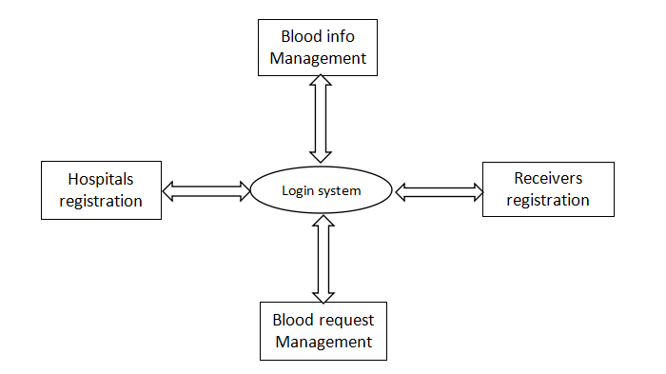

LEVEL 1 DFD

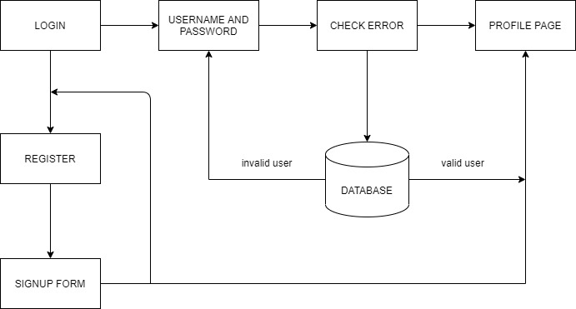

Entity relationship diagram (ER-diagram)

Entity relationship diagram is a specialized graphic that illustrates the interrelationship between entities in a database. ER diagrams often use symbols to represent 3 different types of information. Boxes are commonly used to represent entities. Diamonds are normally used to represent relationships and ovals are used to represent attributes.

An entity relationship model in software engineering is an abstract and conceptual representation of data. Entity relationship modelling is a relation schema database modelling method, used to produce a type of conceptual schema or semantic data model of a system, often a relational database, and its requirements in a top-down fashion.

Symbols used in this E-R diagram:

Entity: Entity is a “thing” in the real world with an independent existence. An entity may be an object with a physical existence such as person, car or employee. Entity symbol is as follows

Attribute: Attribute is a particular property that describes the entity. Attribute symbol is

Relationship: Relationship will be several implicit relationships among various entity types whenever an attribute of one entity refers to another entity type some relationship exits. Relationship symbol is

ER diagram:

**RESULTS**

**Screeshots**

**Home page :**

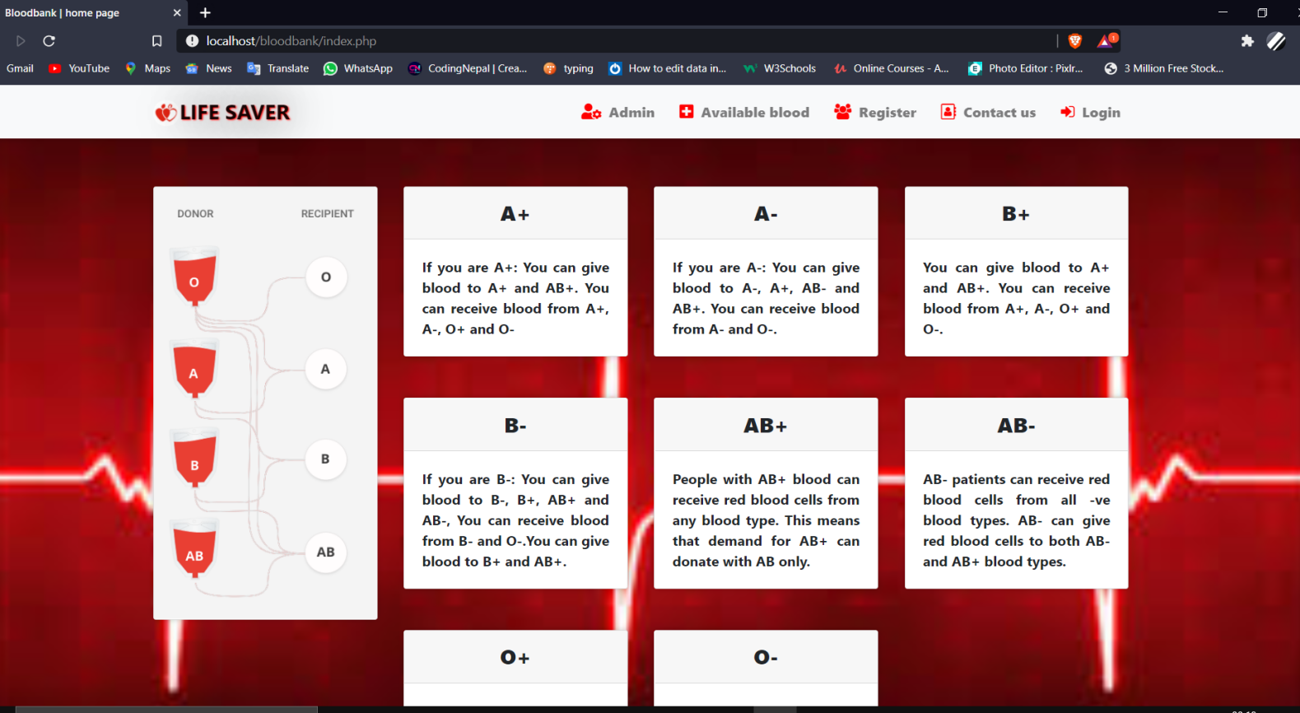

**Receiver and hospitals login :**

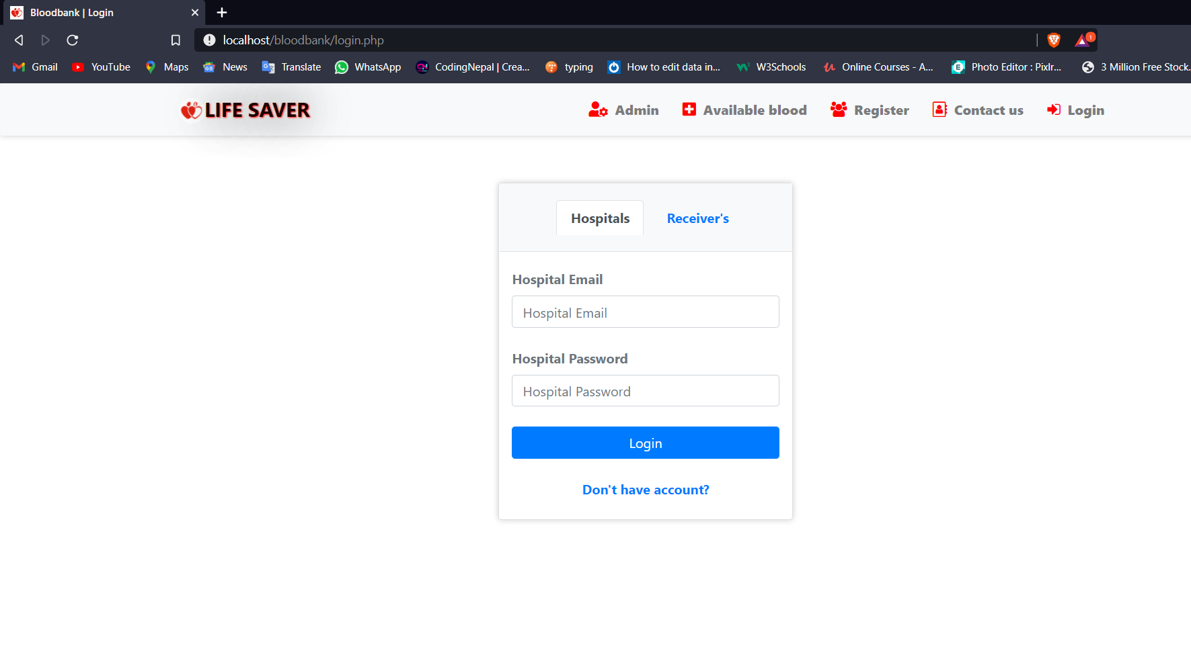

**Register page :**

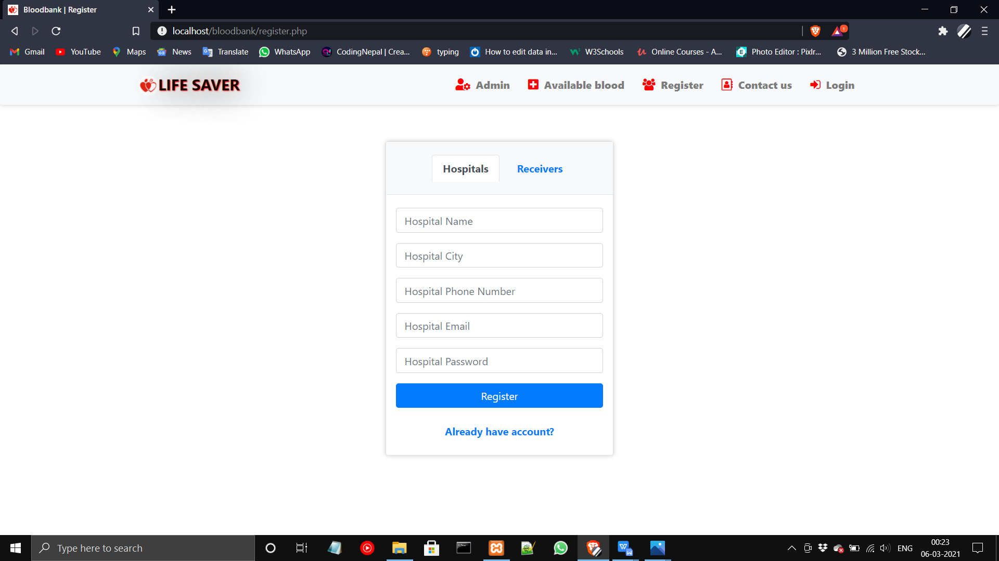

**bloodreq page :**

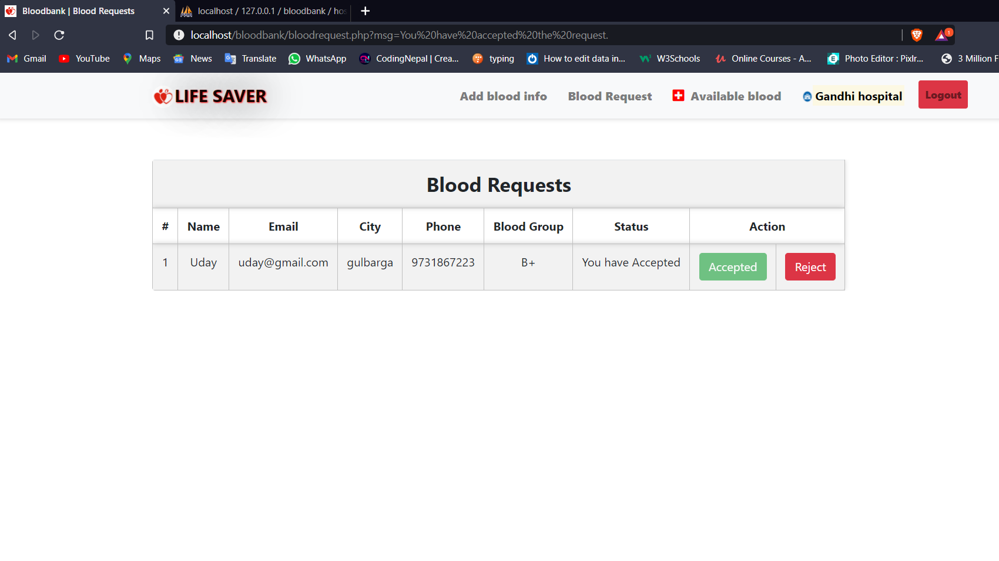

**Add blood page :**

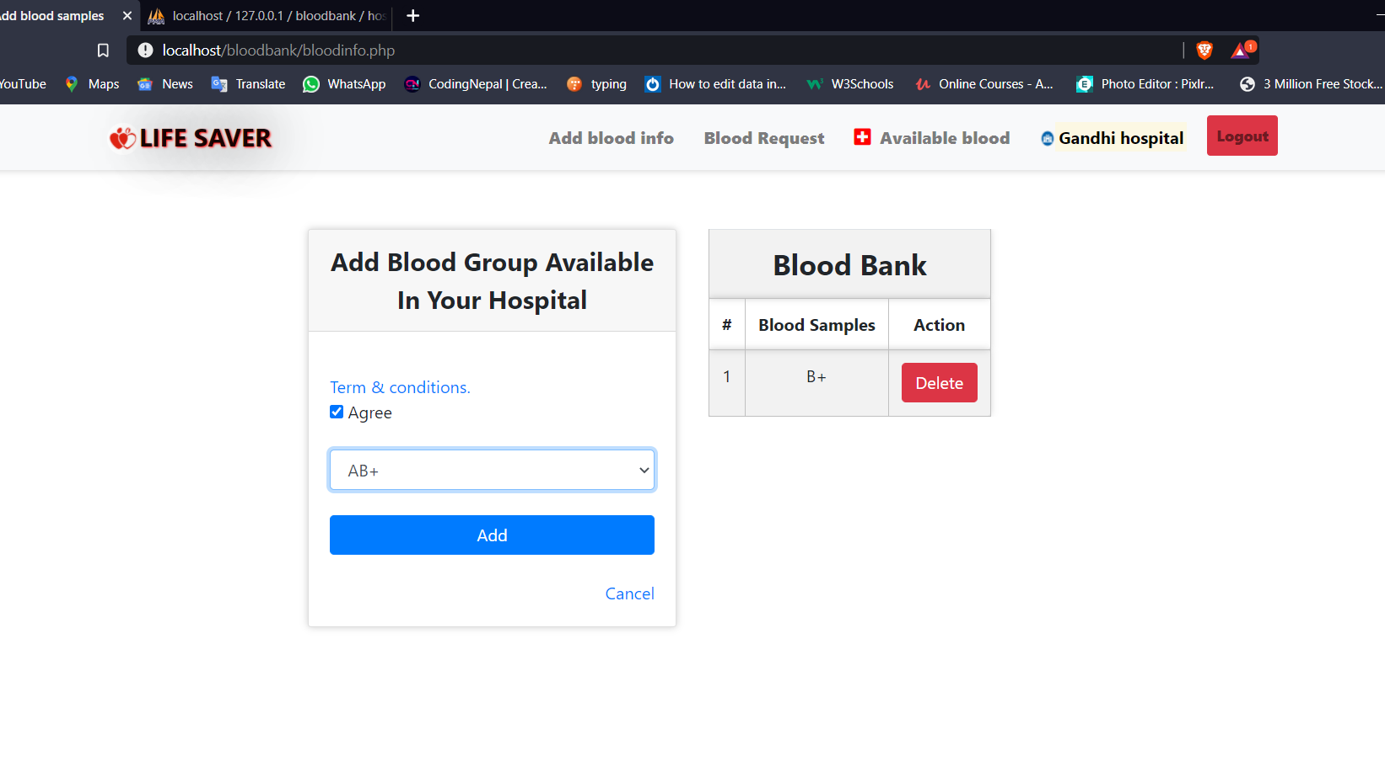

**Available blood page :**

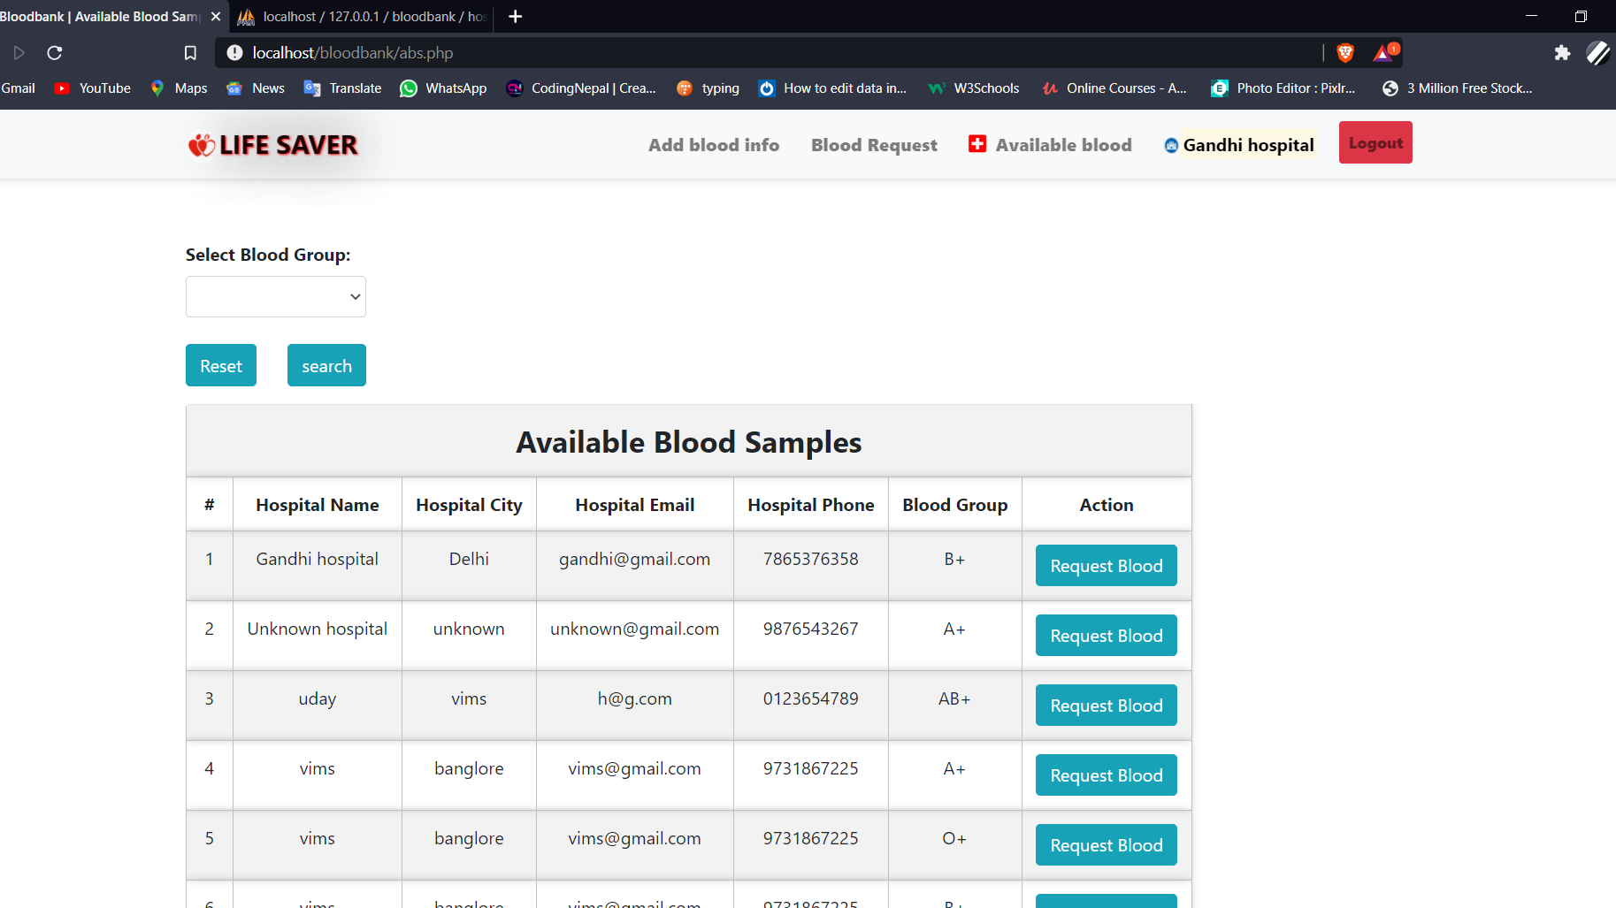

**Send req blood page :**

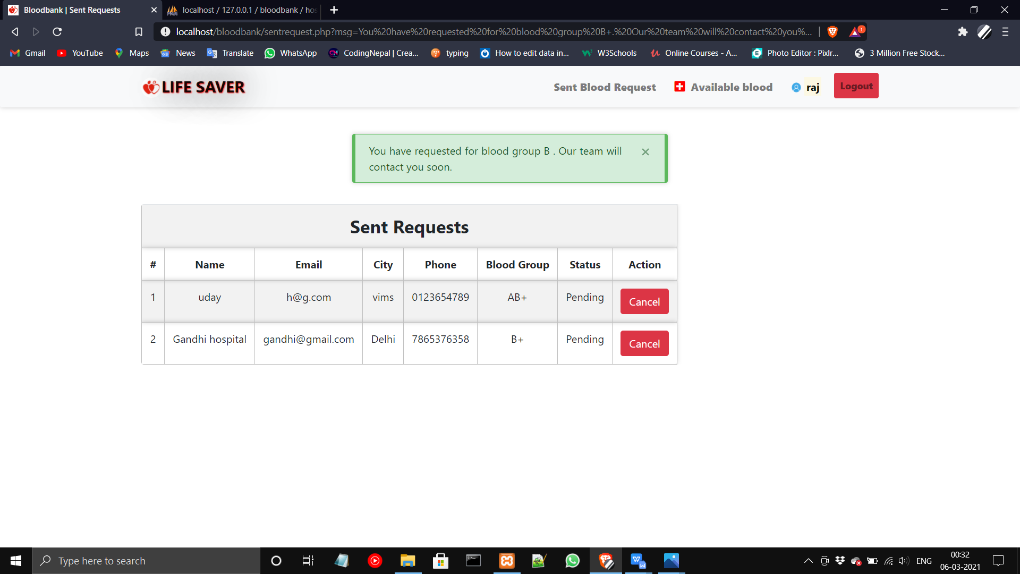

**Contact us page :**

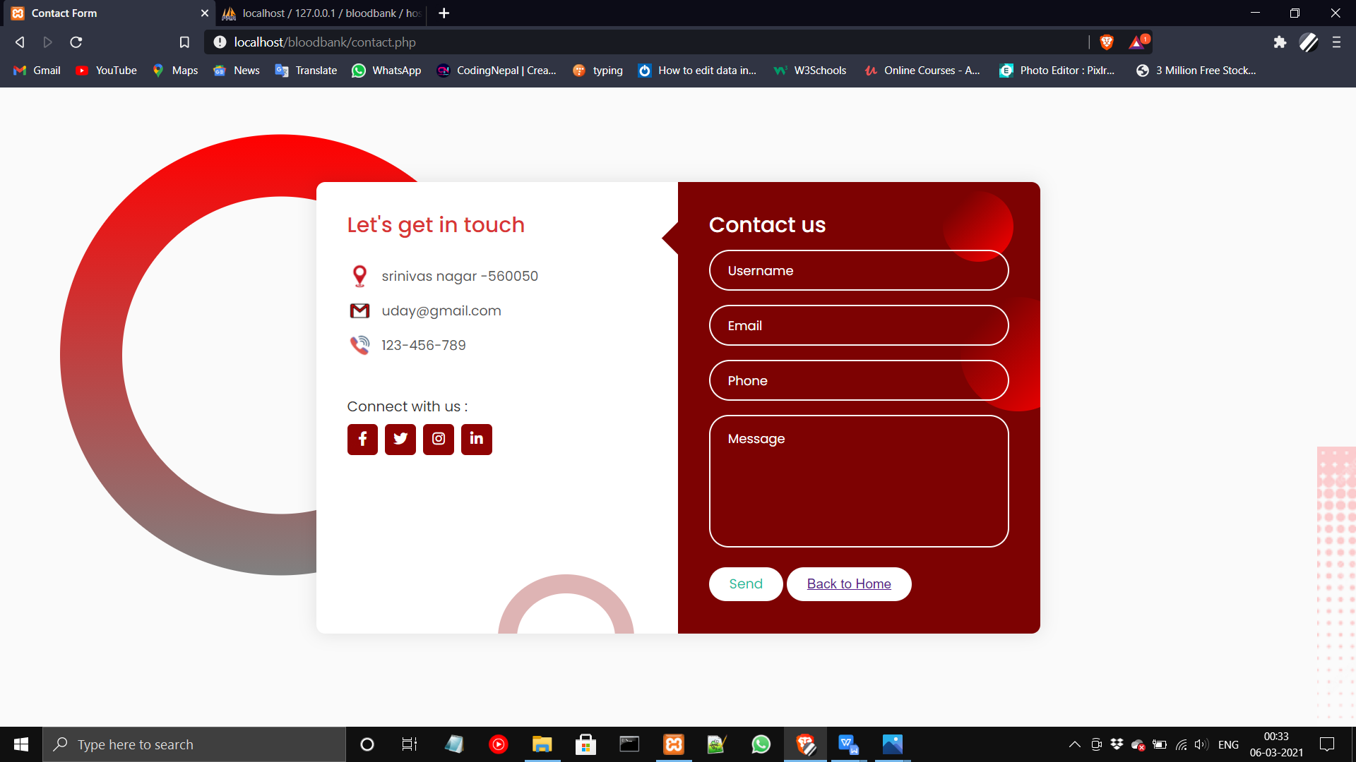

**Hospitals profile page :**

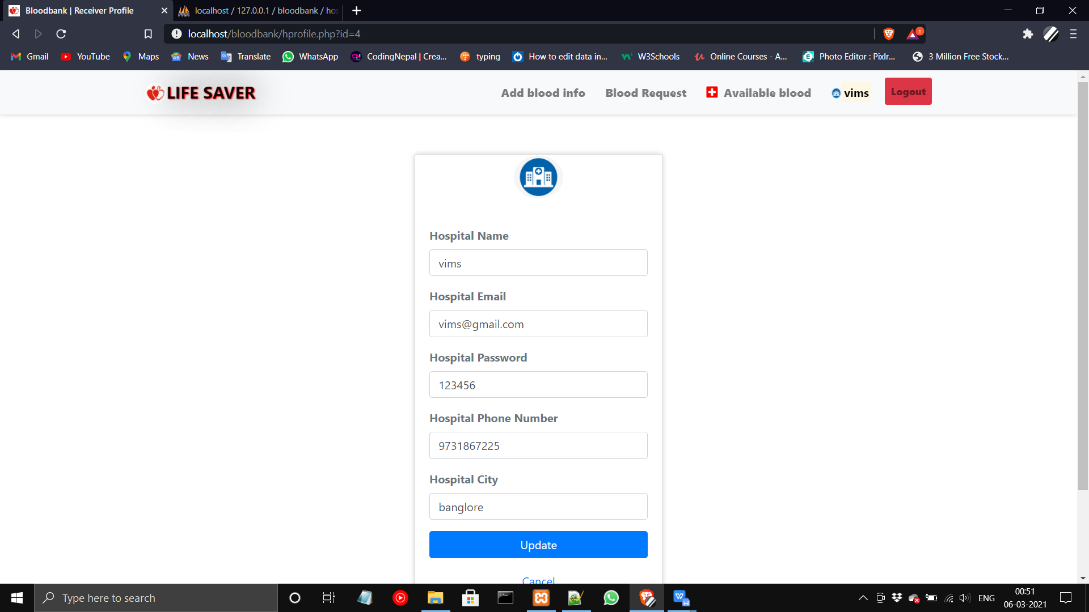

**Receivers profile page :**

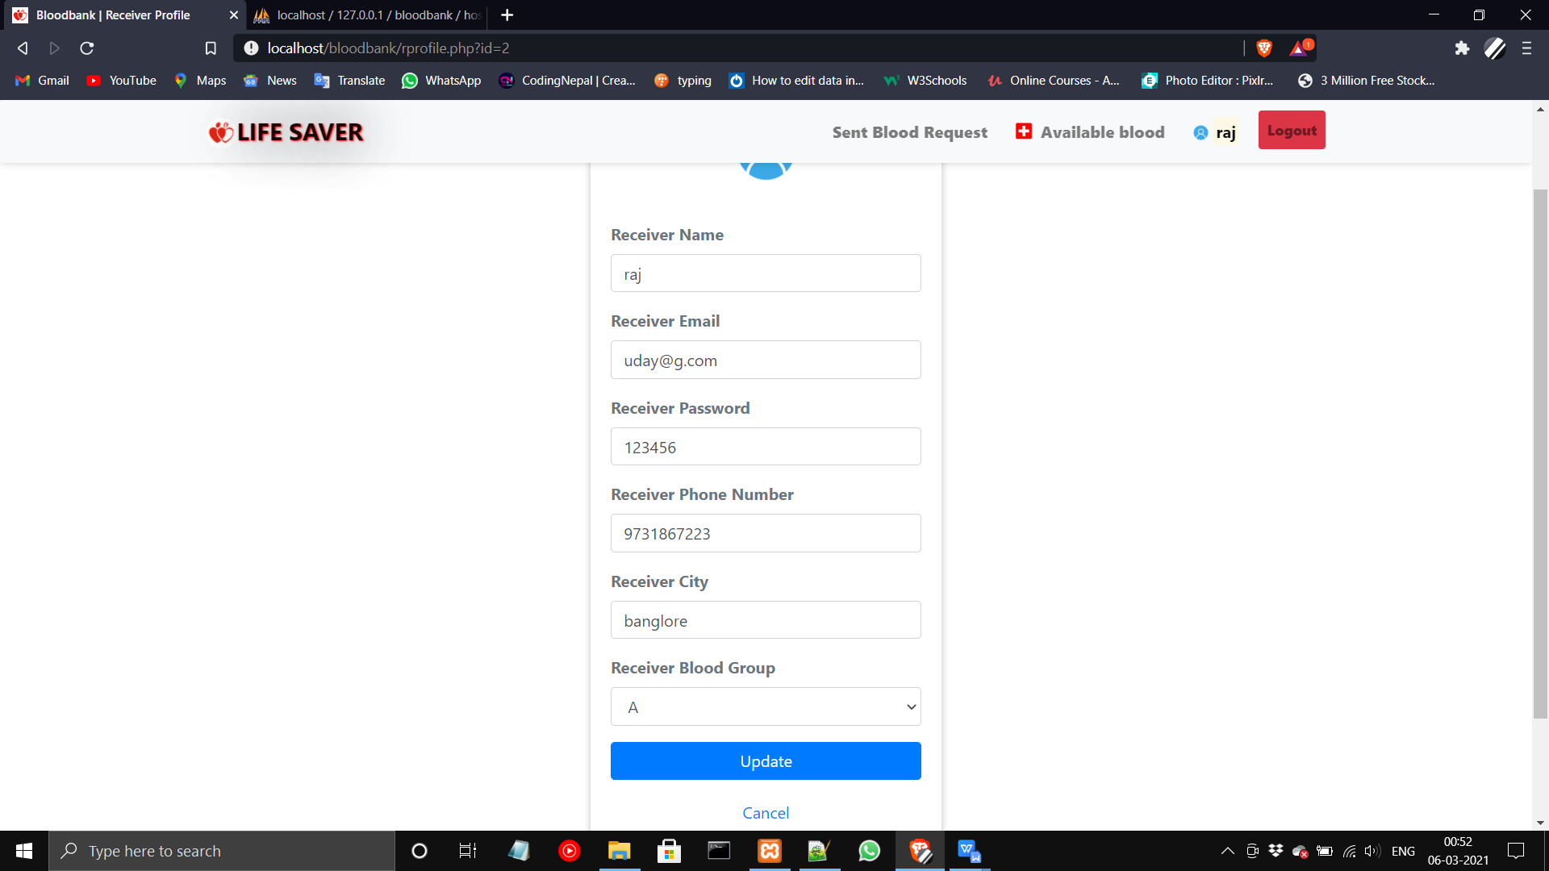

**Admin login :**

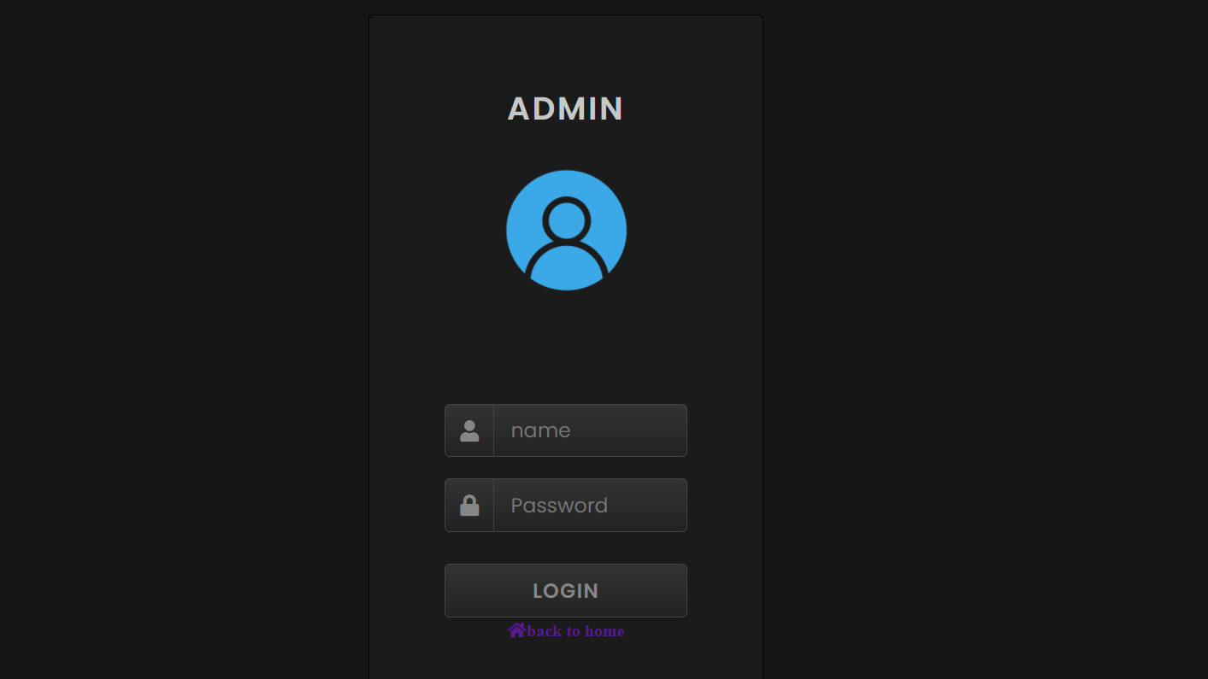

**Admin :**

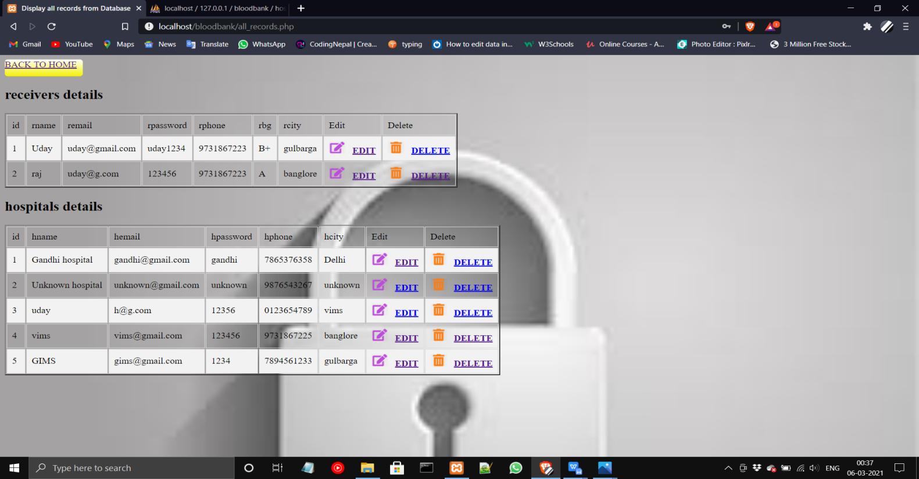

Source Codes

Home page

*<?php*

*session_start();*

*?>*

*<!DOCTYPE html>*

*<html>*

*<?php $title="Bloodbank | home page"; ?>*

*<?php require 'head.php'; ?>*

*<body style="background-image: url('image/fev.jpg');*

*background-repeat: no-repeat;*

*background-attachment: fixed;*

*background-size: cover;">*

*<?php require 'header.php'; ?>*

*<div class="container cont">*

*<?php require 'message.php'; ?>*

*<div class="row justify-content-center">*

*<div class="col-xl-3 col-lg-3 col-md-4 col-sm-5 col-xs-6 mb-5" style="width: 60%">*

*<div class="card">*

*<img src="image/bg.png" class="card-img-top">*

*</div>*

*</div>*

*<div class="col-lg-9">*

*<div class="row">*

*<div class="col-xl-4 col-lg-4 col-md-6 col-sm-6 col-xs-12 mb-5">*

*<div class="card">*

*<div class="card-header text-center">A+</div>*

*<div class="card-body">*

*If you are A+: You can give blood to A+ and AB+. You can receive blood from A+, A-, O+ and O-*

*</div>*

*</div>*

*</div>*

*<div class="col-xl-4 col-lg-4 col-md-6 col-sm-6 col-xs-12 mb-5">*

*<div class="card">*

*<div class="card-header text-center">A-</div>*

*<div class="card-body">*

*If you are A-: You can give blood to A-, A+, AB- and AB+. You can receive blood from A- and O-.*

*</div>*

*</div>*

*</div>*

*<div class="col-xl-4 col-lg-4 col-md-6 col-sm-6 col-xs-12 mb-5">*

*<div class="card">*

*<div class="card-header text-center">B+</div>*

*<div class="card-body">*

*You can give blood to A+ and AB+. You can receive blood from A+, A-, O+ and O-.*

*</div>*

*</div>*

*</div>*

*<div class="col-xl-4 col-lg-4 col-md-6 col-sm-6 col-xs-12 mb-5">*

*<div class="card">*

*<div class="card-header text-center">B-</div>*

*<div class="card-body">*

*If you are B-: You can give blood to B-, B+, AB+ and AB-, You can receive blood from B- and O-.You can give blood to B+ and AB+.*

*</div>*

*</div>*

*</div>*

*<div class="col-xl-4 col-lg-4 col-md-6 col-sm-6 col-xs-12 mb-5">*

*<div class="card">*

*<div class="card-header text-center">AB+</div>*

*<div class="card-body">*

*People with AB+ blood can receive red blood cells from any blood type. This means that demand for AB+ can donate with AB only.*

*</div>*

*</div>*

*</div>*

*<div class="col-xl-4 col-lg-4 col-md-6 col-sm-6 col-xs-12 mb-5">*

*<div class="card">*

*<div class="card-header text-center">AB-</div>*

*<div class="card-body">*

*AB- patients can receive red blood cells from all -ve blood types.*

*AB- can give red blood cells to both AB- and AB+ blood types.*

*</div>*

*</div>*

*</div>*

*<div class="col-xl-4 col-lg-4 col-md-6 col-sm-6 col-xs-12 mb-5">*

*<div class="card">*

*<div class="card-header text-center">O+</div>*

*<div class="card-body">*

*Blood O+ can donate to A+, B+, AB+ and O+ Blood*

*Group O can donate red blood cells to anybody. It's the universal donor.*

*</div>*

*</div>*

*</div>*

*<div class="col-xl-4 col-lg-4 col-md-6 col-sm-6 col-xs-12 mb-5">*

*<div class="card">*

*<div class="card-header text-center">O-</div>*

*<div class="card-body">*

*O- can donate to all Blood group,*

*People with O negative blood can only receive red cell donations from O- donors.*

*</div>*

*</div>*

*</div>*

*</div>*

*</div>*

*</div>*

*</div>*

*<?php require 'footer.php'; ?>*

*</body>*

*</html>*

**login page:**

<?php

session_start();

if (isset($_SESSION['hid'])) {

header("location:bloodrequest.php");

}elseif (isset($_SESSION['rid'])) {

header("location:sentrequest.php");

}else{

?>

<!DOCTYPE html>

<html>

<?php $title="Bloodbank | Login"; ?>

<?php require 'head.php'; ?>

<body>

<?php require 'header.php'; ?>

<div class="container cont">

<?php require 'message.php'; ?>

<div class="row justify-content-center">

<div class="col-lg-4 col-md-5 col-sm-6 col-xs-7 mb-5">

<div class="card rounded">

<ul class="nav nav-tabs justify-content-center bg-light" style="padding: 20px;">

<li class="nav-item">

<a class="nav-link active" data-toggle="tab" href="#hospitals">Hospitals</a>

</li>

<li class="nav-item">

<a class="nav-link" data-toggle="tab" href="#receivers">Receiver's</a>

</li>

</ul>

<div class="tab-content">

<div class="tab-pane container active" id="hospitals">

<form action="file/hospitalLogin.php" method="post">

<label class="text-muted font-weight-bold" class="text-muted font-weight-bold">Hospital Email</label>

<input type="email" name="hemail" placeholder="Hospital Email" class="form-control mb-4">

<label class="text-muted font-weight-bold" class="text-muted font-weight-bold">Hospital Password</label>

<input type="password" name="hpassword" placeholder="Hospital Password" class="form-control mb-4">

<input type="submit" name="hlogin" value="Login" class="btn btn-primary btn-block mb-4">

</form>

</div>

<div class="tab-pane container fade" id="receivers">

<form action="file/receiverLogin.php" method="post">

<label class="text-muted font-weight-bold" class="text-muted font-weight-bold">Receiver Email</label>

<input type="email" name="remail" placeholder="Receiver Email" class="form-control mb-4">

<label class="text-muted font-weight-bold" class="text-muted font-weight-bold">Receiver Password</label>

<input type="password" name="rpassword" placeholder="Receiver Password" class="form-control mb-4">

<input type="submit" name="rlogin" value="Login" class="btn btn-primary btn-block mb-4">

</form>

</div>

</div>

<a href="register.php" class="text-center mb-4" title="Click here">Don't have account?</a>

</div>

</div>

</div>

</div>

</body>

</html>

<?php } ?>

**Register page:**

<?php

session_start();

if (isset($_SESSION['hid'])) {

header("location:bloodrequest.php");

}elseif (isset($_SESSION['rid'])) {

header("location:sentrequest.php");

}else{

?>

<!DOCTYPE html>

<html>

<?php $title="Bloodbank | Register"; ?>

<?php require 'head.php'; ?>

<body>

<?php include 'header.php'; ?>

<div class="container cont">

<?php require 'message.php'; ?>

<div class="row justify-content-center">

<div class="col-lg-4 col-md-5 col-sm-6 col-xs-7 mb-5">

<div class="card rounded">

<ul class="nav nav-tabs justify-content-center bg-light" style="padding: 20px">

<li class="nav-item">

<a class="nav-link active" data-toggle="tab" href="#hospitals">Hospitals</a>

</li>

<li class="nav-item">

<a class="nav-link" data-toggle="tab" href="#receivers">Receivers</a>

</li>

</ul>

<div class="tab-content">

<div class="tab-pane container active" id="hospitals">

<form action="file/hospitalReg.php" method="post" enctype="multipart/form-data">

<input type="text" name="hname" placeholder="Hospital Name" class="form-control mb-3" required>

<input type="text" name="hcity" placeholder="Hospital City" class="form-control mb-3" required>

<input type="tel" name="hphone" placeholder="Hospital Phone Number" class="form-control mb-3" required pattern="[0,6-9]{1}[0-9]{9,11}" title="Password must have start from 0,6,7,8 or 9 and must have 10 to 12 digit">

<input type="email" name="hemail" placeholder="Hospital Email" class="form-control mb-3" required>

<input type="password" name="hpassword" placeholder="Hospital Password" class="form-control mb-3" required minlength="6">

<input type="submit" name="hregister" value="Register" class="btn btn-primary btn-block mb-4">

</form>

</div>

<div class="tab-pane container fade" id="receivers">

<form action="file/receiverReg.php" method="post" enctype="multipart/form-data">

<input type="text" name="rname" placeholder="Receiver Name" class="form-control mb-3" required>

<select name="rbg" class="form-control mb-3" required>

<option disabled="" selected="">Blood Group</option>

<option value="A+">A+</option>

<option value="A-">A-</option>

<option value="B+">B+</option>

<option value="B-">B-</option>

<option value="AB+">AB+</option>

<option value="AB-">AB-</option>

<option value="O+">O+</option>

<option value="O-">O-</option>

</select>

<input type="text" name="rcity" placeholder="Receiver City" class="form-control mb-3" required>

<input type="tel" name="rphone" placeholder="Receiver Phone Number" class="form-control mb-3" required pattern="[0,6-9]{1}[0-9]{9,11}" title="Password must have start from 0,6,7,8 or 9 and must have 10 to 12 digit">

<input type="email" name="remail" placeholder="Receiver Email" class="form-control mb-3" required>

<input type="password" name="rpassword" placeholder="Receiver Password" class="form-control mb-3" required minlength="6">

<input type="submit" name="rregister" value="Register" class="btn btn-primary btn-block mb-4">

</form>

</div>

</div>

<a href="login.php" class="text-center mb-4" title="Click here">Already have account?</a>

</div>

</div>

</div>

</div>

</body>

</html>

<?php } ?>

**Rprofile page:**

<?php

require 'file/connection.php';

session_start();

if(!isset($_SESSION['rid']))

{

header('location:login.php');

}

else {

if(isset($_SESSION['rid'])){

$id=$_SESSION['rid'];

$sql = "SELECT * FROM receivers WHERE id='$id'";

$result = mysqli_query($conn, $sql);

$row = mysqli_fetch_array($result);

}

}

?>

<!DOCTYPE html>

<html>

<?php $title="Bloodbank | Receiver Profile"; ?>

<?php require 'head.php';?>

<body>

<?php require 'header.php'; ?>

<div class="container cont">

<?php require 'message.php'; ?>

<div class="row justify-content-center">

<div class="col-lg-4 col-md-6 col-sm-8 mb-5">

<div class="card">

<div class="media justify-content-center mt-1">

<img src="image/user.png" alt="profile" class="rounded-circle" width="60" height="60">

</div>

<div class="card-body">

<form action="file/updateprofile.php" method="post">

<label class="text-muted font-weight-bold" class="text-muted font-weight-bold">Receiver Name</label>

<input type="text" name="rname" value="<?php echo $row['rname']; ?>" class="form-control mb-3">

<label class="text-muted font-weight-bold" class="text-muted font-weight-bold">Receiver Email</label>

<input type="email" name="remail" value="<?php echo $row['remail']; ?>" class="form-control mb-3">

<label class="text-muted font-weight-bold" class="text-muted font-weight-bold">Receiver Password</label>

<input type="text" name="rpassword" value="<?php echo $row['rpassword']; ?>" class="form-control mb-3">

<label class="text-muted font-weight-bold" class="text-muted font-weight-bold">Receiver Phone Number</label>

<input type="text" name="rphone" value="<?php echo $row['rphone']; ?>" class="form-control mb-3">

<label class="text-muted font-weight-bold" class="text-muted font-weight-bold">Receiver City</label>

<input type="text" name="rcity" value="<?php echo $row['rcity']; ?>" class="form-control mb-3">

<label class="text-muted font-weight-bold" class="text-muted font-weight-bold">Receiver Blood Group</label>

<select class="form-control mb-3" name="bg" required>

<option selected><?php echo $row['rbg']; ?></option>

<option>A-</option>

<option>A+</option>

<option>B-</option>

<option>B+</option>

<option>AB-</option>

<option>AB+</option>

<option>O-</option>

<option>O+</option>

</select>

<input type="submit" name="update" class="btn btn-block btn-primary" value="Update">

</form>

</div>

<a href="index.php" class="text-center">Cancel</a><br>

</div>

</div>

</div>

</div>

<?php require 'footer.php'; ?>

</body>

</html>

**Sent bloodreq page:**

<?php

require 'file/connection.php';

session_start();

if(!isset($_SESSION['rid']))

{

header('location:login.php');

}

else {

$rid = $_SESSION['rid'];

$sql = "select bloodrequest.*, hospitals.* from bloodrequest, hospitals where rid='$rid' && bloodrequest.hid=hospitals.id";

$result = mysqli_query($conn, $sql);

?>

<!DOCTYPE html>

<html>

<?php $title="Bloodbank | Sent Requests"; ?>

<?php require 'head.php'; ?>

<body>

<?php require 'header.php'; ?>

<div class="container cont">

<?php require 'message.php'; ?>

<table class="table table-responsive table-striped rounded mb-5">

<tr><th colspan="8" class="title">Sent requests</th></tr>

<tr>

<th>#</th>

<th>Name</th>

<th>Email</th>

<th>City</th>

<th>Phone</th>

<th>Blood Group</th>

<th>Status</th>

<th>Action</th>

</tr>

<div>

<?php

if ($result) {

$row =mysqli_num_rows( $result);

if ($row) { //echo "<b> Total ".$row." </b>";

}else echo '<b style="color:white;background-color:red;padding:7px;border-radius: 15px 50px;">You have not requested yet. </b>';

}

?>

</div>

<?php while($row = mysqli_fetch_array($result)) { ?>

<tr>

<td><?php echo ++$counter;?></td>

<td><?php echo $row['hname'];?></td>

<td><?php echo $row['hemail'];?></td>

<td><?php echo $row['hcity'];?></td>

<td><?php echo $row['hphone'];?></td>

<td><?php echo $row['bg'];?></td>

<td><?php echo $row['status'];?></td>

<td><?php if($row['status'] == 'Accepted'){ ?>

<?php }

else{ ?>

<a href="file/cancel.php?reqid=<?php echo $row['reqid'];?>" class="btn btn-danger">Cancel</a>

<?php } ?>

</td>

</tr>

<?php } ?>

</table>

</div>

</body>

</html>

<?php } ?>

**Available blood page:**

<?php

session_start();

require 'file/connection.php';

if(isset($_GET['search'])){

$searchKey = $_GET['search'];

$sql = "select bloodinfo.*, hospitals.* from bloodinfo, hospitals where bloodinfo.hid=hospitals.id && bg LIKE '%$searchKey%'";

}else{

$sql = "select bloodinfo.*, hospitals.* from bloodinfo, hospitals where bloodinfo.hid=hospitals.id";

}

$result = mysqli_query($conn, $sql);

?>

<!DOCTYPE html>

<html>

<?php $title="Bloodbank | Available Blood Samples"; ?>

<?php require 'head.php'; ?>

<body>

<?php require 'header.php'; ?>

<div class="container cont">

<?php require 'message.php'; ?>

<div class="row col-lg-8 col-md-8 col-sm-12 mb-3">

<form method="get" action="" style="margin-top:-20px; ">

<label class="font-weight-bolder">Select Blood Group:</label>

<select name="search" class="form-control">

<option><?php echo @$_GET['search']; ?></option>

<option value="A+">A+</option>

<option value="A-">A-</option>

<option value="B+">B+</option>

<option value="B-">B-</option>

<option value="AB+">AB+</option>

<option value="AB-">AB-</option>

<option value="O+">O+</option>

<option value="O-">O-</option>

</select><br>

<a href="abs.php" class="btn btn-info mr-4"> Reset</a>

<input type="submit" name="submit" class="btn btn-info" value="search">

</form>

</div>

<table class="table table-responsive table-striped rounded mb-5">

<tr><th colspan="7" class="title">Available Blood Samples</th></tr>

<tr>

<th>#</th>

<th>Hospital Name</th>

<th>Hospital City</th>

<th>Hospital Email</th>

<th>Hospital Phone</th>

<th>Blood Group</th>

<th>Action</th>

</tr>

<div>

<?php

if ($result) {

$row =mysqli_num_rows( $result);

if ($row) { //echo "<b> Total ".$row." </b>";

}else echo '<b style="color:white;background-color:red;padding:7px;border-radius: 15px 50px;">Nothing to show.</b>';

}

?>

</div>

<?php while($row = mysqli_fetch_array($result)) { ?>

<tr>

<td><?php echo ++$counter;?></td>

<td><?php echo $row['hname'];?></td>

<td><?php echo ($row['hcity']); ?></td>

<td><?php echo ($row['hemail']); ?></td>

<td><?php echo ($row['hphone']); ?></td>

<td><?php echo ($row['bg']); ?></td>

<?php $bid= $row['bid'];?>

<?php $hid= $row['hid'];?>

<?php $bg= $row['bg'];?>

<form action="file/request.php" method="post">

<input type="hidden" name="bid" value="<?php echo $bid; ?>">

<input type="hidden" name="hid" value="<?php echo $hid; ?>">

<input type="hidden" name="bg" value="<?php echo $bg; ?>">

<?php if (isset($_SESSION['hid'])) { ?>

<td><a href="javascript:void(0);" class="btn btn-info hospital">Request Blood</a></td>

<?php } else {(isset($_SESSION['rid'])) ?>

<td><input type="submit" name="request" class="btn btn-info" value="Request Sample"></td>

<?php } ?>

</form>

</tr>

<?php } ?>

</table>

</div>

</body>

<script type="text/javascript">

$('.hospital').on('click', function(){

alert("Hospital user can't request for blood.");

});

</script>

**hprofile page:**

<?php

require 'file/connection.php';

session_start();

if(!isset($_SESSION['hid']))

{

header('location:login.php');

}

else {

if(isset($_SESSION['hid'])){

$id=$_SESSION['hid'];

$sql = "SELECT * FROM hospitals WHERE id='$id'";

$result = mysqli_query($conn, $sql);

$row = mysqli_fetch_array($result);

}

}

?>

<!DOCTYPE html>

<html>

<?php $title="Bloodbank | Receiver Profile"; ?>

<?php require 'head.php';?>

<body>

<?php require 'header.php'; ?>

<div class="container cont ">

<?php require 'message.php'; ?>

<div class="row justify-content-center">

<div class="col-lg-4 col-md-4 col-sm-6 mb-5">

<div class="card">

<div class="media justify-content-center mt-1">

<img src="image/hospital.png" alt="profile" class="rounded-circle" width="70" height="60">

</div>

<div class="card-body">

<form action="file/updateprofile.php" method="post">

<label class="text-muted font-weight-bold" class="text-muted font-weight-bold">Hospital Name</label>

<input type="text" name="hname" value="<?php echo $row['hname']; ?>" class="form-control mb-3">

<label class="text-muted font-weight-bold">Hospital Email</label>

<input type="email" name="hemail" value="<?php echo $row['hemail']; ?>" class="form-control mb-3">

<label class="text-muted font-weight-bold">Hospital Password</label>

<input type="text" name="hpassword" value="<?php echo $row['hpassword']; ?>" class="form-control mb-3">

<label class="text-muted font-weight-bold">Hospital Phone Number</label>

<input type="text" name="hphone" value="<?php echo $row['hphone']; ?>" class="form-control mb-3">

<label class="text-muted font-weight-bold">Hospital City</label>

<input type="text" name="hcity" value="<?php echo $row['hcity']; ?>" class="form-control mb-3">

<input type="submit" name="update" class="btn btn-block btn-primary" value="Update">

</form>

</div>

<a href="index.php" class="text-center">Cancel</a><br>

</div>

</div>

</div>

</div>

<?php require 'footer.php'; ?>

</body>

</html>

**Bloodreq page:**

<?php

require 'file/connection.php';

session_start();

if(!isset($_SESSION['hid']))

{

header('location:login.php');

}

else {

$hid = $_SESSION['hid'];

$sql = "select bloodrequest.*, receivers.* from bloodrequest, receivers where hid='$hid' && bloodrequest.rid=receivers.id";

$result = mysqli_query($conn, $sql);

?>

<!DOCTYPE html>

<html>

<?php $title="Bloodbank | Blood Requests"; ?>

<?php require 'head.php'; ?>

<body>

<?php require 'header.php'; ?>

<div class="container cont">

<?php require 'message.php'; ?>

<table class="table table-responsive table-striped rounded mb-5">

<tr><th colspan="9" class="title">Blood requests</th></tr>

<tr>

<th>#</th>

<th>Name</th>

<th>Email</th>

<th>City</th>

<th>Phone</th>

<th>Blood Group</th>

<th>Status</th>

<th colspan="2">Action</th>

</tr>

<div>

<?php

if ($result) {

$row =mysqli_num_rows( $result);

if ($row) { //echo "<b> Total ".$row." </b>";

}else echo '<b style="color:white;background-color:red;padding:7px;border-radius: 15px 50px;">No one has requested yet. </b>';

}

?>

</div>

<?php while($row = mysqli_fetch_array($result)) { ?>

<tr>

<td><?php echo ++$counter;?></td>

<td><?php echo $row['rname'];?></td>

<td><?php echo $row['remail'];?></td>

<td><?php echo $row['rcity'];?></td>

<td><?php echo $row['rphone'];?></td>

<td><?php echo $row['bg'];?></td>

<td><?php echo 'You have '.$row['status'];?></td>

<td><?php if($row['status'] == 'Accepted'){ ?> <a href="" class="btn btn-success disabled">Accepted</a> <?php }

else{ ?>

<a href="file/accept.php?reqid=<?php echo $row['reqid'];?>" class="btn btn-success">Accept</a>

<?php } ?>

</td>

<td><?php if($row['status'] == 'Rejected'){ ?> <a href="" class="btn btn-danger disabled">Rejected</a> <?php }

else{ ?>

<a href="file/reject.php?reqid=<?php echo $row['reqid'];?>" class="btn btn-danger">Reject</a>

<?php } ?>

</td>

</tr>

<?php } ?>

</table>

</div>

</body>

</html>

<?php } ?>

**Bloodinfo page:**

<?php

require 'file/connection.php';

session_start();

if(!isset($_SESSION['hid']))

{

header('location:login.php');

}

else {

?>

<!DOCTYPE html>

<html>

<?php $title="Bloodbank | Add blood samples"; ?>

<?php require 'head.php'; ?>

<body>

<?php require 'header.php'; ?>

<div class="container cont">

<?php require 'message.php'; ?>

<div class="row justify-content-center">

<div class="col-lg-4 col-md-5 col-sm-6 col-xs-7 mb-5">

<div class="card">

<div class="card-header title">Add blood group available in your hospital</div>

<div class="card-body">

<form action="file/infoAdd.php" method="post">

<a data-toggle="collapse" href="#collapseExample" role="button" aria-expanded="false" aria-controls="collapseExample" title="click to see">Term & conditions. </a><br>

<div class="collapse" id="collapseExample">

If you have a blood sample tested by your doctor’s, nurse, or trained phlebotomist , at a pathology collection centre, clinic or hospital. Blood samples are most commonly taken from the inside of the elbow where the veins are usually closer to the surface. If before the needle is inserted, the area had been cleaned with an antiseptic cloth and blood sample is transferred into tubes containing the correct preservatives then add your blood group available in your hospital to your blood bank.<br><br>

</div>

<input type="checkbox" name="condition" value="agree" required> Agree<br><br>

<select class="form-control" name="bg" required="">

<option disabled selected>Blood Group</option>

<option>A-</option>

<option>A+</option>

<option>B-</option>

<option>B+</option>

<option>AB-</option>

<option>AB+</option>

<option>O-</option>

<option>O+</option>

</select><br>

<input type="submit" name="add" value="Add" class="btn btn-primary btn-block"><br>

<a href="index.php" class="float-right" title="click here">Cancel</a>

</form>

</div>

</div>

</div>

<?php if(isset($_SESSION['hid'])){

$hid=$_SESSION['hid'];

$sql = "select * from bloodinfo where hid='$hid'";

$result = mysqli_query($conn, $sql);

}

?>

<div class="col-lg-4 col-md-5 col-sm-6 col-xs-7 mb-5">

<table class="table table-striped table-responsive">

<th colspan="4" class="title">Blood Bank</th>

<tr>

<th>#</th>

<th>Blood Samples</th>

<th>Action</th>

</tr>

<div>

<?php

if ($result) {

$row =mysqli_num_rows( $result);

if ($row) { //echo "<b> Total ".$row." </b>";

}else echo '<b style="color:white;background-color:red;padding:7px;border-radius: 15px 50px;">Nothing to show.</b>';

}

?>

</div>

<?php while($row = mysqli_fetch_array($result)) { ?>

<tr>

<td><?php echo ++$counter; ?></td>

<td><?php echo $row['bg'];?></td>

<td><a href="file/delete.php?bid=<?php echo $row['bid'];?>" class="btn btn-danger">Delete</a></td>

</tr>

<?php } ?>

</table>

</div>

</div>

</div>

</body>

<?php } ?>

**Contact page:**

<!DOCTYPE html>

<html lang="en">

<head>

<meta charset="UTF-8" />

<meta name="viewport" content="width=device-width, initial-scale=1.0" />

<title>Contact Form</title>

<link rel="stylesheet" href="style.css" />

<script

src="https://kit.fontawesome.com/64d58efce2.js"

crossorigin="anonymous"

></script>

</head>

<body>

<div class="container">

<span class="big-circle"></span>

<img src="img/sh.png" class="square" alt="" />

<div class="form">

<div class="contact-info">

<h3 class="title">Let's get in touch</h3>

<p class="text">

</p>

<div class="info">

<div class="information">

<img src="img/lo.png" class="icon" alt="" />

<p>srinivas nagar -560050</p>

</div>

<div class="information">

<img src="img/em.png" class="icon" alt="" />

<p>uday@gmail.com</p>

</div>

<div class="information">

<img src="img/cl.png" class="icon" alt="" />

<p>123-456-789</p>

</div>

</div>

<div class="social-media">

<p>Connect with us :</p>

<div class="social-icons">

<a href="#">

<i class="fab fa-facebook-f"></i>

</a>

<a href="#">

<i class="fab fa-twitter"></i>

</a>

<a href="#">

<i class="fab fa-instagram"></i>

</a>

<a href="#">

<i class="fab fa-linkedin-in"></i>

</a>

</div>

</div>

</div>

<div class="contact-form">

<span class="circle one"></span>

<span class="circle two"></span>

<form action="contact1.php" method="POST" autocomplete="off">

<h3 class="title">Contact us</h3>

<div class="input-container">

<input type="text" name="rname" class="input" />

<label for="">Username</label>

<span>Username</span>

</div>

<div class="input-container">

<input type="email" name="remail" class="input" />

<label for="">Email</label>

<span>Email</span>

</div>

<div class="input-container">

<input type="tel" name="rphone" class="input" />

<label for="">Phone</label>

<span>Phone</span>

</div>

<div class="input-container textarea">

<textarea name="rmessage" class="input"></textarea>

<label for="">Message</label>

<span>Message</span>

</div>

<input type="submit" value="Send" class="btn" />

<button class="btn" ><a href="index.php">Back to Home</a></button>

</form>

</div>

</div>

</div>

<script src="app.js"></script>

</body>

</html>

**Admin login page:**

<!DOCTYPE html>

<!-- Created By CodingNepal -->

<html lang="en" dir="ltr">

<head>

<title>admin</title>

<meta charset="utf-8">

<link rel="stylesheet" href="style.css">

<script src="https://kit.fontawesome.com/a076d05399.js"></script>

<style>

@import url('https://fonts.googleapis.com/css?family=Poppins&display=swap');

*{

margin: 0;

padding: 0;

font-family: 'Poppins',sans-serif;

}

body{

display: flex;

height: 100vh;

text-align: center;

align-items: center;

justify-content: center;

background: #151515;

}

.login-form{

position: relative;

width: 370px;

height: auto;

background: #1b1b1b;

padding: 40px 35px 60px;

box-sizing: border-box;

border: 1px solid black;

border-radius: 5px;

box-shadow: inset 0 0 1px #272727;

}

.text{

font-size: 30px;

color: #c7c7c7;

font-weight: 600;

letter-spacing: 2px;

}

form{

margin-top: 40px;

}

form .field{

margin-top: 20px;

display: flex;

}

.field .fas{

height: 50px;

width: 60px;

color: #868686;

font-size: 20px;

line-height: 50px;

border: 1px solid #444;

border-right: none;

border-radius: 5px 0 0 5px;

background: linear-gradient(#333,#222);

}

.field input,form button{

height: 50px;

width: 100%;

outline: none;

font-size: 19px;

color: #868686;

padding: 0 15px;

border-radius: 0 5px 5px 0;

border: 1px solid #444;

caret-color: #339933;

background: linear-gradient(#333,#222);

}

input:focus{

color: #339933;

box-shadow: 0 0 5px rgba(0,255,0,.2),

inset 0 0 5px rgba(0,255,0,.1);

background: linear-gradient(#333933,#222922);

animation: glow .8s ease-out infinite alternate;

}

@keyframes glow {

0%{

border-color: #339933;

box-shadow: 0 0 5px rgba(0,255,0,.2),

inset 0 0 5px rgba(0,0,0,.1);

}

100%{

border-color: #6f6;

box-shadow: 0 0 20px rgba(0,255,0,.6),

inset 0 0 10px rgba(0,255,0,.4);

}

}

button{

margin-top: 30px;

border-radius: 5px!important;

font-weight: 600;

letter-spacing: 1px;

cursor: pointer;

}

button:hover{

color: #339933;

border: 1px solid #339933;

box-shadow: 0 0 5px rgba(0,255,0,.3),

0 0 10px rgba(0,255,0,.2),

0 0 15px rgba(0,255,0,.1),

0 2px 0 black;

}

.link{

margin-top: 25px;

color: #868686;

}

.link a{

color: #339933;

text-decoration: none;

}

.link a:hover{

text-decoration: underline;

}

img.avatar {

width: 40%;

border-radius: 50%;

}

</style>

</head>

<body>

<div class="login-form">

<div class="text">

ADMIN

</div>

<img src="image/user.png" alt="Avatar" class="avatar">

<form action = "admin1.php" method = "POST">

<div class="field">

<div class="fas fa-user">

</div>

<input type="text" id="username" name="username" placeholder="name" required>

</div>

<div class="field">

<div class="fas fa-lock">

</div>

<input type="password" id="password" name="password" placeholder="Password" required>

</div>

<button>LOGIN</button>

<br>

<a href="index.php" class="w3-bar-item w3-button w3-padding-large w3-black">

<i class="fa fa-home w3-xxlarge">back to home</i>

</a>

</form>

</div>

</body>

</html>

**Admin alldetails :**

<!DOCTYPE html>

<html>

<head>

<title>Display all records from Database</title>

<style>

<link rel="stylesheet" href="https://www.w3schools.com/w3css/4/w3.css">

<link rel="stylesheet" href="https://cdnjs.cloudflare.com/ajax/libs/font-awesome/4.7.0/css/font-awesome.min.css">

#customers {

font-family: Arial, Helvetica, sans-serif;

border-collapse: collapse;

width: 100%;

}

#customers td, #customers th {

border: 1px solid #ddd;

padding: 8px;

}

#customers tr:nth-child(even){background-color: #f2f2f2;}

#customers tr:hover {background-color: #ddd;}

#customers th {

padding-top: 12px;

padding-bottom: 12px;

text-align: left;

background-color: #4CAF50;

color: white;

}

.icon {

width: 28px;

margin-right: 0.7rem;

}

.button-5 {

width: 130px;

height: 30px;

border-radius: 5px;

background-color: #F4F200;

background-image: #F4F200;

background-image: -moz-linear-gradient(top, #fff 0%, #F4F200 100%);

background-image: -webkit-linear-gradient(top, #fff 0%,#F4F200 100%);

background-image: linear-gradient(to bottom, #fff 0%,#F4F200 100%);

background-size: 300px;

background-repeat: no-repeat;

background-position: 0%;

-webkit-transition: background 300ms ease-in-out;

transition: background 300ms ease-in-out;

}

.button-5:hover {

background-position: -200%;

transition: background 300ms ease-in-out;

}

</style>

</head>

<body style="background-image: url('image/fel2.jpg');

background-repeat: no-repeat;

background-attachment: fixed;

background-size: cover;" >

<div class="button button-5"><a href="index.php">BACK TO HOME</a></div>

</i>

<h2>receivers details</h2>

<table border="2" id="customers">

<tr>

<td>id</td>

<td>rname</td>

<td>remail</td>

<td>rpassword</td>

<td>rphone</td>

<td>rbg</td>

<td>rcity</td>

<td>Edit</td>

<td>Delete</td>

</tr>

<?php

include "dbConn.php"; // Using database connection file here

$records = mysqli_query($db,"select * from receivers"); // fetch data from database

while($data = mysqli_fetch_array($records))

{

?>

<tr>

<td><?php echo $data['id']; ?></td>

<td><?php echo $data['rname']; ?></td>

<td><?php echo $data['remail']; ?></td>

<td><?php echo $data['rpassword']; ?></td>

<td><?php echo $data['rphone']; ?></td>

<td><?php echo $data['rbg']; ?></td>

<td><?php echo $data['rcity']; ?></td>

<td><a href="edit.php?id=<?php echo $data['id']; ?>"><img src="img/edit.png" class="icon" alt="" /><b>EDIT</b></a></td>

<td><a href="delete.php?id=<?php echo $data['id']; ?>"><img src="img/delete.png" class="icon" alt="" /><b>DELETE</b></a></td>

</tr>

<?php

}

?>

</table>

</i>

<h2>hospitals details</h2>

<table border="2" id="customers">

<tr>

<td>id</td>

<td>hname</td>

<td>hemail</td>

<td>hpassword</td>

<td>hphone</td>

<td>hcity</td>

<td>Edit</td>

<td>Delete</td>

</tr>

<?php

include "dbConn.php"; // Using database connection file here

$records = mysqli_query($db,"select * from hospitals"); // fetch data from database

while($data = mysqli_fetch_array($records))

{

?>

<tr>

<td><?php echo $data['id']; ?></td>

<td><?php echo $data['hname']; ?></td>

<td><?php echo $data['hemail']; ?></td>

<td><?php echo $data['hpassword']; ?></td>

<td><?php echo $data['hphone']; ?></td>

<td><?php echo $data['hcity']; ?></td>

<td><a href="edith.php?id=<?php echo $data['id']; ?>"><img src="img/edit.png" class="icon" alt="" /><b>EDIT</b></a></td>

<td><a href="deleteh.php?id=<?php echo $data['id']; ?>"><img src="img/delete.png" class="icon" alt="" /><b>DELETE</b></a></td>

</tr>

<?php

}

?>

</table>

</body>

</html>

**Head:**

<head>

<title><?php echo $title ?></title>

<meta charset="UTF-8" />

<meta name="viewport" content="width=device-width, initial-scale=1.0" />

<meta http-equiv="X-UA-Compatible" content="ie=edge" />

<link rel="stylesheet" href="https://maxcdn.bootstrapcdn.com/bootstrap/4.5.0/css/bootstrap.min.css">

<script src="https://cdnjs.cloudflare.com/ajax/libs/popper.js/1.16.0/umd/popper.min.js"></script>

<script src="https://maxcdn.bootstrapcdn.com/bootstrap/4.5.0/js/bootstrap.min.js"></script>

<link rel="stylesheet" type="text/css" href="../library/css/bootstrap.min.css"/>

<script type="text/javascript" src="../library/js/jquery-3.2.1.min.js"></script>

<script src="https://ajax.googleapis.com/ajax/libs/jquery/3.5.1/jquery.min.js"></script>

<script src="https://stackpath.bootstrapcdn.com/bootstrap/4.5.0/js/bootstrap.min.js"></script>

<script src="https://kit.fontawesome.com/a076d05399.js"></script>

<link href="css/style.css" rel="stylesheet"/>

<link rel="shortcut icon" type="image/jpeg" href="image/favicon.jpg">

<script src='https://kit.fontawesome.com/a076d05399.js' crossorigin='anonymous'></script>

<link rel="stylesheet" href="https://cdnjs.cloudflare.com/ajax/libs/font-awesome/4.7.0/css/font-awesome.min.css">

</head>

**Header:**

<nav class="navbar navbar-expand-sm navbar-light bg-light sticky-top">

<div class="container">

<a class="navbar-brand" href="index.php"><img src="image/favicon.jpg" width="30" height="30" class="rounded-circle">LIFE SAVER</a>

<button class="navbar-toggler" type="button" data-toggle="collapse" data-target="#collapsibleNavbar"><i class="fas fa-align-left"></i></span>

</button>

<div class="collapse navbar-collapse" id="collapsibleNavbar">

<?php if (isset($_SESSION['hid'])) { ?>

<ul class="navbar-nav ml-auto">

<li class="nav-item">

<a class="nav-link btn btn-light" href="bloodinfo.php"><strong><b>Add blood info</strong></b></a>

</li>

<li class="nav-item">

<a class="nav-link btn btn-light" href="bloodrequest.php"><strong><b>Blood Request</strong></b></a>

</li>

<li class="nav-item">

<a class="nav-link btn btn-light" href="abs.php"><i style='font-size:18px;color:red' class='fas'>&#xf0fe;</i>&nbsp; <strong><b>Available blood</b></strong></a>

</li>

<li class="nav-item">

<a href="hprofile.php?id=<?php echo $_SESSION['hid']; ?>" class="nav-link btn font-weight-bold"><img src="image/hospital.png" width="15" height="15" class="rounded-circle"><mark><?php echo $_SESSION['hname']; ?></mark></a>

</li>

<li class="nav-item">

<a class="nav-link btn btn-danger btn-sm font-weight-bold" href="logout.php"><strong><b>Logout</strong></b></a>

</li>

</ul>

<?php } elseif (isset($_SESSION['rid'])) { ?>

<ul class="navbar-nav ml-auto">

<li class="nav-item">

<a class="nav-link btn btn-light" href="sentrequest.php"><strong><b>Sent Blood Request</strong></b></a>

</li>

<li class="nav-item">

<a class="nav-link btn btn-light" href="abs.php"><i style='font-size:18px;color:red' class='fas'>&#xf0fe;</i>&nbsp; <strong><b>Available blood</b></strong></a>

</li>

<li class="nav-item">

<a href="rprofile.php?id=<?php echo $_SESSION['rid']; ?>" class="nav-link btn font-weight-bold" href="#"><img src="image/user.png" width="15" height="15" class="rounded-circle"> <mark><?php echo ' '.$_SESSION['rname']; ?></mark></a>

</li>

<li class="nav-item">

<a class="nav-link btn btn-danger btn-sm font-weight-bold" href="logout.php"><strong><b>Logout</strong></b></a>

</li>

</ul>

<?php } else { ?>

<ul class="navbar-nav ml-auto">

<li class="nav-item">

<a class="nav-link btn btn-light" href="admin.php"> <i class='fas fa-user-cog' style='font-size:18px;color:red'></i>&nbsp; <strong><b>Admin</b></strong></a>

</li>

<li class="nav-item">

<a class="nav-link btn btn-light" href="abs.php"> <i style='font-size:18px;color:red' class='fas'>&#xf0fe;</i>&nbsp; <strong><b>Available blood</b></strong></a>

</li>

<li class="nav-item">

<a class="nav-link btn btn-light" href="register.php"><i class="fa fa-users" style="font-size:18px;color:red"></i>&nbsp; <strong><b>Register</b></strong></a>

</li>

<li class="nav-item">

<a class="nav-link btn btn-light" href="contact.php"><i class="fa fa-address-book-o" style="font-size:18px;color:red"></i>&nbsp;<strong> <b>Contact us</b></strong></a>

</li>

<li class="nav-item">

<a class="nav-link btn btn-light" href="login.php"><b><i class="fa fa-sign-in" style="font-size:18px;color:red"></i>&nbsp; <strong><b>Login</b></strong></a>

</li>

</ul>

<?php } ?>

</div>

</div>

</nav>

**Footer:**

<footer class="footer text-center bg-light">

<p>&copy; Copyright 2021 lifesaver.</p>

<script>

date = new Date();

document.getElementById("demo").innerHTML=date.getFullYear();

</script>

</footer>

**Message:**

<div class="row justify-content-center mb-3">

<?php $counter=0; if(isset($_GET['msg'])) { ?>

<div class="col-5 alert alert alert-success alert-dismissible fade show card" id="message">

<button type="button" class="close" data-dismiss="alert" title="close">&times;</button><?php echo $_GET['msg'];?>

</div>

<?php }?>

<?php if(isset($_GET['error'])) { ?>

<div class="col-5 alert error alert-danger alert-dismissible fade show card" id="message">

<button type="button" class="close" data-dismiss="alert" title="close">&times;</button><?php echo $_GET['error'];?>

</div>

<?php }?>

</div>

<script src="https://code.jquery.com/jquery-1.12.4.min.js"></script>

<script>

$( document ).ready(function(){

$('#message').fadeIn('slow', function(){

$('#message').delay(5000).fadeOut();

});

});

</script>

**dbconnection:**

<?php

$db = mysqli_connect("localhost","root","","bloodbank");

if(!$db)

{

die("Connection failed: " . mysqli_connect_error());

}

?>

**Logout:**

<?php

session_start();

session_unset();

session_destroy();

$msg="You have logged out.";

header( "location:index.php?msg=".$msg );

?>

**Conclusion**

This project is developed with HTML, CSS, PHP and MySQL. The project completely computerizes the existing system. The main focus of developing blood bank management system is to design a application which conatin blood groups and provide interface between hospitals and receivers with accuracy.

We would also like that it was very overwhelming to work with PHP and MySQL.

This system has been advantageous in all aspects,

* This is a quick WEB BASED application.
* It can be used with minimal training.
* It is helpful to find blood availability in hospitals quickly by searching option.

**Bibliography**

Reference:

Software Engineering: Author – Mrs. Vidya. A

Website References:

* <https://www.w3schools.com/>
* <https://www.javatpoint.com/>
* <http://www.telusko.com/>
* <https://www.geeksforgeeks.org/>
* <https://www.python.org/>
* <https://www.tutorialspoint.com/index.htm>
* <https://www.udemy.com/>
* <https://www.youtube.com/>