**DBMS**

Used to store, organize, manipulate large amount of data.

**Components of DBMS**

* Hardware
* Software
* End user
* Data Query Language

**Architecture**

* Single-tier – direct communication between client and server
* Two-tier – intermediate layer **cons:** transparency
* Three-tier – presentation layer, application layer.

**Relational data base**

A relational database (RDB) is a collective set of multiple data sets organized by tables, records and columns. RDBs establish a well-defined relationship between database tables. Structured.

**Types of Databases**

* Distributed
* Centralized
* Relational
* Graph
* NoSQL
* Cloud

Distributed :

When a DB is distributed amoung users it is distributed DB

Centralized :

When multiple users access a centralized DB. it contain multiple tables within a database

Graph :

It is a many to many relationship database

NoSQL :

It Stores unstructed data.

Cloud :

It Stores data in clound Storages like AWS , Azure , Google cloud.

**Metadata** – it’s a kind of cache data which stores the information about the information.

**Model of meta data**

* Structured: ER model through SQL (pictorial way)
* Unstructured : Object based OOPS based.
* Semi-Structed : no specific attributes are there

Components of DBMS

Components Of DBMS - Configuring authentication and authorisation,

* + - * + data backups,
        + storage engine,
        + query language,
        + query processor,
        + optimization engine,
        + metadata catalog,
        + log manager

ER DIAGRAM

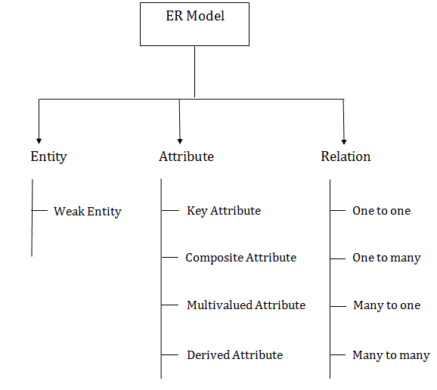

COMPOSITE – one attribute is divided into 2 or more attributes at the same time

DERIVED - Attributed is calculated or otherwise derived from another attribute, such as age from a birthdate.

MULTIVALUED: More than one attribute value is denoted, such as multiple phone numbers for a person.

SQL

**SQL COMMANDS**

DDL – Data Definition Language

DML – Data Manipulation Language

DCL – Data Control Language

TCL – Transaction Control Language

DQL – Data Query Language

**DDL COMMANDS**

* Create
* Alter
* Drop
* Truncate

**DML**

* Insert
* Update
* Delete

**DCL**

* Grant
* Revoke

**TCL**

* Commit
* Rollback
* Savepoint

**DQL**

* Select