**USER INTERFACE FOR COLLEGE PARKING LOT**

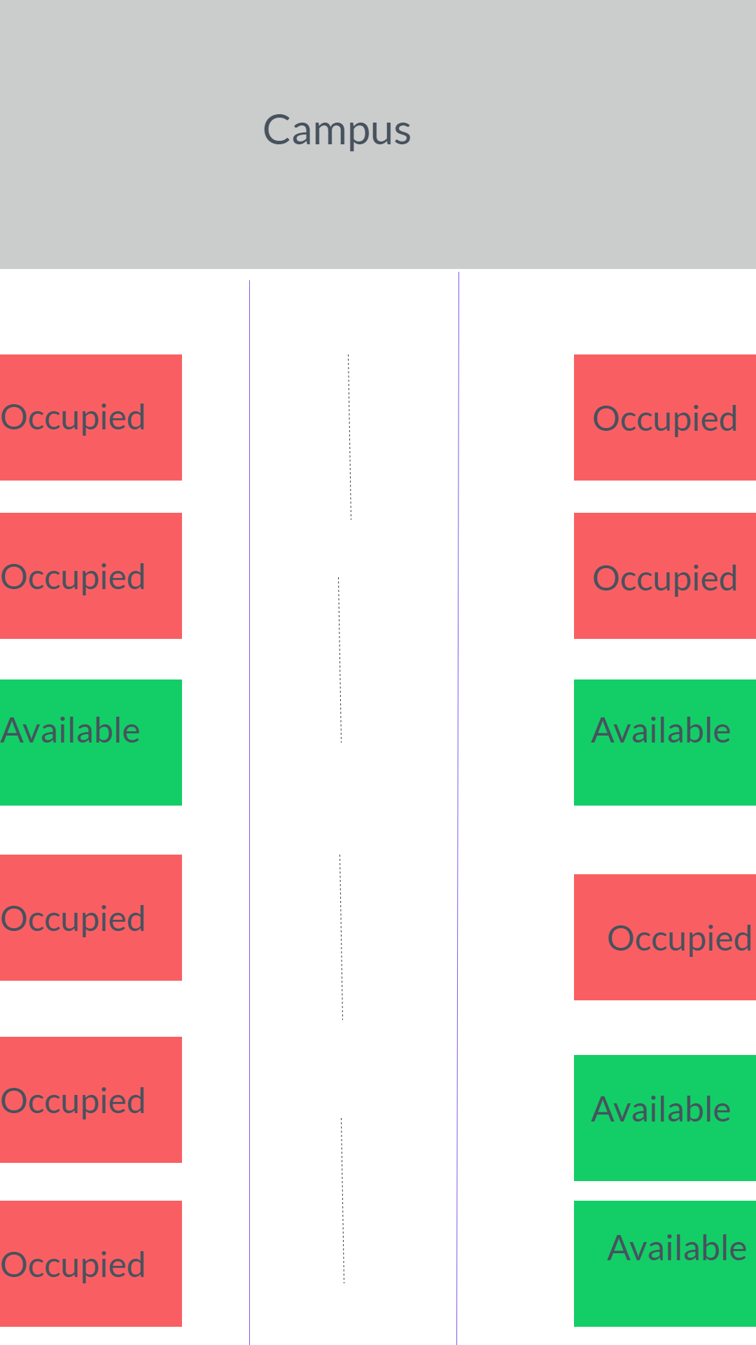

After signing into the app, the parking spots near the device will be displayed and the user will know if the spot is occupied or not.