USED CAR PRICE PREDICTION BASED ON MACHINE LEARNING

# Introduction

Determining whether the listed price of a used car is a challenging task, due to the many factors that drive a used vehicle’s price on the market. The focus of this project is developing machine learning models that can accurately predict the price of a used car based on its features, in order to make informed purchases. We implement and evaluate various learning methods on a dataset consisting of the sale prices of different makes and models . We will compare the performance of various machine learning algorithms like Linear Regression, Ridge Regression, Lasso Regression, Elastic Net, Decision Tree Regressor and choose the best out of it. Depending on various parameters we will determine the price of the car. Regression Algorithms are used because they provide us with continuous value as an output and not a categorized value because of which it will be possible to predict the actual price a car rather than the price range of a car. User Interface has also been developed which acquires input from any user and displays the Price of a car according to user’s inputs.

# Literature Survey

|  |  |  |  |  |  |
| --- | --- | --- | --- | --- | --- |
| Sl.no | Name & Year | Author  Name | Techniques used | Conclusion | Gaps Identified |
| 1 | Car Price Prediction: An Application of Machine Learning(2023) | Nirmala Koshika, et.al | R2 algorithm is used to make model | The increase in the used car market requires more data for  training. | It is challenge for user to choose from variety of cars |
| 2 | Used Car Price Prediction using Machine Learning: A Case Study(2022) | Mustapha Hankar | BeautifulSoup module used for data collection  through web | Regressor model was used to predict the value of car | Need to add more variables to the training set. |
| 3 | Price Prediction of Used Cars Using Machine Learning(2021) | Chuyang Jing et.al | Co-relation map, histogram plot | Price prediction model was created by using neural network. | Include data about interior and exterior quality of car to determine  the price. |
| 4 | Used Car Price Prediction(2021) | Praful Rane, Deep Pandya, Dhawal Kotal | Linear regression, Lasso regression, Decision tree regression. | In the era of ever increasing prices of cars, there is immediate need of system to predict accurate price of used  cars. | Bind this model to various sites which provide platform to sell used cars. |
| 5 | Predictive Analysis of Used Car Prices using Machine  Learning(2021) | Dholiya | Linear Regression | Linear regression can be used to get moderate degree  of accuracy | Produce model to predict prices of cars of different  countries |

|  |  |  |  |  |  |
| --- | --- | --- | --- | --- | --- |
| 6 | Used Car Price Prediction using Different Machine Learning  Algorithms(2020) | Abhash Anil Panwar | Linear Regression | Linear regression model here gave best results | The model can be improved by adding more features |
| 7 | Used Car Price Prediction using Linear Regression Model (2020) | J. S. Shetty | Linear Regression | Doesn’t offer more accuracy than 82% | More accuracy would be returned if train on large datasets |
| 8 | Used Car Price Prediction using Machine Learning  (2020) | Panwar Abhas Anil | Decision Tree Regression | Accuracy attained was of about 85.2% only | Can be improved by add different kind of cars |
| 9 | Used Car Price Prediction using Machine Learning  (2020) | Panwar Abhas Anil | Decision Tree Regression | Accuracy attained was of about 85.2% only | Can be improved by add different kind of cars |
| 10 | Prediction of Used Car Prices using Machine Learning Techniques(2019) | Pal | Random Forest | It is huge task to predict price of used cars, due to ever growing  market of it | To use more accurate data to train the model |

**Objectives**

* To make machine learning model which evaluates the current price of used car given its present condition, its depreciation rate and other factors which affect its pricing in current market, this will allow the buyer to get market price and reduce the chance of him/her paying more.
* This model will be beneficial for both buyers and sellers, as buyer will have full transparency about the cost of vehicle as the car will be assessed without any bias, he/she will be getting what they paid for. It is beneficial for seller as he gets to offer competitive pricing of the car and avoid selling it as underpriced vehicle & he also has upper hand in market as the selling price is backed by historical data.

# Proposed System

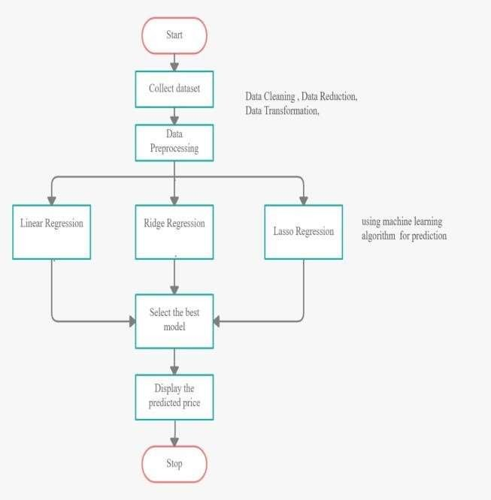

The proposed system will consists of machine learning model which predicts selling price of car based on various factors, here we train multiple model and select the best one to predict the selling price.

1. Mainly we use linear regression model as the data is not categorical data but continuous values.
2. For data collection we use various online portals which provide data sets of used car depreciation rate, selling price of them, market trends of used cars.
3. We now clean the data by identifying outliers and normalize the missing data by either filling them with median data or outright removing them.
4. Will select most important features which are required for prediction of selling price, Ex: Make year of car, engine size, distance travelled of car, color of car.

# Modules Identified

In a used car price prediction project, several modules can be identified based on the different functionalities and tasks involved. Here are some potential modules for your project:

## Data collection and preprocessing:

* 1. This module focuses on collection of datasets from various sources and identified non required fields of data and removed it, kept the necessary fields and cleaned them by identifying outliers and normalizing them.

## Model Training:

* 1. In this step we train models based on multiple algorithms.

## Model Testing:

* 1. In this step we test models we train for its accuracy and select the one which co- relates to real-time price of the car.

## Deployment:

* 1. In this step we deploy the model in real time environment so that it can be used by others.
  2. Scikit module of python can be used to make the interaction with model user- friendly and it improves the user experience of it.

## Maintenance:

* 1. This is last stage where we constantly monitor the performance of the system and handle error if occurred and fix bugs identified in production.

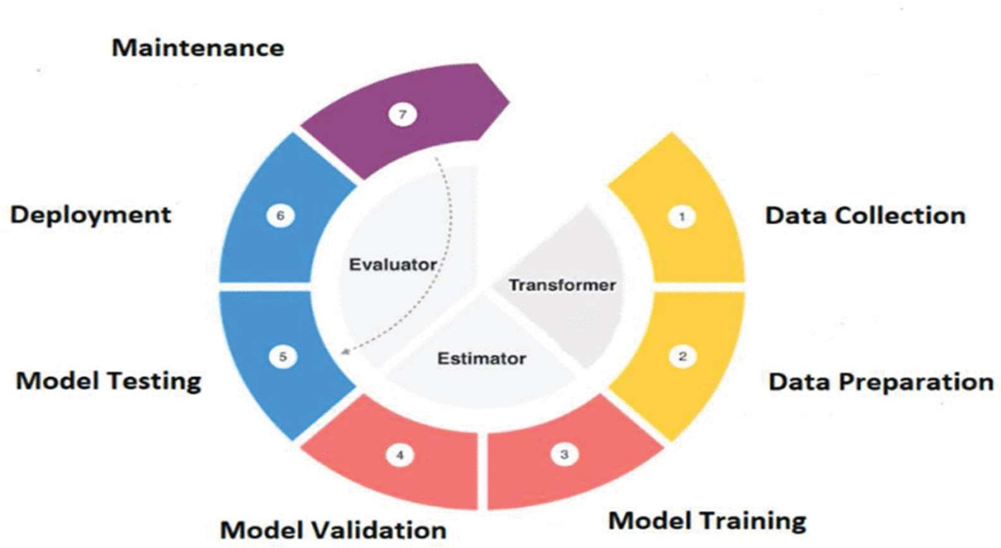

# Hardware & Software Requirements

1. **CPU:** Intel i3 3rd gen and above, AMD Ryzen 2 and above.
2. **RAM:** 4GB and above.
3. **Storage:** 150GB minimum.

## Software Requirements

1. Python3
2. Jupyter Notebook
3. Chrome