E-LEDGER FOR STUDENTS

# Introduction

Student life is one the main phase in everyone’s life where people tend to learn and get to experience many things before actually start to lead their life. Students usually are supported by their parents/guardians in the subject of using money. Parents usually give their ward small amount of money maybe monthly/weekly basis & we call it as pocket money, Students make use of this money maybe for hanging out with their friends, buying materials required for school/college purposes. As students may not have notable experience in handling and tracking money expenditures, it becomes difficult for them to manage their expenses, and to really know how much they are spending on what things.

E-Ledger aims to eliminate this problem by offering solution for the students effectively for free by providing tool where one can feed their day to day expenses and the tool shows total amount that has been spent in any given time period. By using this tool students indirectly inculcate habit of always tracking their expenses and can better analyze where there are overspending and can avoid it in future to increase their saving.

# Literature Survey

|  |  |  |  |  |  |
| --- | --- | --- | --- | --- | --- |
| Sl.no | Name & Year | Author  Name | Techniques used | Conclusion | Gaps Identified |
| 1 | Budget Planner Tool Assessment Report(2022) | Ashley Wong, Jai Singh, et.al | In detail analysis of the problem to identify room for improvements | After certain age human beings tend to neglect budgeting, which causes over the head expenses. | Need to educate people more about managing money. |
| 2 | Expense Tracker(2021) | Aman Garg, Mukul Goel, Sagar Mittal | Developed desktop solution to track expenditures | Application which aims to show people about their expenses | Have feature to summarize overall expenditure. |
| 3 | Expense Tracker: A Smart Approach to track everyday expense | Hrithik Gupta, et.al | Java & MySQL used to develop Application | Aims to reduce confusion & frustration from any user | Still lacks the feature to provide persistent backup |

**Objectives**

* Improve financial literacy: Help students understand their spending habits, track income and expenses, and develop budgeting skills.
* Promote responsible financial decision-making: Encourage students to set financial goals, prioritize needs over wants, and avoid unnecessary debt.
* Increase financial independence: Empower students to manage their finances independently and prepare for future financial responsibilities.
* Reduce stress and anxiety about finances: Provide a clear and organized system for tracking finances, which can alleviate stress and anxiety associated with money management.
* Boost academic performance: Improve time management and study habits by integrating academic progress tracking with financial records.

# Proposed System

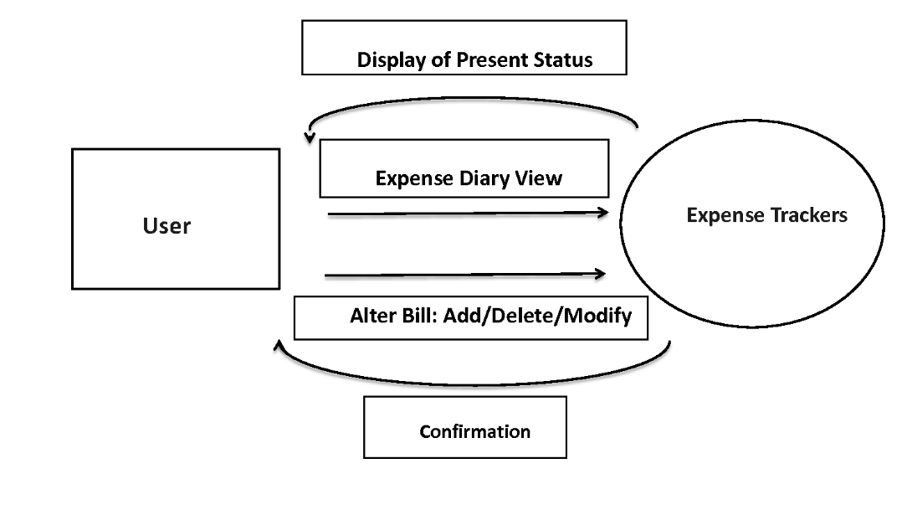

The proposed system will consist of intuitive user interface which will be web based, it will contain form which will consists many fields for helping users in tracking their expenditures.

1. Allow users to create their own account to track their expenses.
2. Allow users to use their own database to store information.
3. This allows users to choose their desirable database & their privacy will be maintained.
4. Enable user to protect their account with safe password.

# Modules Identified

In this project of creating a web based platform for enabling student to track their expenses, there are several modules that we have identified, some of them are:

## Creation of attractive landing page:

* 1. Whenever we are creating web based service, we have to make sure that we make the landing page i.e first page user is showed when he/she visits our site is as much attractive and intuitive as possible.
  2. It should make them organically sign-up to our services and start using them.

## Selecting database for efficient storage:

* 1. We need storage solution for saving all the expenditure of the students, and one of the storage solutions we have identified for this project is using google firebase database.
  2. This is NoSQL type of database which does not have fixed schema, this is helpful in this scenario as every student has different expenditure.

## Account Creation:

* 1. In this stage we work on how exactly we enable our users to create account to use our services.
  2. Google cloud platform allows us to use “Sign-in with Google” feature, this will significantly enable us to onboard many users in short period of time.

## Deployment:

* 1. We can purchase attractive, easy to remember domain where we can host this site.

## Maintenance:

* 1. Initial setup cost can be managed.
  2. We can always ask students to pledge, contribute how much ever they can to keep the service going on.
  3. The webpage can be even hosted by students themselves, hence not needing to use our platform all the time.

# Hardware & Software Requirements

1. **CPU:** Intel i3 3rd gen and above, AMD Ryzen 2 and above.
2. **RAM:** 4GB and above.
3. **Storage:** 150GB minimum.

## Software Requirements

1. Visual Studio Code
2. Chrome Browser
3. NodeJS
4. Google Cloud Platform account