**Mini Project report on**

**“E-ledger for students”**

*A mini project dissertation submitted in partial fulfilment of the requirement for the award of degree*

**MASTER OF COMPUTER APPLICATIONS**

by

**Anirudh Uday Parvatikar 1BY22MC007**

**Keerthana N, 1BY22MC023**

**Under the Guidance of**

**Prof. Nirupama. B. K**

Assistant Professor

Department of MCA

BMSIT&M

Bengaluru-560064



**Department of Master of Computer Applications**

**BMS Institute of Technology and Management**

**(An Autonomous Institution, Affiliated to VTU, Belagavi)**

**Bengaluru – 560064**

**MARCH-2024**

**BMS INSTITUTE OF TECHNOLOGY AND MANAGEMENT**

**(An Autonomous Institution, Affiliated to VTU, Belagavi)**

**Bengaluru – 560064**

**SEPTEMBER-2023**

**Department of MCA**

(Accredited by NBA, New Delhi)



**CERTIFICATE**

This is to certify that **Mr. Anirudh Uday Parvatikar** bearing USN **1BY21MC007, Ms. Keerthana N** bearing USN **1BY21MC023** has successfully completed the VTU prescribed **Mini Project Work – 1 (22MCA307)** titled **“E-ledger for students”** at **Department of MCA, BMS Institute of Technology and Management, Bengaluru** under the guidance of **Ms. Nirupama. B. K, Assistant Professor, Department of MCA** during the period from **DECEMBER 2023 to APRIL 2024.**

Signature of the Guide Signature of HoD

**Ms. Nirupama. B. K Dr. M.Sridevi**

Assistant Professor Assistant Professor & Head

Department of MCA Department of MCA

BMSIT&M BMSIT&M

Bengaluru. Bengaluru

**BMS INSTITUTE OF TECHNOLOGY AND MANAGEMENT**

**(An Autonomous Institution, Affiliated to VTU, Belagavi)**

**Bengaluru – 560064**

**Department of MCA**



**VISION**

To develop quality professionals in Computer Applications who can provide sustainable solutions to the societal and industrial needs.

**MISSION**

Facilitate effective learning environment through quality education, state-of-the-art facilities, and orientation towards research and entrepreneurial skills.

**Programme Educational Objectives (PEOs)**

**PEO 1:** Develop innovative IT applications to meet industrial and societal needs.

**PEO 2:** Adapt themselves to changing IT requirements through life-long learning.

**PEO 3:** Exhibit leadership skills and advance in their chosen career.

**BMS INSTITUTE OF TECHNOLOGY AND MANAGEMENT**

**(An Autonomous Institution, Affiliated to VTU, Belagavi)**

**Bengaluru – 560064**

**Department of MCA**

**Programme Outcomes (POs)**

**PO 1:** Apply knowledge of computing fundamentals, computing specialization, mathematics and domain knowledge to provide IT solutions.

**PO 2:** Identify, analyse and solve IT problems using fundamental principles of mathematics and computing sciences.

**PO 3:** Design, Develop and evaluate software solutions to meet societal and environmental concerns.

**PO 4:** Conduct investigations of complex problems using research-based knowledge and methods to provide valid conclusions.

**PO 5:** Select and apply appropriate techniques and modern tools for complex computing activities.

**PO 6:** Understand professional ethics, cyber regulations and responsibilities.

**PO 7:** Involve in life-long learning for continual development as an IT professional.

**PO 8:** Apply and demonstrate computing and management principles to manage projects in multidisciplinary environments by involving in different roles.

**PO 9:** Comprehend & write effective reports and make quality presentations.

**PO 10:** Understand the impact of IT solutions on socio-environmental issues.

**PO 11:** Work collaboratively as a member or leader in multidisciplinary teams.

**PO 12:** Identify potential business opportunities and innovate to create value for the society and seize that opportunity.

**BMS INSTITUTE OF TECHNOLOGY AND MANAGEMENT**

**(An Autonomous Institution, Affiliated to VTU, Belagavi)**

**Bengaluru – 560064**

**Department of MCA**

**Course Outcomes (COs)**

**CO 1:** Analyse the given requirements.

**CO 2:** Design a suitable system model.

**CO 3:** Develop the solution using appropriate tools.

**CO 4**: Prepare effective documentation.

**CO 5:** Involve in team work.

# 

# ABSTRACT

The "Used Car Price Prediction using Machine Learning with Linear Regression" project aims to develop a predictive model that estimates the price of pre-owned vehicles based on various attributes. Leveraging the power of machine learning, specifically employing the Linear Regression algorithm, this project demonstrates an effective approach to provide valuable insights for both buyers and sellers in the used car market.

The dataset utilized for training and testing the model encompasses a diverse range of features, including make, model, year, mileage, condition, and other relevant factors. Through extensive data preprocessing, feature selection, and engineering, the model is trained to learn the underlying relationships between these attributes and the corresponding prices.

**Keywords: Web development, Cloud computing, Front end designing**

**TABLE OF CONTENTS**

Page No.

1. **INTRODUCTION 01**
   1. Project description 01
2. **LITERATURE SURVEY 03**
   1. Existing system 08
   2. Proposed System 09
   3. Tools and Technologies used 09
   4. System study 13
      1. Feasibility 13
      2. Technical Feasibility 13
      3. Operational Feasibility 13
      4. Economic Feasibility 13
   5. System requirements 14
      1. Hardware Requirements 14
      2. Software Requirements 14
3. **SOFTWARE REQUIREMENTS SPECIFICATION 15**
   1. Functional requirements 15
   2. Non-Functional requirements 16
4. **SYSTEM DESIGN 17**
   1. System Architecture 17
   2. Context Diagram 18
5. **DETAILED DESIGN 19**
   1. Sequence diagram 19
   2. Data flow diagram 20
   3. Activity diagram 22
   4. Use Case diagram 25
6. **IMPLEMENTATION 26**
   1. Snippet code 26
   2. Screenshots 31
7. **SOFTWARE TESTING 36**
   1. System Testing 36
   2. Test Cases 38
8. **CONCLUSION 40**
9. **FUTURE ENHANCEMENTS 41**
10. **BIBLIOGRAPHY 42**
11. **PLAGIARISM REPORT 43**

**LIST OF FIGURES**

|  |  |  |
| --- | --- | --- |
| SLNO | PARTICULARS | PAGE NO |
|  |  |  |
|  |  |  |
|  |  |  |
|  |  |  |
|  |  |  |
|  |  |  |
|  |  |  |
|  |  |  |
|  |  |  |
|  |  |  |
|  |  |  |
|  |  |  |
|  |  |  |
|  |  |  |
|  |  |  |
|  |  |  |

**LIST OF TABLES**

|  |  |  |
| --- | --- | --- |
| SLNO | PARTICULARS | PAGE NO |
|  |  |  |
|  |  |  |
|  |  |  |
|  |  |  |
|  |  |  |
|  |  |  |
|  |  |  |
|  |  |  |
|  |  |  |

1.INTRODUCTION

Student life is one the main phase in everyone’s life where people tend to learn and get to

experience many things before actually start to lead their life. Students usually are supported by

their parents/guardians in the subject of using money. Parents usually give their ward small

amount of money maybe monthly/weekly basis & we call it as pocket money, Students make use

of this money maybe for hanging out with their friends, buying materials required for

school/college purposes. As students may not have notable experience in handling and tracking

money expenditures, it becomes difficult for them to manage their expenses, and to really know

how much they are spending on what things.

E-Ledger aims to eliminate this problem by offering solution for the students effectively for

free by providing tool where one can feed their day-to-day expenses and the tool shows total

amount that has been spent in any given time period. By using this tool students indirectly

inculcate habit of always tracking their expenses and can better analyze where there are

overspending and can avoid it in future to increase their saving.

2.LITERATURE SURVEY

2.1. Existing system

In the current system, students often rely on maintaining a physical ledger or diary to record their expenses. However, this approach can lead to several challenges. Firstly, there is the risk of forgetting the diary or misplacing it, which can result in incomplete records. Additionally, students may encounter issues such as running out of pages in the physical book, necessitating the transfer of data to a new ledger. One of the most problematic issues is the manual totaling of expenses, which can be time-consuming and stressful for the average student. These inefficiencies not only consume valuable time but also increase the likelihood of errors in financial tracking. Implementing an electronic ledger system could alleviate these challenges by providing a digital platform for recording and totalling expenses efficiently. Such a system would offer convenience, accuracy, and accessibility, ultimately relieving students of unnecessary stress and streamlining their financial management processes.

2.2. Proposed System

In our proposed system, we have developed a web-based solution aimed at enhancing the efficiency of expense recording by digitizing students' expenditure logs. This solution offers features such as cloud storage, facilitating the calculation of daily total expenditure for each month, and ensuring greater accessibility to the ledger. By opting for a web-based approach, our goal is to make this solution available to as many students as possible at a negligible cost. This not only improves the convenience and accuracy of expense tracking but also promotes financial awareness and responsibility among students.

2.3.Tools and Technology used

1. Google firebase cloud storage

2. VS Code IDE for development

3. node js for javascript development

2.4.System study

**2.4.1.Feasibility study:**

The feasibility of the project is analyzed in this phase and business proposal is put forth with a very general plan for the project and some cost estimates. During system analysis the feasibility study of the proposed system is to be carried out. This is to ensure that the proposed system is not a burden to the company. For feasibility analysis, some understanding of the major requirements for the system is essential.

**2.4.2 Technical Feasibility study:**

This study is carried out to check the technical feasibility, that is, the technical requirements of the system. Any system developed must not have a high demand on the available technical resources. This will lead to high demands on the available technical resources. This will lead to high demands being placed on the client. The developed system must have a modest requirement, as only minimal or null changes are required for implementing this system.

**2.4.3 Operational Feasibility study:**

The aspect of study is to check the level of acceptance of the system by the user. This includes the process of training the user to use the system efficiently. The user must not feel threatened by the system, instead must accept it as a necessity. The level of acceptance by the users solely depends on the methods that are employed to educate the user about the system and to make him familiar with it. His level of confidence must be raised so that he is also able to make some constructive criticism, which is welcomed, as he is the final user of the system.

**2.4.4 Economic Feasibility study:**

This study is carried out to check the economic impact that the system will have on the organization. The amount of fund that the company can pour into the research and development of the system is limited. The expenditures must be justified. Thus, the developed system as well within the budget and this was achieved because most of the technologies used are freely available. Only the customized products had to be purchased.

2.5. System requirements

**2.5.1. Hardware Requirements:**

1. CPU: Intel i3 3rd gen and above, AMD Ryzen 2 and above.

2. RAM: 4GB and above.

3. Storage: 150GB minimum.

**2.5.2 Software Requirements:**

1. Python3

2. Jupyter Notebook

3. Chrome

4. Pip install

3.SOFTWARE REQUIREMENTS SPECIFICATION

The software requirements document is the specification of the system. It should include both a definition and a specification of requirements. Itis a set of what the system should do rather than how it should do it. The software requirements provide a basis for creating the software requirements specification. It is useful in estimating cost, planning team activities,

performing tasks and tracking the teams and tracking the team’s progress throughout the development activity.

OPERATING SYSTEM: Windows 10 or above

CODING LANGUAGE: Python

WEB FRAMEWORK: Streamlit

3.1. Functional requirements

A Functional Requirement (FR) is a description of the service that the software must offer. It describes a software system or its component. Afunction is nothing but inputs to the software system, its behavior, and outputs. It can be a calculation, data manipulation, business process, userinteraction, or any other specific functionality which defines what function a system is likely to perform. Functional RequirementsinSoftware Engineering are also called Functional Specification

3.2. Non-Functional requirements

Non-Functional Requirements are the constraints or the requirements imposed on the system. They specify the quality attribute of the software. Non-Functional Requirements deal with issues like scalability, maintainability, performance, portability, security, reliability, and many more. Non-Functional Requirements address vital issues of quality for software system.

4. SYSTEM DESIGN

4.1.System Architecture

Designing of system is the process in which it is used to define the interface, modules and data for a system to specify the demand to satisfy. System design is seen as the application of the system theory. The main thing of the design a system is to develop the system architecture by giving the data and information that is necessary for the implementation of a system.



Input

Dataset

Pre- proces sing and Featur

Linear Regressione essor

Predicted Results: Prediction Of Used

Performance Analysis and Graph

#### Fig: 4.1 System Architecture(car price prediction)

5. DETAILED DESIGN

5.1 Sequence diagram

A sequence diagram in Unified Modeling Language (UML) is a kind of interaction diagram that shows how processes operate with one another and in what order. It is a construct of a Message Sequence Chart. Sequence diagrams are sometimes called event diagrams, event scenarios, and timing diagrams.

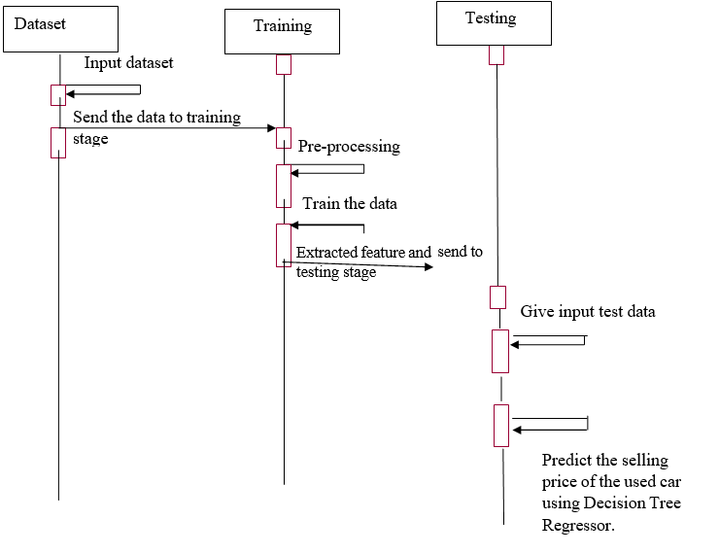

5.2 Class Diagram

In software engineering, a class diagram in the Unified Modeling Language (UML) is a type of static structure diagram that describes the structure of a system by showing the system's classes, their attributes, operations (or methods), and the relationships among the classes. It explains which class contains information.

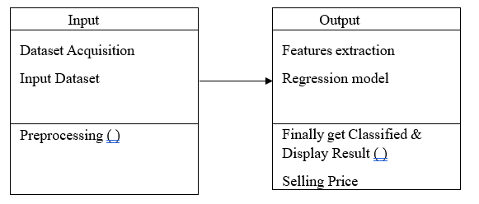

Fig: 5.2 Class Diagram

5.3 Activity Diagram

Activity diagrams are graphical representations of workflows of stepwise activities and actions with support for choice, iteration and concurrency. In the Unified Modeling Language, activity diagrams can be used to describe the business and operational step-by-step workflows of components in a system. An activity diagram shows the overall flow of control.

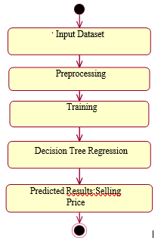

Fig: 5.3 Activity diagram

5.4 Data Flow Diagram

DFD is also known as bubble chart. A DFD may be used to represent a system at any level of abstraction. DFD may be partitioned into levels that represent increasing information flow and

abstraction. DFD may be partitioned into levels that represent increasing information flow and functional detail.

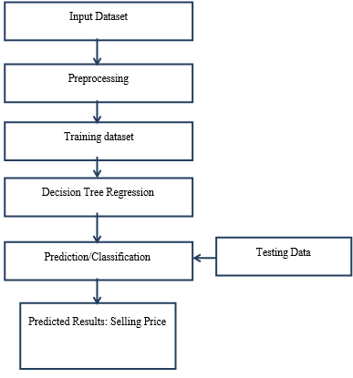

Fig: 4.2 Data Flow Diagram

6. IMPLEMENTATION

6.1 Snippet Code

6.2.Screenshots

7.SYSTEM TESTING

7.1 Integration Testing

Software integration testing is the incremental integration testing of two or more integrated software components on a single platform to produce failures caused by interface defects. The task of the integration test is to check that components or software applications, e.g. components in a software system or – one step up – software applications at the company level – interact without error.

Test Results: All the test cases mentioned above passed successfully. No defects encountered.

7.2 Acceptance Testing

User Acceptance Testing is a critical phase of any project and requires significant participation by the end user. It also ensures that the system meets the functional requirements.

Test Results: All the test cases mentioned above passed successfully. No defects encountered.

8.CONCLUSION

It can be concluded by saying that increased prices of new cars and the monetary lack of ability of clients to get them Used Car market is expanding globally. Therefore, there is an urgent need for a Used Car Price Prediction system that viably determines price of the car using a variety of features. The process of predicting used cars price involves high caution and great knowledge in the field of cars and their models. Our proposed system using Linear Regression achieved good results in predicting the used car prices .

9.FUTURE ENHANCEMENT

Although the model designed here is restricted to predict the price of used cars it can be extended to any electric gadget or household appliance as well. The model can be connected to real-time websites whose data can be scrapped and the model gets trained based on the dynamic dataset using reinforcement learning. The model can be extended to get trained on clusters of data rather than on a small dataset. The accuracy of the model can be increased using large historical data. The model can be deployed on the web using API (Application User Interfaces) like Heroku, REST, Git, etc.

10.BIBLIOGRAPHY