**BMS INSTITUTE OF TECHNOLOGY AND MANAGEMENT**

**Doddaballapura Road, Avalahalli, Yelahanka, Bangalore-560064 Affiliated to Visvesvaraya Technological University**



**DEPARTMENT OF MCA 2nd SEMESTER MCA**

**COURSE: MOBILE APPLICATIONS LABORATORY**

**COURSE CODE: 22MCA202 LABORATORY MANUAL**

**Prepared by: Prof. Dwarakanath G V, Assistant Professor**

**Reviewed by: Prof. Shivakumara T, Assistant Professor**

**ACADEMIC YEAR: 2022-23 (EVEN)**

**Department of MCA**

**Department Vision**

To develop quality professionals in Computer Applications who can provide sustainable solutions to the societal and industrial needs

**Department Mission**

Facilitate effective learning environment through quality education, state-of-the-art facilities, and orientation towards research and entrepreneurial skills

Programme Educational Objectives (PEOs)

**PEO1:** Develop innovative IT applications to meet industrial and societal needs **PEO2:** Adapt themselves to changing IT requirements through life-long learning **PEO3:** Exhibit leadership skills and advance in their chosen career

Programme Outcomes (POs)

**PO1:** Apply knowledge of computing fundamentals, computing specialization, mathematics and domain knowledge to provide IT solutions.

**PO2:** Identify, analyse and solve IT problems using fundamental principles of mathematics and computing sciences.

**PO3:** Design, Develop and evaluate software solutions to meet societal and environmental concerns.

**PO4:** Conduct investigations of complex problems using research based knowledge and methods to provide valid conclusions.

**PO5:** Select and apply appropriate techniques and modern tools for complex computing activities.

**PO6:** Understand professional ethics, cyber regulations and responsibilities.

**PO7:** Involve in life-long learning for continual development as an IT professional.

**PO8:** Apply and demonstrate computing and management principles to manage projects in multidisciplinary environments by involving in different roles

**PO9:** Comprehend& write effective reports and make quality presentations.

**PO10:** Understand and assess the impact of IT solutions on socio-environmental Issues.

**PO11:** Work collaboratively as a member or leader in multidisciplinary teams.

**PO12:** Identify potential business opportunities and innovate to create value to the society and seize that opportunity.

Course Title: Mobile Applications Laboratory Course Code: 21MCA2064

Course Outcomes (PEOs)

CO1: Explore the design features of mobile devices.

CO2: Develop applications using views, intents, fragments and graphics.

CO3: Design an application using Internal and external database.

CO4: Design an application using image capturing and location based.

CO5: Develop a mobile application based on societal and environmental issues.

Laboratory Instructions:

|  |  |
| --- | --- |
| **Hardware Requirements:** | |
| Hardware | Above 4GB Ram, Latest Graphic Card, and Android Mobile Phone, Multimedia  supported Keyboard and mouse |
| **Software Requirements:** | |
| Operating System | Windows (2007 onwards) / Linux OS (Ubuntu / Fedora) |
| IDE | Android Studio with Android SDK |
| Programming  Language/s | JAVA JDK 8 onwards |
| Script | JavaScript, PHP, PERL |
| Emulator | Built-in with Android Studio or Geny Motion |
| Database | Built-in SQLite or Firebase |

Note:

1. **Students are required to execute one question from lot of all 9 Questions.**
2. **Change of program is not permitted in the examination.**

Particulars of the Experiments to be Performed CONTENTS

|  |  |  |
| --- | --- | --- |
| **Experiment No.** | **Programs** | **Page No.** |
| 1 | Develop a standard calculator application to perform basic calculations like addition, subtraction, multiplication and  division using 2 EditText and 1 TextView for displaying result. | 7 |
| 2 | Develop a mobile application to register a form in first activity and display the registered information in second  activity using intents. | 19 |
| 3 | Develop a mobile application to list the tourist places of  Karnataka using ListView. | 26 |
| 4 | Create an application that uses Layout Managers and Event  Listeners. | 32 |
| 5 | Devise an application that draws basic graphical primitives  (rectangle, circle) on the screen | 36 |
| 6 | Build an mobile application that create, save, update and  delete data in a database. | 38 |
| 7 | Develop a mobile application that uses GPS location  information | 48 |
| 8 | Create an application that writes data to the SD card. | 52 |
| 9 | Implement an application that creates an alert upon receiving  a message. | 56 |

**Program-1: Develop a standard calculator application to perform basic calculations like addition, subtraction, multiplication and division** using 2 EditText and 1 TextView for displaying result. (Android

4.0 version used)

Xml:

*<?*xml version="1.0" encoding="utf-8"*?>*

<LinearLayout xmlns:android="<http://schemas.android.com/apk/res/android>" android:orientation="vertical" android:layout_width="match_parent" android:layout_height="match_parent" android:layout_margin="20dp">

<EditText android:id="@+id/editText1"

android:layout_width="match_parent" android:layout_height="wrap_content" android:layout_weight="1" android:inputType="numberDecimal" android:textSize="20sp" />

<EditText android:id="@+id/editText2"

android:layout_width="match_parent" android:layout_height="wrap_content" android:layout_weight="1" android:inputType="numberDecimal" android:textSize="20sp" />

<Button android:id="@+id/Add"

android:layout_width="match_parent" android:layout_height="wrap_content" android:layout_weight="1" android:text="+" android:textSize="30sp"/>

<Button android:id="@+id/Sub"

android:layout_width="match_parent" android:layout_height="wrap_content" android:layout_weight="1" android:text="-" android:textSize="30sp"/>

<Button android:id="@+id/Mul"

android:layout_width="match_parent"

android:layout_height="wrap_content" android:layout_weight="1" android:text="*" android:textSize="30sp"/>

<Button android:id="@+id/Div"

android:layout_width="match_parent" android:layout_height="wrap_content" android:layout_weight="1" android:text="/" android:textSize="30sp"/>

<TextView android:id="@+id/textView"

android:layout_width="match_parent" android:layout_height="wrap_content" android:layout_marginTop="50dp" android:text="Answer is" android:textSize="30sp" android:gravity="center"/>

</**LinearLayout**> MainActivity.java

**package** com.example.lab2calculator;

**import** android.annotation.SuppressLint;

**import** androidx.appcompat.app.AppCompatActivity;

**import** android.os.Bundle; **import** android.text.TextUtils; **import** android.view.View;

**import** android.view.View.OnClickListener;

**import** android.widget.Button; **import** android.widget.EditText; **import** android.widget.TextView;

**public class** MainActivity **extends** AppCompatActivity **implements** OnClickListener { EditText **Num1**;

EditText **Num2**; Button **Add**; Button **Sub**; Button **Mul**; Button **Div**; TextView **Result**;

@Override

**protected void** onCreate(Bundle savedInstanceState) {

**super**.onCreate(savedInstanceState);

setContentView(R.layout.***activity_main***);

**Num1** = (EditText) findViewById(R.id.***editText1***); **Num2** = (EditText) findViewById(R.id.***editText2***); **Add** = (Button) findViewById(R.id.***Add***);

**Sub** = (Button) findViewById(R.id.***Sub***); **Mul** = (Button) findViewById(R.id.***Mul***); **Div** = ( Button ) findViewById ( R.id.***Div*** );

**Result** = (TextView) findViewById(R.id.***textView***); **Add**.setOnClickListener(**this**); **Sub**.setOnClickListener(**this**); **Mul**.setOnClickListener(**this**); **Div**.setOnClickListener(**this**);

}

**public void** onClick (View v)

{

**float** num1 = 0; **float** num2 = 0; **float** result = 0; String oper = **""**;

**if** (TextUtils.*isEmpty*(**Num1**.getText().toString()) || TextUtils.*isEmpty*(**Num2**.getText().toString()))

return;

num1 = Float.*parseFloat*(**Num1**.getText().toString()); num2 = Float.*parseFloat*(**Num2**.getText().toString()); **switch** (v.getId())

{

**case** R.id.***Add***: oper = **"+"**;

result = num1 + num2;

break;

**case** R.id.***Sub***: oper = **"-"**;

result = num1 - num2;

break;

**case** R.id.***Mul***: oper = **"*"**;

result = num1 * num2;

**break**; **case** R.id.***Div***:

oper = **"/"**;

result = num1 / num2;

break; default:

break;

}

**Result**.setText(num1 + **" "** + oper + **" "** + num2 + **" = "** + result);

}

@Override

**public void** onPointerCaptureChanged(**boolean** hasCapture) {

}

}

Output:

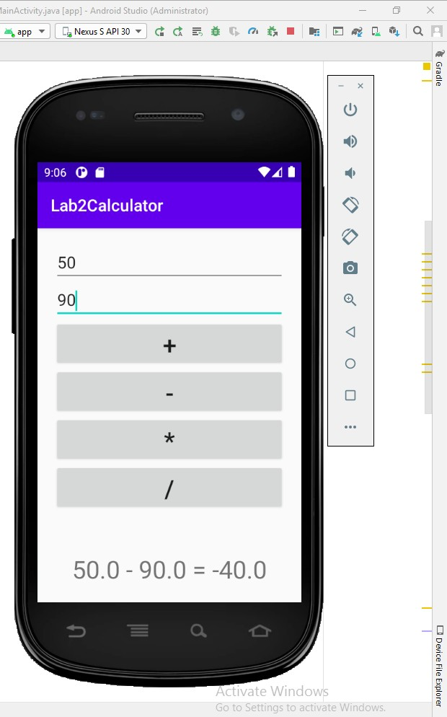

**Program-2:** Develop a mobile application to register a form in first activity and display the registered information in second activity using intents.

Solution Code:

AndroidMainfest.xml

<?xml version="1.0" encoding="utf-8"?>

<manifest xmlns:android="http://schemas.android.com/apk/res/android"

xmlns:tools="http://schemas.android.com/tools">

<application

android:allowBackup="true"

android:dataExtractionRules="@xml/data_extraction_rules"

android:fullBackupContent="@xml/backup_rules"

android:icon="@mipmap/ic_launcher"

android:label="@string/app_name"

android:roundIcon="@mipmap/ic_launcher_round"

android:supportsRtl="true"

android:theme="@style/Theme.MyIndent"

tools:targetApi="31">

<activity

android:name=".MainActivity"

android:exported="true">

<intent-filter>

<action android:name="android.intent.action.MAIN" />

<category android:name="android.intent.category.LAUNCHER" />

</intent-filter>

</activity>

<activity android:name=".DisplayActivity" />

</application>

</manifest>

activity_main.xml (First Activity)

<?xml version="1.0" encoding="utf-8"?>

<LinearLayout xmlns:app="http://schemas.android.com/apk/res-auto"

xmlns:tools="http://schemas.android.com/tools"

xmlns:android="http://schemas.android.com/apk/res/android"

android:layout_width="match_parent"

android:layout_height="match_parent"

android:orientation="vertical"

tools:context=".MainActivity">

<TextView

android:id="@+id/tv1"

android:layout_width="match_parent"

android:layout_height="wrap_content"

android:layout_marginTop="40dp"

android:fontFamily="sans-serif-black"

android:gravity="center"

android:text="Registration Form"

android:textColor="#9C27B0"

android:textSize="30dp"

android:textStyle="bold" />

<TextView

android:layout_width="match_parent"

android:layout_height="wrap_content"

android:layout_marginTop="40dp"

android:gravity="center"

android:text="Enter Full Name"

android:textColor="#9C27B0"

android:textSize="30sp"

android:textStyle="bold" />

<EditText

android:layout_marginTop="15dp"

android:layout_width="match_parent"

android:layout_height="wrap_content"

android:id="@+id/fullname"

android:hint="Full Name"

android:textSize="25dp"/>

<TextView

android:layout_width="match_parent"

android:layout_height="wrap_content"

android:layout_marginTop="25dp"

android:gravity="center"

android:text="Enter USN"

android:textColor="#9C27B0"

android:textSize="30sp"

android:textStyle="bold" />

<EditText

android:layout_marginTop="20dp"

android:layout_width="match_parent"

android:layout_height="wrap_content"

android:id="@+id/stu_usn"

android:hint="USN"

android:textSize="25dp"/>

<TextView

android:layout_width="match_parent"

android:layout_height="wrap_content"

android:layout_marginTop="25dp"

android:gravity="center"

android:text="Enter Department"

android:textColor="#9C27B0"

android:textSize="30sp"

android:textStyle="bold" />

<EditText

android:layout_marginTop="20dp"

android:layout_width="match_parent"

android:layout_height="wrap_content"

android:id="@+id/clg_Dept"

android:hint="Department"

android:textSize="25dp"/>

<Button

android:id="@+id/btn"

android:layout_width="wrap_content"

android:layout_height="wrap_content"

android:layout_gravity="center"

android:layout_marginTop="20dp"

android:background="#1A0467"

android:text="SHOW"

android:textColor="#FFFFFF"

android:textSize="25dp" />

</LinearLayout>

**Second_activity.xml (Second Activity)**

<?xml version="1.0" encoding="utf-8"?>

<RelativeLayout xmlns:android="http://schemas.android.com/apk/res/android"

android:layout_width="match_parent"

android:layout_height="match_parent"

android:gravity="top"

android:orientation="vertical">

<TextView

android:id="@+id/textView"

android:layout_width="match_parent"

android:layout_height="wrap_content"

android:layout_marginTop="100dp"

android:gravity="center"

android:text="STUDENT Details"

android:textAlignment="center"

android:textColor="#C6281C"

android:textSize="30sp"

android:textStyle="bold" />

<TextView

android:id="@+id/textView1"

android:layout_width="match_parent"

android:layout_height="wrap_content"

android:layout_marginTop="210dp"

android:gravity="center"

android:text="NAME"

android:textAlignment="center"

android:textColor="#C6281C"

android:textSize="30sp"

android:textStyle="bold" />

<TextView

android:id="@+id/Name"

android:layout_width="match_parent"

android:layout_height="wrap_content"

android:layout_marginTop="260dp"

android:gravity="center"

android:text="Empty"

android:textAlignment="center"

android:textColor="#1682D8"

android:textSize="30sp"

android:textStyle="bold" />

<TextView

android:id="@+id/textView2"

android:layout_width="match_parent"

android:layout_height="wrap_content"

android:layout_marginTop="340dp"

android:gravity="center"

android:text="USN"

android:textAlignment="center"

android:textColor="#C6281C"

android:textSize="30sp"

android:textStyle="bold" />

<TextView

android:id="@+id/usn2"

android:layout_width="match_parent"

android:layout_height="wrap_content"

android:layout_marginTop="380dp"

android:gravity="center"

android:text="Empty"

android:textAlignment="center"

android:textColor="#1375C3"

android:textSize="30sp"

android:textStyle="bold" />

<TextView

android:id="@+id/textView3"

android:layout_width="match_parent"

android:layout_height="wrap_content"

android:layout_marginTop="460dp"

android:gravity="center"

android:text="DEPARTMENT"

android:textAlignment="center"

android:textColor="#C6281C"

android:textSize="30sp"

android:textStyle="bold" />

<TextView

android:id="@+id/dept2"

android:layout_width="match_parent"

android:layout_height="wrap_content"

android:layout_marginTop="500dp"

android:gravity="center"

android:text="Empty"

android:textAlignment="center"

android:textColor="#1A70B5"

android:textSize="30sp"

android:textStyle="bold" />

</RelativeLayout>

MainActivity.java

package com.example.myindent;

import androidx.appcompat.app.AppCompatActivity;

import android.content.Intent;

import android.os.Bundle;

import android.view.View;

import android.widget.Button;

import android.widget.EditText;

public class MainActivity extends AppCompatActivity {

public static final String Efn = "com.example.MyIndent.Efn";

public static final String Eus = "com.example.MyIndent.Eus";

public static final String Ed = "com.example.MyIndent.Ed";

@Override

protected void onCreate(Bundle savedInstanceState) {

super.onCreate(savedInstanceState);

setContentView(R.layout.activity_main);

Button button = (Button) findViewById(R.id.btn);

button.setOnClickListener(new View.OnClickListener() {

public void onClick(View view)

{

DisActivity();

}

});

}

public void DisActivity() {

EditText et1 = (EditText) findViewById(R.id.fullname);

EditText et2 = (EditText) findViewById(R.id.stu_usn);

EditText et3 = (EditText) findViewById(R.id.clg_Dept);

String fn = et1.getText().toString();

String usn = et2.getText().toString();

String dept = et3.getText().toString();

Intent intent = new Intent(this,DisplayActivity.class);

intent.putExtra(Efn,fn);

intent.putExtra(Eus,usn);

intent.putExtra(Ed,dept);

startActivity(intent);

}

}

DisplayActivity.java

package com.example.myindent;

import android.content.Intent;

import android.os.Bundle;

import android.widget.TextView;

import androidx.appcompat.app.AppCompatActivity;

public class DisplayActivity extends AppCompatActivity {

@Override

public void onCreate(Bundle savedInstanceState) {

super.onCreate(savedInstanceState);

setContentView(R.layout.second_activity);

Intent intent = getIntent();

String s1 = intent.getStringExtra(MainActivity.Efn);

String s2 = intent.getStringExtra(MainActivity.Eus);

String s3 = intent.getStringExtra(MainActivity.Ed);

TextView t1 = (TextView) findViewById(R.id.Name);

TextView t2 = (TextView) findViewById(R.id.usn2);

TextView t3 = (TextView) findViewById(R.id.dept2);

t1.setText(s1);

t2.setText(s2);

t3.setText(s3);

}

}

Output:

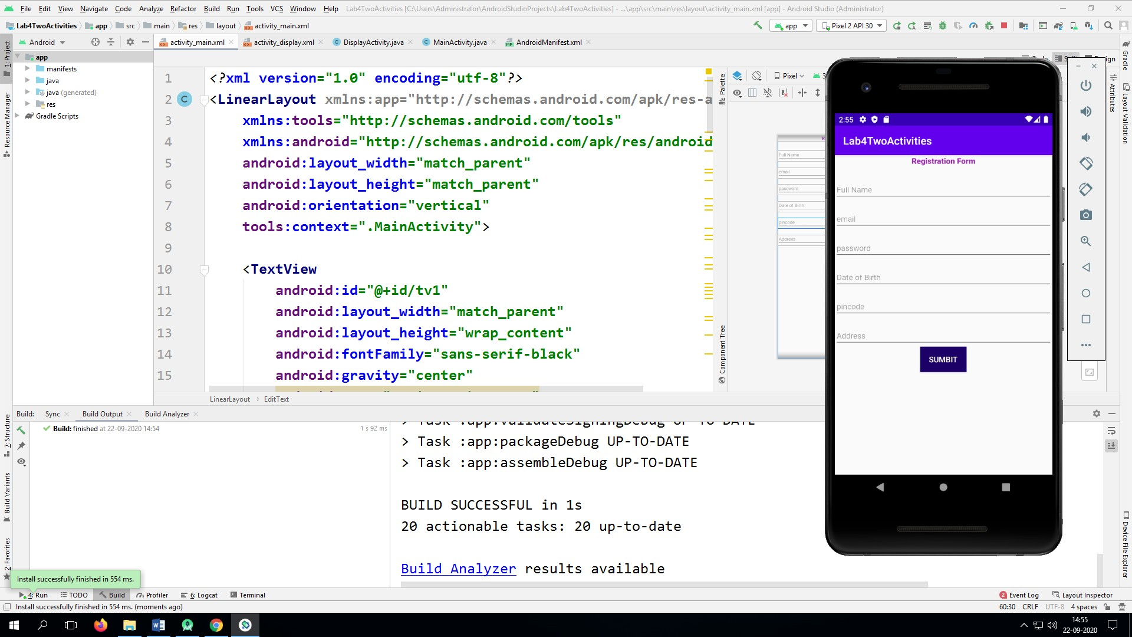

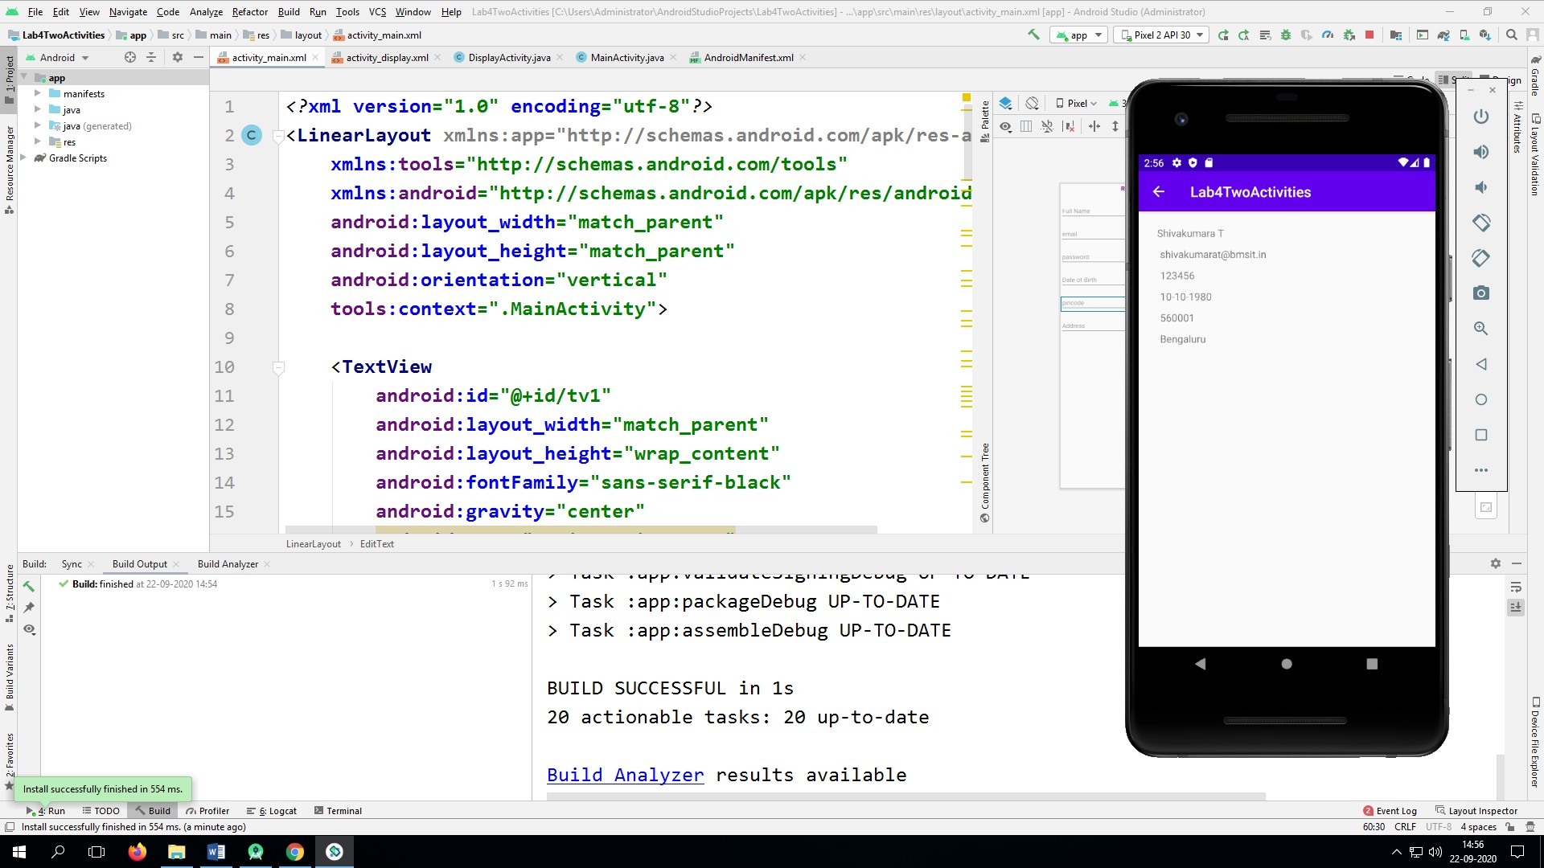

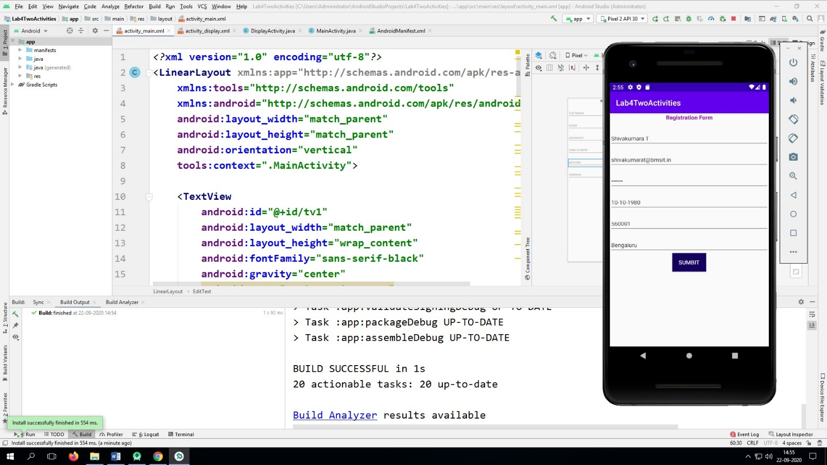

**Program-3:** Develop a mobile application to list the tourist places of Karnataka using ListView.

Solution Code:

Activity_main.xml

<?xml version="1.0" encoding="utf-8"?>

<LinearLayout xmlns:android="<http://schemas.android.com/apk/res/android>" xmlns:tools="[http://schemas.android.com/tools"](http://schemas.android.com/tools) android:layout_width="match_parent" android:layout_height="match_parent"

android:orientation="vertical" android:scrollbarTrackVertical="@drawable/gandabherunda" android:visibility="visible"

tools:context=".MainActivity" tools:visibility="visible">

<ImageView android:id="@+id/Kan"

android:layout_width="match_parent" android:layout_height="76dp" android:src="@drawable/gandabherunda" android:tooltipText="Emblem of Karnataka State" android:background="#3F51B5"/>

<TextView android:id="@+id/tours"

android:layout_width="match_parent" android:layout_height="wrap_content" android:background="#090000" android:gravity="center" android:text="Karnataka Tourist Places" android:textColor="#FFFFFF" android:textSize="30dp" android:textStyle="bold" android:fontFamily="sans-serif-medium"/>

<LinearLayout android:layout_width="wrap_content" android:layout_height="wrap_content"

>

<ListView android:id="@+id/places_list" android:layout_width="409dp" android:layout_height="729dp" tools:layout_editor_absoluteX="1dp"

tools:layout_editor_absoluteY="1dp" />

</LinearLayout>

</LinearLayout>

Res/layout/Activity_listview.xml

<?xml version="1.0" encoding="utf-8"?>

<TextView xmlns:android="<http://schemas.android.com/apk/res/android>" android:id="@+id/label"

android:layout_width="fill_parent" android:layout_height="fill_parent" android:padding="10dip" android:textSize="25dip" android:textStyle="bold" android:textColor="#690C78"

android:background="#00BCD4" android:clickable="true">

</TextView>

MainActivity.java

package com.example.program5touristplaces;

import androidx.appcompat.app.AppCompatActivity; import android.os.Bundle;

import android.view.View; import android.widget.Adapter;

import android.widget.ArrayAdapter; import android.widget.ListAdapter; import android.widget.ListView; import android.widget.TextView;

public class MainActivity extends AppCompatActivity {

String[] places = {"Bengaluru","Mysore","Nanjanagudu","Jog Falls","Agumbe", "Dharmastala", "Badami","Hampi", "Bagali", "Manasa Sarovara", "Mantralaya", "Chamundi Hills", "Sirsi", "Mahadeswara Hills", "Nandi Hills","Bijapura", "Daroji Karadi Dhama" , "SiddaroodaMatt", "Horanadu", "Sringeri","Udupi","Madikeri", "Talakadu", "Mekedatu", "Yediyur", "Adichunchanagiri", "Chitradurga","Kottur","Sangama"};

@Override

protected void onCreate(Bundle savedInstanceState) { super.onCreate(savedInstanceState); setContentView(R.layout.activity_main);

ListView listView = (ListView) findViewById(R.id.places_list);

Adapter adapter = new ArrayAdapter<String> (this,R.layout.activity_listview, places); listView.setAdapter((ListAdapter) adapter);

}

}

Output:

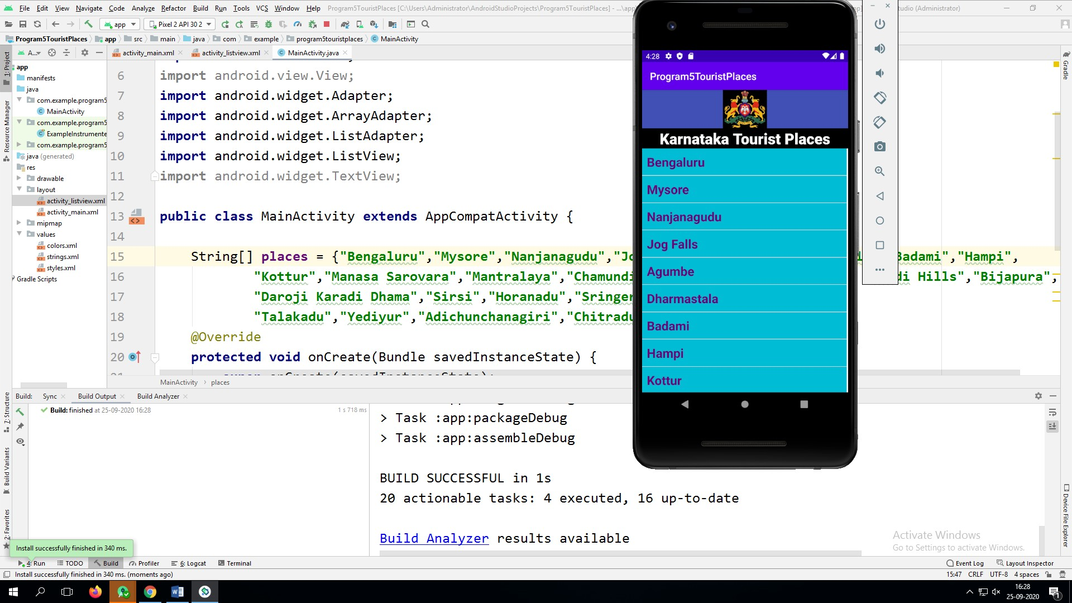

Program-4: Create an application that uses Layout Managers and Event Listeners. Xml :

*<?*xml version="1.0" encoding="utf-8"*?>*<RelativeLayout xmlns:android="http://schemas.android.com/apk/res/android" xmlns:app="http://schemas.android.com/apk/res-auto"  
 xmlns:tools="http://schemas.android.com/tools"  
 android:layout_width="match_parent"  
 android:layout_height="match_parent"  
 tools:context=".MainActivity" >  
  
 <LinearLayout  
 android:layout_width="match_parent"  
 android:layout_height="100dp"  
 android:orientation="vertical">  
  
 <TextView  
 android:id="@+id/textView"  
 android:layout_width="match_parent"  
 android:layout_height="wrap_content"  
 android:layout_gravity="center"  
 android:layout_margin="30dp"  
 android:text="DETAILS FORM"  
 android:textAlignment="center"  
 android:textColor="#3B56F1"  
 android:textSize="24sp"  
 android:textStyle="bold" />  
 </LinearLayout>  
  
 <androidx.gridlayout.widget.GridLayout  
 android:layout_width="match_parent"  
 android:layout_height="match_parent"  
 android:layout_marginTop="100dp"  
 android:layout_marginBottom="200dp"  
 app:columnCount="2"  
 app:rowCount="3">  
  
 <TextView  
 android:id="@+id/textView2"  
 android:layout_width="wrap_content"  
 android:layout_height="wrap_content"  
 android:layout_margin="10dp"  
 android:gravity="center"  
 android:text="Name"  
 android:textAlignment="center"  
 android:textColor="#4E65E6"  
 android:textSize="24sp"  
 app:layout_column="0"  
 app:layout_row="0"  
 app:layout_rowWeight="0" />  
  
 <EditText  
 android:id="@+id/editTextTextPersonName"  
 android:layout_width="wrap_content"  
 android:layout_height="wrap_content"  
 android:layout_margin="10dp"  
 android:ems="10"  
 android:inputType="textPersonName"  
 android:text="Enter Name"  
 app:layout_column="1"  
 app:layout_row="0" />

<TextView  
 android:id="@+id/textView3"  
 android:layout_width="wrap_content"  
 android:layout_height="wrap_content"  
 android:layout_margin="10dp"  
 android:gravity="center"  
 android:text="RegNo."  
 android:textAlignment="center"  
 android:textColor="#5F75ED"  
 android:textSize="24sp"  
 android:textStyle="bold"  
 app:layout_column="0"  
 app:layout_row="1" />  
  
 <EditText  
 android:id="@+id/editTextTextPersonName2"  
 android:layout_width="wrap_content"  
 android:layout_height="wrap_content"  
 android:layout_margin="10dp"  
 android:ems="10"  
 android:inputType="number"  
 android:text="Enter RegNo."  
 app:layout_column="1"  
 app:layout_row="1" />  
  
 <TextView  
 android:id="@+id/textView4"  
 android:layout_width="wrap_content"  
 android:layout_height="wrap_content"  
 android:layout_margin="10dp"  
 android:gravity="center"  
 android:text="Department"  
 android:textAlignment="center"  
 android:textColor="#5B70E1"  
 android:textSize="24sp"  
 android:textStyle="bold"  
 app:layout_column="0"  
 app:layout_row="2" />  
  
 <Spinner  
 android:id="@+id/spinner"  
 android:layout_width="wrap_content"  
 android:layout_height="wrap_content"  
 android:layout_margin="10dp"  
 android:spinnerMode="dropdown"  
 app:layout_column="1"  
 app:layout_row="2" />  
 </androidx.gridlayout.widget.GridLayout>  
  
 <Button  
 android:id="@+id/button"  
 android:layout_width="wrap_content"  
 android:layout_height="wrap_content"  
 android:layout_alignParentBottom="true"  
 android:layout_centerInParent="true"  
 android:layout_marginBottom="150dp"  
 android:text="SUBMIT"  
 android:textAlignment="center"  
 android:textColor="#E3175C"  
 android:textSize="34sp"  
 android:textStyle="bold" />  
</RelativeLayout>

*Second Activity.xml*

*<?*xml version="1.0" encoding="utf-8"*?>*<LinearLayout xmlns:android="http://schemas.android.com/apk/res/android"  
 xmlns:app="http://schemas.android.com/apk/res-auto"  
 xmlns:tools="http://schemas.android.com/tools"  
 android:layout_width="match_parent"  
 android:layout_height="match_parent"  
 android:gravity="center"  
 android:orientation="vertical"  
 tools:context=".Second_activity">  
  
 <TextView  
 android:id="@+id/textView5"  
 android:layout_width="wrap_content"  
 android:layout_height="wrap_content"  
 android:layout_margin="20dp"  
 android:text="NEW TEXT"  
 android:textAlignment="center"  
 android:textColor="#4962E8"  
 android:textSize="30sp"  
 android:textStyle="bold" />  
  
 <TextView  
 android:id="@+id/textView6"  
 android:layout_width="wrap_content"  
 android:layout_height="wrap_content"  
 android:layout_margin="20dp"  
 android:text="NEW TEXT"  
 android:textAlignment="center"  
 android:textColor="#4B61DD"  
 android:textSize="30sp"  
 android:textStyle="bold" />  
  
 <TextView  
 android:id="@+id/textView7"  
 android:layout_width="wrap_content"  
 android:layout_height="wrap_content"  
 android:layout_margin="20dp"  
 android:text="NEW TEXT"  
 android:textAlignment="center"  
 android:textColor="#3F51B5"  
 android:textSize="30sp"  
 android:textStyle="bold" />  
</LinearLayout>

Java:

package com.example.myprogram4app;  
  
import androidx.appcompat.app.AppCompatActivity;  
  
import android.os.Bundle;  
import android.view.View;  
import android.widget.ArrayAdapter;  
import android.widget.Button;  
import android.widget.EditText;  
import android.widget.Spinner;  
import android.content.Intent;  
  
public class MainActivity extends AppCompatActivity {  
  
 *//Defining the Views*

EditText e1,e2;  
 Button bt;  
 Spinner s;  
  
 *//Data for populating in Spinner* String [] dept_array={"CSE","ECE","IT","Mech","Civil","MCA"};  
  
 String name,reg,dept;  
  
 @Override  
 protected void onCreate(Bundle savedInstanceState) {  
 super.onCreate(savedInstanceState);  
 setContentView(R.layout.*activity_main*);  
  
 *//Referring the Views* e1= (EditText) findViewById(R.id.*editTextTextPersonName*);  
 e2= (EditText) findViewById(R.id.*editTextTextPersonName2*);  
  
 bt= (Button) findViewById(R.id.*button*);  
  
 s= (Spinner) findViewById(R.id.*spinner*);  
  
 *//Creating Adapter for Spinner for adapting the data from array to Spinner* ArrayAdapter adapter= new ArrayAdapter(MainActivity.this,android.R.layout.*simple_spinner_dropdown_item*,dept_array);  
 s.setAdapter(adapter);  
  
 *//Creating Listener for Button* bt.setOnClickListener(new View.OnClickListener() {  
 @Override  
 public void onClick(View v) {  
  
 *//Getting the Values from Views(Edittext & Spinner)* name=e1.getText().toString();  
 reg=e2.getText().toString();  
 dept=s.getSelectedItem().toString();  
  
 *//Intent For Navigating to Second Activity* Intent i = new Intent(MainActivity.this,Second_activity.class);  
  
 *//For Passing the Values to Second Activity* i.putExtra("name_key", name);  
 i.putExtra("reg_key",reg);  
 i.putExtra("dept_key", dept);  
  
 startActivity(i);  
  
 }  
 });  
 }  
}

Second_Activity.java

package com.example.myprogram4app;  
  
import androidx.appcompat.app.AppCompatActivity;  
  
import android.os.Bundle;  
import android.widget.TextView;  
import android.content.Intent;  
  
public class Second_activity extends AppCompatActivity {  
  
 TextView t1,t2,t3;

String name,reg,dept;  
  
 @Override  
 protected void onCreate(Bundle savedInstanceState) {  
 super.onCreate(savedInstanceState);  
 setContentView(R.layout.*activity_second*);  
  
 t1= (TextView) findViewById(R.id.*textView5*);  
 t2= (TextView) findViewById(R.id.*textView6*);  
 t3= (TextView) findViewById(R.id.*textView7*);  
  
 *//Getting the Intent* Intent i = getIntent();  
  
 *//Getting the Values from First Activity using the Intent received* name=i.getStringExtra("name_key");  
 reg=i.getStringExtra("reg_key");  
 dept=i.getStringExtra("dept_key");  
  
 *//Setting the Values to Intent* t1.setText(name);  
 t2.setText(reg);  
 t3.setText(dept);  
  
 }  
}

Output:

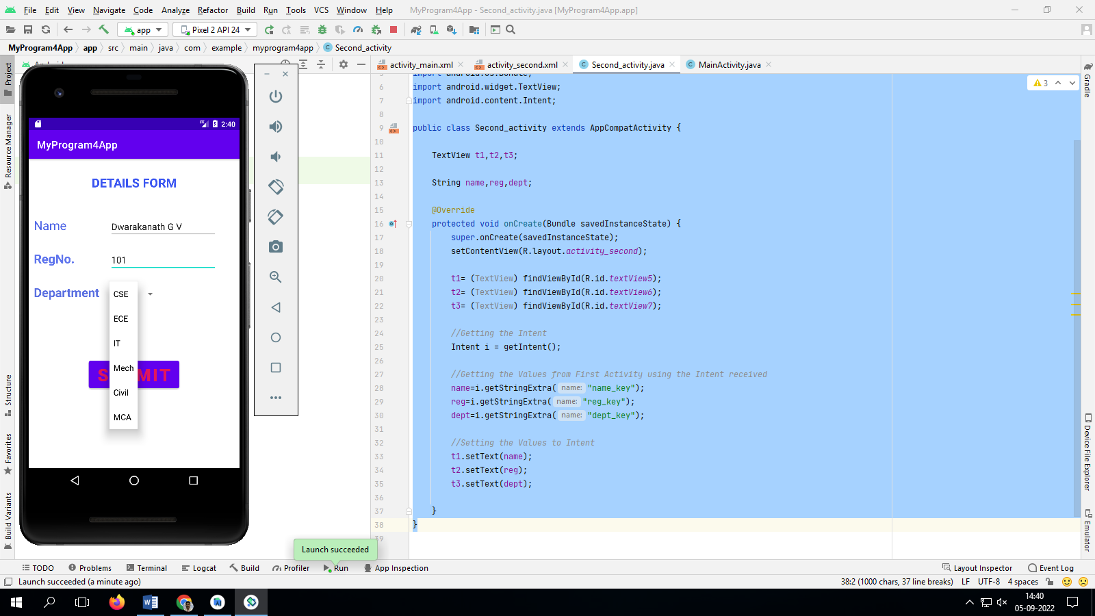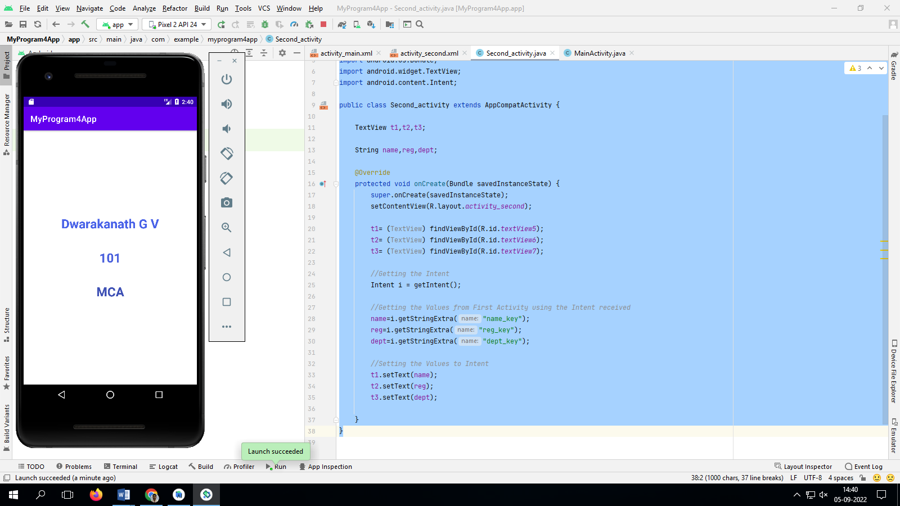

Program-5: Devise an application that draws basic graphical primitives (rectangle, circle) on the screen

Xml:

*<?*xml version="1.0" encoding="utf-8"*?>*

<RelativeLayout xmlns:android="<http://schemas.android.com/apk/res/android>" android:layout_width="match_parent" android:layout_height="match_parent">

<ImageView android:layout_width="match_parent" android:layout_height="match_parent" android:id="@+id/imageView" />

</RelativeLayout>

Java:

**package** com.example.prog4;

**import** androidx.appcompat.app.AppCompatActivity;

**import** android.os.Bundle; **import** android.graphics.Bitmap; **import** android.graphics.Canvas; **import** android.graphics.Color; **import** android.graphics.Paint;

**import** android.graphics.drawable.BitmapDrawable;

**import** android.os.Bundle;

**import** android.widget.ImageView;

**public class** MainActivity **extends** AppCompatActivity { @Override

**protected void** onCreate(Bundle savedInstanceState) { **super**.onCreate ( savedInstanceState ); setContentView ( R.layout.***activity_main*** );

Bitmap bg = Bitmap.*createBitmap*(720, 1280, Bitmap.Config.***ARGB_8888***); ImageView i = (ImageView) findViewById(R.id.***imageView***); i.setBackgroundDrawable(**new** BitmapDrawable(bg));

Canvas canvas = **new** Canvas(bg); Paint paint = **new** Paint();

paint.setColor(Color.***BLUE***); paint.setTextSize(50);

canvas.drawText(**"Rectangle"**, 420, 150, paint);

canvas.drawRect(400, 200, 650, 700, paint);

canvas.drawText(**"Circle"**, 120, 150, paint);

canvas.drawCircle(200, 350, 150, paint);

canvas.drawText(**"Square"**, 120, 800, paint);

canvas.drawRect(50, 850, 350, 1150, paint);

canvas.drawText(**"Line"**, 480, 800, paint);

canvas.drawLine(520, 850, 520, 1150, paint);

}

}

Output:

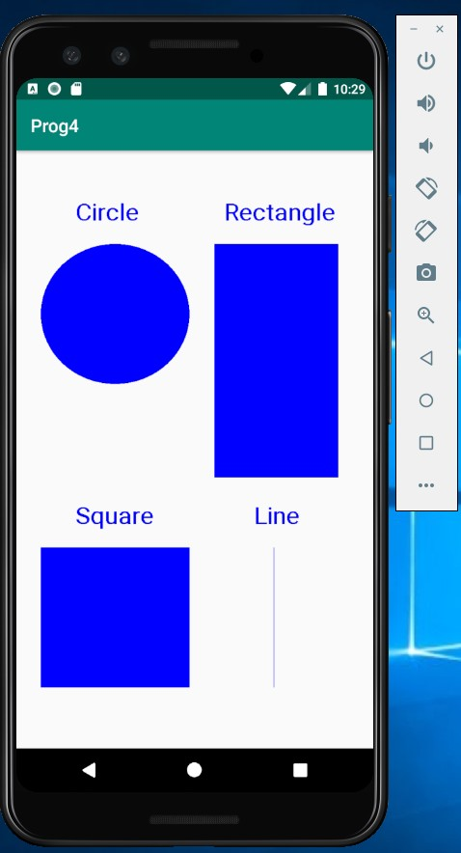

Program-6: Build a mobile application that create, save, update and delete data in a database. Xml:

*<?*xml version="1.0" encoding="utf-8"*?>*

<AbsoluteLayout xmlns:android="<http://schemas.android.com/apk/res/android>" android:layout_width="match_parent" android:layout_height="match_parent">

<TextView android:layout_width="wrap_content" android:layout_height="wrap_content" android:layout_x="50dp" android:layout_y="20dp" android:text="Student Details" android:textSize="30sp" />

<TextView android:layout_width="wrap_content" android:layout_height="wrap_content" android:layout_x="20dp" android:layout_y="110dp" android:text="Enter Rollno:" android:textSize="20sp" />

<EditText android:id="@+id/Rollno" android:layout_width="150dp"

android:layout_height="wrap_content" android:layout_x="175dp" android:layout_y="100dp" android:inputType="number" android:textSize="20sp" />

<TextView android:layout_width="wrap_content" android:layout_height="wrap_content" android:layout_x="20dp" android:layout_y="160dp" android:text="Enter Name:"

android:textSize="20sp" />

<EditText android:id="@+id/Name" android:layout_width="150dp"

android:layout_height="wrap_content" android:layout_x="175dp" android:layout_y="150dp"

android:inputType="text" android:textSize="20sp" />

<TextView android:layout_width="wrap_content" android:layout_height="wrap_content" android:layout_x="20dp" android:layout_y="210dp" android:text="Enter Marks:" android:textSize="20sp" />

<EditText android:id="@+id/Marks" android:layout_width="150dp"

android:layout_height="wrap_content" android:layout_x="175dp" android:layout_y="200dp" android:inputType="number" android:textSize="20sp" />

<Button

android:id="@+id/Insert" android:layout_width="150dp" android:layout_height="wrap_content" android:layout_x="25dp" android:layout_y="300dp" android:text="Insert" android:textSize="30dp" />

<Button android:id="@+id/Delete" android:layout_width="150dp"

android:layout_height="wrap_content" android:layout_x="200dp" android:layout_y="300dp" android:text="Delete" android:textSize="30dp" />

<Button android:id="@+id/Update" android:layout_width="150dp"

android:layout_height="wrap_content" android:layout_x="25dp" android:layout_y="400dp" android:text="Update" android:textSize="30dp" />

<Button

android:id="@+id/View" android:layout_width="150dp"

android:layout_height="wrap_content" android:layout_x="200dp" android:layout_y="400dp" android:text="View" android:textSize="30dp" />

<Button android:id="@+id/ViewAll" android:layout_width="200dp"

android:layout_height="wrap_content" android:layout_x="100dp" android:layout_y="500dp" android:text="View All" android:textSize="30dp" />

</AbsoluteLayout>

Java:

**package** com.example.prog5;

**import** android.app.Activity;

**import** android.app.AlertDialog.Builder;

**import** android.content.Context;

**import** android.database.Cursor;

**import** android.database.sqlite.SQLiteDatabase;

**import** android.os.Bundle;

**import** android.view.View;

**import** android.view.View.OnClickListener;

**import** android.widget.Button;

**import** android.widget.EditText;

**public class** MainActivity **extends** Activity **implements** OnClickListener

{

EditText **Rollno**,**Name**,**Marks**;

Button **Insert**,**Delete**,**Update**,**View**,**ViewAll**; SQLiteDatabase **db**;

@Override

**public void** onCreate(Bundle savedInstanceState)

{

**super**.onCreate(savedInstanceState); setContentView(R.layout.***activity_main***);

**Rollno**=(EditText)findViewById(R.id.***Rollno***); **Name**=(EditText)findViewById(R.id.***Name***);

**Marks**=(EditText)findViewById(R.id.***Marks***); **Insert**=(Button)findViewById(R.id.***Insert***); **Delete**=(Button)findViewById(R.id.***Delete***); **Update**=(Button)findViewById(R.id.***Update***); **View**=(Button)findViewById(R.id.***View***); **ViewAll**=(Button)findViewById(R.id.***ViewAll***); **Insert**.setOnClickListener(**this**); **Delete**.setOnClickListener(**this**); **Update**.setOnClickListener(**this**); **View**.setOnClickListener(**this**); **ViewAll**.setOnClickListener(**this**);

**db**=openOrCreateDatabase(**"StudentDB"**, Context.***MODE_PRIVATE***, **null**); **db**.execSQL(**"CREATE TABLE IF NOT EXISTS student(rollno VARCHAR,name**

VARCHAR,marks VARCHAR);");

}

**public void** onClick(View view)

{

**if**(view==**Insert**)

{

**if**(**Rollno**.getText().toString().trim().length()==0|| **Name**.getText().toString().trim().length()==0|| **Marks**.getText().toString().trim().length()==0)

{

showMessage(**"Error"**, **"Please enter all values"**); **return**;

}

**db**.execSQL(**"INSERT INTO student VALUES('"**+**Rollno**.getText()+**"','"**+**Name**.getText()+ **"','"**+**Marks**.getText()+**"');"**);

showMessage(**"Success"**, **"Record added"**); clearText();

}

**if**(view==**Delete**)

{

**if**(**Rollno**.getText().toString().trim().length()==0)

{

showMessage(**"Error"**, **"Please enter Rollno"**); **return**;

**null**);

}

Cursor c=**db**.rawQuery(**"SELECT * FROM student WHERE rollno='"**+**Rollno**.getText()+**"'"**,

**if**(c.moveToFirst())

{

**db**.execSQL(**"DELETE FROM student WHERE rollno='"**+**Rollno**.getText()+**"'"**); showMessage(**"Success"**, **"Record Deleted"**);

}

else

{

showMessage(**"Error"**, **"Invalid Rollno"**);

}

clearText();

}

**if**(view==**Update**)

{

**if**(**Rollno**.getText().toString().trim().length()==0)

{

showMessage(**"Error"**, **"Please enter Rollno"**); **return**;

}

**null**);

Cursor c=**db**.rawQuery(**"SELECT * FROM student WHERE rollno='"**+**Rollno**.getText()+**"'"**,

**if**(c.moveToFirst()) {

**db**.execSQL(**"UPDATE student SET name='"** + **Name**.getText() + **"',marks='"** +

**Marks**.getText() +

**"' WHERE rollno='"**+**Rollno**.getText()+**"'"**); showMessage(**"Success"**, **"Record Modified"**);

}

else {

showMessage(**"Error"**, **"Invalid Rollno"**);

}

clearText();

}

**if**(view==**View**)

{

**if**(**Rollno**.getText().toString().trim().length()==0)

{

showMessage(**"Error"**, **"Please enter Rollno"**); **return**;

}

**null**);

Cursor c=**db**.rawQuery(**"SELECT * FROM student WHERE rollno='"**+**Rollno**.getText()+**"'"**,

**if**(c.moveToFirst())

{

**Name**.setText(c.getString(1)); **Marks**.setText(c.getString(2));

}

else

{

showMessage(**"Error"**, **"Invalid Rollno"**);

clearText();

}

}

**if**(view==**ViewAll**)

{

Cursor c=**db**.rawQuery(**"SELECT * FROM student"**, **null**); **if**(c.getCount()==0)

{

showMessage(**"Error"**, **"No records found"**); **return**;

}

StringBuffer buffer=**new** StringBuffer();

**while**(c.moveToNext())

{

buffer.append(**"Rollno: "**+c.getString(0)+**"\n"**); buffer.append(**"Name: "**+c.getString(1)+**"\n"**); buffer.append(**"Marks: "**+c.getString(2)+**"\n\n"**);

}

showMessage(**"Student Details"**, buffer.toString());

}

}

**public void** showMessage(String title,String message)

{

Builder builder=**new** Builder(**this**); builder.setCancelable(**true**); builder.setTitle(title); builder.setMessage(message); builder.show();

}

**public void** clearText()

{

**Rollno**.setText(**""**);

**Name**.setText(**""**);

**Marks**.setText(**""**); **Rollno**.requestFocus();

}

}

Output:

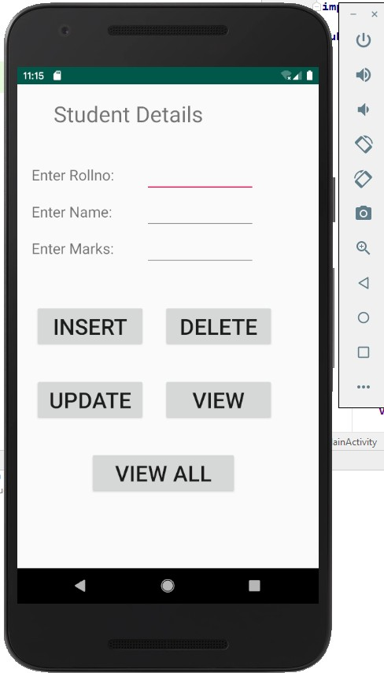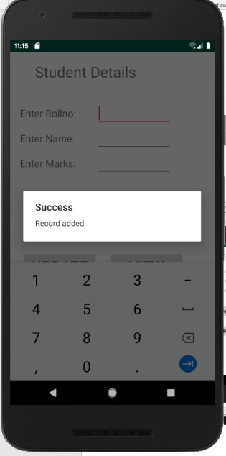

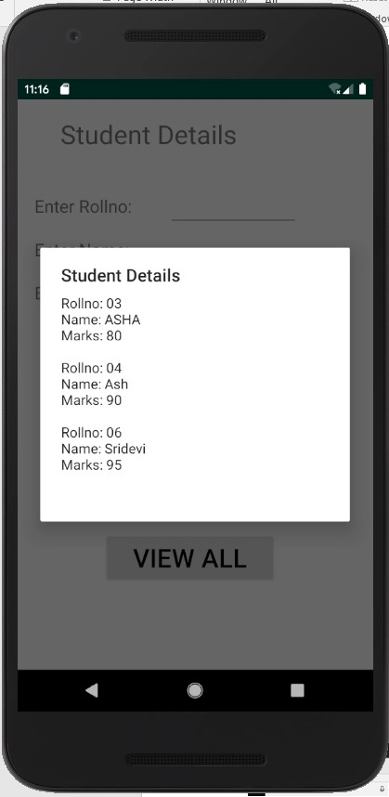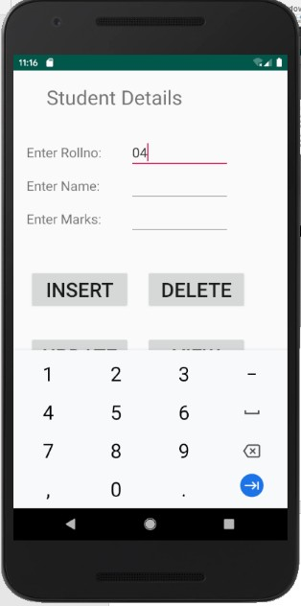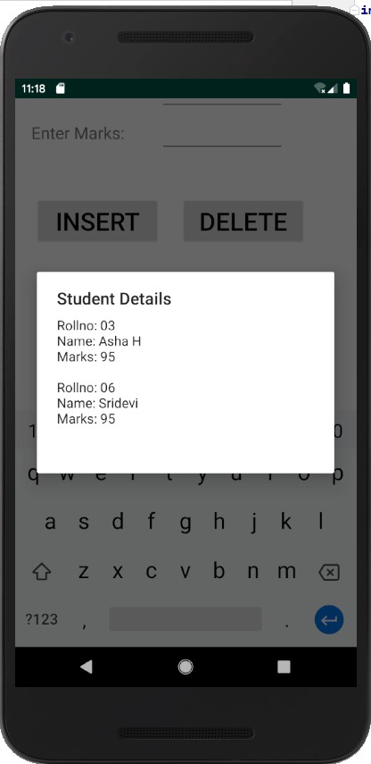

Program-7: Develop a mobile application that uses GPS location information Xml:

*<?*xml version="1.0" encoding="utf-8"*?>*

<androidx.constraintlayout.widget.ConstraintLayout xmlns:android="<http://schemas.android.com/apk/res/android>"

xmlns:app="[http://schemas.android.com/apk/res-auto"](http://schemas.android.com/apk/res-auto) xmlns:tools="[http://schemas.android.com/tools"](http://schemas.android.com/tools) android:layout_width="match_parent" android:layout_height="match_parent" tools:context=".MainActivity">

<LinearLayout android:layout_width="368dp" android:layout_height="551dp" android:layout_marginBottom="8dp" android:layout_marginEnd="8dp" android:layout_marginStart="8dp" android:orientation="vertical"

app:layout_constraintBottom_toBottomOf="parent" app:layout_constraintEnd_toEndOf="parent" app:layout_constraintStart_toStartOf="parent">

<TextView android:id="@+id/textView3" android:layout_width="match_parent"

android:layout_height="wrap_content" android:gravity="center" android:text="Current Location" android:textSize="30sp" android:textStyle="bold" tools:text="Current Location" />

<TextView android:layout_width="match_parent" android:layout_height="wrap_content" android:text=" " />

<TextView android:id="@+id/textView1" android:layout_width="match_parent"

android:layout_height="wrap_content" android:layout_marginLeft="10dp" android:text="TextView" android:textSize="24sp" />

<TextView android:id="@+id/textView2" android:layout_width="match_parent"

android:layout_height="wrap_content" android:layout_marginLeft="10dp" android:text="TextView" android:textSize="24sp" />

</LinearLayout>

</androidx.constraintlayout.widget.ConstraintLayout>

Manifest:

*<?*xml version="1.0" encoding="utf-8"*?>*

<manifest xmlns:android="<http://schemas.android.com/apk/res/android>" package="com.example.prog7">

<uses-permission android:name="android.permission.ACCESS_FINE_LOCATION"/>

<application android:allowBackup="true" android:icon="@mipmap/ic_launcher" android:label="@string/app_name"

android:roundIcon="@mipmap/ic_launcher_round" android:supportsRtl="true" android:theme="@style/AppTheme">

<activity android:name=".MainActivity">

<intent-filter>

<action android:name="android.intent.action.MAIN" />

<category android:name="android.intent.category.LAUNCHER" />

</intent-filter>

</**activity**>

</**application**>

</**manifest**>

Java:

**package** com.example.prog7;

**import** androidx.appcompat.app.AppCompatActivity;

**import** android.annotation.SuppressLint;

**import** android.os.Bundle; **import** android.content.Context; **import** android.location.Criteria; **import** android.location.Location;

**import** android.location.LocationListener; **import** android.location.LocationManager; **import** android.os.Bundle;

**import** android.widget.TextView;

**import** android.widget.Toast;

**public class** MainActivity **extends** AppCompatActivity **implements** LocationListener { @SuppressLint(**"MissingPermission"**)

@Override

**protected void** onCreate(Bundle savedInstanceState) { **super**.onCreate(savedInstanceState); setContentView(R.layout.***activity_main***);

LocationManager lm=(LocationManager)getSystemService(Context.***LOCATION_SERVICE***);

Criteria c=**new** Criteria();

String s=lm.getBestProvider(c, **false**); **if**(s!=**null** && !s.equals(**""**))

{

@SuppressLint(**"MissingPermission"**) Location l=lm.getLastKnownLocation(s); lm.requestLocationUpdates(s,20000, 1, **this**);

**if**(l!=**null**) onLocationChanged(l);

else

Toast.*makeText*(getApplicationContext(), **"Location can't be retrieved !!!"**, Toast.***LENGTH_LONG***).show();

}

else

Toast.*makeText*(getApplicationContext(), **"Provider not found**

**!!!"**,Toast.***LENGTH_LONG***).show();

}

@Override

**public void** onLocationChanged(Location arg0) {

*//* ***TODO Auto-generated method stub***

TextView t1=(TextView)findViewById(R.id.***textView1***); t1.setText(**"Latitude : \n"**+arg0.getLatitude()); TextView t2=(TextView)findViewById(R.id.***textView2***); t2.setText(**"Longitude : \n"**+arg0.getLongitude());

}

**public void** onProviderDisabled(String arg0) {

*//* ***TODO Auto-generated method stub***

}@

Override

**public void** onProviderEnabled(String arg0) {

*//* ***TODO Auto-generated method stub***

}@

Override

**public void** onStatusChanged(String arg0, **int** arg1, Bundle arg2) {

*//* ***TODO Auto-generated method stub***

}

}

Output:

GO to Settings in the Emulator Select Apps & Notifications Select Program Name

Select Permission Select Location (on)

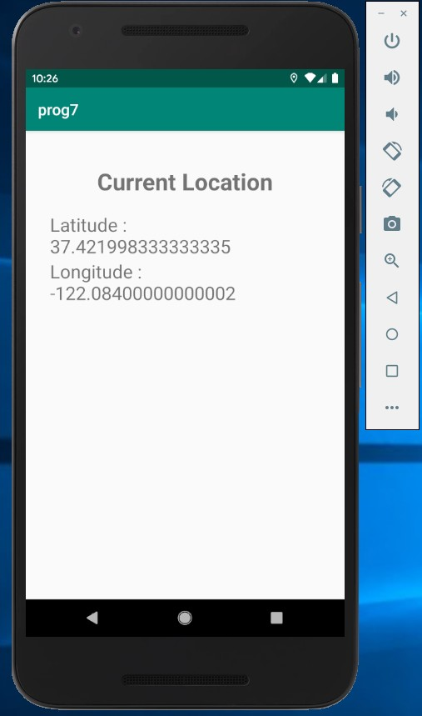

Program-8: Create an application that writes data to the SD card. Xml:

*<?*xml version="1.0" encoding="utf-8"*?>*

<LinearLayout xmlns:android="<http://schemas.android.com/apk/res/android>" android:layout_width="match_parent" android:layout_height="match_parent"

android:layout_margin="20dp" android:orientation="vertical">

<EditText android:id="@+id/editText"

android:layout_width="match_parent" android:layout_height="wrap_content" android:singleLine="true" android:textSize="30dp" />

<Button android:id="@+id/button"

android:layout_width="match_parent" android:layout_height="wrap_content" android:layout_margin="10dp" android:text="Write Data" android:textSize="30dp" />

<Button android:id="@+id/button2"

android:layout_width="match_parent" android:layout_height="wrap_content" android:layout_margin="10dp" android:text="Read data" android:textSize="30dp" />

<Button android:id="@+id/button3"

android:layout_width="match_parent" android:layout_height="wrap_content" android:layout_margin="10dp" android:text="Clear" android:textSize="30dp" />

</LinearLayout>

Manifest:

*<?*xml version="1.0" encoding="utf-8"*?>*

<manifest xmlns:android="<http://schemas.android.com/apk/res/android>" package="com.example.administrator.sdcard">

<uses-permission

android:name="android.permission.WRITE_EXTERNAL_STORAGE"></uses-permission>

<application android:allowBackup="true" android:icon="@mipmap/ic_launcher" android:label="@string/app_name"

android:roundIcon="@mipmap/ic_launcher_round" android:supportsRtl="true" android:theme="@style/AppTheme">

<activity android:name="com.example.program8.MainActivity">

<intent-filter>

<action android:name="android.intent.action.MAIN" />

<category android:name="android.intent.category.LAUNCHER" />

</intent-filter>

</**activity**>

</**application**>

</**manifest**>

Java:

**package** com.example.program8;

**import** androidx.appcompat.app.AppCompatActivity;

**import** android.os.Bundle; **import** android.view.View; **import** android.widget.Button; **import** android.widget.EditText; **import** android.widget.Toast;

**import** androidx.appcompat.app.AppCompatActivity;

**import** com.example.administrator.sdcard.R;

**import** java.io.BufferedReader;

**import** java.io.File;

**import** java.io.FileInputStream; **import** java.io.FileOutputStream; **import** java.io.InputStreamReader;

**public class** MainActivity **extends** AppCompatActivity { EditText **e1**;

Button **write**,**read**,**clear**; @Override

**protected void** onCreate(Bundle savedInstanceState) { **super**.onCreate ( savedInstanceState ); setContentView ( R.layout.***activity_main*** );

**e1**= (EditText) findViewById(R.id.***editText***); **write**= (Button) findViewById(R.id.***button***); **read**= (Button) findViewById(R.id.***button2***); **clear**= (Button) findViewById(R.id.***button3***);

**write**.setOnClickListener(**new** View.OnClickListener()

{

@Override

**public void** onClick(View v)

{

String message=**e1**.getText().toString();

try

{

File f=**new** File(**"/sdcard/myfile.txt"**);

f.createNewFile();

FileOutputStream fout=**new** FileOutputStream(f); fout.write(message.getBytes());

fout.close(); Toast.*makeText*(getBaseContext(),**"Data Written in**

**SDCARD"**,Toast.***LENGTH_LONG***).show();

}

**catch** (Exception e)

{

}

});

Toast.*makeText*(getBaseContext(),e.getMessage(),Toast.***LENGTH_LONG***).show();

}

**read**.setOnClickListener(**new** View.OnClickListener()

{

@Override

**public void** onClick(View v)

{

String message; String buf = **""**; **try**

{

File f = **new** File(**"/sdcard/myfile.txt"**); FileInputStream fin = **new** FileInputStream(f);

BufferedReader br = **new** BufferedReader(**new** InputStreamReader(fin));

**while** ((message = br.readLine()) != **null**)

{

buf += message;

}

**e1**.setText(buf); br.close();

fin.close();

Toast.*makeText*(getBaseContext(),**"Data Recived from SDCARD"**,Toast.***LENGTH_LONG***).show();

}

**catch** (Exception e)

{

Toast.*makeText*(getBaseContext(), e.getMessage(), Toast.***LENGTH_LONG***).show();

}

}

});

**clear**.setOnClickListener(**new** View.OnClickListener()

{

@Override

**public void** onClick(View v)

{

**e1**.setText(**""**);

}

});

}

}

OUTPUT:

(Steps depends on which Emulator You Select) GO to Settings in the Emulator

Select Apps & Notifications Select Program Name Select Permission

Select Location (on)

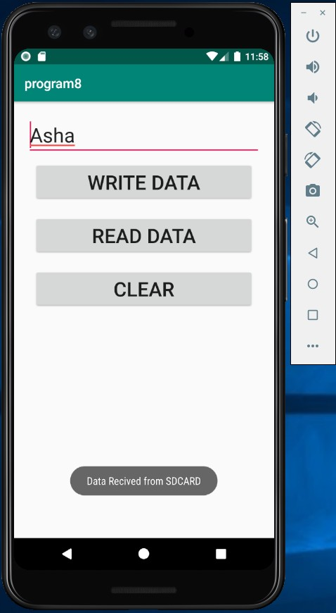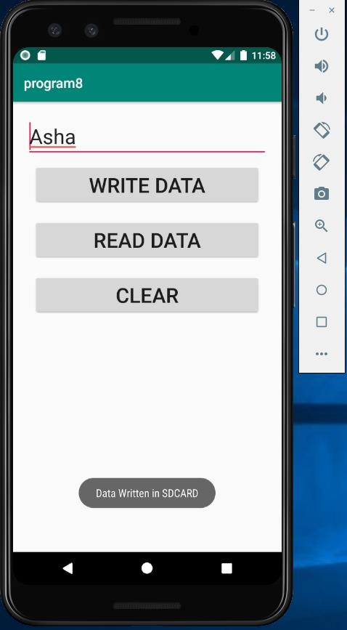

Program-9: Implement an application that creates an alert upon receiving a message. Xml:

*<?*xml version="1.0" encoding="utf-8"*?>*

<LinearLayout xmlns:android="<http://schemas.android.com/apk/res/android>" xmlns:app="[http://schemas.android.com/apk/res-auto"](http://schemas.android.com/apk/res-auto) xmlns:tools="[http://schemas.android.com/tools"](http://schemas.android.com/tools) android:layout_width="match_parent" android:layout_height="match_parent"

tools:context=".MainActivity" android:orientation="vertical">

<TextView android:layout_width="wrap_content" android:layout_height="wrap_content" android:text="Message!" android:textSize="30sp"/>

<EditText android:id="@+id/editText"

android:layout_width="match_parent" android:layout_height="wrap_content" android:singleLine="true" android:textSize="30sp"/>

<Button android:id="@+id/button"

android:layout_width="wrap_content" android:layout_height="wrap_content" android:layout_margin="30dp" android:layout_gravity="center" android:text="notify" android:textSize="30sp"

/>

</LinearLayout>

Java:

**package** com.example.pr9;

**import** androidx.appcompat.app.AppCompatActivity; **import** androidx.core.app.NotificationCompat; **import** android.app.NotificationChannel;

**import** android.content.Context; **import** android.os.Bundle; **import** android.app.Notification;

**import** android.app.NotificationManager; **import** android.app.PendingIntent; **import** android.content.Intent;

**import** android.os.Bundle; **import** android.text.TextUtils; **import** android.view.View;

**import** android.widget.Button;

**import** android.widget.EditText;

**public class** MainActivity **extends** AppCompatActivity { Button **notify**;

EditText **e**;

@Override

**protected void** onCreate(Bundle savedInstanceState) { **super**.onCreate(savedInstanceState); setContentView(R.layout.***activity_main***);

**notify** = (Button) findViewById(R.id.***button***);

**e** = (EditText) findViewById(R.id.***editText***);

**notify**.setOnClickListener(**new** View.OnClickListener() { @Override

**public void** onClick(View view) {

*//Intent intent = new Intent(MainActivity.this,SecondActivity.class);*

*//PendingIntent pending = PendingIntent.getActivity(MainActivity.this,0,intent,0);*

String texts = **""**;

**if** (TextUtils.*isEmpty*(**e**.getText().toString())) { texts = **"<Empty>"**;

} **else** {

texts = **e**.getText().toString();

}

NotificationManager manager = (NotificationManager) getSystemService((Context.***NOTIFICATION_SERVICE***));

NotificationChannel channel = **new** NotificationChannel(**"Android"**, **"Kuch Bhi"**, NotificationManager.***IMPORTANCE_DEFAULT***);

channel.setDescription(**"Something"**); manager.createNotificationChannel(channel); NotificationCompat.Builder builder = **new** NotificationCompat

.Builder(MainActivity.**this**, **"Android"**)

.setSmallIcon(R.drawable.***ic_launcher_foreground***)

.setContentTitle(**"P9"**).setContentText(texts)

.setAutoCancel(**true**);

*//.setPriority(NotificationCompat.PRIORITY_DEFAULT);*

}

});

}

}

Intent intent = **new** Intent(MainActivity.**this**, MainActivity.**class**); intent.addFlags(Intent.***FLAG_ACTIVITY_CLEAR_TOP***);

PendingIntent pending = PendingIntent.*getActivity*(MainActivity.**this**, 0, intent, PendingIntent.***FLAG_UPDATE_CURRENT***);

builder.setContentIntent(pending); manager.notify(0, builder.build());

OUTPUT:

