**BMS INSTITUTE OF TECHNOLOGY AND MANAGEMENT**

**(An Autonomous Institution, Affiliated to VTU Belagavi)**

**DEPARTMENT OF MCA**



**WEB TECHNOLOGIES LAB MANUAL**

**SCOND SEMESTER MCA**

**22MCA203**

**Prepared by: Nirupama B K, Assistant Professor**

**Vision and Mission of Department of MCA**

**VISION**

To develop quality professionals in Computer Applications who can provide

sustainable solutions to the societal and industrial needs.

**MISSION**

Facilitate effective learning environment through quality education, state-ofthe-art facilities, and orientation towards research and entrepreneurial skills.

**Programme Educational Objectives of Department of MCA**

**PEO 1**

Develop innovative IT applications to meet industrial and societal needs

**PEO 2**

Adapt themselves to changing IT requirements through life-long learning

**PEO 3**

Exhibit leadership skills and advance in their chosen career

**Programme Outcomes of MCA**

**MCA Graduates will be able to**

**PO1:** Apply knowledge of computing fundamentals, computing specialization,

mathematics and domain knowledge to provide IT solutions

**PO2:** Identify, analyse and solve IT problems using fundamental principles of

mathematics and computing sciences

**PO3:** Design, Develop and evaluate software solutions to meet societal and

environmental concerns

**PO4:** Conduct investigations of complex problems using research based

knowledge and methods to provide valid conclusions.

**PO5:** Select and apply appropriate techniques and modern tools for complex

computing activities

**PO6:** Practice and follow professional ethics and cyber regulations

**PO7:** Involve in life-long learning for continual development as an IT professional.

**PO8:** Apply and demonstrate computing and management principles to manage

projects in multidisciplinary environments by involving in different roles

**PO9:** Comprehend& write effective reports and make quality presentations.

**PO10:** Understand and assess the impact of IT solutions on socio-environmental

issues

**PO11:** Work collaboratively as a member or leader in multidisciplinary teams.

**PO12:** Identify potential business opportunities and innovate to create value to the

society and seize that opportunity

**Course Outcomes of DBMS**

CO1: Explore Basic Concepts and tools of web technologies.

CO2: Design simple to complex web pages using suitable web technologies.

CO3: Validate the web page at client side, server side using suitable scripting technologies.

CO4: Apply the creativity in building web pages using suitable GUI code.

CO5: Build a web application with data handling capability.

**LAB INSTRUCTIONS**

1. Duration of each laboratory session is 2 hours /week.

2. Maximum marks for Internal Assessment is 50.

3. Two internal tests will be conducted for the laboratory.

4. Award of I.A marks is based on the two internal tests, Continuous Evaluation, & AAT.

2. **HARDWARE AND SOFTWARE REQUIREMENTS**

**Hardware:**

RAM : 512 MB

HDD : 40 GB

**Software:**

OS : WINDOWS XP

Notepad or Notepad++

**PROGRAM LIST**

1. Design a web page of Karnataka Tourism and apply appropriate CSS styles to the web page

using HTML/XHTML elements

2. Design an Entertainment portfolio and apply appropriate web contents

a. Use Image/video/frames in the appropriate positions of the webpage

b. Display the visitor count of the page.

3. Design a web page of Complaint registration form and apply the following:

a. Appropriate bootstrap styles to the web page/s

b. Display attempted complaints and update status as solved using appropriate image.

4. Design a Login web page to accept the username and password as input and do the

Following:

a. Validate the password, it should consist of at least 8 characters in length, must consists 1 capital

case, 1 small case, 1 special characters.

b. Display both username and encrypted password.

5. Design an attractive event registration web page to accept the name, primary contact,

address, email, type of event to participate, gender, age-group and terms & conditions field

and perform the following:

a. Make all fields are mandatory to fill out.

b. Display the accepted values for re-confirmation.

6. Design a simple 2D game web page, which uses XHTML, CSS and Dynamic Javascript.

7. Build a department web application page using AJAX.

8. Build a college single page web application using ReactJS.

1. Design a web page of Karnataka Tourism and apply appropriate CSS styles to the web page

using HTML/XHTML elements

<!DOTYPE>

<!--1st Lab Program-->

<html>

<head><link href="2.css" rel="stylesheet">

<style type="text/css">

h1 {color:red;}

</style>

</head>

</head>

<body>

<h1><center> Welcome to Karnataka Tourism </center></h1>

<p> Karnataka is a state in southwest India with Arabian Sea coastlines. The capital, Bengaluru (formerly Bangalore), is a high-tech hub known for its shopping and nightlife. To the southwest, Mysore is home to lavish temples including Mysore Palace, former seat of the region’s maharajas. Hampi, once the medieval Vijayanagara empire’s capital, contains ruins of Hindu temples, elephant stables and a stone chariot.</p>

<h2><i> This is about the Tourism</i><h2>

<h3 style="color:blue;bor;padding:30px;border-style:solid;width:300px">Karnataka has many Tourist Places</h3>

<label for="Places">Choose a Tourist Place:</label>

</br>

<frameset rows = "20%, 60%, 20%">

<frame name = "top" src =

"C:/Users/dharam/Desktop/attr1.png" />

</frameset>

<select name="TouristPlaces" id="Places">

<option value="volvo">Agra</option>

<option value="saab">Goa</option>

<option value="">Manali</option>

</select>

</body>

</html>

1.css file

p

{

color:maroon;

}

body {

background-image: url('sky.jpg');

background-repeat: no-repeat;

}

**Output:**

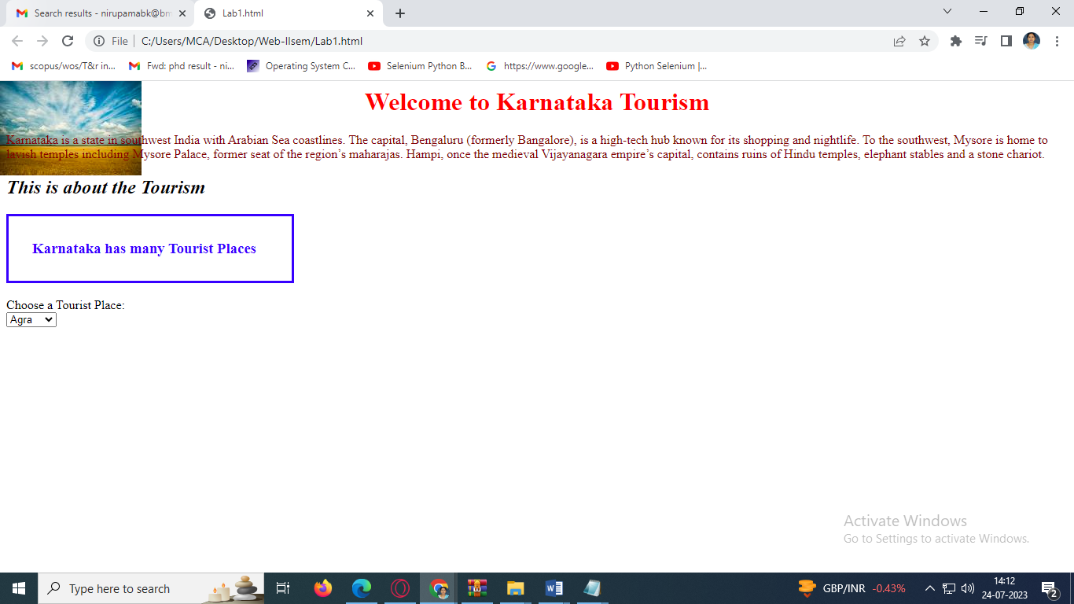

2. Design an Entertainment portfolio and apply appropriate web contents

1. Use Image/video/frames in the appropriate positions of the webpage
2. Display the visitor count of the page.

<!DOCTYPE html>

<html lang="en">

<head>

<meta charset="UTF-8">

<meta name="viewport" content=

"width=device-width, initial-scale=1.0">

<title>HTML Project</title>

</head>

<body>

<!--Header(start)-->

<table id="header" border="0" width="100%"

cellpadding="0" cellspacing="0" bgcolor="#4CAF50">

<tr>

<td>

<table border="0" cellpadding="15"

cellspacing="0" width="90%" align="center">

<tr>

<td>

</td>

<td>

<font face="Comic sans MS" size="6">

<b>BMS Music channel</b>

</font>

</td>

<td width="15%">

</td>

<td>

<a href="#home" style="text-decoration:none">

<font face="Verdana" size="5" color=black>

Home

</font>

</a>

</td>

<td>

|

</td>

<td>

<a href="#Movies" style="text-decoration:none">

<font face="Verdana" size="5" color=black>

Movie

</font>

</a>

</td>

<td>

|

</td>

<td>

<a href="#Music" style="text-decoration:none">

<font face="Verdana" size="5" color=black>

Music

</font>

</a>

</td>

<td>

|

</td>

<td>

<a href="#achievements" style="text-decoration:none">

<font face="Verdana" size="5" color=black>

Achievements

</font>

</a>

</td>

<td>

|

</td>

<td>

<a href="#contact">

<font face="Verdana" size="5" color=black>

Contact

</font>

</a>

</td>

</tr>

</table>

</td>

</tr>

</table>

<!--Header(end)-->

<!--Home(start)-->

<table id="home" border="1" width="100%"

cellpadding="20" cellspacing="0" bgcolor="black">

<tr>

<td>

<table border="0" cellpadding="15"

cellspacing="0" width="90%" align="center">

<tr>

<td align="center" valign="middle">

<h3>

<font face="Times New Roman"

size="6" color="#ffffff">

Hello Music lovers!

</font>

</h3>

<h2>

<font face="Verdana" size="6"

color="#4CAF50">

<!-- Freelance Programmer -->

</font>

</h2>

</td>

</tr>

</table>

</td>

</tr>

</table>

<!--Home(end)-->

<!--About(start)-->

<table id="about" border="0" width="100%"

cellpadding="0" cellspacing="0" bgcolor="black">

<tr>

<td>

<table border="0" cellpadding="15"

cellspacing="0" width="80%" align="center">

<tr>

<td height="180" align="center"

valign="middle" colspan="2">

<font face="Verdana" size="7"

color="#4CAF50">

About Me

</font>

<hr color="#4CAF50" width="90">

</td>

</tr>

<tr>

<td width="40%">

<img src="img.png">

</td>

<td width="60%">

<font face="Verdana" size="4"

color="white">

About music content should be written

<b>GeeksForGeeks.</b>

</font>

</td>

</tr>

</table>

</td>

</tr>

</table>

<!--About(end)-->

<!--Achievement(start)-->

<table id="achievements" border="0" width="100%"

cellpadding="0" cellspacing="0" bgcolor="black">

<tr>

<td>

<table border="0" cellpadding="15"

cellspacing="0" width="80%" align="center">

<tr>

<td height="180" align="center" valign="middle">

<font face="Verdana" size="7" color="#4CAF50">

Achievements

<hr color="#4CAF50" width="100">

</font>

</td>

</tr>

<tr>

<td>

<font face="Verdana" size="4" color="white">

<ul>

<li>

<b>Award Details</b>

<ul>

<li>

Best Channel award

</li>

<li>

Best news channel with valid data

</li>

</ul>

</li>

<li>

<b>TRP Details</b>

<ul>

<li>

News channels

</li>

<li>

Cricket channels

</li>

</ul>

</li>

</tr>

</table>

</td>

</tr>

</table>

<!--Achievement(end)-->

<!--Contact(start)-->

<table id="contact" border="0" width="100%"

cellpadding="0" cellspacing="0" bgcolor="#c2c0c3">

<tr>

<td>

<table border="0" cellpadding="15"

cellspacing="0" width="80%" align="center">

<tr>

<td height="180" align="center"

valign="middle" colspan="2">

<font face="Verdana" size="7"

color="black">

Contact

</font>

<hr color="black" width="90">

</td>

</tr>

<tr>

<td align="center" valign="top">

<table border="0" width="50%" cellpadding="15"

cellspacing="0" align="center" bgcolor="black">

<tr>

<td width="30%">

<hr color="black">

<font face="Verdana" size="4"

color="#ffffff">

Name

</font>

</td>

<td width="70%">

<font face="Verdana" size="4"

color="#ffffff">

<input type="text" size="40">

</font>

</td>

</tr>

<tr>

<td width="30%">

<font face="Verdana" size="4"

color="#ffffff">

Email

</font>

</td>

<td width="70%">

<font face="Verdana" size="4"

color="#ffffff">

<input type="email" size="40">

</font>

</td>

</tr>

<tr>

<td width="30%">

<font face="Verdana" size="4"

color="#ffffff">

Number

</font>

</td>

<td width="70%">

<font face="Verdana" size="4"

color="#ffffff">

<input type="number" size="12">

</font>

</td>

</tr>

<tr>

<td width="30%">

<font face="Verdana" size="4"

color="#ffffff">

Message

</font>

</td>

<td width="70%">

<font face="Verdana" size="4"

color="#ffffff">

<textarea rows="5"

cols="37">

</textarea>

</font>

</td>

</tr>

<tr>

<td width="30%">

</td>

<td width="70%">

<button type="Submit">

<font face="Verdana"

size="4" color="black">

<b>Submit</b>

</font>

</button>

<hr color="black">

<hr color="black">

</td>

</tr>

</table>

</td>

</tr>

<tr>

<td colspan="2">

</td>

</tr>

</table>

</td>

</tr>

</table>

<!--Footer2(start)-->

<table id="footer" border="0" width="100%"

cellpadding="0" cellspacing="0" bgcolor="black">

<tr>

<td>

<table border="0" cellpadding="15"

cellspacing="0" width="90%" align="center">

<tr>

<td width="80%" valign="top">

<font face="Verdana"

color="#4CAF50" size="5">

©Copyright 2050 by nobody.

All rights reserved.

</font>

</td>

<td width="10%">

<font face="arial" color="black" size="5">

<a href="#header" style="text-decoration:none">

<font face="Verdana" color="#4CAF50" size="6">

<b>TOP ☝</b>

</font>

</a>

</font>

</td>

</tr>

</table>

</td>

</tr>

</table>

<!--Footer2(end)-->

</body>

</html>

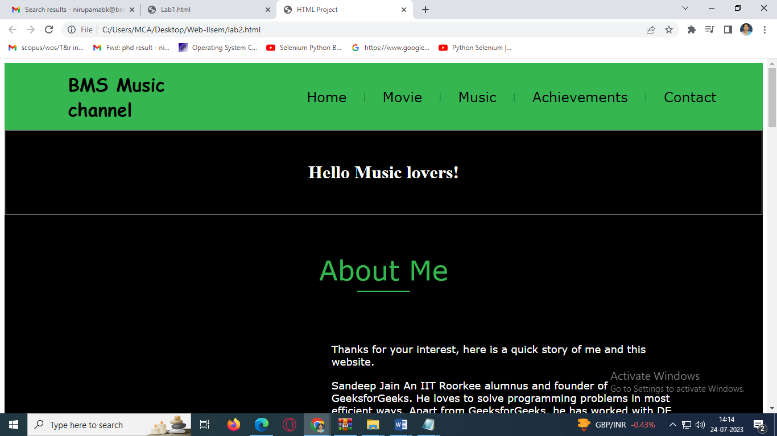

3. Design a web page of Complaint registration form and apply the following:

1. Appropriate bootstrap styles to the web page/s
2. Display attempted complaints and update status as solved using appropriate image.

<!DOCTYPE html>

<html>

<head>

<meta name="viewport" content="width=device-width, initial-scale=1">

<style>

body {font-family: Arial, Helvetica, sans-serif;}

* {box-sizing: border-box;}

input[type=text], select, textarea {

width: 100%;

padding: 12px;

border: 1px solid #ccc;

border-radius: 4px;

box-sizing: border-box;

margin-top: 6px;

margin-bottom: 16px;

resize: vertical;

}

input[type=submit] {

background-color: #04AA6D;

color: white;

padding: 12px 20px;

border: none;

border-radius: 4px;

cursor: pointer;

}

input[type=submit]:hover {

background-color: #45a049;

}

.container {

border-radius: 5px;

background-color: #f2f2f2;

padding: 20px;

}

</style>

</head>

<body>

<h3>Wifi Complaint Registration Form</h3>

<div class="container">

<label for="fname">Name</label>

<input type="text" id="fname" name="Name" placeholder="Your name..">

<label for="lname">Block Name</label>

<input type="text" id="lname" name="lastname" placeholder="Block name..">

<label for="Issue">Issue</label>

<select id="Issue" name="Issues">

<option value="No wifi">No wifi</option>

<option value="Low Speed">Low speed</option>

<option value="device">Device problem</option>

</select>

<label for="subject">Feedback</label>

<textarea id="subject" name="subject" placeholder="Write something.." style="height:200px"></textarea>

<input type="submit" value="Submit">

</form>

</div>

</body>

</html>

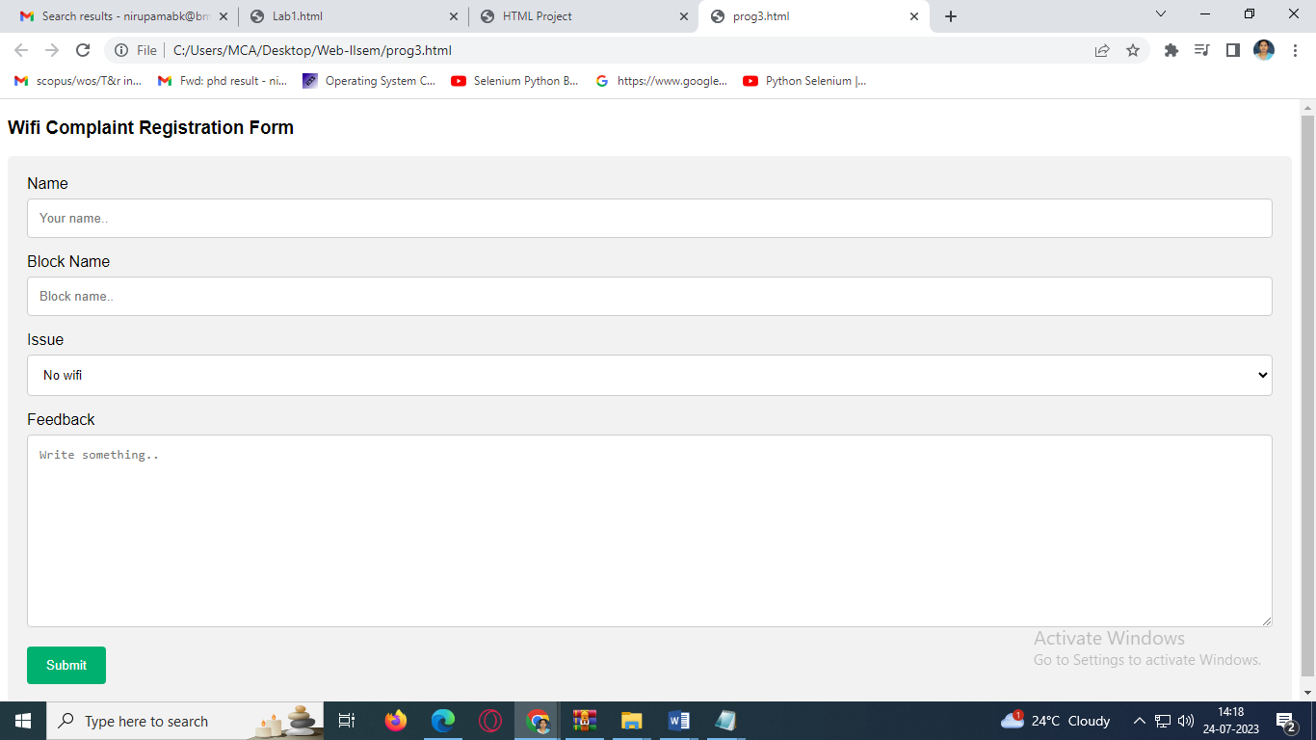

4. Design a Login web page to accept the username and password as input and do the

Following:

1. Validate the password, it should consist of at least 8 characters in length, must consists 1 capital case, 1 small case, 1 special characters.
2. Display both username and encrypted password.

<!DOCTYPE html>

<html>

<head>

<meta name="viewport" content="width=device-width, initial-scale=1">

<title> Login Page </title>

<style>

Body {

font-family: Calibri, Helvetica, sans-serif;

background-color: pink;

}

button {

background-color: #4CAF50;

width: 100%;

color: orange;

padding: 15px;

margin: 10px 0px;

border: none;

cursor: pointer;

}

form {

border: 3px solid #f1f1f1;

}

input[type=text], input[type=password] {

width: 100%;

margin: 8px 0;

padding: 12px 20px;

display: inline-block;

border: 2px solid green;

box-sizing: border-box;

}

button:hover {

opacity: 0.7;

}

.cancelbtn {

width: auto;

padding: 10px 18px;

margin: 10px 5px;

}

.container {

padding: 25px;

background-color: lightblue;

}

</style>

</head>

<body>

<center> <h1> Student Login Form </h1> </center>

<form>

<div class="container">

<label>Username : </label>

<input type="text" placeholder="Enter Username" name="username" required>

<label>Password : </label>

<input type="password" placeholder="Enter Password" name="password" required>

<button type="submit">Login</button>

<input type="checkbox" checked="checked"> Remember me

<button type="button" class="cancelbtn"> Cancel</button>

Forgot <a href="#"> password? </a>

</div>

</form>

</body>

</html>

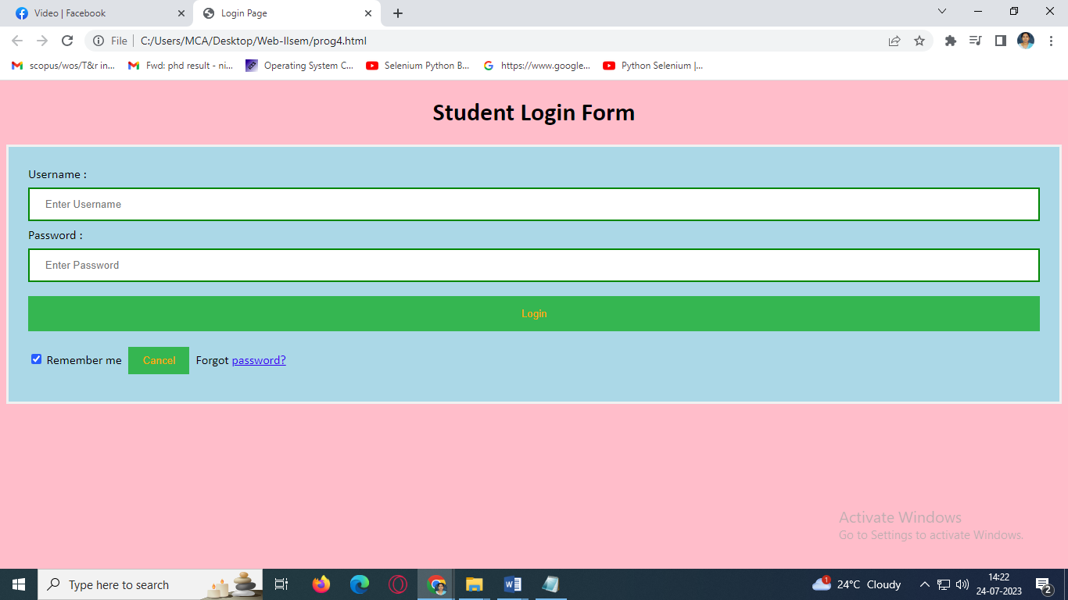

5. Design an attractive event registration web page to accept the name, primary contact,

address, email, type of event to participate, gender, age-group and terms & conditions field

and perform the following:

1. Make all fields are mandatory to fill out.
2. Display the accepted values for re-confirmation.

<!DOCTYPE html>

<html>

<head>

<meta name="viewport" content="width=device-width, initial-scale=1">

<title> Login Page </title>

<style>

Body {

font-family: Calibri, Helvetica, sans-serif;

background-color: pink;

}

button {

background-color: #4CAF50;

width: 100%;

color: orange;

padding: 15px;

margin: 10px 0px;

border: none;

cursor: pointer;

}

form {

border: 3px solid #f1f1f1;

}

input[type=text], input[type=password] {

width: 100%;

margin: 8px 0;

padding: 12px 20px;

display: inline-block;

border: 2px solid green;

box-sizing: border-box;

}

button:hover {

opacity: 0.7;

}

.cancelbtn {

width: auto;

padding: 10px 18px;

margin: 10px 5px;

}

.container {

padding: 25px;

background-color: lightblue;

}

</style>

</head>

<body>

<center> <h1> Student Login Form </h1> </center>

<form>

<div class="container">

<label>Username : </label>

<input type="text" placeholder="Enter Username" name="username" required>

<label>Password : </label>

<input type="password" placeholder="Enter Password" name="password" required>

<button type="submit">Login</button>

<input type="checkbox" checked="checked"> Remember me

<button type="button" class="cancelbtn"> Cancel</button>

Forgot <a href="#"> password? </a>

</div>

</form>

</body>

</html>

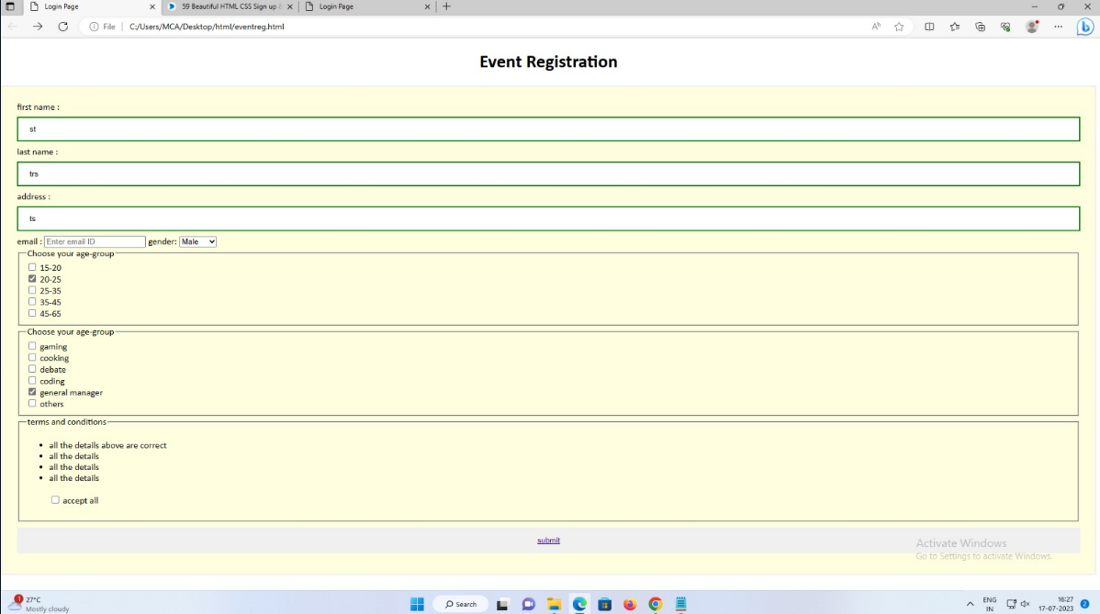

6. Design a simple 2D game web page, which uses XHTML, CSS and Dynamic Javascript.

<div class="windows">

<div class="window"></div>

<div class="window"></div>

<div class="window"></div>

<div class="window"></div>

<div class="window"></div>

<div class="window"></div>

<div class="window"></div>

<div class="window"></div>

<div class="window"></div>

<div class="window"></div>

</div>

<div class="fan">

<div class="fan__root"> <span class="top"> <label class="red" for="engine"></label> <label class="green"

for="engine2"></label> <label class="blue" for="jack"></label> </span> <span class="bottom"></span>

</div>

<div class="fan__staddle"></div> <input type="checkbox" id="jack" hidden />

<div class="head">

<div class="fan__engine"> <span class="center"></span> </div> <input type="checkbox" id="engine" hidden

checked />

<div> <span class="fly"></span> <span class="fly"></span> <span class="fly"></span>

<div class="fan__blades"> <input type="checkbox" id="engine2" hidden checked />

<div class="fan__blades">

<div class="center"></div>

<div class="blade"><span></span></div>

<div class="blade"><span></span></div>

<div class="blade"><span></span></div>

<div class="blade"><span></span></div>

</div>

</div>

</div>

</div>

</div>

CSS

html {

overflow: hidden;

}

body {

overflow: hidden;

margin: 0;

padding: 0;

background: linear-gradient(90deg, #addfff, #fff9e8);

display: flex;

justify-content: center;

align-items: center;

width: 100vw;

height: 100vh;

position: relative;

}

body::after {

position: absolute;

width: 100%;

content: "";

height: calc(100% - 600px);

z-index: 0;

background: #efefef;

bottom: 0;

}

@keyframes spin {

from {

transform: rotate(0deg);

}

to {

transform: rotate(360deg);

}

}

@keyframes off {

to {

transform: rotate(380deg);

}

}

@keyframes off2 {

to {

transform: rotate(880deg);

}

}

@keyframes fly {

to {

margin-top: 50px;

}

}

span {

display: block;

}

.windows {

width: 100vw;

height: 100vh;

position: absolute;

z-index: 0;

top: 0;

left: 0;

display: flex;

flex-wrap: wrap;

align-content: flex-start;

}

.window {

flex: 1 20%;

box-sizing: border-box;

height: 300px;

position: relative;

border: 10px inset rgba(51, 51, 51, 0.2);

}

.window::after {

position: absolute;

height: 60%;

width: 1px;

border-radius: 10px;

background: linear-gradient(to top, #0f80c7 20%, transparent 30%, transparent 50%, #3f7ba0 100%);

opacity: 1;

z-index: 5;

top: 30px;

left: 50%;

transform: rotate(45deg);

display: block;

content: "";

}

.window::before {

position: absolute;

height: 40%;

width: 1px;

border-radius: 10px;

background: linear-gradient(to top, #0f80c7 20%, transparent 10%, transparent 50%, #addfff 100%);

opacity: 1;

z-index: 5;

top: 100px;

left: 60%;

transform: rotate(45deg);

display: block;

content: "";

}

.window:nth-child(5n - 3)::after,

.window:nth-child(5n - 3)::before {

opacity: 0.8 !important;

}

.window:nth-child(5n - 2)::after,

.window:nth-child(5n - 2)::before {

opacity: 0.4 !important;

}

.window:nth-child(5n - 1)::after,

.window:nth-child(5n -1)::before {

opacity: 0.3 !important;

}

.window:nth-child(5n)::after,

.window:nth-child(5n)::before {

opacity: 0.2 !important;

}

.fly {

transition: 0.5s all cubic-bezier(0.04, 0.06, 0, 1.18), 1s transform;

width: 10px;

height: 6px;

background: green;

border-radius: 50%;

position: absolute;

animation: fly 5s alternate infinite ease-in-out;

}

.fly:nth-of-type(1) {

top: -78px;

left: -200px;

}

.fly:nth-of-type(2) {

transform: translateY(-10px);

animation-delay: 4s;

top: 5px;

right: -250px;

}

.fly:nth-of-type(3) {

transform: translateY(0px);

top: 400px;

animation-delay: 2s;

right: -400px;

}

.fly::after,

.fly::before {

content: "";

position: absolute;

width: 7px;

height: 5px;

background-color: rgba(0, 0, 0, 0.5);

display: block;

border-radius: 50%;

}

.fly::before {

bottom: 4px;

transform: rotate(325deg);

left: 3px;

}

.fly::after {

transform: rotate(45deg);

bottom: 6px;

}

.fan {

width: 500px;

height: 500px;

position: relative;

z-index: 1;

margin-top: 75px;

perspective: 500px;

}

.fan::after {

content: "";

display: block;

position: absolute;

height: 364px;

width: 200px;

background: rgba(0, 0, 0, 0.08);

top: calc(100% - 24px);

left: calc(50% - 100px);

z-index: -1;

transform: rotateX(104deg) rotateY(-1deg) rotate(25deg);

transform-origin: top;

}

.fan__root {

width: 200px;

position: absolute;

bottom: 0;

left: 50%;

transform: translateX(-50%);

}

.fan__root .top {

overflow: hidden;

width: 200px;

height: 25px;

position: relative;

}

.fan__root .top::after {

content: "";

display: block;

width: 200px;

height: 50px;

background: #2f423f;

border-radius: 50%;

}

.fan__root .top .red {

position: absolute;

width: 30px;

height: 15px;

border-radius: 15px;

display: block;

right: 30px;

background: #f15249;

cursor: pointer;

overflow: hidden;

}

.fan__root .top .green {

position: absolute;

width: 30px;

height: 15px;

border-radius: 15px;

display: block;

right: 85px;

background: #32ba7c;

cursor: pointer;

overflow: hidden;

}

.fan__root .top .green::after {

content: "";

display: block;

width: 100%;

height: 50%;

position: absolute;

bottom: 0;

background: #0aa06e;

}

.fan__root .top .red::after {

content: "";

display: block;

width: 100%;

height: 50%;

position: absolute;

bottom: 0;

background: #a00000;

}

.fan__root .top .blue {

position: absolute;

cursor: pointer;

width: 30px;

height: 15px;

border-radius: 15px;

display: block;

left: 30px;

background: #3ac2f2;

overflow: hidden;

}

.fan__root .top .blue::after {

content: "";

display: block;

width: 100%;

height: 50%;

position: absolute;

bottom: 0;

background: #009cc6;

}

.fan__root .bottom {

overflow: hidden;

width: 200px;

height: 20px;

}

.fan__root .bottom::after {

content: "";

display: block;

width: 200px;

height: 40px;

background: #2f423f;

border-radius: 18%;

transform: translateY(-30px);

}

.fan__staddle {

position: absolute;

bottom: 45px;

background: #2f423f;

height: 270px;

width: 13px;

left: 50%;

transform: translateX(-50%);

}

.fan__engine {

position: absolute;

bottom: 0px;

width: 130px;

height: 130px;

background: #2f423f;

border-radius: 50%;

left: 50%;

transform: translateX(-50%);

}

.fan__engine::after {

content: "";

background: #2f423f;

display: block;

width: 25px;

height: 50px;

position: absolute;

top: 105px;

left: 50%;

transform: translateX(-50%);

border-radius: 0 0 5px 5px;

}

.fan__blades {

width: 230px;

height: 230px;

position: absolute;

bottom: -50px;

transition: 2s;

transform-origin: center center;

left: calc(50% - 115px);

z-index: 1;

animation: spin infinite 0.38s linear forwards;

}

.fan__blades .fan__blades {

bottom: 0;

animation: spin infinite 0.5s linear forwards;

}

.fan__blades .blade {

position: absolute;

width: 50px;

height: 100%;

left: 50%;

transform: translateX(-50%) skewY(25deg);

perspective: 500px;

transform-style: preserve-3d;

}

.fan__blades .blade:nth-child(2) {

transform: translateX(-50%) rotate(90deg) skewY(25deg);

}

.fan__blades .blade:nth-child(3) {

transform: translateX(-50%) rotate(180deg) skewY(25deg);

}

.fan__blades .blade:nth-child(4) {

transform: translateX(-50%) rotate(270deg) skewY(25deg);

}

.fan__blades .blade span {

width: 100%;

height: 200%;

border-radius: 44px;

background: #ffc114;

position: absolute;

top: -66px;

display: block;

transform-style: preserve-3d;

transform: rotateX(81deg);

overflow: hidden;

}

.fan__blades .blade span::after {

width: 50%;

height: 100%;

content: "";

display: block;

background: #fca12a;

transform: rotate(0deg);

}

.fan__blades .center {

position: absolute;

overflow: hidden;

width: 40px;

height: 40px;

border-radius: 50%;

left: 50%;

top: 50%;

transform: translate(-50%, -50%) rotate(45deg);

background: #32ba7c;

z-index: 2;

}

.fan__blades .center::after {

display: block;

content: "";

width: 40px;

height: 20px;

background: #0aa06e;

}

.head {

transition: 1s transform;

height: auto;

width: auto;

position: absolute;

width: 300px;

height: 300px;

bottom: 195px;

left: calc(50% - 150px);

/* transform: translateX(-50%); */

}

#engine:checked+div>div {

animation: off2 1s ease-out forwards;

}

#engine:checked+div>span:nth-child(1) {

transition: 5s all ease-in-out, 1s transform;

left: 0px;

top: 0px;

}

#engine:checked+div>span:nth-child(2) {

transition: 5s all ease-in-out, 1s transform;

right: 0px;

top: 0px;

}

#engine:checked+div>span:nth-child(3) {

transition: 7s all ease-in-out, 1s transform;

right: -50px;

top: 200px;

}

#engine2:checked+div {

animation: off 1s ease-out forwards;

}

#jack:checked+div {

transform: translateY(-115px);

}

#jack:checked+div>div:nth-child(3)>span {

transform: translateY(115px);

}

@media screen and (max-width: 900px) {

.window {

flex: 1 25% !important;

}

}

@media screen and (max-width: 800px) {

.window {

flex: 1 33.3333333% !important;

}

}

@media screen and (max-width: 700px) {

.window {

flex: 1 50% !important;

}

}

Javascript

