Homework Assignment 3
- Why are entity integrity and referential integrity important in a database?
- Represent a M:N relationship (shown below) in an E-R diagram using only 1:M relationships.
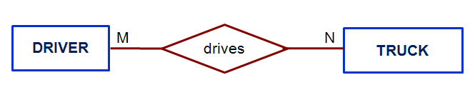
- Perform the relational algebra indicated below:
STUDENT table | INSTRUCTOR table | Relational Operations
 |  | Union: | STUDENT U INSTRUCTOR
  Name | Number
  Susan | 123
  Sam | 234
  Mary | 321
  Name | Number
  Dan | 255
  Mary | 321
 |  | Intersect: | STUDENT ∩ INSTRUCTOR
 |  | Difference: | STUDENT − INSTRUCTOR

STAFF table | INSTRUCTOR table | Relational Operations
 |  | Natural Join: | STAFF |X| INSTRUCTOR
  Adm | Number
  Secretary | 123
  Janitor | 255
  Dean | 321
  Name | Number
  Dan | 255
  Mary | 321
 |  | Left Outer Join: | STAFF ]X| INSTRUCTOR
 |  | Right Outer Join: | STAFF |X[ INSTRUCTOR

- For each table below (Table: Charter, Aircraft, Model, Pilot, Employee, and Customer), please identify where possible, the primary key, a super key, a candidate key that is not a primary key, all foreign keys, and a secondary key.
Notes: Please assume that for each table below, we can only provide you part of the table due to the limit of the space.
- Draw the E-R diagram of Question 4.

ROBCOR: Aircraft Charter Company
Table: CHARTER
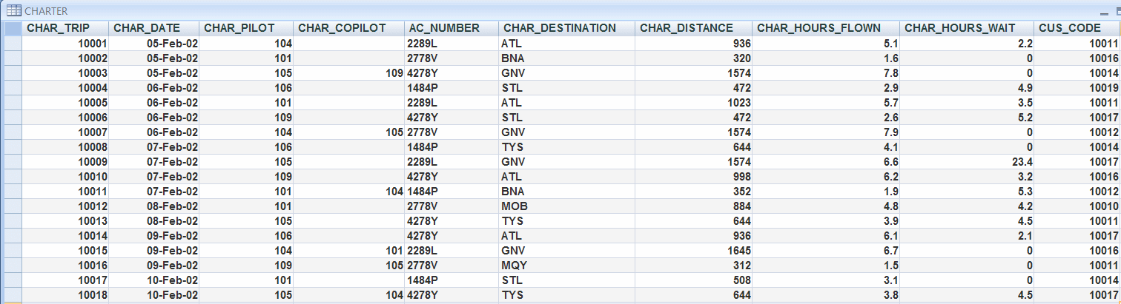
The destinations are indicated by standard three-letter airport code. For example,
STL = St. Louis, MO ATL = Atlanta, GA BNA = Nashville, TN
Table: AIRCRAFT
AC-TTAF = Aircraft total time, airframe (hours)
AC-TTEL = Total time, left engine (hours)
AC-TTER = Total time, right engine (hours)
In a fully developed database system, such attribute values would be updated by application software when the CHARTER table entries are posted.
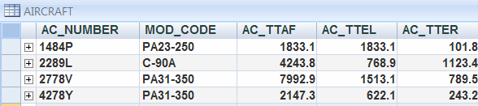
Table: MODEL
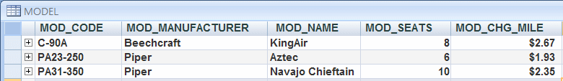
Customers are charged per roundtrip mile, using the MOD_CHG_MILE rate. The MOD_SEAT gives the total number of seats in the airplane, including the pilot and copilot seats. Therefore, a PA31-350 trip that is flown by a pilot and a copilot has eight passenger seats available.
Table: PILOT
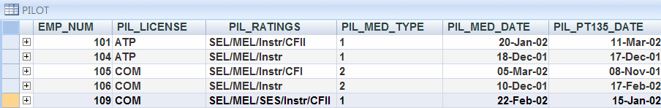
The pilot licenses shown in the PILOT table include the ATP (Airline Transport Pilot) and COM (Commercial Pilot Business). Businesses that operate "on demand" air services are governed by Part 135 of the Federal Air Regulations (FARs) that are enforced by the Federal Aviation Administration (FAA). Such businesses are known as "Part 135 operators." Part 135 operations require that pilots successfully complete flight proficiency checks each six months. The "Part 135" flight proficiency check date is recorded in PIL_PT135_DATE. To fly commercially, pilots must have at least a commercial license and a 2nd class medical certificate (PIL_MED_TYPE =2).
The PIL_RATINGS include SEL (Single-engine, Land), MEL (Multi-engine, Land), SES (Single-engine, Sea), Instr (Instrument), CFI (Certified Flight Instructor), CFII (Certified Flight Instructor, Instrument).
Table: EMPLOYEE
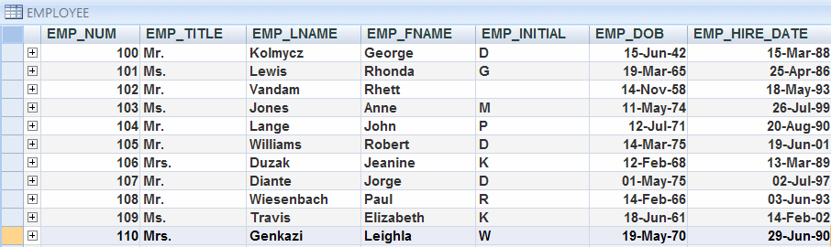
Table: CUSTOMER
