Homework Assignment 4

FNU Anirudh

October 16, 2015

Solution 1

# As per question I have changed 137.6 to 13.76  
child <- c(1:18)  
age <- c(109,113,115,116,119,120,121,124,126,129,130,133,134,135,137,139,141,142)  
height <- c(13.76,147.8,136.8,140.7,132.7,145.4,135.0,133.0,148.5,148.3,147.5,148.8,133.2,148.7,152.0,150.6,165.3,149.9)  
  
data <- cbind(as.matrix(child),as.matrix(age),as.matrix(height))  
colnames(data) <- c("child","Age", "Height")  
#data <- matrix(data = c(child,age,height),byrow=TRUE,nrow=18,ncol=3,dimnames()  
  
threepointline1 <- function(x,y) {  
 n <- length(x); nmod3 <- n%%3  
 if(nmod3 == 0) {  
 n3 <- n/3  
 }  
 if (nmod3 ==1) {  
 n3 <- (n-1)/3  
 }  
 if (nmod3 ==3) {  
 n3 <- (n+1)/3  
 }   
 x.sort <- sort(x)  
 y.sort <- sort(y)  
 medxL <- median(x.sort[1:n3])  
 medxR <- median(rev(x.sort)[1:n3])  
 medyL <- median(y.sort[1:n3])  
 medyR <- median(rev(y.sort)[1:n3])  
 slopeb <- (medyR - medyL)/(medxR - medxL)  
 medianx <- median(x)  
 mediany <- median(y)  
 intercepta <- ((medyL-slopeb*medxL) + (mediany-slopeb*medianx) + (medyR-slopeb*medxR))/3  
 abline(intercepta,slopeb,col='red')  
 meanx <- mean(x)  
 meany <- mean(y)  
 den <- 0  
 num <- 0  
 for (i in length(x)){  
 den <- den + (x[i] - meanx)^2  
 num <- num + (x[i] - meanx)*(y[i] - meany)  
 }  
 slopels <- num/den  
 interceptls <- meany - slopels*meanx  
 abline(interceptls,slopels,col='green')  
}  
bartlett <- function(x,y){  
 n <- length(x); nmod3 <- n%%3  
 if(nmod3 == 0) {  
 n3 <- n/3  
 }  
 if (nmod3 ==1) {  
 n3 <- (n-1)/3  
 }  
 if (nmod3 ==3) {  
 n3 <- (n+1)/3  
 }   
 x.sort <- sort(x)  
 n <- length(x); nmod3 <- n%%3  
 if(nmod3 == 0) {  
 n3 <- n/3  
 }  
 if (nmod3 ==1) {  
 n3 <- (n-1)/3  
 }  
 if (nmod3 ==3) {  
 n3 <- (n+1)/3  
 }   
 x.sort <- sort(x)  
 y.sort <- sort(y)  
 meanxL <- mean(x.sort[1:n3])  
 meanxR <- mean(rev(x.sort)[1:n3])  
 meanyL <- mean(x.sort[1:n3])  
 meanyR <- mean(rev(y.sort)[1:n3])  
 meanx <- mean(x.sort)  
 meany <- mean(y.sort)  
 slopeb <- (meanyR - meanyL)/(meanxR - meanxL)  
 interceptb <- meany - slopeb * meanx  
 abline(interceptb,slopeb,col='blue')  
}  
plot(height~age,xlab="Age in months",ylab = " Height in cm",main="Age VS Height Plot")  
threepointline1(age,height)  
bartlett(age,height)

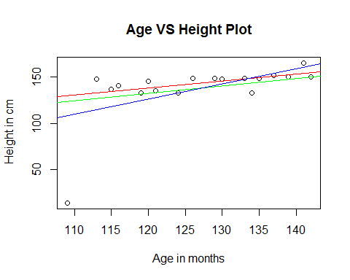

Solution 2

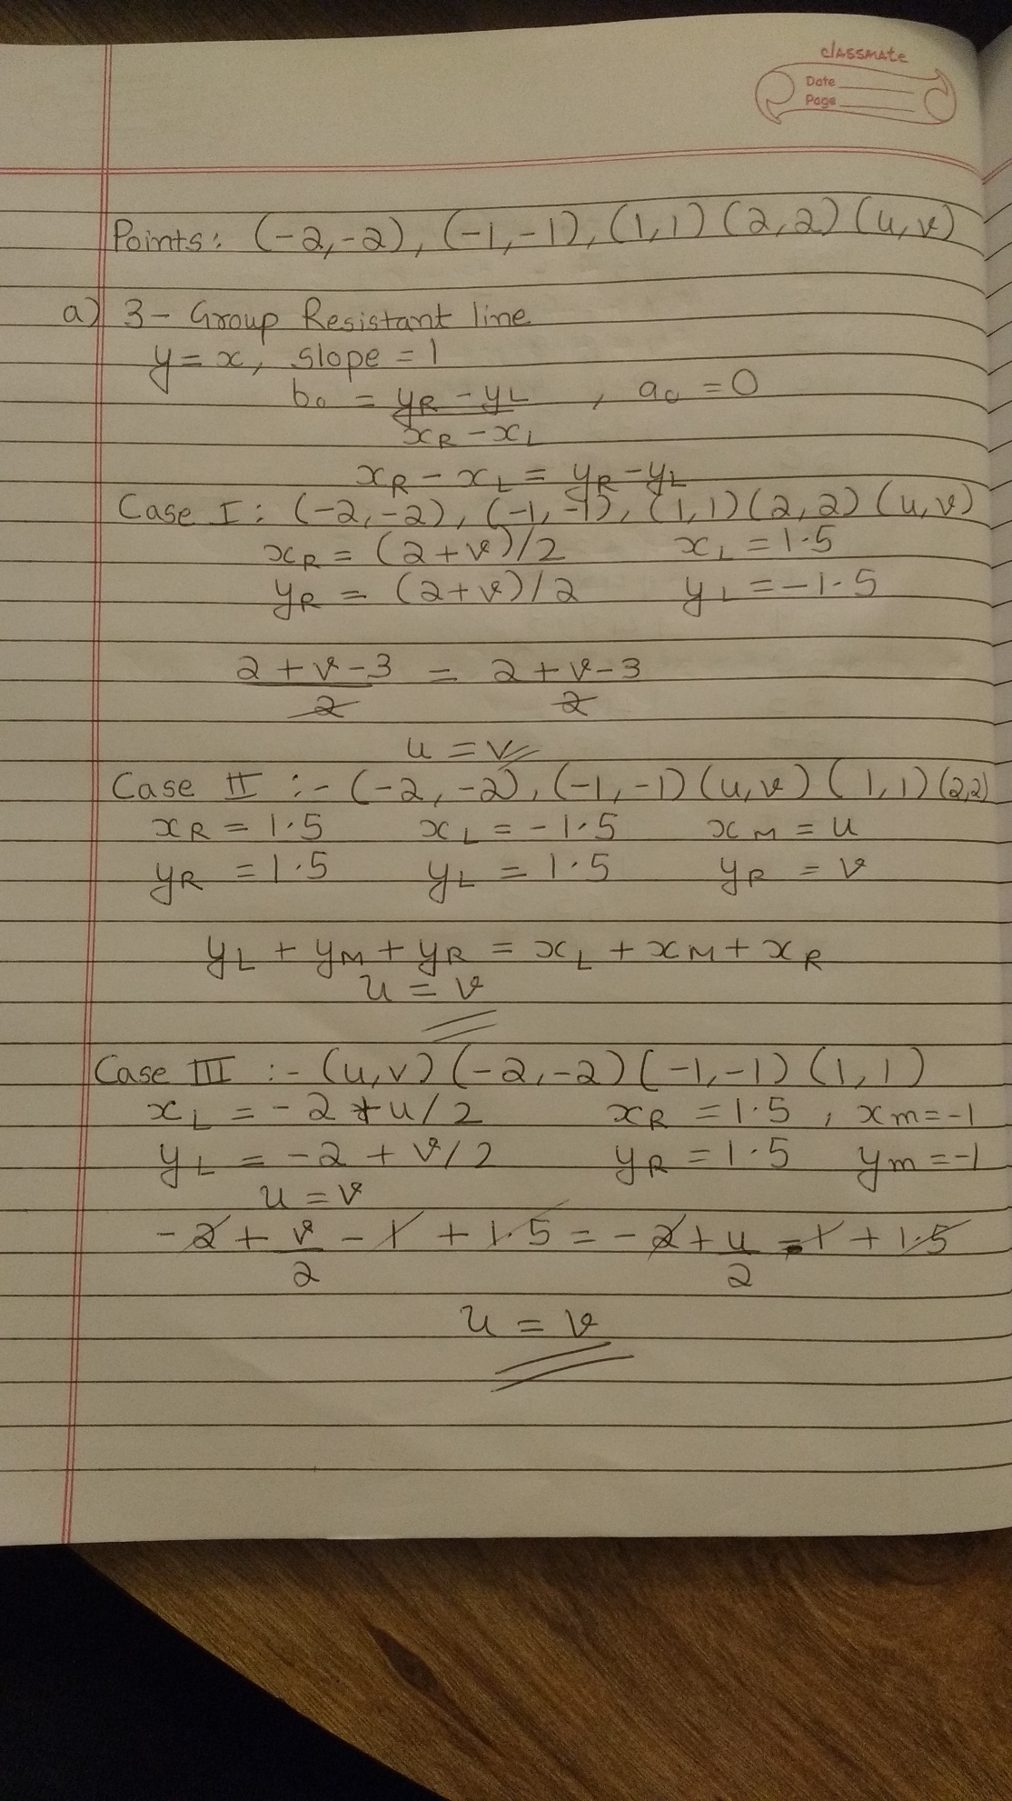

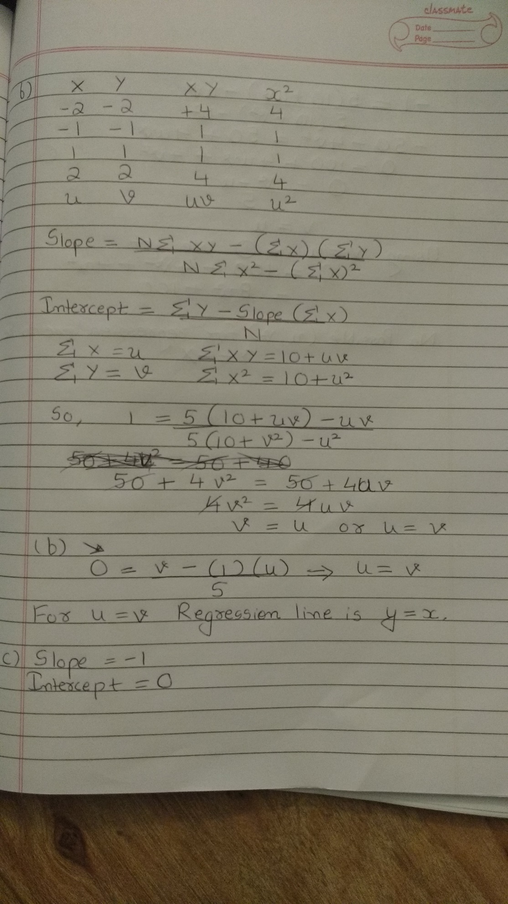

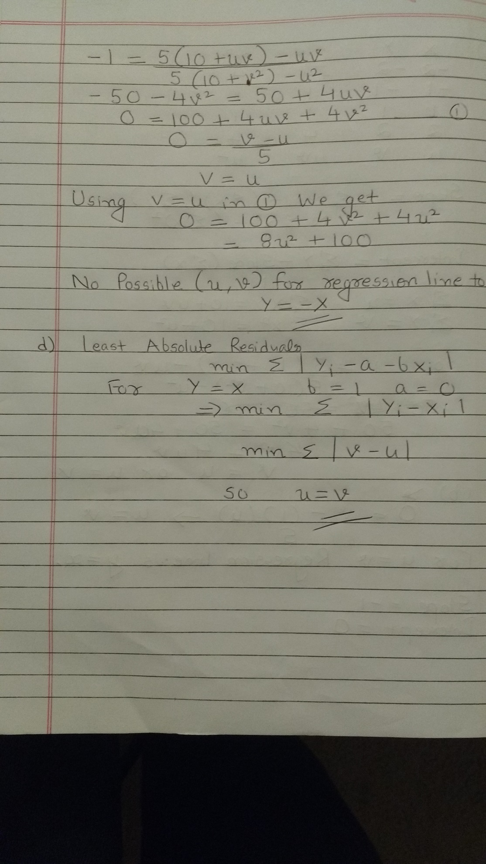

source("rrline.r")

X1 = c(61, 54, 70, 81, 46, 63, 54, 44, 53, 60, 80, 25, 59, 42, 34, 46, 63, 62, 67, 54, 31, 54, 31, 26, 41, 34, 42, 82, 202, 89, 84, 133, 85, 51, 91, 45, 102, 48, 60)

X2 = c(38, 47, 40, 40, 36, 37, 37, 35, 36, 42, 52, 34, 37, 42, 37, 37, 37, 39, 39, 41, 37, 38, 37, 43, 39, 34, 35, 44, 57, 46, 61, 50, 35, 37, 37, 37, 38, 33, 37)

X3 = c(127, 213, 134, 131, 116, 127, 128, 114, 123, 130, 177, 104, 113, 112, 91, 108, 126, 122, 121, 122, 96, 118, 88, 95, 101, 90, 101, 125, 231, 145, 214, 158, 148, 114, 144, 113, 151, 106, 120, 88)

X4 = c(144, 152, 149, 219, 174, 171, 178, 125, 213, 191, 194, 96, 167, 118, 165, 135, 178, 243, 107, 176, 109, 146, 104, 70, 156, 157, 136, 257, 276, 141, 177, 140, 198, 154, 152, 119, 171, 151, 204)

X5 = c(50, 37, 40, 67, 48, 50, 85, 58, 78, 52, 59, 19, 45, 32, 31, 41, 57, 48, 64, 63, 46, 41, 31, 15, 38, 49, 49, 108, 153, 124, 138, 88, 54, 72, 70, 40, 57, 84, 42, 15)

y = c(92, 163, 215, 210, 128, 239, 317, 195, 108, 158, 263, 101, 266, 290, 169, 168, 146, 145, 195, 254, 99, 146, 132, 105, 131, 198, 237, 202, 461, 350, 275, 467, 201, 169, 253, 202, 195, 140, 179, 467)

fit1 = run.rrline(X1, y)

c1 = fit1$coef[6,2]

y.1 = y - c1*X1

fit2 = run.rrline(X2, X1)

d21 = fit2$coef[6,2]

X2.1 = X2 - d21*X1

fit3 = run.rrline(X2.1, y.1)

c2 = fit3$coef[6,2]

y.12 = y.1 - c2*X2.1

fit4 = run.rrline(X4, X1)

d41 = fit4$coef[6, 2]

fit5 = run.rrline(X4, X2.1)

d421 = fit5$coef[6, 2]

X.124 = X2.1 - d421*X4

fit6 = run.rrline(X4, y.12)

c421 = fit6$coef[6, 2]

y.124 = y.12 - c421*X.124

b0 = median(y.124)

b0

b1 = c1 - c2*d21 - c421*d421

b2 = c2 - c421*d421

b3 = c421

b1

b2

b3