Assignment 5 (S670)

FNU Anirudh

October 30, 2015

Question 1

infant_mortality<-c(25.3,32.1,38.8,25.4,25.3,29.0,31.0,21.1,18.2,18.8,19.3,20.3,18.3,24.3,15.7,24.0,16.3,19.0,16.8,17.5)  
infant_mortality<-matrix(infant_mortality,c(4,5))  
dimnames(infant_mortality)<-list(c("NorthEast","North Central","South","West"), c("<8","9-11","12","13-15",">16"))  
mat<-infant_mortality  
twoway.median <- function(mat){   
 meff.MP <- median(mat)  
 beff.MP <- apply(mat,2,median,na.rm=T)   
 mat.res <- mat - matrix(rep(beff.MP,each=nrow(mat)),byrow=F,nrow=nrow(mat));   
   
 beff.MP <- beff.MP - median(beff.MP)   
   
 aeff.MP <- apply(mat.res,1,median,na.rm=T)  
   
 res.MP <- mat.res - matrix(rep(aeff.MP,each=ncol(mat)),byrow=T,ncol=ncol(mat))   
   
 list(overall=meff.MP, row=aeff.MP, col=beff.MP, res=res.MP)  
}  
iter1 <- twoway.median(mat); #1st iteration  
iter2<-twoway.median(iter1$res) #2nd iteration  
mat<-rbind(iter2$res,iter2$col)  
mat<-cbind(mat,iter2$row)

## Warning in cbind(mat, iter2$row): number of rows of result is not a  
## multiple of vector length (arg 2)

mat[5,6]<-iter2$overall  
rownames(mat)[5]<-"col effect"  
colnames(mat)[6]<-"row effect"  
mat

## <8 9-11 12 13-15 >16 row effect  
## NorthEast -1.55 0.00 0.55 -1.15 1.00 0.00  
## North Central 1.55 0.00 -2.55 1.15 0.00 0.00  
## South 10.30 4.05 0.00 -5.40 -0.15 -0.45  
## West -3.65 -6.40 0.45 2.35 0.00 0.00  
## col effect -0.05 0.00 0.45 0.15 0.00 0.00

# There is a difference when compared to table with row and column effect  
#hence it depends if we start with row or column.

Question 2

#a)  
r1<-c(22.2,44.5,59.6,73.2,86.8)  
r2<-c(10.5, 15.5, 29.0,36.5,46.2)  
r3<-c(3.53, 5.76, 9.71, 14.0, 21.1)  
r4<-c(1.04, 1.98, 2.45, 3.40, 5.40)  
r5<-c(.641, .974, 1.80, 2.60, 3.64)  
  
rowNames<-c("Food/Tobacco","Household","Medical/Health","Personal care","Educ/research")  
colNames<-c(1940, 1945, 1950, 1955, 1960)  
personalExpenditureTable <- rbind(r1,r2,r3,r4,r5)  
rownames(personalExpenditureTable)<-rowNames  
colnames(personalExpenditureTable)<-colNames  
  
medPolished<-medpolish(personalExpenditureTable)

## 1: 139.595  
## Final: 139.595

AnalogRSqr<- 1-((sum(abs(medPolished$residuals))) /(sum(abs(personalExpenditureTable-medPolished$overall))))  
AnalogRSqr

## [1] 0.6722237

#b)  
plot(NA, NA, type = "n", xlim=c(1, 5), ylim=c(1, 5), xlab = "Rows",ylab = "Columns")  
for (i in 1:nrow(medPolished$residuals)){  
 for (j in 1:ncol(medPolished$residuals)){  
 if (medPolished$residuals[i,j]<0) {  
 symbols(i,j,circles=abs(medPolished$residuals[i,j]/100),inches = FALSE,add=T)  
 }  
 else {  
 symbols(i,j,squares=abs(medPolished$residuals[i,j]/100),inches = FALSE,add=T)}  
 }  
}

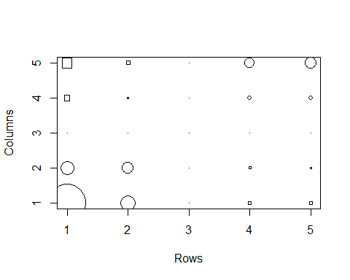

#From Plot we can say that value in bottom left and upper right are  
# negative, whereas for bottom right and upper left they are positive.  
  
#c)  
x<- vector()  
y<- vector()  
for(i in 1:length(medPolished$row)){  
 for(j in 1:length(medPolished$col)){  
 x<- c(x,(medPolished$row[i] * medPolished$col[j])/medPolished$overall)  
 }  
   
}  
  
  
residuals<-vector()  
for (i in 1:5){  
 residuals<-c(residuals,medPolished$residuals[i,])  
}  
plot(x,residuals,xlab="Comparison Values",ylab="Residual Values",main="Diagnostic plot")  
abline(h=0,v=0)  
fit<-lm(residuals~x)  
abline(fit)

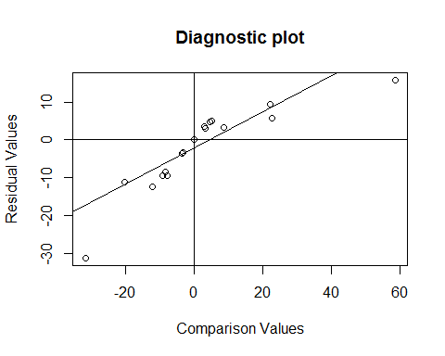

#d)  
  
PETable.log<-log(personalExpenditureTable)  
PETable.log<-matrix(PETable.log,c(5,5))  
dimnames(PETable.log)=list(c("Food/Tobacco","Household","Medical/Health","Personal Care","Educ / Research"),c("1940","1945","1950","1955","1960"))   
PETable.log.MP <- medpolish(PETable.log)

## 1: 1.962294  
## 2: 1.746089  
## Final: 1.746089

MedianPolishdata<-rbind(PETable.log,PETable.log.MP$col)  
MedianPolishdata<-cbind(MedianPolishdata,PETable.log.MP$row)

## Warning in cbind(MedianPolishdata, PETable.log.MP$row): number of rows of  
## result is not a multiple of vector length (arg 2)

colnames(MedianPolishdata)[6]<-"Row Effect"  
rownames(MedianPolishdata)[6]<-"Column Effect"  
MedianPolishdata[6,6]<-medPolished$overall  
  
#After transformation  
MedianPolishdata

## 1940 1945 1950 1955 1960  
## Food/Tobacco 3.10009229 3.79548919 4.0876556 4.2931954 4.463607  
## Household 2.35137526 2.74084002 3.3672958 3.5973123 3.832980  
## Medical/Health 1.26129787 1.75093747 2.2731563 2.6390573 3.049273  
## Personal Care 0.03922071 0.68309684 0.8960880 1.2237754 1.686399  
## Educ / Research -0.44472582 -0.02634398 0.5877867 0.9555114 1.291984  
## Column Effect -0.98756329 -0.52221881 0.0000000 0.3276874 0.704197  
## Row Effect  
## Food/Tobacco 1.8144993  
## Household 0.9964686  
## Medical/Health 0.0000000  
## Personal Care -1.2909543  
## Educ / Research -1.6853696  
## Column Effect 9.7100000

sum_res<-sum(abs(PETable.log.MP$residual))  
sum_data<-sum(abs(PETable.log-PETable.log.MP$overall))  
Analogrsquare<-1-(sum_res/sum_data)  
# AnalogRSquare after Transformation  
Analogrsquare

## [1] 0.9444153

#e)  
scan(file.choose())  
myplotfit(PETable.log.MP)

Question 3

#To find value of y, substitute i  
y<- vector()  
Mu<- expression(t + 0.5 * (exp(-50*(t-0.5)^2)))  
mu<- function(dp){  
 return (dp + 0.5 * (exp(-50*(dp-0.5)^2)))  
}  
x<- seq(0,1,length.out=50)  
f<-function(t){ (2 * t - 1)/100}  
time<- f(x)  
t<-time  
error <- rnorm(50,0,0.5)  
y<-mu(time)+error  
#y[i] <- mu(time) + error[i]  
dataFrame<- cbind(time,y)  
plot(dataFrame)

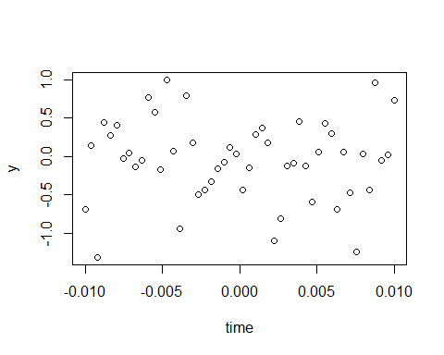

plot(mu(time))

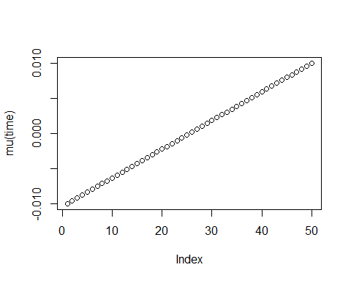

m2<-1  
rk<-1/(2*sqrt(pi))  
sigma2<-0.5^2  
n<-50  
ddut<-D(D(Mu , 't'),'t')  
J2Mu <- function(t){( -(0.5 * (exp(-50 * ((t - 0.5)^2)) * (50 * 2) - exp(-50 * ((t -   
 0.5)^2)) * (50 * (2 * (t - 0.5))) * (50 * (2 * (t - 0.5))))))^2}  
IntegrateJ2Mu <- integrate(J2Mu,lower=0,upper = 1)  
J2muValue <- IntegrateJ2Mu$value  
  
lamda_optimum<-(n^(-1/5))*(((sigma2)*rk)/(J2muValue*(m2^2)))^1/5  
plot(x,y,main="Kernel Estimation",xlab="Time")  
lines(ksmooth(x,y,kernel="normal",bandwidth=0.084))

