Quiz

FNU Anirudh

September 30, 2015

test1<- c(50,35,15,64,53,18,40,24,16,67,46,64,32,71,16)  
test2<- c(58,46,40,76,62,39,57,41,31,75,62,64,54,65,51)  
# a) Box Plot with Notches  
boxplot(test1,test2,notch = TRUE,names= c("Test1","Test2"),col= c("blue","green"),  
main= "Box Plot of two tests")

## Warning in bxp(structure(list(stats = structure(c(15, 21, 40, 58.5, 71, :  
## some notches went outside hinges ('box'): maybe set notch=FALSE

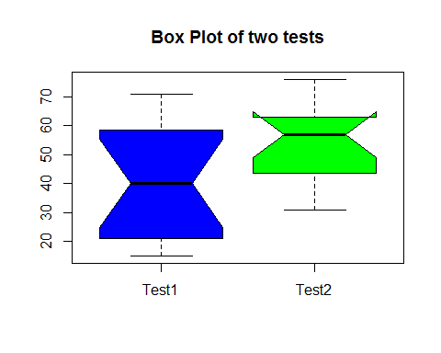

# Based on notches there is significant difference brtween the median values.  
# Median for 2nd test is greater than 1st test  
# b) Median, F-pseudo sigma and Standard Deviation of two tests1   
m1=median(test1)  
m2=median(test2)  
p1= IQR(test1)/1.35  
p2= IQR(test2)/1.35  
sd1= sd(test1)  
sd2= sd(test2)  
summary(test1)

## Min. 1st Qu. Median Mean 3rd Qu. Max.   
## 15.00 21.00 40.00 40.73 58.50 71.00

summary(test2)

## Min. 1st Qu. Median Mean 3rd Qu. Max.   
## 31.00 43.50 57.00 54.73 63.00 76.00

# c) Generating two new sets of tests with n=500  
t1<- rnorm(500,m1,sd1)  
t2<- rnorm(500,m2,sd2)  
# d) Notched Box Plots to Compare two new datasets  
boxplot(t1,t2,notch = TRUE, names= c("Test1","Test"),col= c("blue","green"),  
 main= "New Box Plot of two sets")

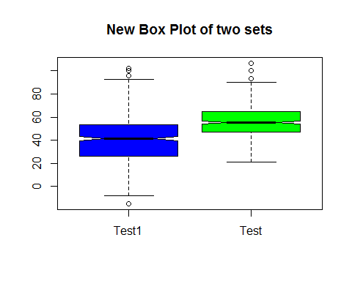

# e) Letter value Boxplots for Test  
source("C:/Users/lenovo/Documents/lvalprogs.R")  
lval(t1)

## Depth Lower Upper Mid Spread pseudo-s  
## M 250.5 41.3984 41.3984 41.3984 0.0000 0.0000  
## F 125.5 26.2833 53.4069 39.8451 27.1236 20.1068  
## E 63.0 18.7886 64.0892 41.4389 45.3006 19.6899  
## D 32.0 12.3199 72.3650 42.3425 60.0452 19.5699  
## C 16.5 4.6076 78.2895 41.4486 73.6819 19.7779  
## B 8.5 0.0818 85.3416 42.7117 85.2598 19.7922  
## A 4.5 -7.2204 89.6581 41.2188 96.8784 20.0364  
## Z 2.5 -11.2082 98.0472 43.4195 109.2555 20.5362  
## Y 1.5 -14.7442 101.4572 43.3565 116.2013 20.1344  
## X 1.0 -14.8316 102.3559 43.7622 117.1874 18.9179

lval(t2)

## Depth Lower Upper Mid Spread pseudo-s  
## M 250.5 55.3246 55.3246 55.3246 0.0000 0.0000  
## F 125.5 47.2532 64.9557 56.1044 17.7025 13.1229  
## E 63.0 40.2651 71.3110 55.7880 31.0460 13.4941  
## D 32.0 36.3970 77.0373 56.7172 40.6403 13.2455  
## C 16.5 31.7731 80.2704 56.0218 48.4973 13.0178  
## B 8.5 29.6541 83.4854 56.5697 53.8313 12.4964  
## A 4.5 26.9667 88.3524 57.6595 61.3858 12.6958  
## Z 2.5 24.2223 96.7608 60.4915 72.5385 13.6347  
## Y 1.5 21.4194 103.4349 62.4272 82.0155 14.2110  
## X 1.0 21.1272 106.6392 63.8832 85.5120 13.8044

lvplot(t1,main="Letter value plot for Test1")

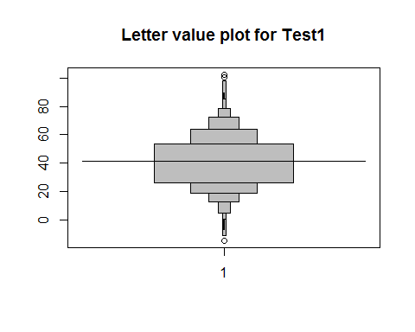

lvplot(t2,main="Letter value plot for Test2")

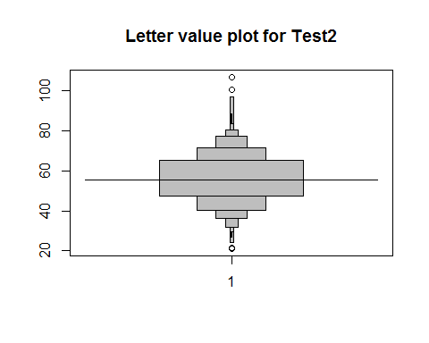

library(MASS)  
data(pressure)  
attach(pressure)

## The following object is masked _by_ .GlobalEnv:  
##   
## pressure  
##   
## The following object is masked from package:datasets:  
##   
## pressure

y=pressure$pressure  
x=pressure$temperature  
  
y= y * 0.1333  
x=x + 273.15  
# a) Scatter Plot of Pressure versus Temperature  
plot(x,y,main = "Pressure versus Temperature",xlab="Temperature in Kelvin",  
 ylab="Pressure in Kilo Pascals")

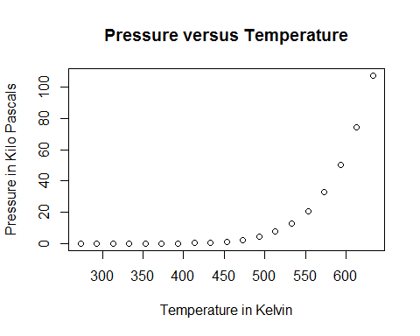

# b) Let us try Log, Square root and Cube root transform  
plot(y~log(x),main="Log Transform")

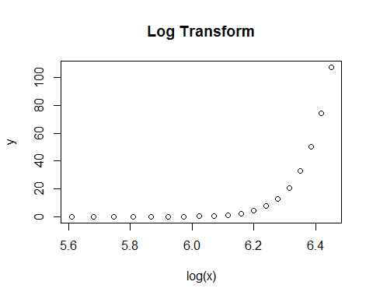

plot(y~sqrt(x), main="Square root Transform")

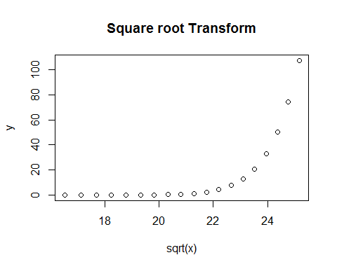

plot(y, x^(1/3))

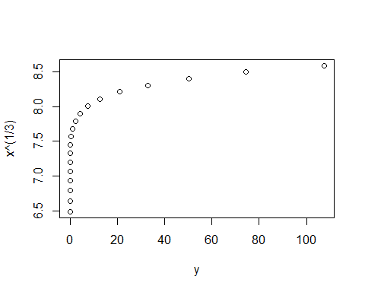

# c)   
plot(y~I(1/x))

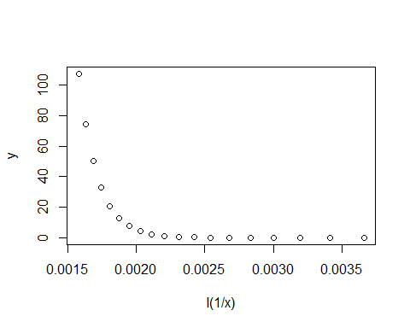

# e) Box Cox Transformation  
boxcox(y~I(1/x))

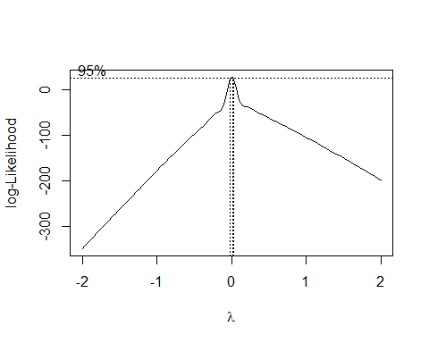

plot(log(y)~I(1/x))

