Class Project: What's Cooking

FNU Anirudh and Prudhvi Raj Indana

December 10, 2015

## INTRODUCTION

The goal of this project is to study the characterstics of dishes in training set and learn traits associated to particular cuisine and classify cuisine based on ingredients in test set.

In the report, we describe the data we use and how we process it. Then we explore techniques for classification and also look at unsupervised learning techniques for more information. JSON files for training and test dataset has been provided.

## 1. DATASET

Our Main dataset is train data set which we use to train our model and then implement our model to classify cuisines in test dataset. First let us analyze dimension of training dataset. Both training and test datasets are in JSON format and were read using library jsonlite in R.

## [1] 39774 3

There are 39774 rows and 3 columns in our training dataset.

Let us now analyze the column names in our dataset

## [1] "id" "cuisine" "ingredients"

From this we see that there are 3 colummns in training data namely id, cuisine and ingredients.

Let us print first row to see how our dataset looks.

## id cuisine  
## 1 10259 greek  
## ingredients  
## 1 romaine lettuce, black olives, grape tomatoes, garlic, pepper, purple onion, seasoning, garbanzo beans, feta cheese crumbles

From above we see that all the ingredient that are associated with a dish are stored in single vector hence in order to classify we will have to split each ingredient and check it's occurence in other dishes to understand the pattern.

Let us now Analyze how many unique cuisines are there in our dataset and how they are distributed and how many times does each appear in our training data.

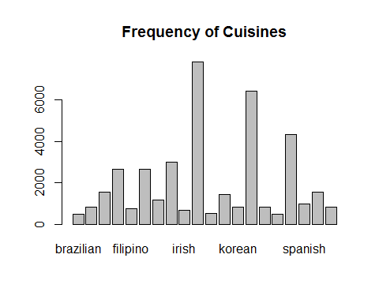 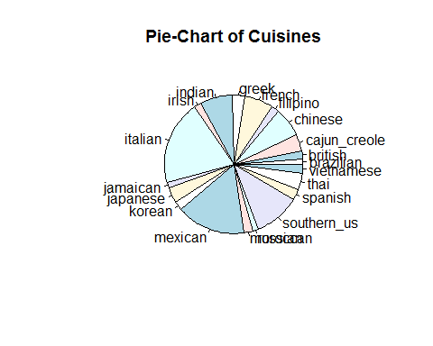

##   
## brazilian british cajun_creole chinese filipino   
## 467 804 1546 2673 755   
## french greek indian irish italian   
## 2646 1175 3003 667 7838   
## jamaican japanese korean mexican moroccan   
## 526 1423 830 6438 821   
## russian southern_us spanish thai vietnamese   
## 489 4320 989 1539 825

## [1] 7838

We find that there are 20 different or unique cuisines in our dataset. From barplot we see that there are couple of cuisines which have high frequency, To get better understanding we plot Pie Chart and find out that Italian and Mexican cuisines have high frequency compared to other dishes.We print all the cuisines in our dataset and number of times each cuisine repeats and find that there are 7838 Italian dishes out of 39,774 dishes. Our data is categorical data.

# 2. TECHNIQUES

We have used following classification algorithms in our project to classify cuisines:-

### 2.1 Naive Bayes

The Naive Bayes algorithm is an intuitive method that uses the probabilities of each attribute belonging to each class to make a prediction. It is the supervised learning approach to model a predictive modeling problem probabilistically.

Naive bayes simplifies the calculation of probabilities by assuming that the probability of each attribute belonging to a given class value is independent of all other attributes. This is a strong assumption but results in a fast and effective method.

The probability of a class value given a value of an attribute is called the conditional probability. By multiplying the conditional probabilities together for each attribute for a given class value, we have a probability of a data instance belonging to that class.

To make a prediction we can calculate probabilities of the instance belonging to each class and select the class value with the highest probability.

Naive bases is often described using categorical data because it is easy to describe and calculate using ratios. A more useful version of the algorithm for our purposes supports numeric attributes and assumes the values of each numerical attribute are normally distributed (fall somewhere on a bell curve). Again, this is a strong assumption, but still gives robust results.

#### Reason for Using Naive Bayes

* Naive Bayes can handle missing data
* We can use Naive Bayes for Categorical data by calculating frequency of observation.
* Probabilities for each attribute are calculated independently from the training dataset. We can use a search algorithm to explore the combination of the probabilities of different attributes together and evaluate their performance at predicting the output variable. We can use probabilities to do feature selection.
* Naive Bayes can give increased performance and focus on the elements of the problem that are more difficult to model by identifying and separating out segments that are easily handled by a simple probabilistic apporach.
* One of the Benefit of Naive Bayes is that we can re-calculate probabilities as data changes.
* An interesting point about Naive Bayes is that even when the independence assumption is violated and there are clear known relationships between attributes, it works anyway.

### 2.2 K- Nearest Neighbour

The purpose of the k Nearest Neighbours (kNN) algorithm is to use a database in which the data points are separated into several separate classes to predict the classification of a new sample point.

we consider each of the characteristics in our training set as a different dimension in some space, and take the value an observation has for this characteristic to be its coordinate in that dimension, so getting a set of points in space. We can then consider the similarity of two points to be the distance between them in this space under some appropriate metric.

The algorithm can be summarised as:

* A positive integer k is specified, along with a new sample
* We select the k entries in our database which are closest to the new sample
* We find the most common classification of these entries
* This is the classification we give to the new sample

### Reason for Using KNN Algorithm

* Cost of Learning process is zero.
* No assumptions about the characterstics of the concept to learn have to be done.
* Complex concepts can be learned by local approximation using simple procedures.

### 2.3 Neural Network

Neural networks or artificial neural networks (ANNs) have received a lot of attention for their abilities to 'learn' relationships among variables. They represent an innovative technique for model fitting that doesn't rely on conventional assumptions necessary for standard models and they can also quite effectively handle multivariate response data. As a part of this project we want to train on multivariate data from whats cooking and compare it with other bench mark algorithams.

### Reasons for using Neural Networks

* Ability to implicitly detect complex nonlinear relationships between dependent and independent variables.
* Ability to detect all possible interactions between predictor variables.
* Availability of multiple training algorithms.

### 2.4 Random Forest

Random Forests grows many classification trees. To classify a new object from an input vector, put the input vector down each of the trees in the forest. Each tree gives a classification, and we say the tree "votes" for that class. The forest chooses the classification having the most votes (over all the trees in the forest).

Each tree is grown as follows:

* If the number of cases in the training set is N, sample N cases at random - but with replacement, from the original data. This sample will be the training set for growing the tree.
* If there are M input variables, a number m<<M is specified such that at each node, m variables are selected at random out of the M and the best split on these m is used to split the node. The value of m is held constant during the forest growing.
* Each tree is grown to the largest extent possible. There is no pruning.

### Reasons for using Random Forest

* It runs efficiently on large data bases.
* It can handle thousands of input variables without variable deletion.
* It gives estimates of what variables are important in the classification.
* It offers an experimental method for detecting variable interactions.

# 3.RESULTS

## 3.1 Naive Bayes

We run the Naive Bayes Algorithm after removing redundant features or ingredients from our training dataset.We will first try to predict our accuracy on training dataset and then try to predict cuisine in test dataset.

## [1] "Naive Bayes Predictions"

## t  
## brazilian british cajun_creole chinese filipino   
## 203 4367 1755 1170 461   
## french greek indian irish italian   
## 1427 1300 2382 3666 4598   
## jamaican japanese korean mexican moroccan   
## 379 631 4850 4227 1642   
## russian southern_us spanish thai vietnamese   
## 1555 663 931 972 2595

## [1] "Accuracy of Naive Bayes is ="

## [1] 40.46362

We get only 40% accuracy on Implementing Naive Bayes. Let us now predict cuisine in our test data set.

## t  
## brazilian british cajun_creole chinese filipino   
## 40 612 452 263 125   
## french greek indian irish italian   
## 203 266 798 1162 1169   
## jamaican japanese korean mexican moroccan   
## 83 152 1588 888 231   
## russian southern_us spanish thai vietnamese   
## 608 87 207 189 821

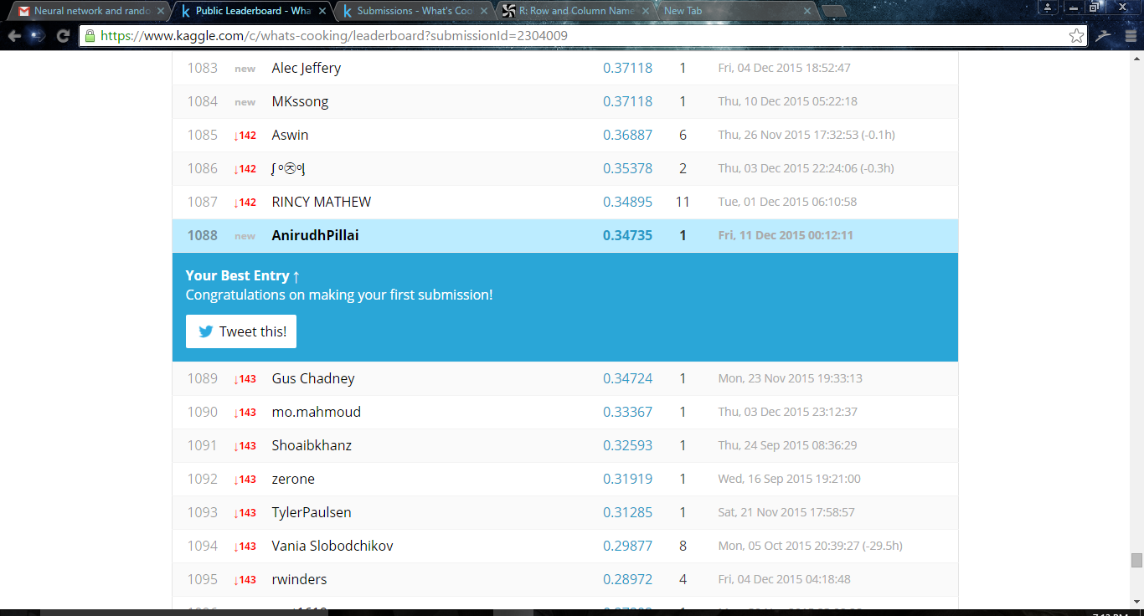

We get very low accuracy on our test dataset as seen above. We should try a different algorithm.

## 3.2 K-Nearest Neighbours

We try K-Nearest Neighbours Algorithm to predict cuisine in our training dataset. We split our original training dataset into training and test dataset. We have chosen first 30,000 dishes as training and remaining 9774 as test dataset, We apply KNN to predict cuisine on test dataset.

## [1] "The Accuracy of K- Nearest Neighbours is ="

## [1] 56.90608

We get 57% accuracy on Implementing K Nearest Neighbour. Let us now predict cuisine in our test data set.

## m2  
## brazilian british cajun_creole chinese filipino   
## 145 22 193 205 27   
## french greek indian irish italian   
## 289 56 765 68 3241   
## jamaican japanese korean mexican moroccan   
## 24 509 82 1789 18   
## russian southern_us spanish thai vietnamese   
## 2 2399 29 57 24

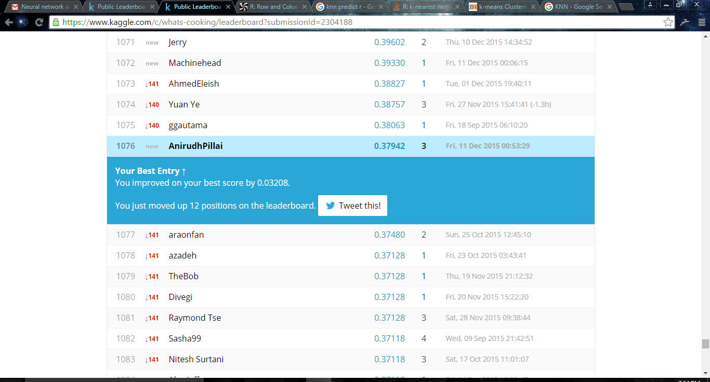

We get accuracy of 38% on test dataset which is slightly better than our naive bayes algorithm.

## 3.3 Random Forest

# LIST OF REFERENCES

* <https://www.stat.berkeley.edu/~breiman/RandomForests/cc_home.htm>
* <http://www.cs.upc.edu/~bejar/apren/docum/trans/03d-algind-knn-eng.pdf>
* <http://machinelearningmastery.com/naive-bayes-classifier-scratch-python/>
* <http://www.rdatamining.com/>
* <http://www.analyticsvidhya.com/blog/2015/08/common-machine-learning-algorithms/>