Zappos Analytics Challenge

Anirudh Pillai

July 14, 2016

# Introduction

###### **The first step to do before visualizing data is to understand our dataset.Lets check dimension of our dataset.**

## [1] 21061 12

###### **Our Dataset has 21061 rows and 12 columns.**

###### **I observed that dataset has lot of missing values and data for Months March, April and May are missing.Let's check each column name or feature name in our dataset.**

## [1] "day" "site" "new_customer"   
## [4] "platform" "visits" "distinct_sessions"   
## [7] "orders" "gross_sales" "bounces"   
## [10] "add_to_cart" "product_page_views" "search_page_views"

###### **Let us find datatype of each attribute.**

## 'data.frame': 21061 obs. of 12 variables:  
## $ day : Factor w/ 268 levels "1/1/2013 0:00",..: 1 1 1 1 1 1 1 1 1 1 ...  
## $ site : Factor w/ 6 levels "Acme","Botly",..: 1 1 4 1 2 1 4 4 1 1 ...  
## $ new_customer : int 1 1 1 1 1 1 1 1 0 0 ...  
## $ platform : Factor w/ 15 levels "","Android","BlackBerry",..: 2 3 6 14 2 9 2 14 8 7 ...  
## $ visits : int 24 0 0 922 11 384 14 1 41 448 ...  
## $ distinct_sessions : int 16 0 0 520 10 214 10 0 27 368 ...  
## $ orders : int 14 0 0 527 11 213 4 0 6 36 ...  
## $ gross_sales : int 1287 13 98 60753 1090 28129 432 31 705 4637 ...  
## $ bounces : int 4 0 0 149 0 65 4 0 6 80 ...  
## $ add_to_cart : int 16 0 0 610 11 245 7 0 12 79 ...  
## $ product_page_views: int 104 1 0 3914 4 1783 33 2 130 722 ...  
## $ search_page_views : int 192 0 0 7367 19 3255 52 2 272 1073 ...

###### **Let's summarize our dataset.**

## day site new_customer platform   
## 12/19/2013 0:00: 86 Acme :7392 Min. :0.000 iOS :3435   
## 11/29/2013 0:00: 85 Botly : 804 1st Qu.:0.000 Android:3172   
## 12/11/2013 0:00: 85 Pinnacle:5725 Median :0.000 Windows:2399   
## 12/7/2013 0:00 : 85 Sortly :5532 Mean :0.448 MacOSX :2054   
## 12/2/2013 0:00 : 84 Tabular : 804 3rd Qu.:1.000 Linux :2036   
## 12/5/2013 0:00 : 84 Widgetry: 804 Max. :1.000 Unknown:1641   
## (Other) :20552 NA's :8259 (Other):6324   
## visits distinct_sessions orders gross_sales   
## Min. : 0 Min. : 0 Min. : 0.00 Min. : 1   
## 1st Qu.: 3 1st Qu.: 2 1st Qu.: 0.00 1st Qu.: 79   
## Median : 24 Median : 19 Median : 0.00 Median : 851   
## Mean : 1935 Mean : 1515 Mean : 62.38 Mean : 16473   
## 3rd Qu.: 360 3rd Qu.: 274 3rd Qu.: 7.00 3rd Qu.: 3145   
## Max. :136057 Max. :107104 Max. :4916.00 Max. :707642   
## NA's :9576   
## bounces add_to_cart product_page_views search_page_views  
## Min. : 0.0 Min. : 0.0 Min. : 0 Min. : 0   
## 1st Qu.: 0.0 1st Qu.: 0.0 1st Qu.: 3 1st Qu.: 4   
## Median : 5.0 Median : 4.0 Median : 53 Median : 82   
## Mean : 743.3 Mean : 166.3 Mean : 4358 Mean : 8584   
## 3rd Qu.: 97.0 3rd Qu.: 43.0 3rd Qu.: 708 3rd Qu.: 1229   
## Max. :54512.0 Max. :7924.0 Max. :187601 Max. :506629   
##

###### **I have added new column called month which contains initials of each Month.e.g:- Jan, Feb etc which will help when grouping attributes monthly.I have also calculated conversion rate, bounce rate and add to cart rate and added column for each in our dataset.**

###### **Let us now check which site is most visisted by our customers.**

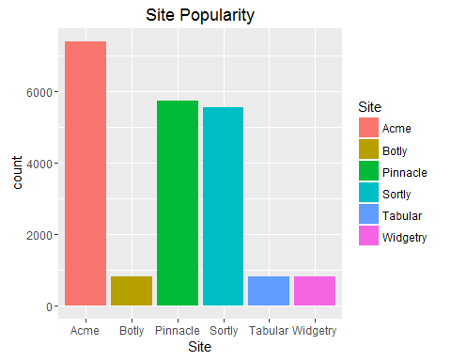

###### **Clearly Acme is favorite among users as seen from plot.Pinnacle and Sortly are not far behind and are doing ok. Botly, Tabular and Widgetry are on the same page with minimum customers visiting the website. In my opinion we shoud:**

* promote Botly, Tabular and Widgetry by publishing their contents or offers as advertisments on Acme,Pinnacle and Sortly.
* provide huge discounts or deals initially to lure customers.

###### **Let us check Platform Popularity or which platform is widely used by customers to visit our sites.**

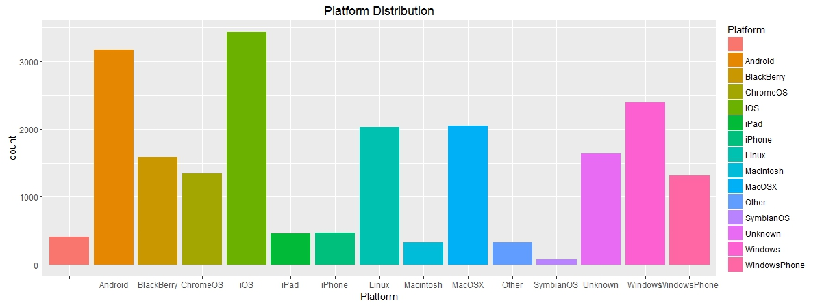

###### **Both Android and iOS are seen to be widely popular platforms among customers for browsing our sites but iOS has slight edge compared to Android when we compare the exact count.**

###### **If we divide Platform into sub classes like Mobile OS and System OS. We can see that iOS tops the chart among smartphones and tablets whereas Windows slightly edges past all the other Operating systems.**

###### **We can further plot stacked bar chart indicating popularity of sites in each platform.**

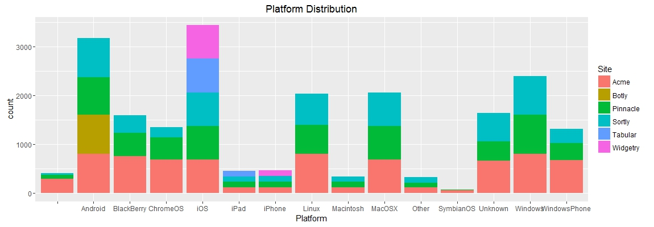

###### **Let's find out our highest revenue generating website and platform.**

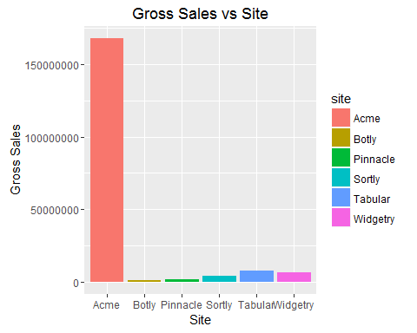

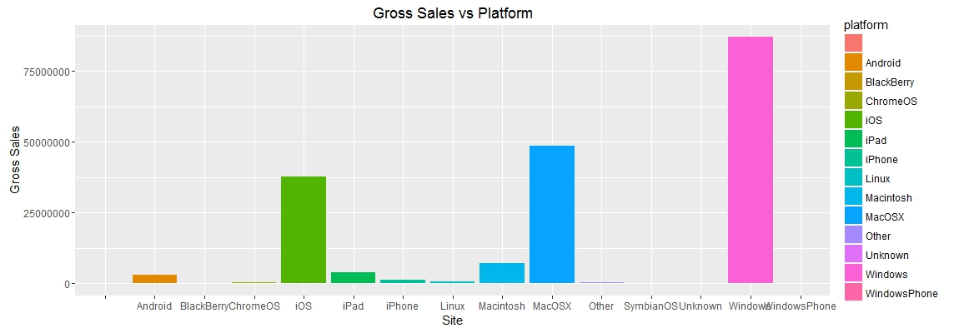

###### **Clearly, Acme generates way more revenue than any other website.We should take steps to improve revenue from other websites.**

###### ** Windows Desktops, MacOSX, iOS Devices generate majority of revenue with Windows being top performer.

###### **Let us check conversion rate for each platform.**

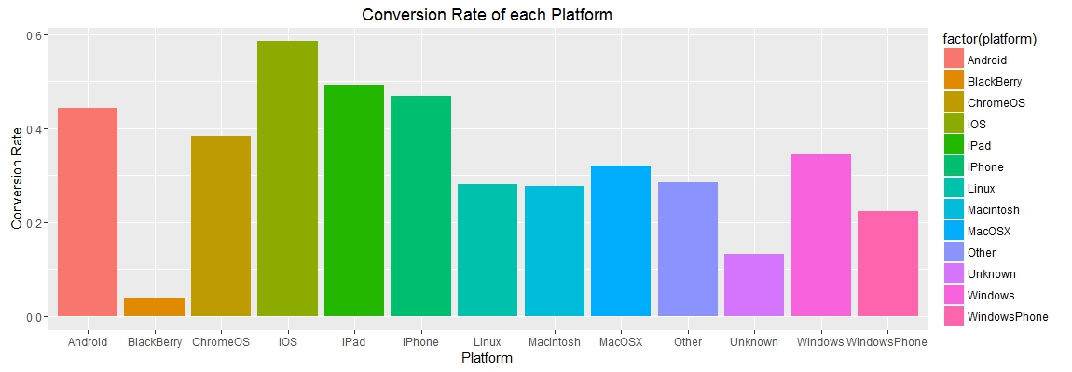

###### **Conversion rates for Blackberry and Symbian OS is very low. We can ignore Symbian OS since there are only 74 users who have used symbian device for browsing. Moreover Symbion is no longer popular or widely used among users.**

###### **We have 1574 customers who use Blackberry device for browsing our websites and we should take steps to improve conversion rate on this platform by providing some Blackberry specific deal or offers.**

# Key Performance Index

###### **Since there are so many parameters in our dataset which can be used to judge performance of webistes so let's make a correlation matrix of all key performance index.**

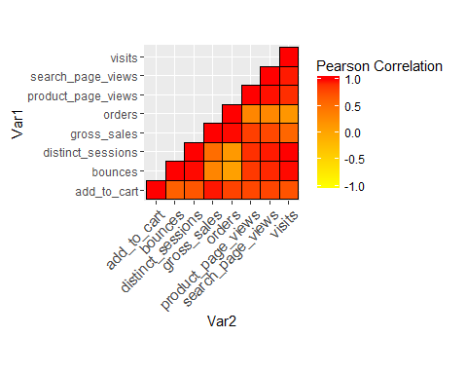 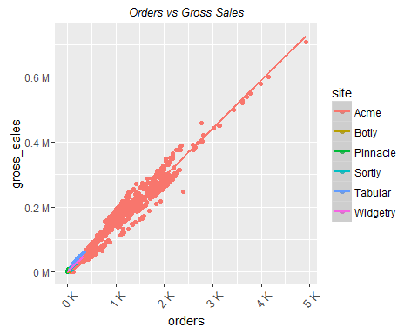 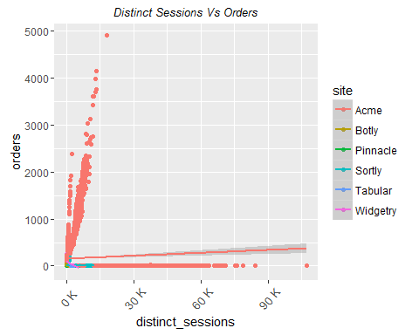

###### **My observations from above is**

* All the Key Performance Indicators have positive correlations
* Low correlation between Vists and Orders.
* Correlation between Vists and Bounces is very high and we need some kind of load balancer to handle traffic specially when there are lot of customers or during festive season. I also recommend load testing and stress testing from my personal experience.

###### **Let's check average bounce rate per site.**

## site Average Bounce Rate  
## 1 Acme 0.313272750  
## 2 Botly 0.171117865  
## 3 Pinnacle 0.478650826  
## 4 Sortly 0.382362938  
## 5 Tabular 0.027045166  
## 6 Widgetry 0.007752247

## site Number of Visits  
## 1 Acme 35593107  
## 2 Botly 156598  
## 3 Pinnacle 636269  
## 4 Sortly 2449196  
## 5 Tabular 713049  
## 6 Widgetry 1198667

###### **Bounce Rate represents the percentage of visitors who enter the site and then leave ("bounce") rather than continuing on to view other pages within the same site.**

###### **Bounce rate looks pretty decent and shows that customers do navigate to other pages in our webistes.**

###### **As seen from the results:**

* Acme is our most visited website
* Botly is our least visited website.

###### **These results help us to understand customer behavior and we can improve their experiences in areas we lack and get better results.**

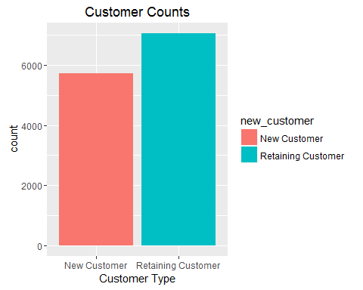

###### **We have 7066 returning customer which shows that our customers had positive experience in past and are loyal to the brand. We have 5736 new customers which is equally good.**

# Future Implementations Possible

* Add Heatmap indicating busiest months. (I tried to implement but was getting error related to package version for which I could not find any solution).
* We can also have visualization related to new customers and retaining customers who add items to carts and their sessions.
* We can Implement Regression to predict sales for next year or Time series analysis to predict sales for each month next year.