**Assignment: 2**

1. The possible states are those which can be achieved given an initial state and a legal move or a sequence of legal moves (within the rules) taken by the player.

The initial state describes the position of each player. For e.g. – in Tic tac Toe, it is an empty grid.

The transition function describes the set of all possible states that can be achieved by a player at with the current state and a legal moves/series of moves.

1. The legal terminal stated for checkers are Red player winning (1-12 red pieces left), black player winning (1-12 pieces left) or a draw.

For TTT 3X3, it could be X winning, with three X’s in any one of the rows/columns/diagonals and the other way round for player playing as O. For a draw, it is neither one being to get 3 of a kind in the same rows/columns/diagonal.

1. This heuristic function is one that approximates a utility function. White winning implies positive or greater red pieces and vice versa hence this function is valid.
2. The heuristic function approximated the utility function if it is very close or equal to the utility function in all the cases. That it means it doesn’t underestimate or overestimate the cost/score of the function.
3. A king can make jumps as shown in below diagram. The heuristic is less than 0 but it can still win.

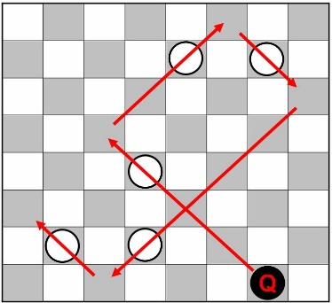

1. Yes. It can still suffer from the same problem. It is the difference of the wins at particular state subtracted from the losses at the same state. It is possible that *N*(*A*, *s*)>0 but it still ends up loosing (if not playing optimally).

