Assignment: 1

Q1: The matrices are: PI :1 2 0.5 0.5 A: 2 2 0.5 0.5 0.5 0.5 B: 2 2 0.9 0.1 0.5 0.5 where A represents the state transition probabilities , B represents the emission probabilities and PI represents the initial state probabilities at t=0.

Q2: The product of state transition matrix (A) and the current estimates of states will give us a row vector representing the probability of being at the respective state at the next interval of time. In the example it is X: 1 2 0.5 0.5.

Q3: The mentioned product of matrices gives us the probability of each observation i.e. either head or tail at a time interval. In the example provided it is X: 1 2 0.7 0.3.
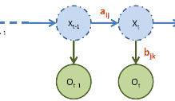
Q4: It is valid to make the mentioned substitution because of the Markov property. Given X(t), O(t) is conditionally independent of all the previous states. This can also be understood from the below diagram.

Q5: δ has T values where as δ^idx has T-1 values where T length of the observation sequence.

Q6: The Di gamma function represents the probability of being in state i at time t and being in state j at time t+1 given all made observations. To achieve this, we need to divide by the Probability of the entire Observation sequence given lambda, our model. the sum of the final alpha values at t=T gives us this value. Hence, we divide with this figure.

Q7: The Baum welch algorithm implemented as per the stamp tutorial runs for 2055 iterations when trained using the observation sequence hmm_c_N1000. The resulting estimates of A and B matrices are close to the initial values but don’t converge completely. Similar results were observed when tested with the sequence of length 100,500 and 750 respectively. However, the results were closest for sequence of length 1000.
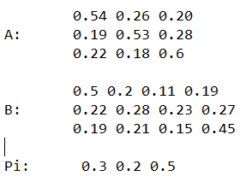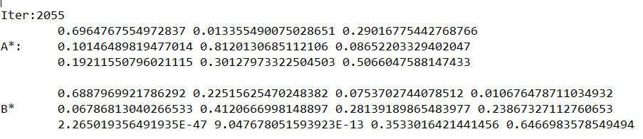

Q8: The Baum welch algorithm implemented as per the stamp tutorial runs for 2470 iterations when trained using the observation sequence hmm_c_N1000 on random initialisation values of A, B, Pi. The resulting estimates of A and B matrices are close to the initial values but don’t converge completely. The EM algorithm converges to the nearest local maxima. To get the optimal results it is advised to initiate the initial matrices as close the actual matrices.
.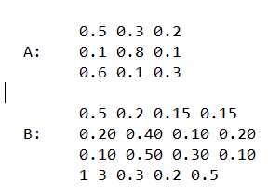 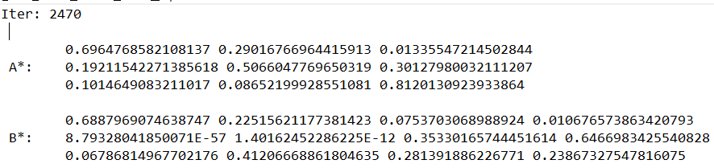
Q9: Choosing the number of stated which maximises the likelihood is optimal. While fitting models ,it is possible to increase the likelihood by adding parameters , but doing this will result in overfitting. We could also BIC, AIC values that are based on,likelihood function to pick the best models. These algorithms include a penalty terms for the number of parameters can help choose the best models.

Q10: If we initialise Baum Welch algorithm with a uniform distribution, it converges to a local maximum from which it is not possible to climb further. Learning doesn’t take place, so it is advised to use rather random row stochastic values.
If we initialize a diagonal A matrix and use PI as [ 0 0 1], we end up with a lot of NaN values due to the mathematical calculations involving a lot of zeros.
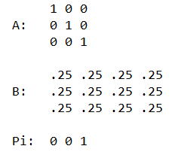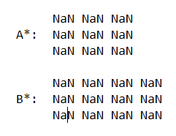
If initialization values are closer to the solution, the Baum welch algorithm converges in less iterations and learning is faster as compared to randomly generated initial matrices.

