**Ideation Phase**

**Define the Problem Statements**

|  |  |
| --- | --- |
| Date | 15 April 2025 |
| Team ID | SWTID1743315070 |
| Project Name | ShopEZ – A Seamless Online Shopping Platform |
| Maximum Marks | 2 Marks |

**Customer Problem Statement Template:**

Create a problem statement to understand your customer's point of view. The Customer Problem Statement template helps you focus on what matters to create experiences people will love.

A well-articulated customer problem statement allows you and your team to find the ideal solution for the challenges your customers face. Throughout the process, you’ll also be able to empathize with your customers, which helps you better understand how they perceive your product or service.

**Example:**

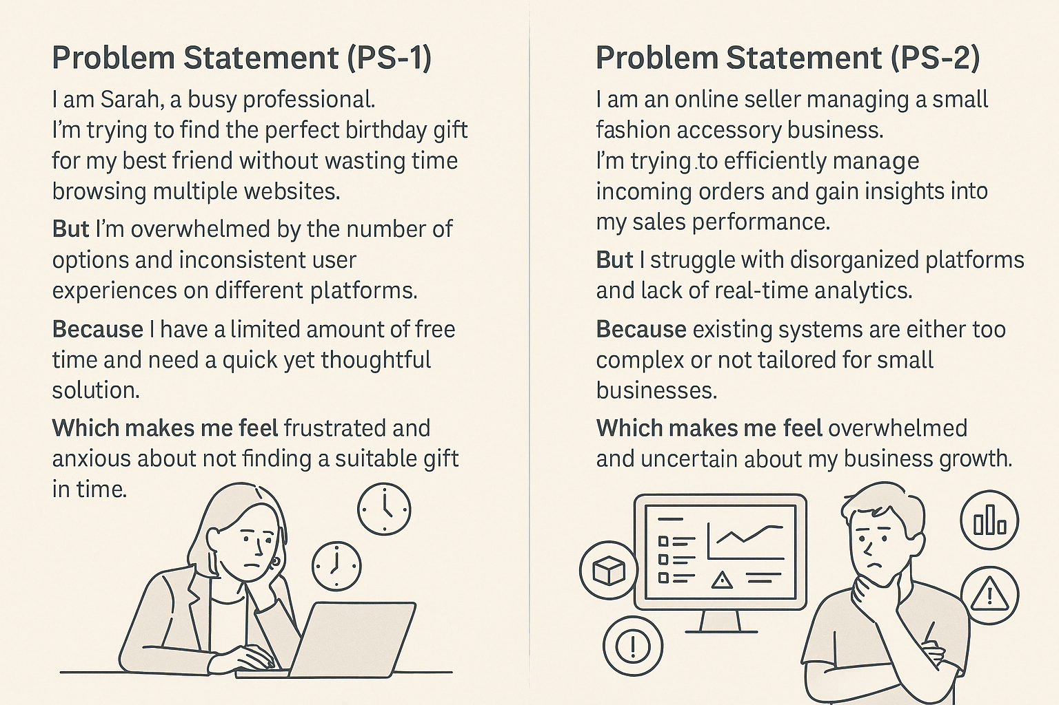

|  |  |  |  |  |  |
| --- | --- | --- | --- | --- | --- |
| **Problem Statement (PS)** | **I am (Customer)** | **I’m trying to** | **But** | **Because** | **Which makes me feel** |
| PS-1 | I am Sarah, a busy professional. | **I’m trying to** find the perfect birthday gift for my best friend without wasting time browsing multiple websites. | **But** I’m overwhelmed by the number of options and inconsistent user experiences on different platforms. | **Because** I have a limited amount of free time and need a quick yet thoughtful solution. | **Which makes me feel** frustrated and anxious about not finding a suitable gift in time. |
| PS-2 | **I am** an online seller managing a small fashion accessory business. | **I’m trying to** efficiently manage incoming orders and gain insights into my sales performance. | **But** I struggle with disorganized platforms and lack of real-time analytics. | **Because** existing systems are either too complex or not tailored for small businesses. | **Which makes me feel** overwhelmed and uncertain about my business growth. |