**Project Design Phase**

**Problem – Solution Fit**

|  |  |
| --- | --- |
| Date | 14 April 2025 |
| Team ID | SWTID1743315070 |
| Project Name | ShopEZ: E-commerce Application |
| Maximum Marks | 2 Marks |

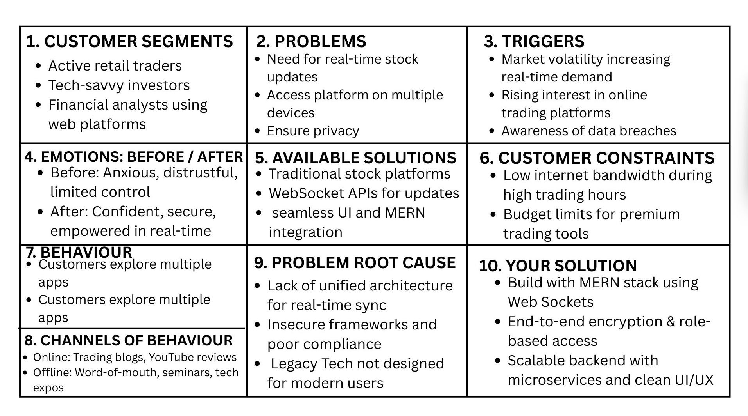

# Project Details - ShopEZ

ShopEZ is your one-stop destination for effortless online shopping. With a user-friendly interface and a comprehensive product catalog, finding the perfect items has never been easier. Seamlessly navigate through detailed product descriptions, customer reviews, and available discounts to make informed decisions. Enjoy a secure checkout process and receive instant order confirmation. For sellers, our robust dashboard provides efficient order management and insightful analytics to drive business growth. Experience the future of online shopping with ShopEZ today.

Key Features:

- Seamless Checkout Process

- Effortless Product Discovery

- Personalized Shopping Experience

- Efficient Order Management for Sellers

- Insightful Analytics for Business Growth

## Scenario: Sarah's Birthday Gift

Sarah, a busy professional, is scrambling to find the perfect birthday gift for her best friend, Emily. She knows Emily loves fashion accessories, but with her hectic schedule, she hasn't had time to browse through multiple websites to find the ideal present. Feeling overwhelmed, Sarah turns to ShopEZ to simplify her search.

1. Effortless Product Discovery: Sarah opens ShopEZ and navigates to the fashion accessories category. She's greeted with a diverse range of options, from chic handbags to elegant jewelry. Using the filtering options, Sarah selects "bracelets" and refines her search based on Emily's preferred style and budget.  
2. Personalized Recommendations: As Sarah scrolls through the curated selection of bracelets, she notices a section labeled "Recommended for You." Intrigued, she clicks on it and discovers a stunning gold bangle that perfectly matches Emily's taste. Impressed by the personalized recommendation, Sarah adds it to her cart.  
3. Seamless Checkout Process: With the bracelet in her cart, Sarah proceeds to checkout. She enters Emily's address as the shipping destination and selects her preferred payment method. Thanks to ShopEZ's secure and efficient checkout process, Sarah completes the transaction in just a few clicks.  
4. Order Confirmation: Moments after placing her order, Sarah receives a confirmation email from ShopEZ. Relieved to have found the perfect gift for Emily, she eagerly awaits its arrival.  
5. Efficient Order Management for Sellers: Meanwhile, on the other end, the seller of the gold bangle receives a notification of Sarah's purchase through ShopEZ's seller dashboard. They quickly process the order and prepare it for shipment, confident in ShopEZ's streamlined order management system.  
6. Celebrating with Confidence: On Emily's birthday, Sarah presents her with the beautifully packaged bracelet, knowing it was chosen with care and thoughtfulness. Emily's eyes light up with joy as she adorns the bracelet, grateful for Sarah's thoughtful gesture.

In this scenario, ShopEZ proves to be the perfect solution for Sarah's busy lifestyle, offering a seamless and personalized shopping experience. From effortless product discovery to secure checkout and efficient order management, ShopEZ simplifies the entire process, allowing Sarah to celebrate Emily's birthday with confidence and ease.

## Technical Architecture

In this architecture diagram:  
- The frontend is represented by the "Frontend" section, including user interface components such as User Authentication, Cart, Products, Profile, Admin dashboard, etc.  
- The backend is represented by the "Backend" section, consisting of API endpoints for Users, Orders, Products, etc. It also includes Admin Authentication and an Admin Dashboard.  
- The Database section represents the database that stores collections for Users, Cart, Orders, and Products.