**Topics: Descriptive Statistics and Probability**

1. Look at the data given below. Plot the data, find the outliers and find out $μ, σ, σ^{2}$

|  |  |
| --- | --- |
| **Name of company** | **Measure X** |
| Allied Signal | 24.23% |
| Bankers Trust | 25.53% |
| General Mills | 25.41% |
| ITT Industries | 24.14% |
| J.P.Morgan& Co. | 29.62% |
| Lehman Brothers | 28.25% |
| Marriott | 25.81% |
| MCI | 24.39% |
| Merrill Lynch | 40.26% |
| Microsoft | 32.95% |
| Morgan Stanley | 91.36% |
| Sun Microsystems | 25.99% |
| Travelers | 39.42% |
| US Airways | 26.71% |
| Warner-Lambert | 35.00% |

Answer:

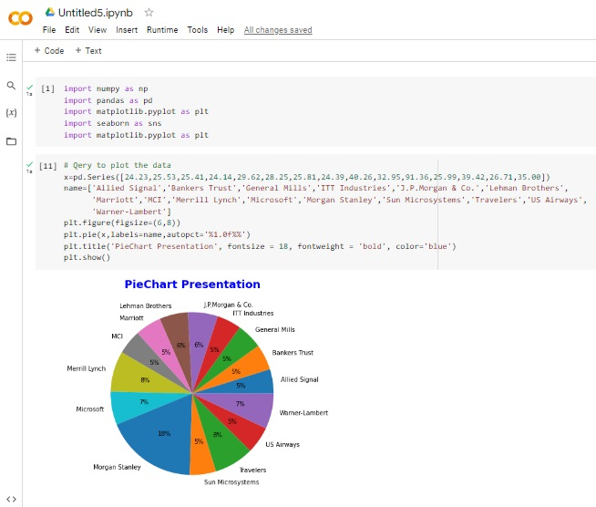

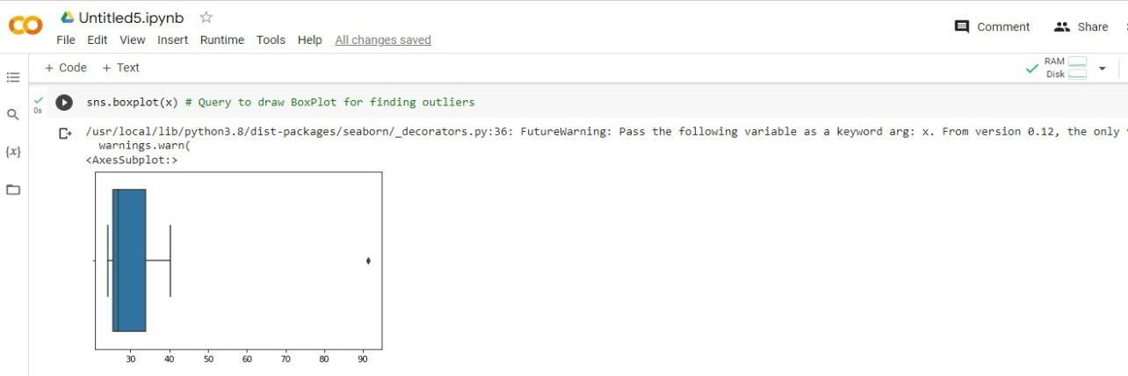





Answer the following three questions based on the box-plot above.

1. What is inter-quartile range of this dataset? (please approximate the numbers) In one line, explain what this value implies.

**Answer:** First Quantile Range (Q1) = 5, Third Quantile Range (Q3) = 12,

IQR = Q3-Q1 (12-5) = 7. Hence 50% of data is in the range of 5 and 12.

1. What can we say about the skewness of this dataset?

**Answer:** The dataset is Right-skewed as the median is towards the left side

1. If it was found that the data point with the value 25 is actually 2.5, how would the new box-plot be affected?

**Answer:** In the above mentioned case there is no Outliers on the given dataset because of that the data will normal distributed



Answer the following three questions based on the histogram above.

1. Where would the mode of this dataset lie?

**Answer:** The mode of this data set will be in between 4 to 8.

1. Comment on the skewness of the dataset.

**Answer:** Right-Skewed. Mean>Median>Mode

1. Suppose that the above histogram and the box-plot in question 2 are plotted for the same dataset. Explain how these graphs complement each other in providing information about any dataset.

**Answer:** Both are right-skewed as both of them are having outliers the median can be easily visualized in box plot where in histogram the mode is much more visible.

1. AT&T was running commercials in 1990 aimed at luring back customers who had switched to one of the other long-distance phone service providers. One such commercial shows a businessman trying to reach Phoenix and mistakenly getting Fiji, where a half-naked native on a beach responds incomprehensibly in Polynesian. When asked about this advertisement, AT&T admitted that the portrayed incident did not actually take place but added that this was an enactment of something that “could happen.” Suppose that one in 200 long-distance telephone calls is misdirected. What is the probability that at least one in five attempted telephone calls reaches the wrong number? (Assume independence of attempts.)

**Answer: -** IF 1 in 200 long-distance telephone calls are getting misdirected.

Probability of call misdirecting   = 1/200

Probability of call not Misdirecting = 1-1/200 = 199/200

The probability for at least one in five attempted telephone calls reaches the wrong number

Number of Calls = 5

n = 5

p = 1/200

q = 199/200

P(x) = at least one in five attempted telephone calls reaches the wrong number

P(x) = ⁿCₓ pˣ qⁿ⁻ˣ

P (x) = (nCx) (p^x) (q^n-x)     # **nCr = n! / r! * (n - r)!**

P (1) = (5C1) (1/200)^1 (199/200)^5-1

P (1) = 0.0245037

1. Returns on a certain business venture, to the nearest $1,000, are known to follow the following probability distribution

|  |  |
| --- | --- |
| x | P(x) |
| -2,000 | 0.1 |
| -1,000 | 0.1 |
| 0 | 0.2 |
| 1000 | 0.2 |
| 2000 | 0.3 |
| 3000 | 0.1 |

Answer: - E(X) =Sum X.*P(X) | E(X^2) =X^2*P(X)

-200 400000

-100 100000

0 0

200 200000

600 1200000

300 900000

Total: 800 2800000

1. What is the most likely monetary outcome of the business venture?

**Answer: -** The most likely monetary outcome of the business venture is 2000$

1. As for 2000$ the probability is 0.3 which is maximum as compared to others
2. p(x>0)+p(x>1000)+p(x>2000)+p(x=3000) = 0.2+0.2+0.3+0.1 = 0.8 this states that there is a good 80% chances for this venture to be making a profit
3. Is the venture likely to be successful? Explain

**Answer: -** Yes, the probability that the venture will make more than 0 or a profit

1. What is the long-term average earning of business ventures of this kind? Explain

**Answer: -** The long-term average is Expected value = Sum (X * P(X)) = 800$ which means

On an average the returns will be + 800$

1. What is the good measure of the risk involved in a venture of this kind? Compute this measure

**Answer: -** The good measure of the risk involved in a venture of this kind depends on the Variability in the distribution. Higher Variance means more chances of risk

Var (X) = E(X^2) – (E(X)) ^2

             = 2800000 – 800^2

             = 2160000