Topics: Confidence Intervals

- For each of the following statements, indicate whether it is True/False. If false, explain why.

- The sample size of the survey should at least be a fixed percentage of the population size in order to produce representative results.
Answer: - True - The presentation of the review results ought to have an example size. The example size should be a proper level of the all out population size of the review.
- The sampling frame is a list of every item that appears in a survey sample, including those that did not respond to questions.
Answer: - False - Because the testing frame points toward a list of a thing which answers the inquiry and not the ones which don't answer the inquiries.
- Larger surveys convey a more accurate impression of the population than smaller surveys.
Answer: - True - The bigger conveys the more precise impression of the population as bigger reviews include enormous example size which lessens the possibilities of error.

- PC Magazine asked all of its readers to participate in a survey of their satisfaction with different brands of electronics. In the 2004 survey, which was included in an issue of the magazine that year, more than 9000 readers rated the products on a scale from 1 to 10. The magazine reported that the average rating assigned by 225 readers to a Kodak compact digital camera was 7.5. For this product, identify the following:

- The population
- The parameter of interest
- The sampling frame
- The sample size
- The sampling design
- Any potential sources of bias or other problems with the survey or sample

- For each of the following statements, indicate whether it is True/False. If false, explain why.

- If the 95% confidence interval for the average purchase of customers at a department store is $50 to $110, then $100 is a plausible value for the population mean at this level of confidence.
Answer: - True – As the, confidence span recognizes the assortment of values for the populace boundary that are steady with the noticed example.
- If the 95% confidence interval for the number of moviegoers who purchase concessions is 30% to 45%, this means that fewer than half of all moviegoers purchase concessions.
Answer: - False - As we can see that the way yet we can't confirm 100% light of this information. We need to consider the qualities out of this range(i.e. over 95% confidance stretch).
- The 95% Confidence-Interval for μ only applies if the sample data are nearly normally distributed.
Answer: - False - We ought to have a huge sample (usually basically bigger than 30 for
most cases), as far as possible hypothesis infers that the testing appropriation is typical
no matter what the actual information.

- What are the chances that ?

- ¼
- ½
- ¾
- 1
Answer: - Based on the assumption the answer should be B.

- In January 2005, a company that monitors Internet traffic (WebSideStory) reported that its sampling revealed that the Mozilla Firefox browser launched in 2004 had grabbed a 4.6% share of the market.

- If the sample were based on 2,000 users, could Microsoft conclude that Mozilla has a less than 5% share of the market?
Sol: - 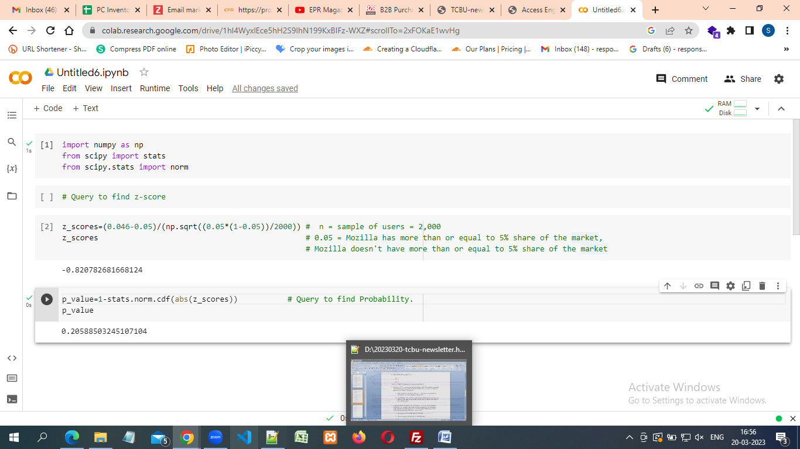

- WebSideStory claims that its sample includes all the daily Internet users. If that’s the case, then can Microsoft conclude that Mozilla has a less than 5% share of the market?
Sol : - For this situation, we have information on the whole population and the example precisely mirrors the population number. Accordingly we can reason that the share is less than 5%.
- A book publisher monitors the size of shipments of its textbooks to university bookstores. For a sample of texts used at various schools, the 95% confidence interval for the size of the shipment was 250 ± 45 books. Which, if any, of the following interpretations of this interval are correct?

- All shipments are between 205 and 295 books.
Answer: - INCORRECT-The interval of (205,295) is for 95% confidence not for 100%.
- 95% of shipments are between 205 and 295 books.
Answer: - INCORRECT-The interval doesn’t describe individual shipments.
- The procedure that produced this interval generates ranges that hold the population mean for 95% of samples.
Answer: - CORRECT-95% of intervals created in this way contain the true population mean
- If we get another sample, then we can be 95% sure that the mean of this second sample is between 205 and 295.
Answer: - INCORRECT-The interval doesn’t describe the mean of another sample.
- We can be 95% confident that the range 160 to 340 holds the population mean.
Answer: - Option C is correct. As the 95% of intervals created in this way contain the true population mean. All shipments are not between and books. Because due to % confidence interval for the size of shipment not all shipments.

- Which is shorter: a 95% z-interval or a 95% t-interval for μ if we know that σ =s?

- The z-interval is shorter
- The t-interval is shorter
- Both are equal
- We cannot say
Answer: - The z-interval is shorter, as it differentiates between mean of distribution and data points in standard deviation.

Questions 8 and 9 are based on the following: To prepare a report on the economy, analysts need to estimate the percentage of businesses that plan to hire additional employees in the next 60 days.

- How many randomly selected employers (minimum number) must we contact in order to guarantee a margin of error of no more than 4% (at 95% confidence)?

- 600
- 400
- 550
- 1000
Answer: - n=number of employers, Assume ^P=0.5,q^=0.5 Margin of Error=0.04
For 95% confidence interval,
The critical value Z= 1.96
ME = Z * √ ^pq^ n
0.04 = 1.96 * √ 0.5∗0.5 /n
n= 1.962²∗0.5∗0.5 / 0.042²
= 0.9604 / 0.0016
=600
= A

- Suppose we want the above margin of error to be based on a 98% confidence level. What sample size (minimum) must we now use?

- 1000
- 757
- 848
- 543

Answer: - Z= 2.576
0.04 = 2.326 * √ 0.5∗0.5 / n
n= (2.3262)²∗0.5∗0.5 / (0.042)²
= 1.3525 / 0.0016
= 845.35
= C

