Q1. A F&B manager wants to determine whether there is any significant difference in the diameter of the cutlet between two units. A randomly selected sample of cutlets was collected from both units and measured? Analyze the data and draw inferences at 5% significance level. Please state the assumptions and tests that you carried out to check validity of the assumptions.

**Answer: -** 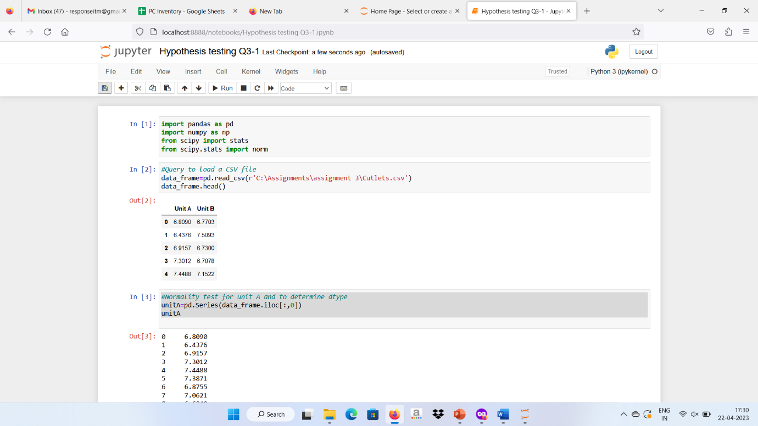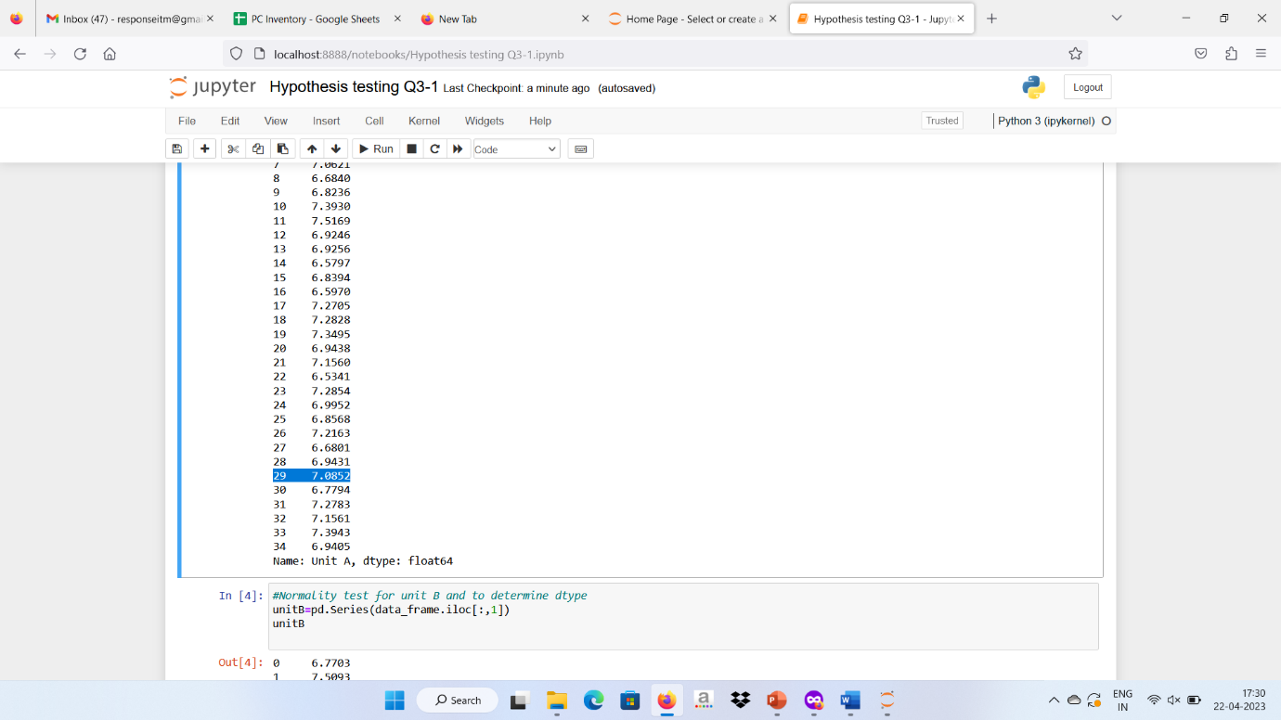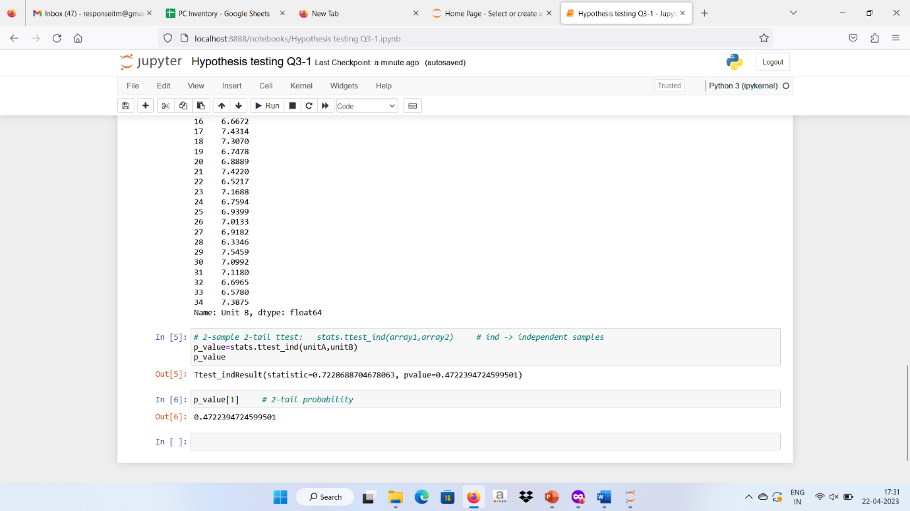

null hypothesis(H0): Data are normal  
alternate hypothesis (Ha):data are not normal  
if p-value is > 0.05 => Accept null hypothesis  
if p-value is < 0.05 =>Reject null hypothesis

Q2. A hospital wants to determine whether there is any difference in the average Turn Around Time (TAT) of reports of the laboratories on their preferred list. They collected a random sample and recorded TAT for reports of 4 laboratories. TAT is defined as sample collected to report dispatch.

Analyze the data and determine whether there is any difference in average TAT among the different laboratories at 5% significance level.

**Answer: -** However, timeliness which is expressed as the turnaround time (TAT) is often used by the clinicians as the benchmark for laboratory performance.

Abstract Turnaround time

Abstract. Turnaround time (TAT) is one of the most noticeable signs of laboratory service and is often used as a key performance indicator of laboratory performance.

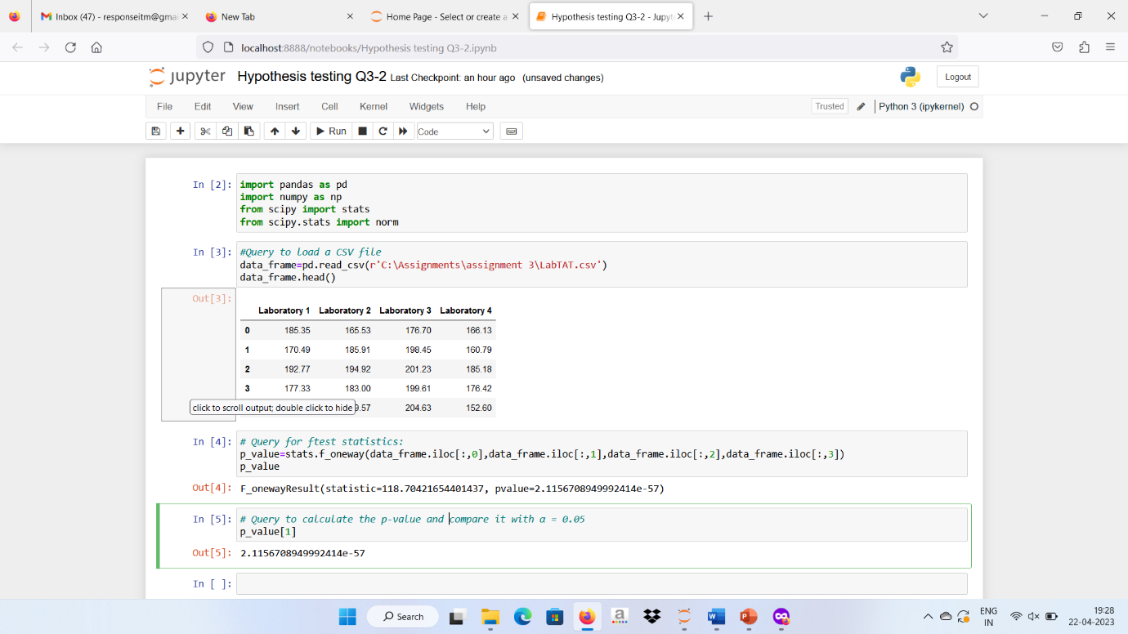

Q3 Sales of products in four different regions is tabulated for males and females. Find if male-female buyer rations are similar across regions.

**Answer: -** Thus we conclude that the proportion of male and female buying rations are similar across regions.

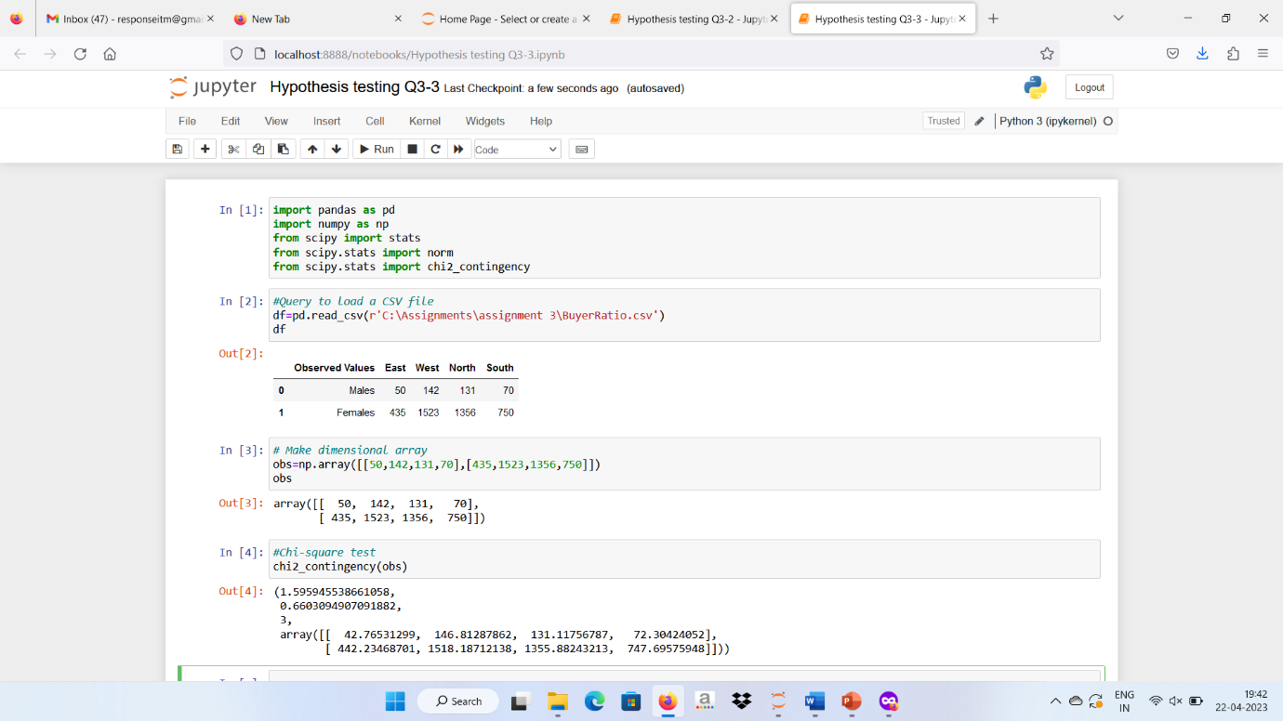

Q4 TeleCall uses 4 centers around the globe to process customer order forms. They audit a certain % of the customer order forms. Any error in order form renders it defective and has to be reworked before processing. The manager wants to check whether the defective % varies by centre. Please analyze the data at *5%* significance level and help the manager draw appropriate inferences

**Answer: -**

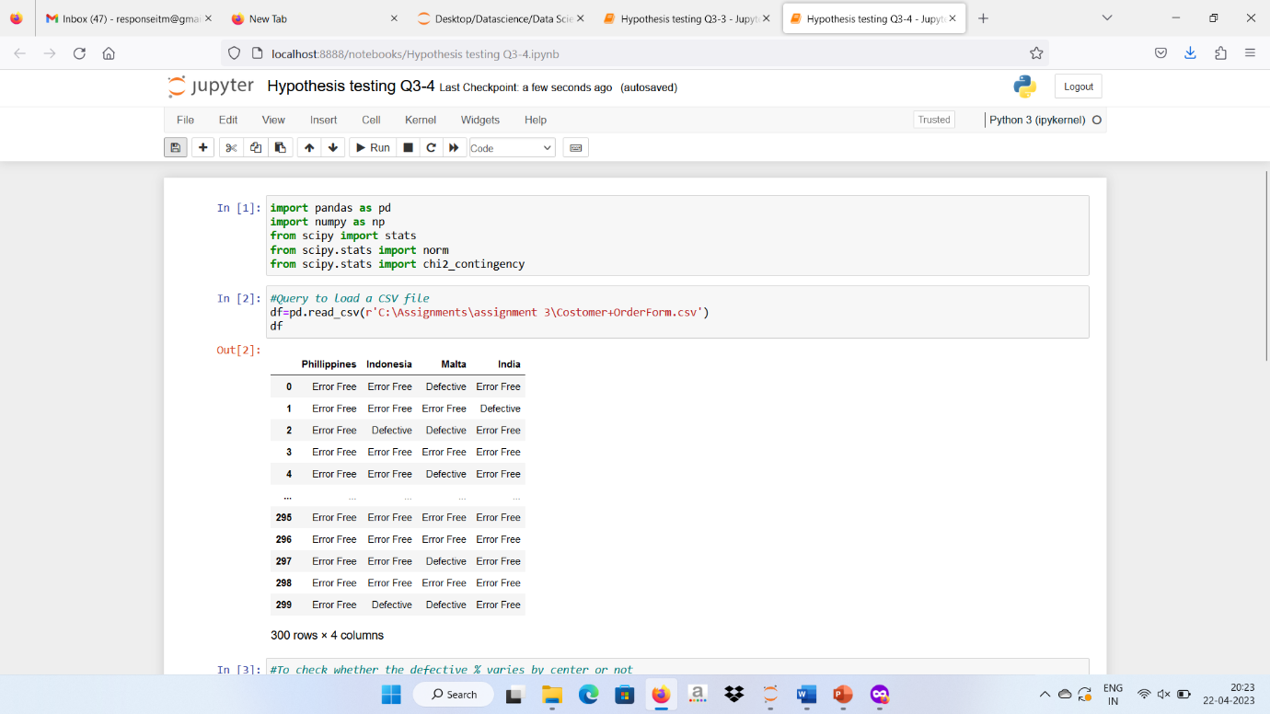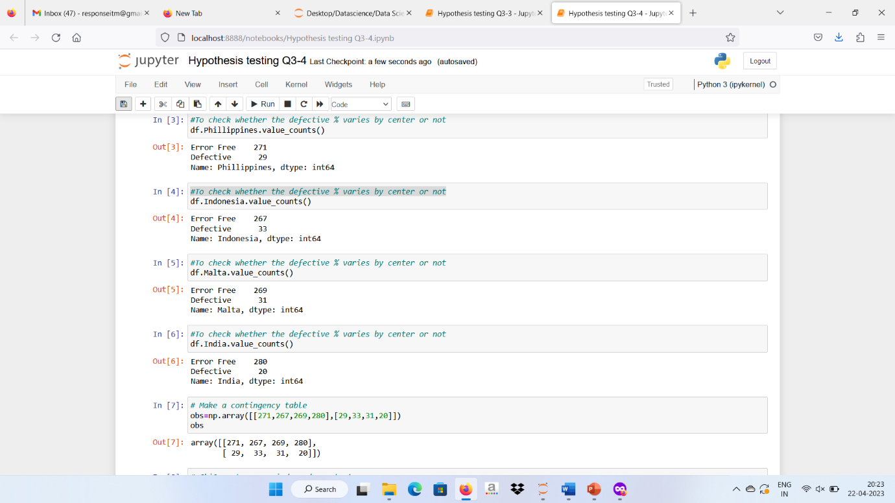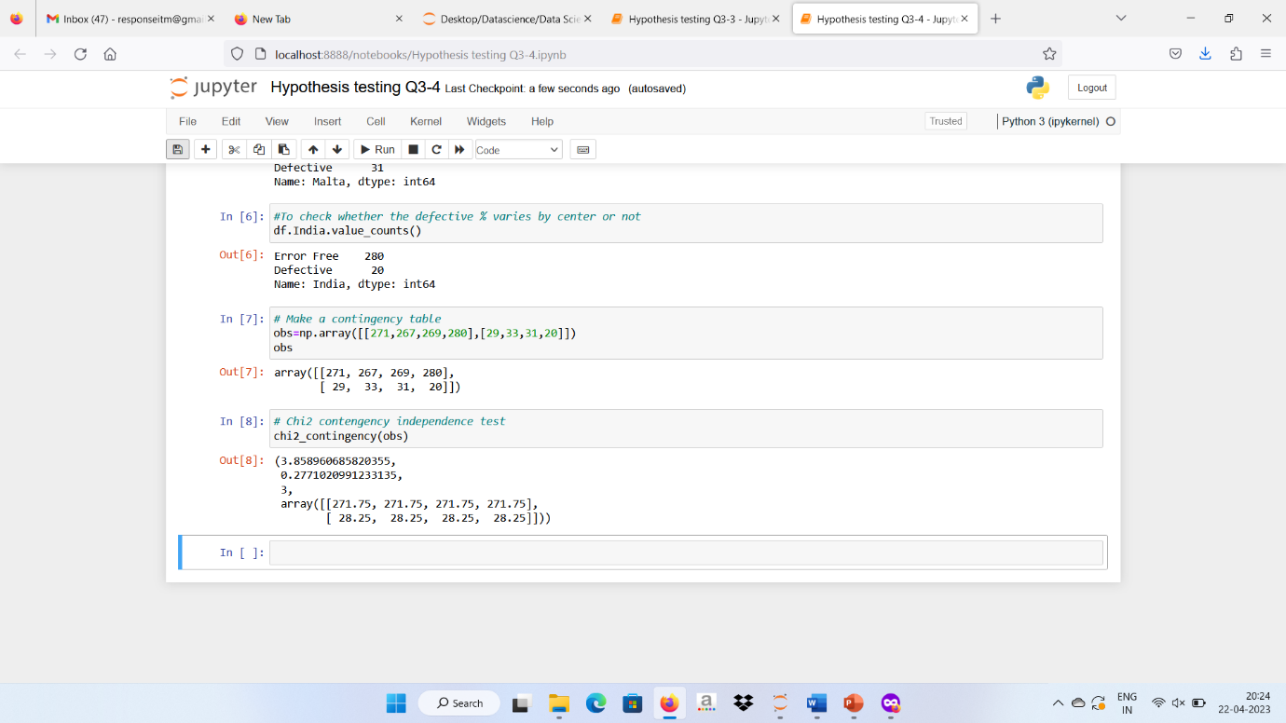

P-value is 0.227 > 0.05=>P high Ho fly => Accept Ho, hence Average are same  
As per results we can say that all the canters are equal.