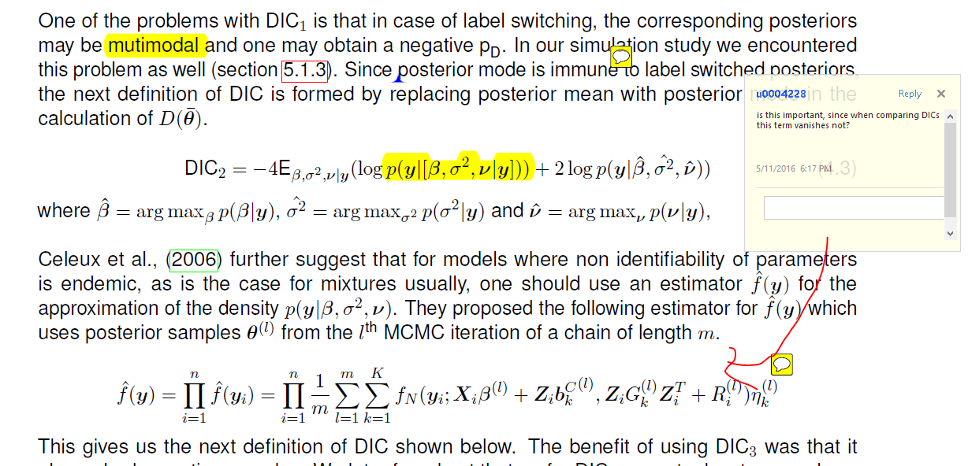

**No it won’t vanish as it depends on the parameters, which in turn depend on the model.**

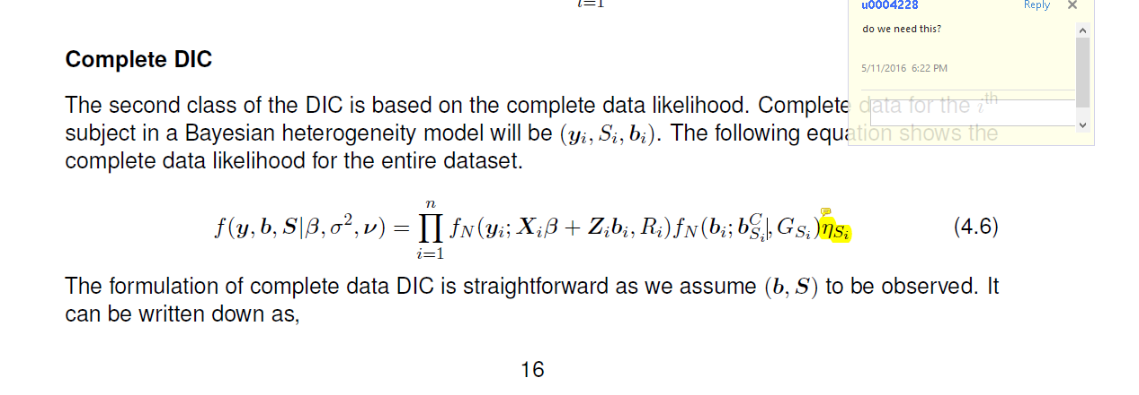

**Yes, although I replaced it with f(Si ; ) now.**

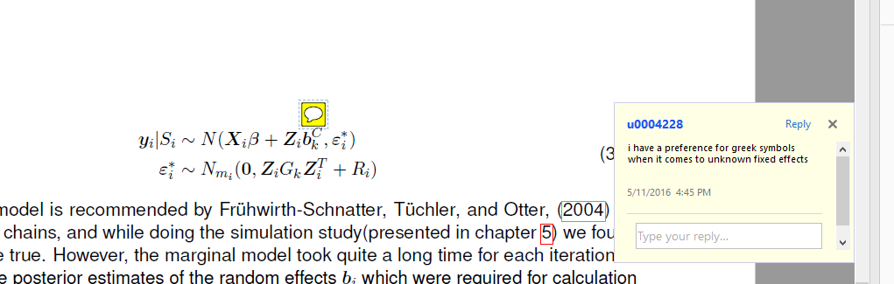

**I was thinking about it after reading your comment. But at this point I would stick to the notation because otherwise I might end up doing an error.**

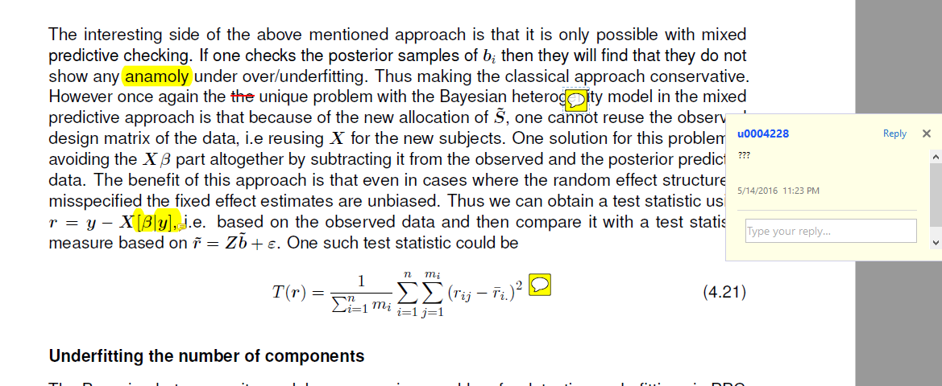

**I have updated the text, please let me know if you still have questions about it.**