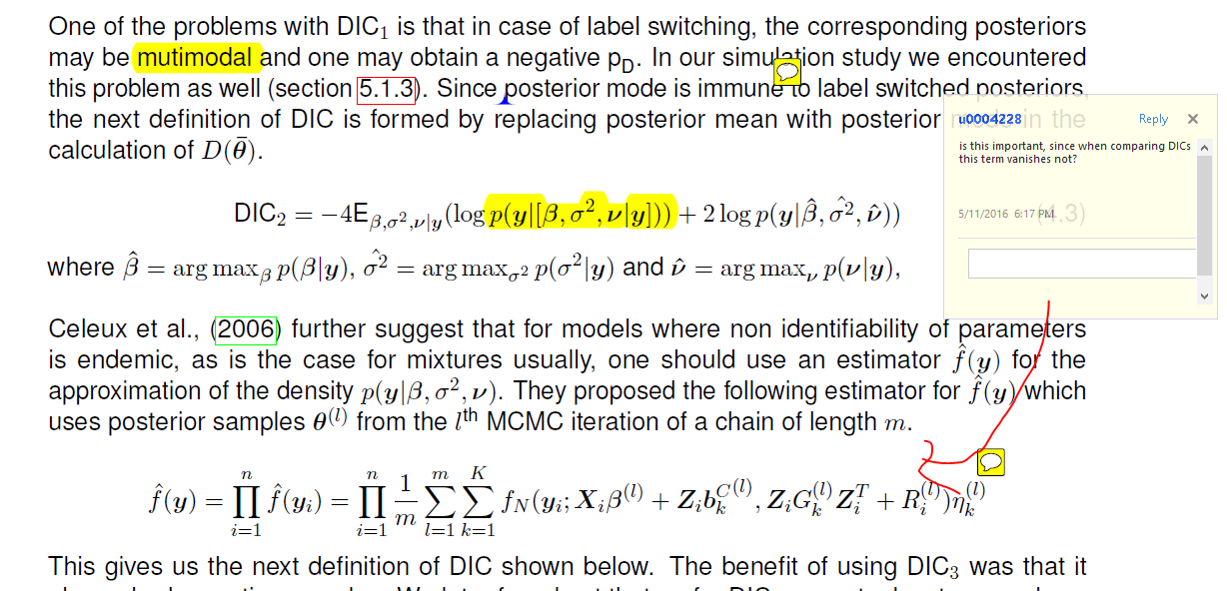

**No it won’t vanish as it depends on the parameters, which in turn depend on the model.**

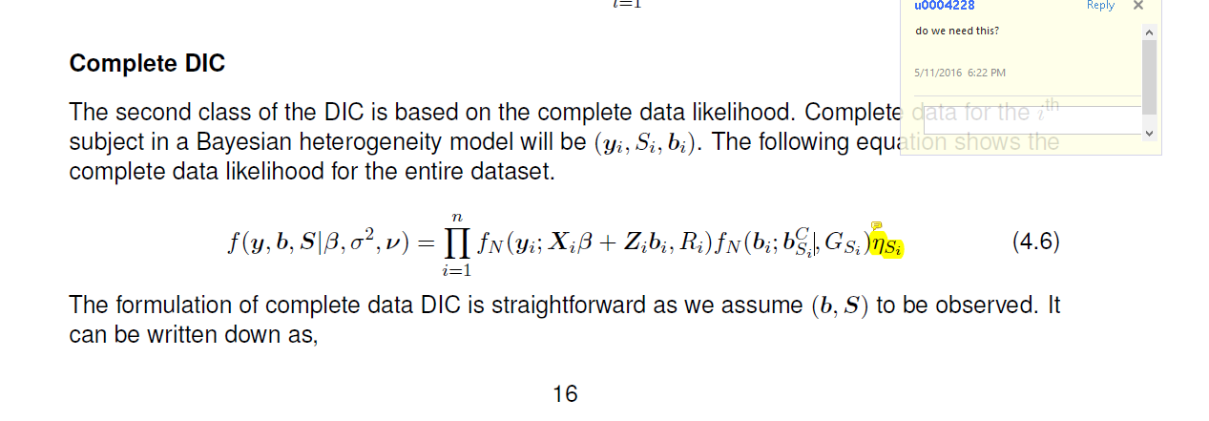

**Yes, although I replaced it with f(Si ; ) now.**

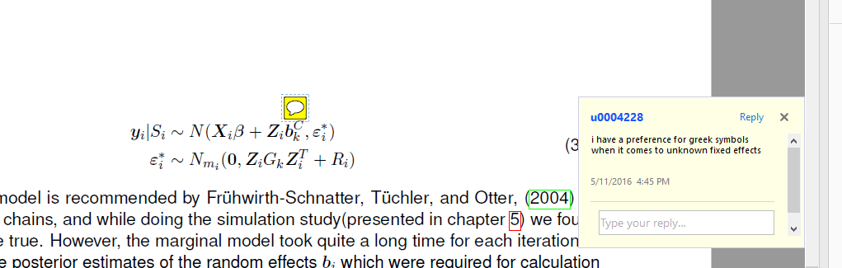

**I was thinking about it after reading your comment. But at this point I would stick to the notation because otherwise I might end up doing an error.**

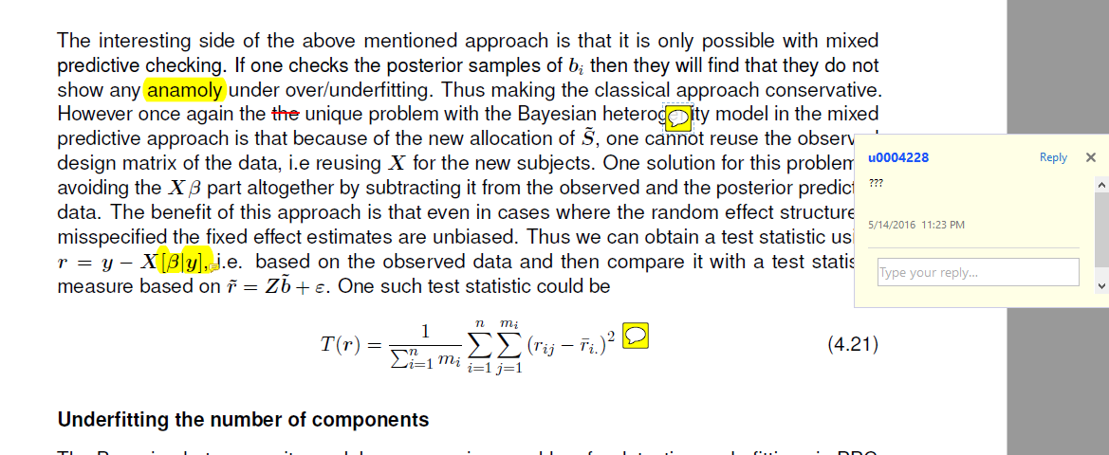

**I have updated the text, please let me know if you still have questions about it.**

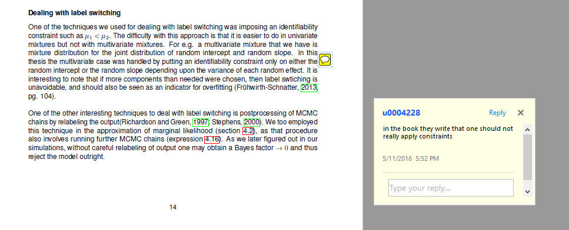

**This one I disagree with. They used similar identifiability constraints in their 2004 paper on Bayesian heterogeneity model. Also they suggest using identifiability constraint in the book.**

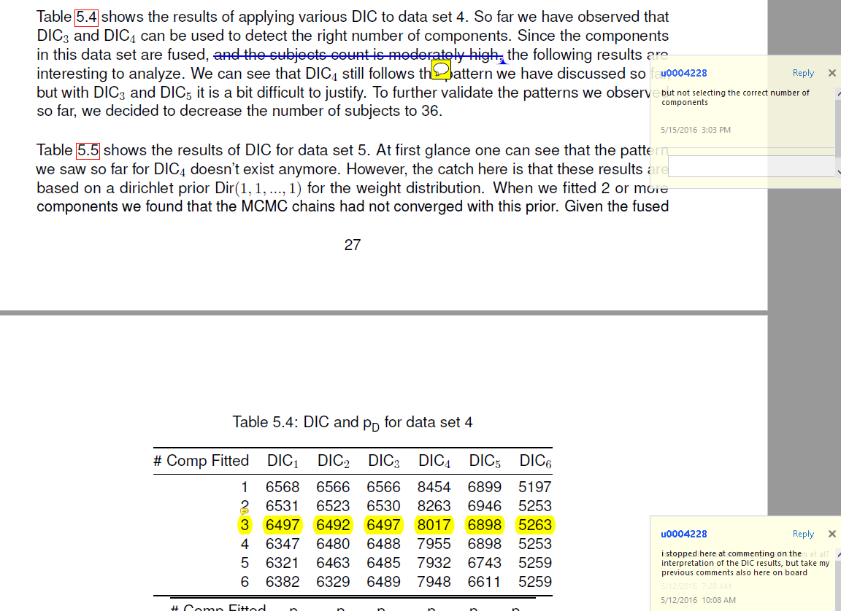

**I think I will have to rethink how to present this because even here DIC4 decreases by a large amount till the right number of components are fitted. For e.g. it decreases by almost 200 till 3 components are fitted andthen decreases by a smaller amount relatively for 4,5 and 6 components.**

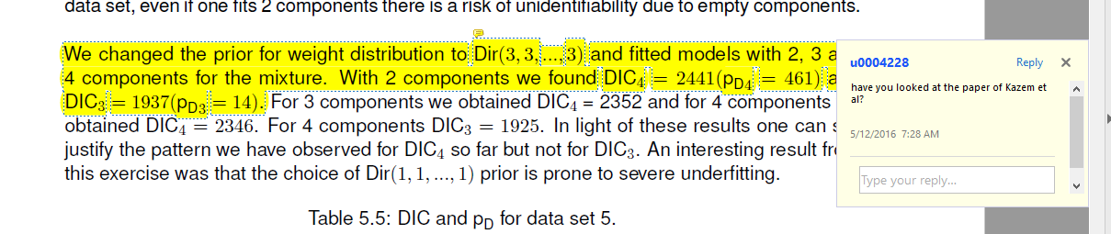

**Yes Kazem et. al seem to be using 0.1 as shown in the snippet below. But I also found in Dr. Schnatter’s book that Dirichlet prior with slightly higher prior hypeparameter values could be used when one of the components is empty.**

