- CPU Scheduling in Operating Systems
https://www.naukri.com/code360/library/scheduling-algorithms-in-operating-systems

- The problem of indefinite blockage (starvation) of low-priority jobs in priority scheduling algorithms is solved using Aging, a technique where the priority of processes waiting for a long time is gradually increased until they reach a high enough priority to be executed, ensuring every job eventually gets processed. Other solutions involve combining algorithms like Round Robin or using Multilevel Feedback Queues.
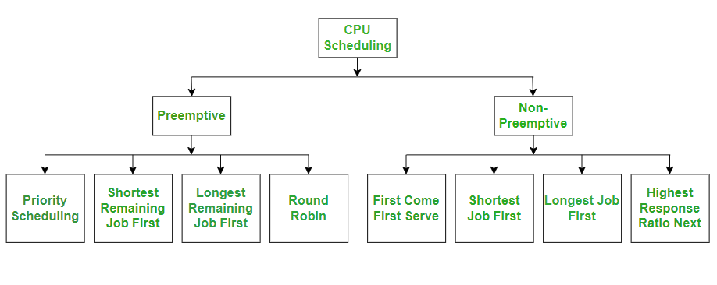
- Paging suffers from internal fragmentation, not external fragmentation.
- Paging increases the context-switch time.

- The Banker’s Algorithm is a deadlock avoidance technique in operating systems that prevents deadlocks by simulating resource allocation. It checks if granting a request keeps the system in a "safe state"—where all processes can eventually complete—before allowing it. Developed by Edsger Dijkstra, it acts like a banker, only lending resources if it can still satisfy the needs of all clients.
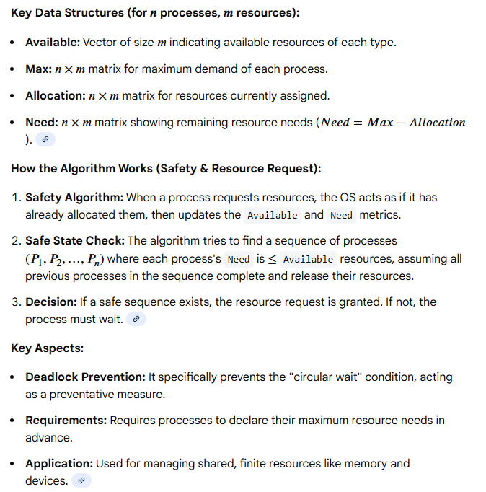
The Banker's Algorithm avoids deadlocks by checking if granting resource requests keeps the system in a safe state (safe sequence) using Need = Max - Allocation. If Need <= Available for a process, its request is granted, resources are used, and then released back to Available. Key steps include computing the Need matrix, checking for safe states, and verifying if a resource request can be granted safely.
Exercise 1
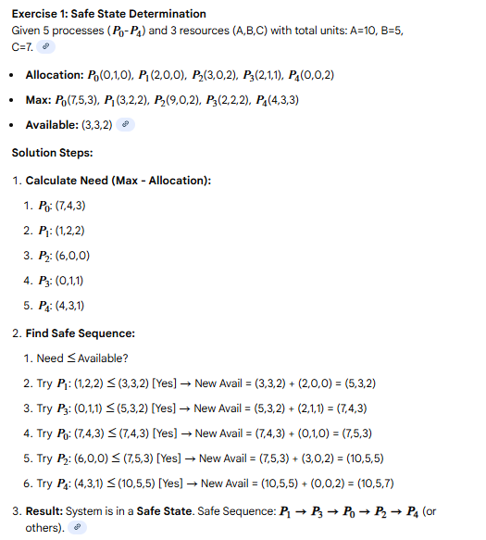

Exercise 2
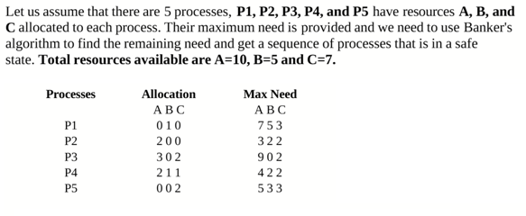
Check whether the system is in safe state, if it is in safe state find out the safe sequence.
Solution:
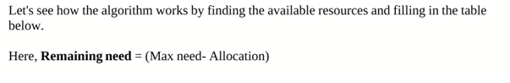
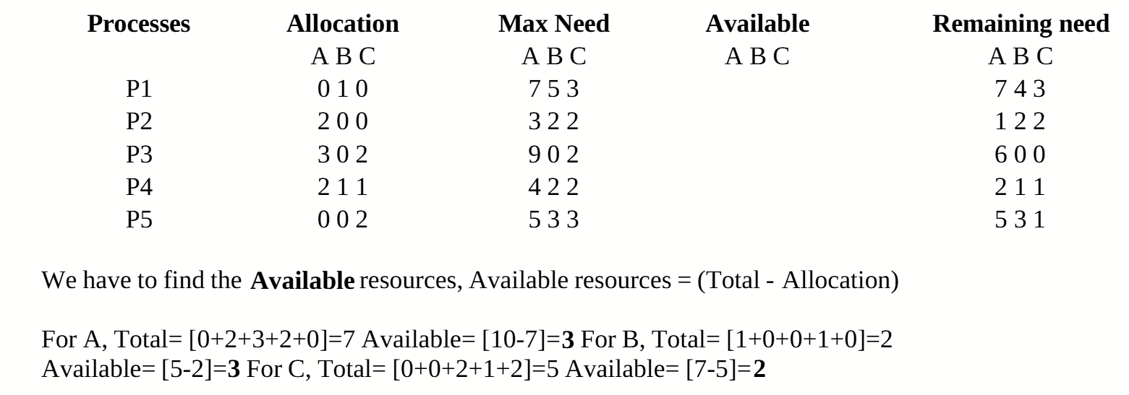
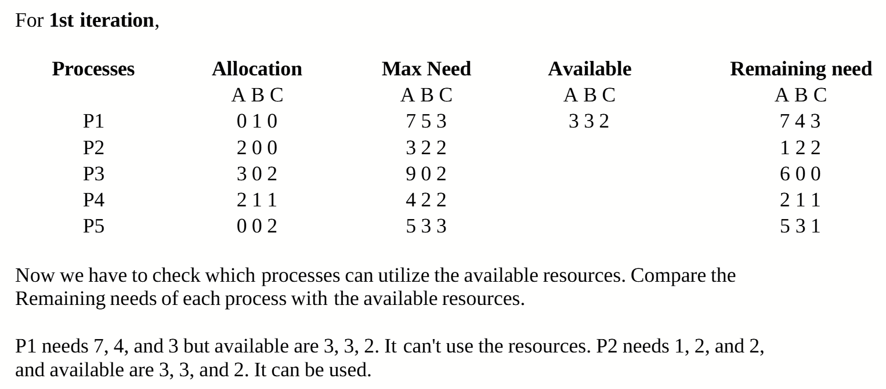
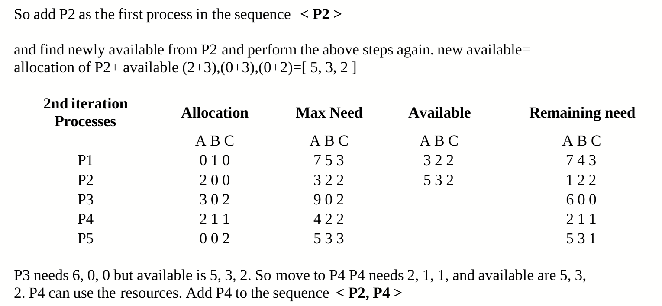
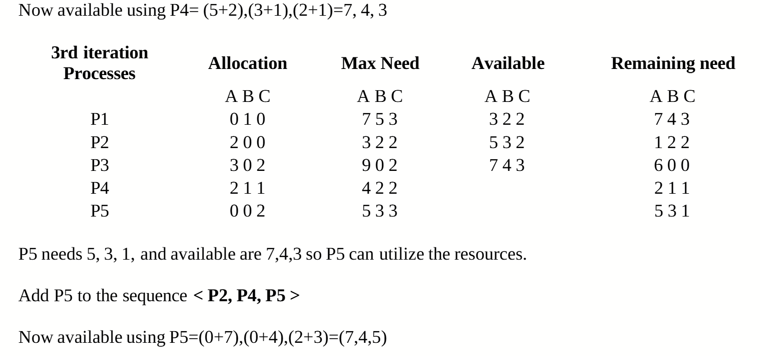
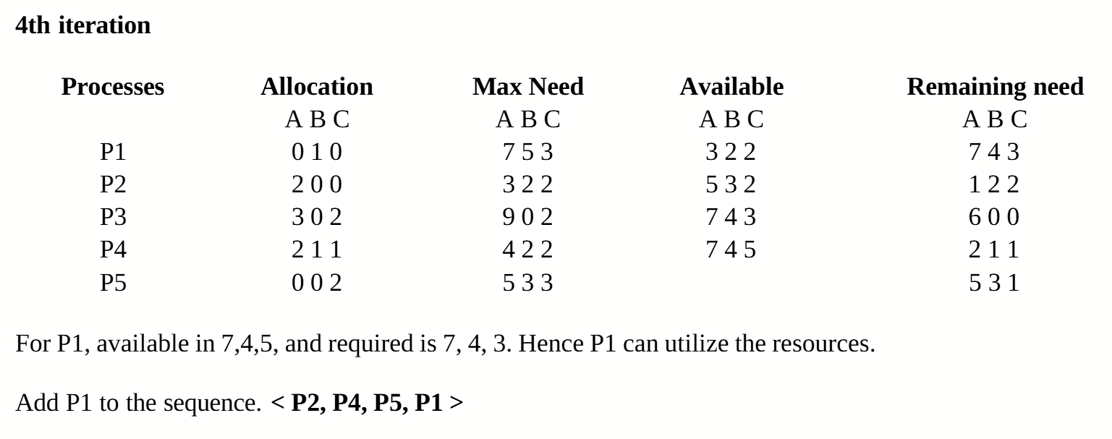
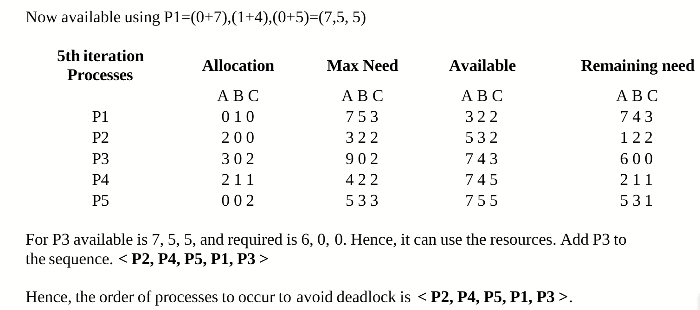
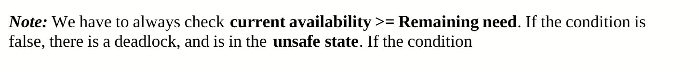

Exercise 3
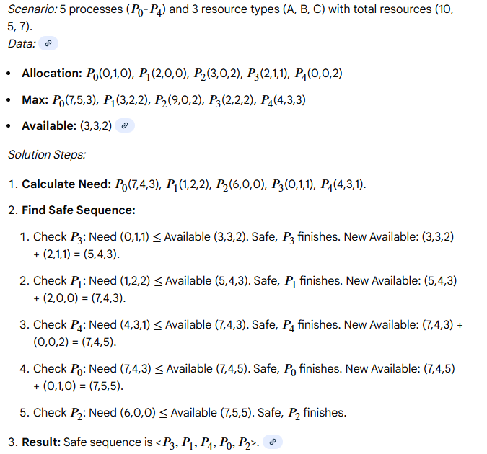

Exercise 4
Let us revisit the dining philosophers problem using banker’s algorithm. Suppose there are only 3 philosophers P0, P1 and P2 and 3 chopsticks C0, C1 and C2. Initially, the system starts with the following:
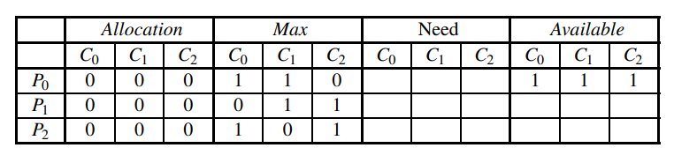
Again, each philosopher will request his left chopstick followed by his right chopstick. Therefore, philosopher Pi will do the following:
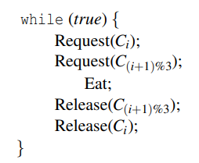
Note that philosophers may make their requests/releases concurrently; however, you may assume each request and release will be handled in a mutually exclusive way. With banker’s algorithm to allocate chopsticks, each philosopher wants to eat at least twice, what is the safe sequence.
Ans: < P1,P0,P2 >< P1,P0,P2 >
Exercise 5
Consider a demand paging memory management system with 32-bit logical address, 20-bit physical address, and page size of 2048 bytes. Assuming that the memory is byte addressable, what is the maximum number of entries in the page table?
(A) 2²¹
(B) 2²⁰
(C) 2²²
(D) 2²⁴
Correct Answer: (A) 2²¹
Solution: The logical address is 32 bits, and the page size is 2048 bytes (2¹¹ bytes). The number of pages in the system can be calculated by dividing the total address space by
the page size: 2³² / 2¹¹ = 2²¹. The page table must have an entry for each page, so the number of entries in the page table is 2²¹. Thus, the correct answer is A .
Exercise 6
