Consider three CPU-intensive processes, which require 10 ,20 and 30 time units and arrive at times 0, 2 and 6 respectively. How many context switches are needed if the operating system implements a shortest remaining time first scheduling algorithm? Do not count the context switches at time zero and at the end.
************************************************************************************************************************************************************************************************
Consider the set of 4 processes whose arrival time and burst time are given below-
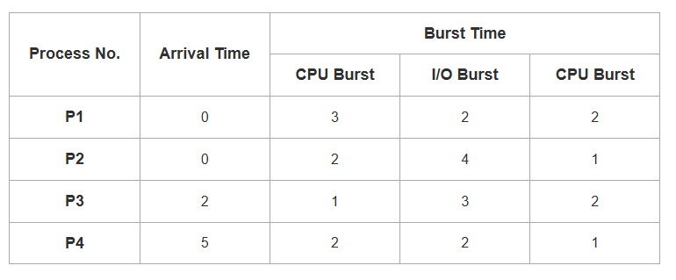
If the CPU scheduling policy is Shortest Remaining Time First, calculate the average waiting time and average turn around time.
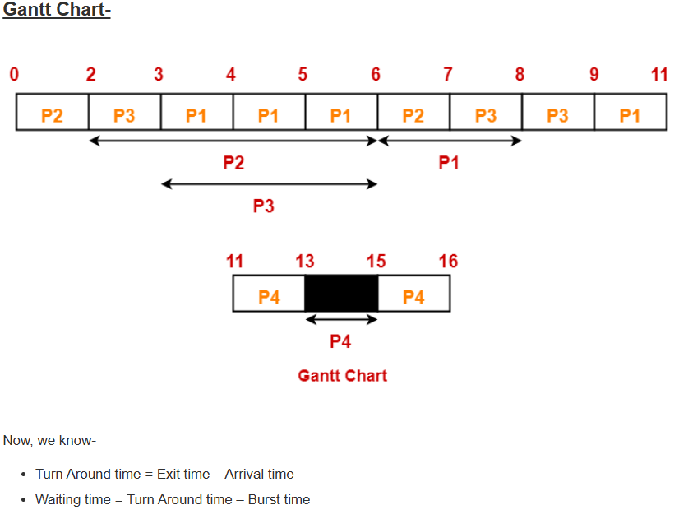
************************************************************************************************************************************************************************************************
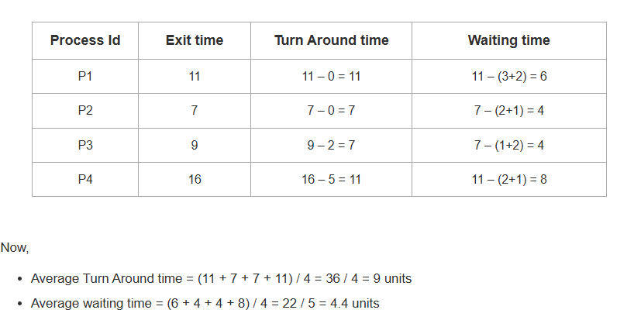

Consider the set of 4 processes whose arrival time and burst time are given below-
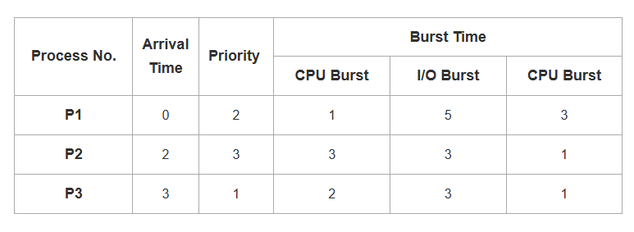
If the CPU scheduling policy is Priority Scheduling, calculate the average waiting time and average turn around time. (Lower number means higher priority)
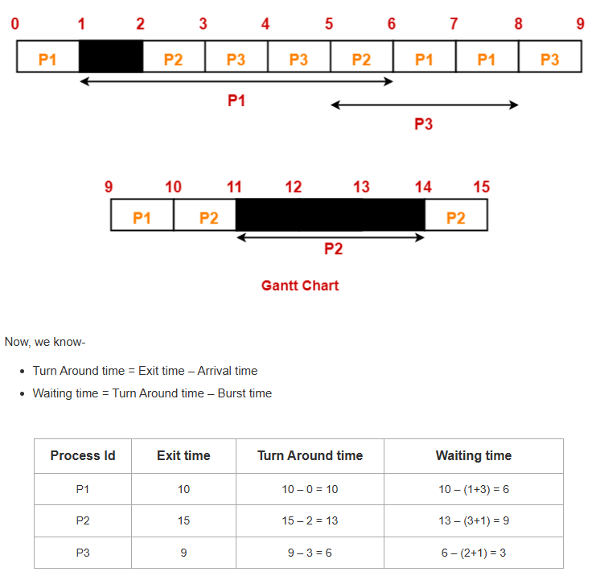
- Average Turn Around time = (10 + 13 + 6) / 3 = 29 / 3 = 9.67 units
- Average waiting time = (6 + 9 + 3) / 3 = 18 / 3 = 6 units

************************************************************************************************************************************************************************************************

Consider the following pseudocode, where S is a semaphore initialized to 5 in line 2 and counter is a shared variable initialized to 0 in line 1. Assume that the increment operation in line 7 is atomic.
- int counter = 0;
- Semaphore S = init(5);
- void parop(void)
- {
- wait(S);
- wait(S);
- counter++;
- signal(S);
- signal(S);
- }
If five threads execute the function concurrently, which of the following program behavior(s) is/are possible?
- The value of counter is 5 after all the threads successfully complete the execution
- The value of counter is 1 after all the threads successfully complete the excecution
- The value of counter is 0 after all the threads successfully complete the execution
- There is a deadlock involving all the threads

- Assume that the threads execute sequentially with no interleaving then after each thread ends the counter value increments by 1. Hence after threads finish, counter value will be incremented times from to Possible.
- Let’s assume that a process used 2 waits and reads the counter value and didn’t update the value yet, all the other process let’s say the other processes executed sequentially incremented and stored the value as 4 but since the value isn’t written the first process yet the current value is overwritten by the first process as 1. Possible
- There exists no pattern of execution in which the process increments the current value and completes while maintaining 0 as the counter value. Not possible
- Assume that all the process use up the first wait operation, the semaphore value will now become zero and deadlock would’ve occurred. Possible

********************************************************************************************************************************************************************************

Which one or more of the following need to be saved on a context switch from one thread (T1) of a process to another thread (T2) of the same process?
(A) Page table base register
(B) Stack pointer
(C) Program counter
(D) General purpose registers
Correct Answer: (B), (C), and (D)
Solution:
Understanding context switch When switching from one thread (T1) to another (T2) within the same process, the CPU must save the current execution state of T1 and load the execution state of T2. This execution state primarily consists of CPU registers and pointers required to resume execution later.
Evaluating each option-
(A) Page table base register: All threads of the same process share the same virtual address space, hence the same page table base register. Therefore, it does not need to be saved or changed during a thread-to-thread context switch. ⇒Not required.
(B) Stack pointer: Each thread maintains its own stack (for function calls, local variables, return addresses). To resume T2 correctly, its stack pointer must be restored. ⇒Must be saved / restored.
(C) Program counter: The program counter (PC) holds the address of the next instruction to execute. Without saving/restoring the PC, the thread cannot resume from where it left off. ⇒Must be saved / restored.-
(D) General purpose registers: General purpose registers (like AX, BX in x86, or r0, r1 in ARM) hold intermediate data during computation. Each thread requires its own register values to resume correctly. ⇒Must be saved / restored.
Conclusion: Only the thread-specific state (stack pointer, program counter, and general registers) needs to be saved / restored. The address-space-related state (page table base register) remains unchanged because threads of a process share memory.
************************************************************************************************************************************************************************************************

Which one or more of the following options guarantee that a computer system will transition from user mode to kernel mode?
(A) Function Call
(B) malloc Call
(C) Page Fault
(D) System Call
Correct Answer: (C) and (D)
Solution:
Analyze Option (A) Function Call: A normal function call in user space executes entirely in user mode. It does not involve the operating system kernel. Hence, there is no user-to-kernel mode switch. ⇒(A)is False.
Analyze Option (B) malloc Call The malloc() function is part of the C standard library. In most cases, it only allocates memory from the heap of the process without involving the kernel. However, if more memory is required, it may internally invoke a system call such as brk() or mmap(), which would cause a kernel transition. But this is not guaranteed for every malloc call. ⇒(B) is False.
Analyze Option (C) Page Fault: A page fault occurs when a program accesses a memory page that is not present in physical memory. This is a hardware exception, which always triggers the operating system’s page fault handler in the kernel. Thus, the CPU must switch to kernel mode to handle it. ⇒(C)is True.
Analyze Option (D) System Call System calls are explicit requests made by a user process to the operating system for services like I/O, process management, or memory management. Executing a system call instruction (e.g., int 0x80, syscall) always causes a trap into kernel mode. ⇒(D)is True.
************************************************************************************************************************************************************************************************

Which one or more of the following CPU scheduling algorithms can potentially cause starvation?
(A) First-in First-Out
(B) Round Robin
(C) Priority Scheduling
(D) Shortest Job First

Round Robin (RR) scheduling will never lead to starvation because every job is guaranteed CPU time after a fixed time quantum.
Since the time quantum is finite, each process eventually gets its turn to execute after a finite period, ensuring fairness among all tasks.
It is worth noting that the time quantum can be very large — for example, 10 minutes, 10 years, or even 100 years — but as long as it remains finite, every process will still receive CPU time and starvation will not occur.
Can First Come First Serve lead to Starvation?
Just imagine a first job submitted to CPU is –
while(1);
Yes, Infinite loop. Do you think other jobs will ever get a chance?
************************************************************************************************************************************************************************************************

Consider the two functions incr and decr shown below.
incr(){ decr(){
wait(s); wait(s);
X = X+1; X = X-1;
signal(s); signal(s);
} }
There are 5 threads each invoking incr once, and 3 threads each invoking decor once, on the same shared variable X. The initial value of X is 10.
Suppose there are two implementations of the semaphore s, as follows:
I-1: s is a binary semaphore initialized to 1.
I-2: s is a counting semaphore initialized to 2.
Let V1, and V2 be the values of X at the end of the execution of all the threads with implementations I-1, and I-2, respectively.
Which one of the following choices corresponds to the minimum possible values of V1, V2, respectively?
  - 15,7
  - 7,7
  - 12,7
  - 12,8

I==> S is a binary semaphore initialized to 1
as s is a binary semphore it can take only two values 0 & 1.

now let's see the code
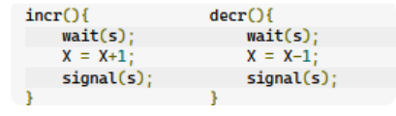

so code is simple increment by 1 and decremnet by 1 is done.
Now it is mentioned in the question there are 5 inc and 3 dec
and intial value of x is 10
now it is asking us the min value we can have after execution of 5 inc and 3 dec operation on X.
so think as s=1 it mean either you enter inc or decr code you will not able to enter the other at the same time you have to only do one at a time .
so what ever order of sequence you implement you know that you are doing 5 inc and 3 decr at all in the value of x
so final min value of x =x+5-3=10+5-2=12 ans .
Now look at the second method using Counting semaphore
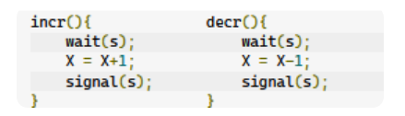
and s=2 and x=10
now as s=2 it mean you can enter in both the inc or decr block at the same and access the critical section of the code at the same time >
ok let 's see it
you know that inc works
as 1.first value of x is stored in a r1
2.valu of r1 is inc by 1
3.value of r1 is stored in x
simliarly decrment works the same way
1.first value of x is stored in a r2
2.valu of r2 is dec by 1
3.value of r2 is stored in x
Now suppose both enters into inc and decr at the same time executed wait so s=0
now both access the shared variable i.e critical section
now suppose
in inc r1=x=10
in dec r2=x=10
now 5 incr operation continuosly followed out so x=15
now we know we also have to run decr and we have executed first decr untill r2=x=10
now 2nd step of decr will have so r2=9
now r2 is stored in x
so 15 is replaced by 9
and remaining 2 dec operation willl carry on and make the value of x =7(min).

************************************************************************************************************************************************************************************************
Consider two processes P1 and P2 accessing the shared variables X and Y protected by two binary semaphores SX and SY respectively, both initialized to 1. P and V denote the usual semaphore operators, where P decrements the semaphore value, and V increments the semaphore value. The pseudo-code of P1 and P2 is as follows :
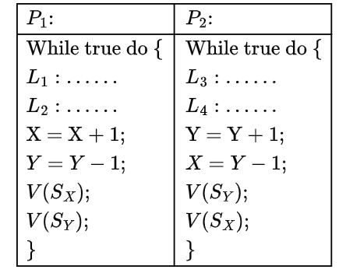
In order to avoid deadlock, the correct operators at L1, L2, L3 and L4 are respectively
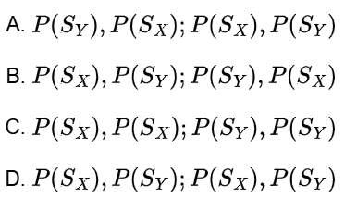

************************************************************************************************************************************************************************************************

Each of a set of n processes executes the following code using two semaphores a and b initialized to 1 and 0, respectively. Assume that count is a shared variable initialized to 0 and not used in CODE SECTION P.
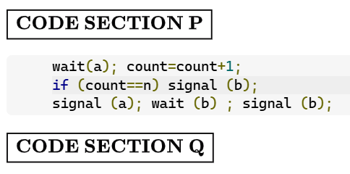
What does the code achieve?

- It ensures that no process executes CODE SECTION Q before every process has finished CODE SECTION P.
- It ensures that atmost two processes are in CODE SECTION Q at any time.
- It ensures that all processes execute CODE SECTION P mutually exclusively.
- It ensures that at most n-1 processes are in CODE SECTION P at any time.
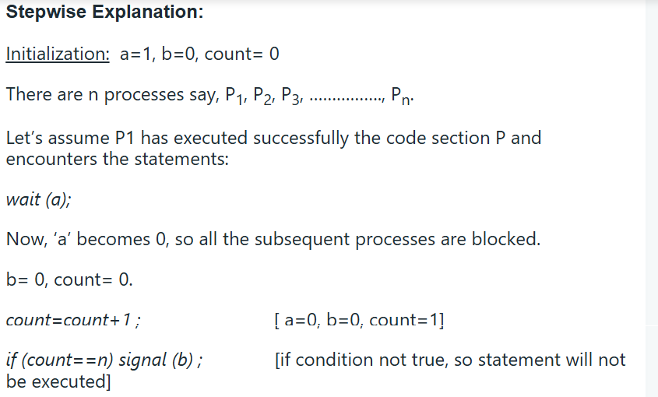
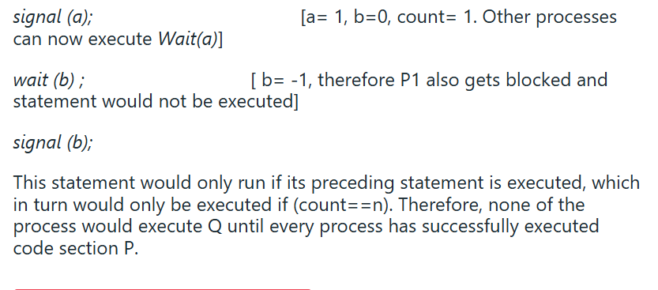
Concurrency and synchronization
https://www.geeksforgeeks.org/quizzes/gate-ipc-concurrency-and-synchronization-deadlock-pyq-2010-to2025/

- Paging is a non-contiguous memory allocation technique.
- Page Table is a data structure that performs the mapping of page number to the frame number.

Important Formulas-

The following list of formulas is very useful for solving the numerical problems based on paging.

For Main Memory-

- Physical Address Space = Size of main memory
- Size of main memory = Total number of frames x Page size
- Frame size = Page size
- If number of frames in main memory = 2^{X}, then number of bits in frame number = X bits
- If Page size = 2^{X} Bytes, then number of bits in page offset = X bits
- If size of main memory = 2^{X} Bytes, then number of bits in physical address = X bits

For Process-

- Virtual Address Space = Size of process
- Number of pages the process is divided = Process size / Page size
- If process size = 2^{X} bytes, then number of bits in virtual address space = X bits

For Page Table-

- Size of page table = Number of entries in page table x Page table entry size
- Number of entries in pages table = Number of pages the process is divided
- Page table entry size = Number of bits in frame number + Number of bits used for optional fields if any

NOTE-

- In general, if the given address consists of ‘n’ bits, then using ‘n’ bits, 2^{n} locations are possible.
- Then, size of memory = 2^{n} x Size of one location.
- If the memory is byte-addressable, then size of one location = 1 byte.
- Thus, size of memory = 2^{n} bytes.
- If the memory is word-addressable where 1 word = m bytes, then size of one location = m bytes.
- Thus, size of memory = 2^{n} x m bytes.

PRACTICE PROBLEMS BASED ON PAGING AND PAGE TABLE-

Problem-01:

Calculate the size of memory if its address consists of 22 bits and the memory is 2-byte addressable.

Solution-

We have-
- Number of locations possible with 22 bits = 2²² locations
- It is given that the size of one location = 2 bytes

Thus, Size of memory
= 2²² x 2 bytes
= 2²³ bytes
= 8 MB

Problem-02:

Calculate the number of bits required in the address for memory having size of 16 GB. Assume the memory is 4-byte addressable.

Solution-

Let ‘n’ number of bits are required. Then, Size of memory = 2^{n} x 4 bytes.
Since, the given memory has size of 16 GB, so we have-
2^{n} x 4 bytes = 16 GB
2^{n} x 4 = 16 G
2^{n} x 2² = 2³⁴
2^{n} = 2³²
∴ n = 32 bits

Problem-03:

Consider a system with byte-addressable memory, 32 bit logical addresses, 4 kilobyte page size and page table entries of 4 bytes each. The size of the page table in the system in megabytes is _____.
  - 2
  - 4
  - 8
  - 16

Solution-

Given-
- Number of bits in logical address = 32 bits
- Page size = 4KB
- Page table entry size = 4 bytes

Process Size-

Number of bits in logical address = 32 bits
Thus,
Process size
= 2³² B
= 4 GB

Number of Entries in Page Table-

Number of pages the process is divided
= Process size / Page size
= 4 GB / 4 KB
= 2²⁰ pages

Thus,
Number of entries in page table = 2²⁰ entries

Page Table Size-

Page table size
= Number of entries in page table x Page table entry size
= 2²⁰ x 4 bytes
= 4 MB

Thus, Option (B) is correct.

Problem-04:

Consider a machine with 64 MB physical memory and a 32 bit virtual address space. If the page size is 4 KB, what is the approximate size of the page table?
- 16 MB
- 8 MB
- 2 MB
- 24 MB

Solution-

Given-
- Size of main memory = 64 MB
- Number of bits in virtual address space = 32 bits
- Page size = 4 KB

We will consider that the memory is byte addressable.

Number of Bits in Physical Address-

Size of main memory
= 64 MB
= 2²⁶ B
Thus, Number of bits in physical address = 26 bits

Number of Frames in Main Memory-

Number of frames in main memory
= Size of main memory / Frame size
= 64 MB / 4 KB
= 2²⁶ B / 2¹² B
= 2¹⁴
Thus, Number of bits in frame number = 14 bits

Number of Bits in Page Offset-

We have,
Page size
= 4 KB
= 2¹² B
Thus, Number of bits in page offset = 12 bits

So, Physical address is-
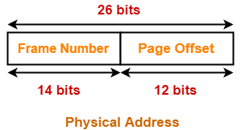

Process Size-

Number of bits in virtual address space = 32 bits
Thus,
Process size
= 2³² B
= 4 GB

Number of Entries in Page Table-

Number of pages the process is divided
= Process size / Page size
= 4 GB / 4 KB
= 2²⁰ pages
Thus, Number of entries in page table = 2²⁰ entries

Page Table Size-

Page table size
= Number of entries in page table x Page table entry size
= Number of entries in page table x Number of bits in frame number
= 2²⁰ x 14 bits
= 2²⁰ x 16 bits (Approximating 14 bits ≈ 16 bits)
= 2²⁰ x 2 bytes
= 2 MB

Thus, Option (C) is correct.

************************************************************************************************************************************************************************************************
Consider a system using paging scheme where-
- Logical Address Space = 4 GB
- Physical Address Space = 16 TB
- Page size = 4 KB

Now, let us find how many levels of page table will be required.

Number of Bits in Physical Address-

Size of main memory
= Physical Address Space
= 16 TB
= 2⁴⁴ B
Thus, Number of bits in physical address = 44 bits

Number of Frames in Main Memory-

Number of frames in main memory
= Size of main memory / Frame size
= 16 TB / 4 KB
= 2³² frames
Thus, Number of bits in frame number = 32 bits

Number of Bits in Page Offset-

We have,
Page size
= 4 KB
= 2¹² B
Thus, Number of bits in page offset = 12 bits

Alternatively,
Number of bits in page offset
= Number of bits in physical address – Number of bits in frame number
= 44 bits – 32 bits
= 12 bits

So, Physical address is-
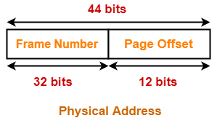

Number of Pages of Process-

Number of pages the process is divided
= Process size / Page size
= 4 GB / 4 KB
= 2²⁰ pages

Inner Page Table Size-

Inner page table keeps track of the frames storing the pages of process.
Inner Page table size
= Number of entries in inner page table x Page table entry size
= Number of pages the process is divided x Number of bits in frame number
= 2²⁰ x 32 bits
= 2²⁰ x 4 bytes
= 4 MB
Now, we can observe-
- The size of inner page table is greater than the frame size (4 KB).
- Thus, inner page table can not be stored in a single frame.
- So, inner page table has to be divided into pages.

Number of Pages of Inner Page Table-

Number of pages the inner page table is divided
= Inner page table size / Page size
= 4 MB / 4 KB
= 2¹⁰ pages
Now, these 2¹⁰ pages of inner page table are stored in different frames of the main memory.

Number of Page Table Entries in One Page of Inner Page Table-

Number of page table entries in one page of inner page table
= Page size / Page table entry size
= Page size / Number of bits in frame number
= 4 KB / 32 bits
= 4 KB / 4 B
= 2¹⁰

Number of Bits Required to Search an Entry in One Page of Inner Page Table-

One page of inner page table contains 2¹⁰ entries.
Thus,
Number of bits required to search a particular entry in one page of inner page table = 10 bits

Outer Page Table Size-

Outer page table is required to keep track of the frames storing the pages of inner page table.
Outer Page table size
= Number of entries in outer page table x Page table entry size
= Number of pages the inner page table is divided x Number of bits in frame number
= 2¹⁰ x 32 bits
= 2¹⁰ x 4 bytes
= 4 KB
Now, we can observe-
- The size of outer page table is same as frame size (4 KB).
- Thus, outer page table can be stored in a single frame.
- So, for given system, we will have two levels of page table.
- Page Table Base Register (PTBR) will store the base address of the outer page table.

Number of Bits Required to Search an Entry in Outer Page Table-

Outer page table contains 2¹⁰ entries.
Thus,
Number of bits required to search a particular entry in outer page table = 10 bits

The paging system will look like as shown below-
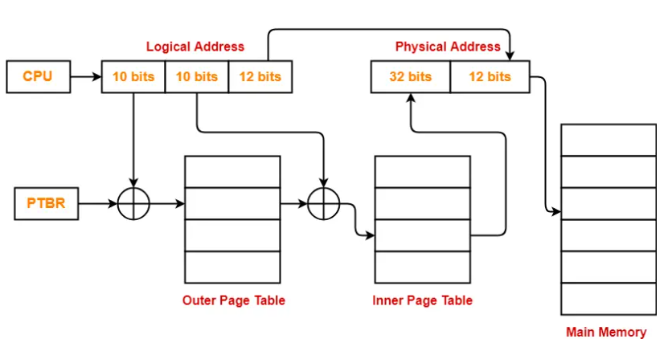
************************************************************************************************************************************************************************************************
Consider a system using multilevel paging scheme. The page size is 16 KB. The memory is byte addressable and virtual address is 48 bits long. The page table entry size is 4 bytes.
Find-
- How many levels of page table will be required?
- Give the divided physical address and virtual address.

Solution-

Given-
- Virtual Address = 48 bits
- Page size = 16 KB
- Page table entry size = 4 bytes

Number of Bits in Frame Number-

We have,
Page table entry size
= 4 bytes
= 32 bits
Thus, Number of bits in frame number = 32 bits

Number of Frames in Main Memory-

We have, Number of bits in frame number = 32 bits
Thus,
Number of frames in main memory
= 2³² frames

Size of Main Memory-

Size of main memory
= Total number of frames x Frame size
= 2³² x 16 KB
= 2⁴⁶ B
= 64 TB
Thus, Number of bits in physical address = 46 bits

Number of Bits in Page Offset-

We have,
Page size
= 16 KB
= 2¹⁴ B
Thus, Number of bits in page offset = 14 bits
Alternatively,
Number of bits in page offset
= Number of bits in physical address – Number of bits in frame number
= 46 bits – 32 bits
= 14 bits

Process Size-

Number of bits in virtual address = 48 bits
Thus,
Process size
= 2⁴⁸ bytes
= 256 TB

Number of Pages of Process-

Number of pages the process is divided
= Process size / Page size
= 256 TB / 16 KB
= 2⁴⁸ B / 2¹⁴ B
= 2³⁴ pages

Inner Page Table Size-

Inner page table keeps track of the frames storing the pages of process.
Inner Page table size
= Number of entries in inner page table x Page table entry size
= Number of pages the process is divided x Page table entry size
= 2³⁴ x 4 bytes
= 2³⁶ bytes
= 64 GB

Now, we can observe-
- The size of inner page table is greater than the frame size (4 KB).
- Thus, inner page table can not be stored in a single frame.
- So, inner page table has to be divided into pages.

Number of Pages of Inner Page Table-

Number of pages the inner page table is divided
= Inner page table size / Page size
= 64 GB / 16 KB
= 2³⁶ B / 2¹⁴ B
= 2²² pages

Now, these 2²² pages of inner page table are stored in different frames of the main memory.

Number of Page Table Entries in One Page of Inner Page Table-

Number of page table entries in one page of inner page table
= Page size / Page table entry size
= 16 KB / 4 B
= 2¹² entries

Number of Bits Required to Search an Entry in One Page of Inner Page Table-

One page of inner page table contains 2¹² entries.
Thus,
Number of bits required to search a particular entry in one page of inner page table = 12 bits

Outer Page Table-1 Size-

Outer page table-1 is required to keep track of the frames storing the pages of inner page table.
Outer Page table-1 size
= Number of entries in outer page table-1 x Page table entry size
= Number of pages the inner page table is divided x Page table entry size
= 2²² x 4 bytes
= 16 MB

Now, we can observe-
- The size of outer page table-1 is greater than the frame size (4 KB).
- Thus, outer page table-1 can not be stored in a single frame.
- So, outer page table-1 has to be divided into pages.

Number of Pages of Outer Page Table-1

Number of pages the outer page table-1 is divided
= Outer page table-1 size / Page size
= 16 MB / 16 KB
= 2¹⁰ pages

Now, these 2¹⁰ pages of outer page table-1 are stored in different frames of the main memory.

Number of Page Table Entries in One Page of Outer Page Table-1

Number of page table entries in one page of outer page table-1
= Page size / Page table entry size
= 16 KB / 4 B
= 2¹² entries

Number of Bits Required to Search an Entry in One Page of Outer Page Table-1

One page of outer page table-1 contains 2¹² entries.
Thus,
Number of bits required to search a particular entry in one page of outer page table-1 = 12 bits

Outer Page Table-2 Size-

Outer page table-2 is required to keep track of the frames storing the pages of outer page table-1.
Outer Page table-2 size
= Number of entries in outer page table-2 x Page table entry size
= Number of pages the outer page table-1 is divided x Page table entry size
= 2¹⁰ x 4 bytes
= 4 KB

Now, we can observe-
- The size of outer page table-2 is less than the frame size (16 KB).
- Thus, outer page table-2 can be stored in a single frame.
- In fact, outer page table-2 will not completely occupy one frame and some space will remain vacant.
- So, for given system, we will have three levels of page table.
- Page Table Base Register (PTBR) will store the base address of the outer page table-2.

Number of Bits Required to Search an Entry in Outer Page Table-2

Outer page table-2 contains 2¹⁰ entries.
Thus,
Number of bits required to search a particular entry in outer page table-2 = 10 bits

The paging system will look like as shown below-

Important Points-

- At any level, the page table entry size of any page table will always be same because each entry points to the frame number.
- When there is only one level of paging, there is only one page table whose size is less than or equal to page size.
- All the page tables are completely filled except possibly the last page.

- ********************************************************************************************************************************************************************************

PAGE REPLACEMENT ALGORITHMS-

Problem-01:

A system uses 3 page frames for storing process pages in main memory. It uses the First in First out (FIFO) page replacement policy. Assume that all the page frames are initially empty. What is the total number of page faults that will occur while processing the page reference string given below-
4 , 7, 6, 1, 7, 6, 1, 2, 7, 2
Also calculate the hit ratio and miss ratio.

Solution-

Total number of references = 10

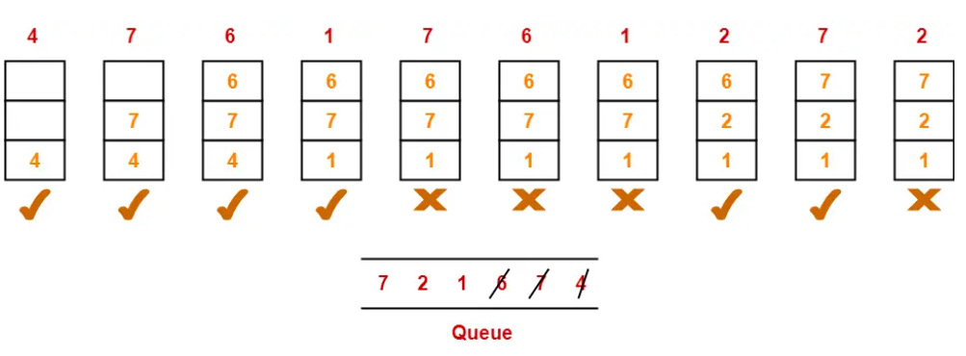

From here,
Total number of page faults occurred = 6

Calculating Hit ratio-

Total number of page hits
= Total number of references – Total number of page misses or page faults
= 10 – 6
= 4

Thus, Hit ratio
= Total number of page hits / Total number of references
= 4 / 10
= 0.4 or 40%

Calculating Miss ratio-

Total number of page misses or page faults = 6

Thus, Miss ratio
= Total number of page misses / Total number of references
= 6 / 10
= 0.6 or 60%

Alternatively,
Miss ratio
= 1 – Hit ratio
= 1 – 0.4
= 0.6 or 60%

******************************************************************************************************************************************

