Take Your Pills

(not so) proudly presents

Pill Hunt

Simo Sahlstedt
Miro Varilo
Anis Moubarik

Take Your Pills 1
Pill Hunt 1
Description 3
Technical Design 3
Problems and failures 4
What we want to implement 5
AI 5
Maps 5
In conclusion 5
What we want to implement v2.0 5

Description
Our project uses screen manager to handle different states of the game, modularly we can add new menu entries and options. The game itself is about pill hunter Max Awesome whose only purpose in life is to eat pills, on pills he gets on pillrage and gets very excited and bouncy when hitting a wall.

Mechanics are quite simple; try to eat as many pills as possible within the time limit, watch out though, controlling Max will become harder to control as you hit walls. You move max with the WASD controls, esc pauses the game.
You can pause the game anytime you want and leave it as well, in the main menu you have the possibility to start new game, see the help section or quit the game altogether.

Technical Design
As we started the project so late our motto was, keep it simple, stupid. Only very technical part was the screen manager and integrating our game to it, as we developed the manager earlier and then ditched it in hopes of easier and simpler solution, and made the game without it, it made the integration bit painful, but we managed to make it work. In the end we’re happy how the manager and game works together.

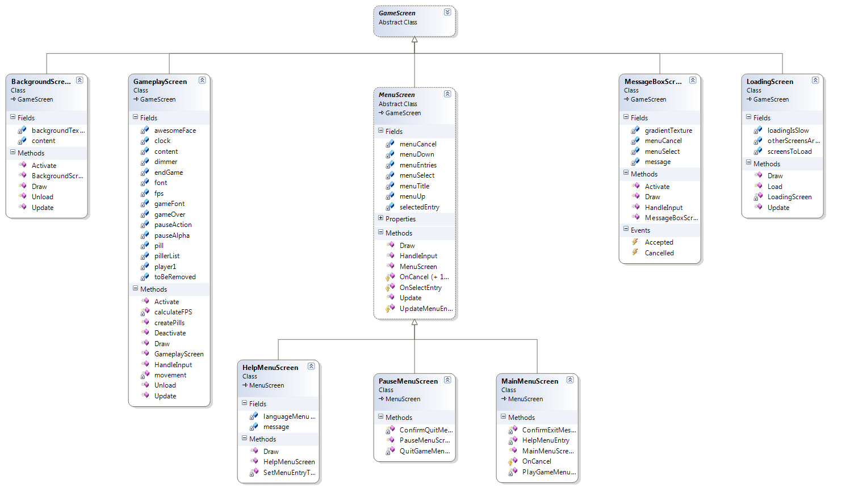
Reference 1
Click here for bigger picture

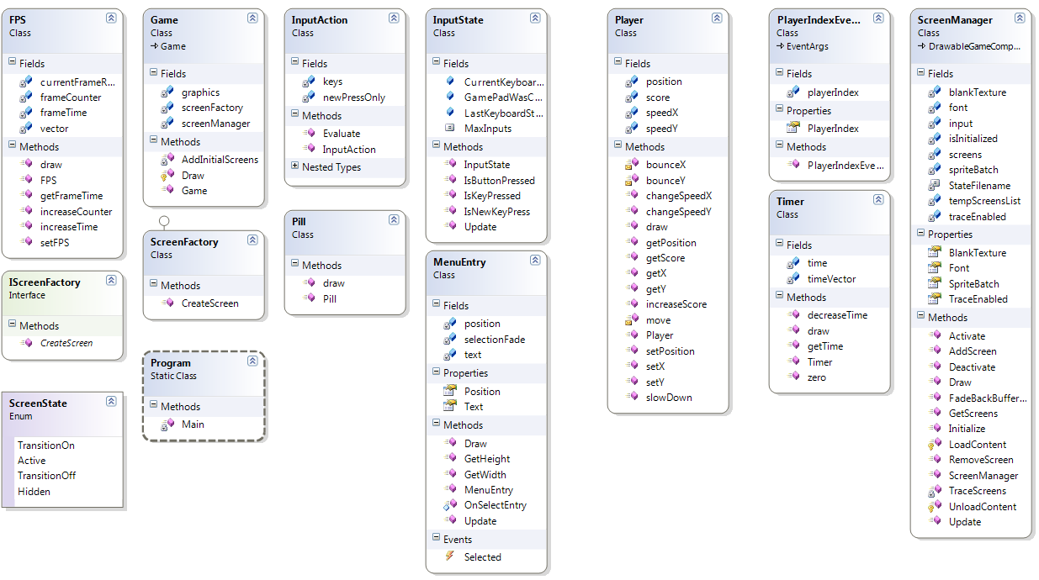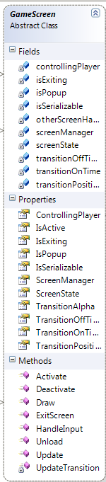
Reference 2 Reference 3

Click here for bigger picture

In reference 1 we see how our game play class implements GameScreen super class and all menus implement MenuScreen class, that has appropriate methods for drawing them.
Reference 2 shows us ScreenManager which basicly does all the hard work for us, it handles the screens, drawing, updating and providing content- and graphicsdevice.
GameScreen is introduced in reference 3, it provides the override methods for screens to implement, like all the Is- methods, ScreenState and transition information.

Problems and failures
Biggest problem was the fact that our team pretty much broke up few days before the deadline. Me, Simo and Miro decided to continue even with only 48 hours to complete the game, we came up with new game idea (very simple) and started to implement features into it from ground up, after that actually making the game wasn’t problematic at all.

What we want to implement
As didn’t have as much time as we were hoping for, there were a lot of features we couldn’t implement.
As for now here’s the list we want to implement;
- Two-player support
- AI who tries to eat your precious pills
- Obstruction (collision with objects in the map)
- High scores
- Different difficulty levels (timer shrinks, harder maps, etc.)

AI
We went with four different difficulties with the AI;
level 1 = easy, AI player gets totally random directions,
level 2 = medium, AI player gets starting direction and the rest is based on bounces and luck
level 3 = hard, AI player gets in turns medium or very hard targets
level 4 = very hard, AI player gets always the location of the nearest pill and tries to go towards it
With these levels we get more variation in the gameplay, and hardcore players have some challenge with the hardest bots.

Maps
At the moment we have 5 different maps;
Wrecked Star: We don’t even know what the hell is happening here.
Trap ‘em all: psychedelic rave party with trapping walls, watch out withdrawal might occur if you get trapped.
Flying chess boards: After long chess tourney pills are the perfect relaxant, but watch out, those boards hurt.
Roman Night: Rome, and what better ways to spend time there than pop some pills and see some ancient buildings.
Green Roots: Hot night at lake Toba, eat some pills and see the local nature.
Goal was to make fun maps with psychedelic vibe in them,

In conclusion
We’re really happy with the end product, from the above list we implemented everything except high scores which, in the end, didn’t really fit in our game.
We would like to implement single player (maybe even campaign mode), online mode and level editor.

What we want to implement v2.0
- Single player
- Online gaming
- Level editor

