**WEB MINING PROJECT:**

**Analysis done as on 12/20/2016.**

**Gainers of the day:**

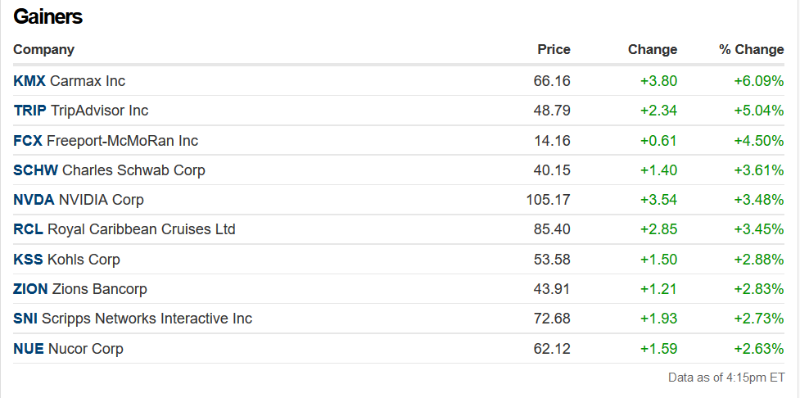

**Losers:**

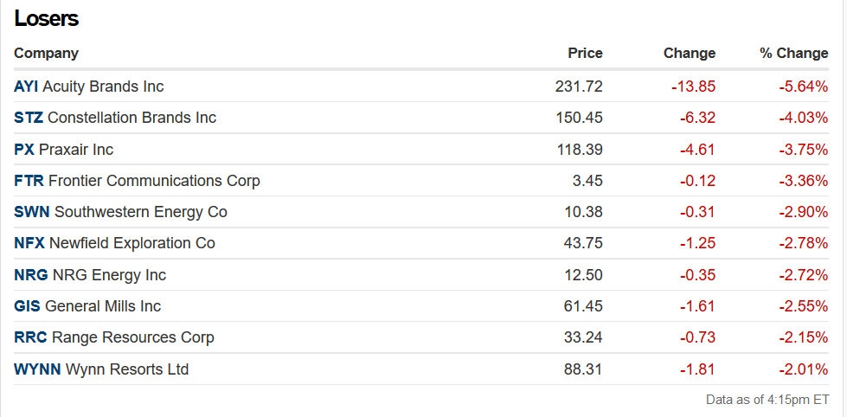

**Step 1:**

**Creating twitter App using twitter:**

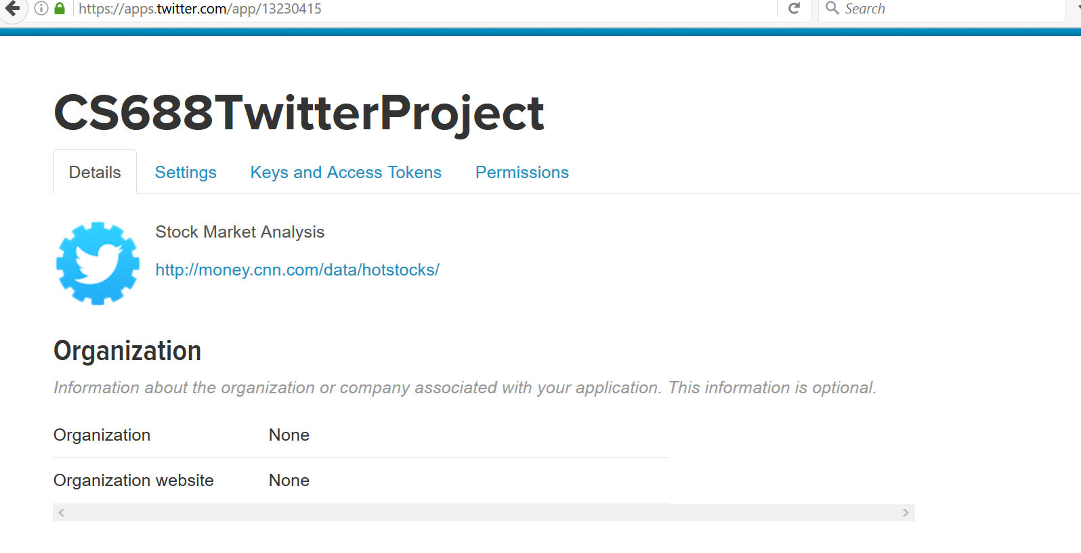

**Step 2:**

**Use and Authenticate twitter using R as below:**

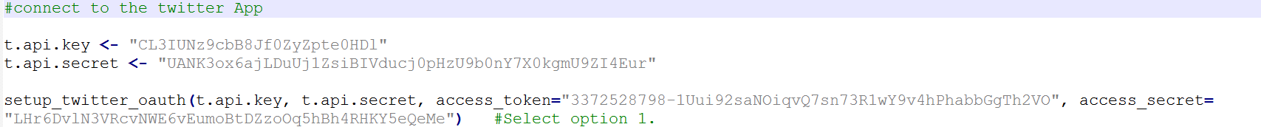

**Step 3:**

**Extracting Gainer Tweets:**

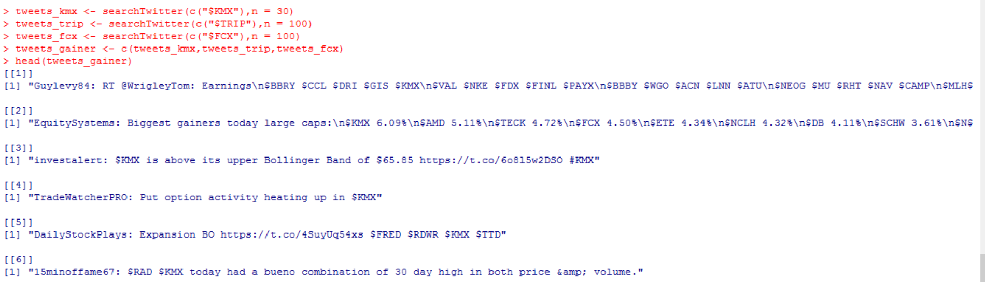

**Step 4:**

**Extracting Loser Tweets:**

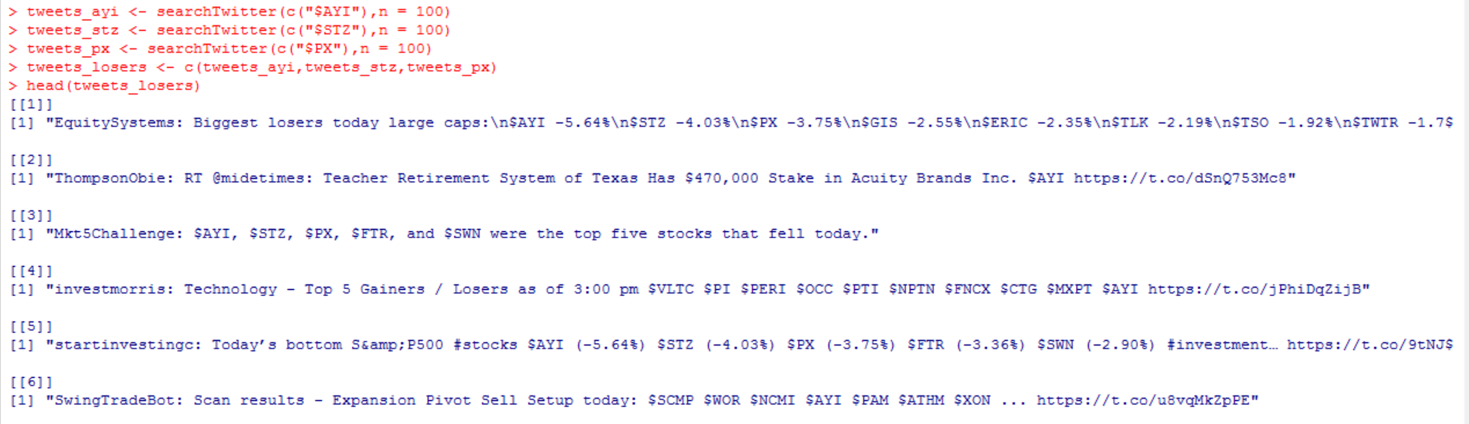

**Step 5:**

**Creating Corpus of gainer tweets and loser tweets:**

**Positive-**

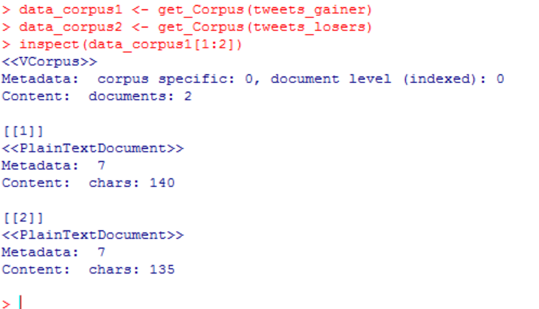

**Negative-**

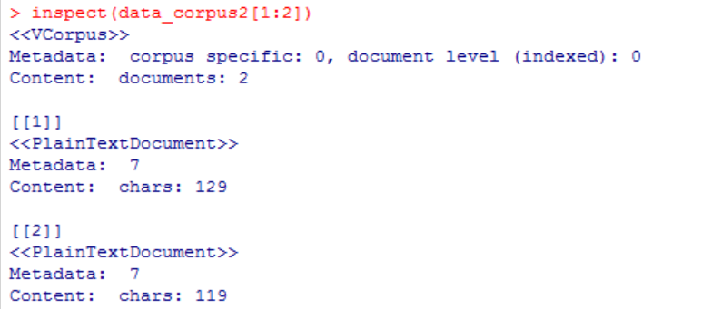

**Step 6:**

**PREPROCESSING-**

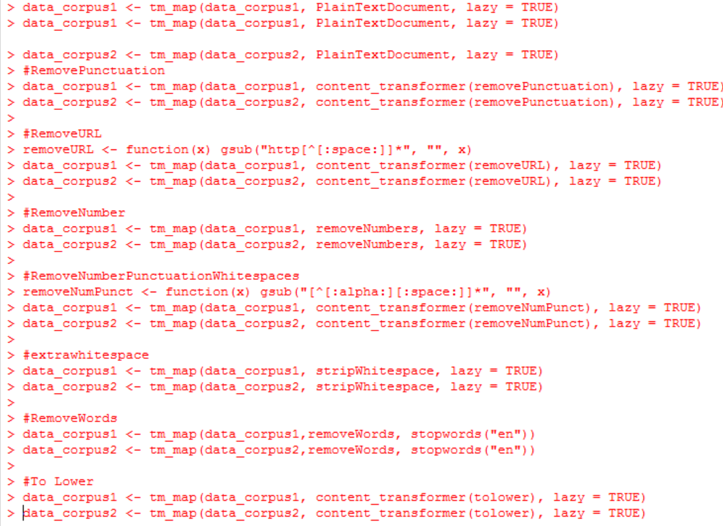

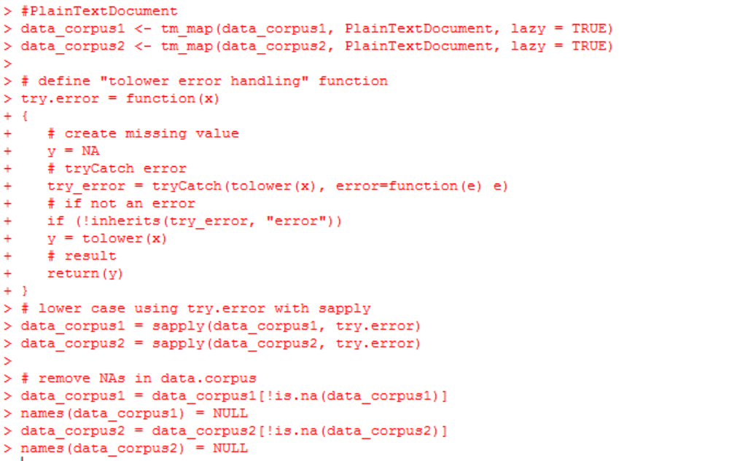

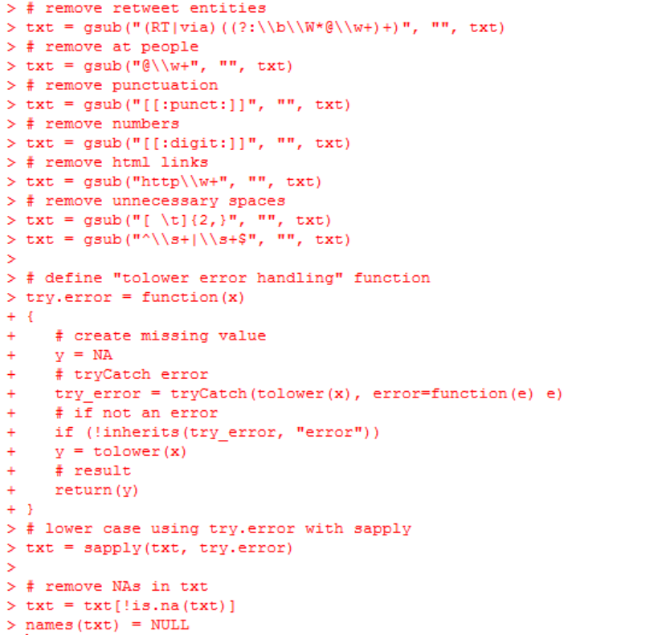

**Step 7:**

**Checking the content of the corpus after preprocessing-**

**The gainers-**

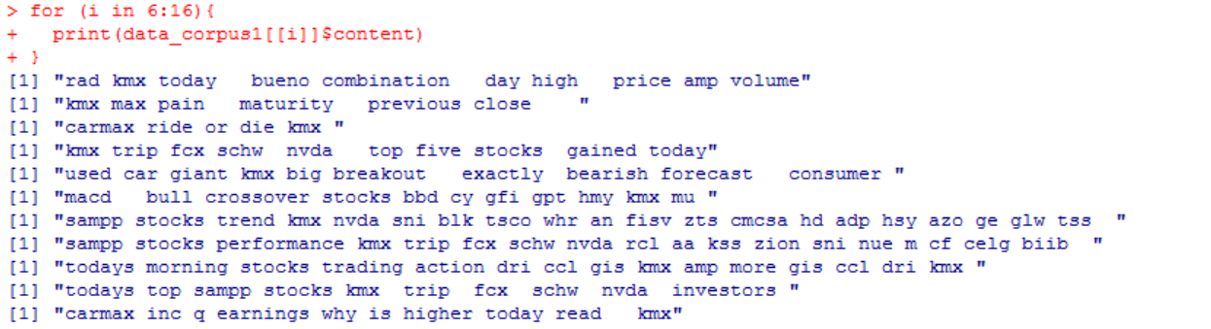

**The losers-**

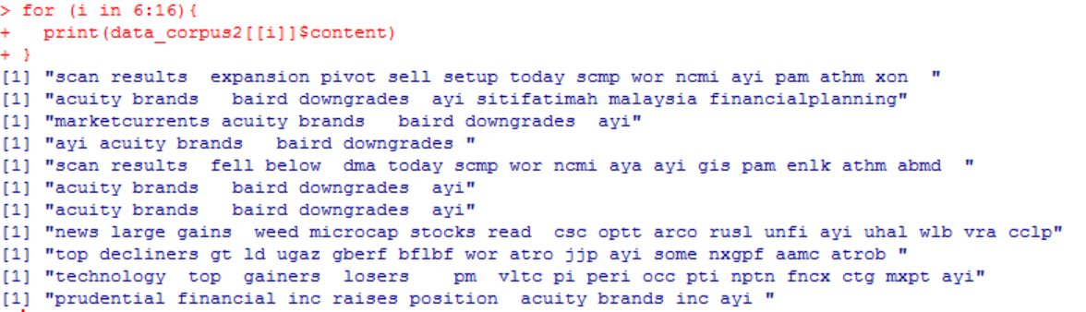

**Step 8:**

**Document term matrix-**

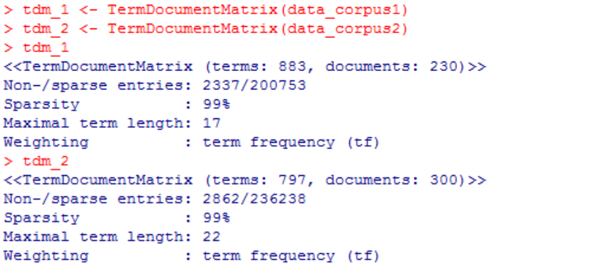

**Step 9:**

**Frequencies-**

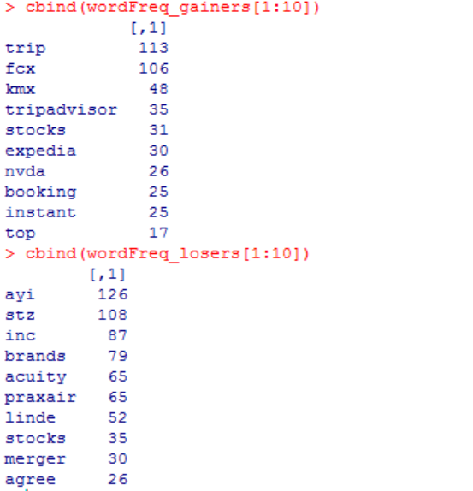

**Step 10:**

**Word Cloud for Gainers-**

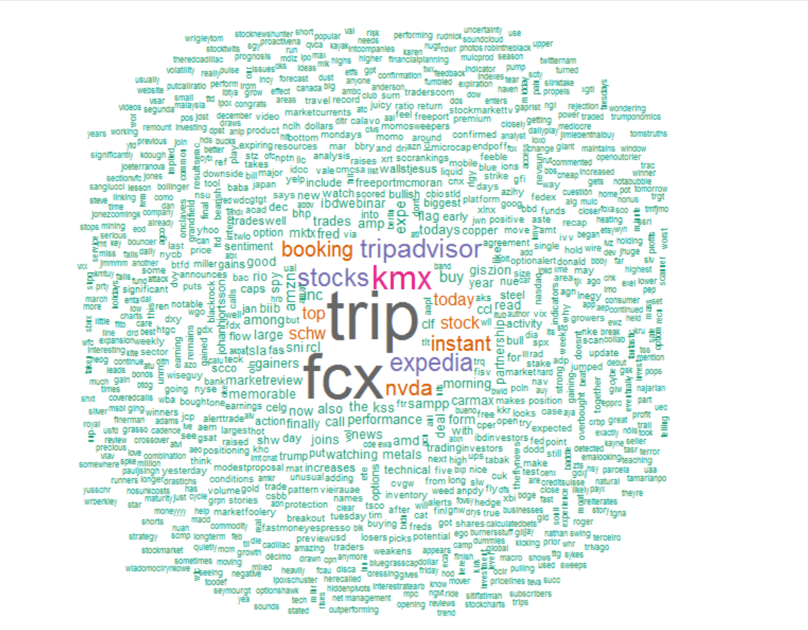

**Word Cloud for Losers:**

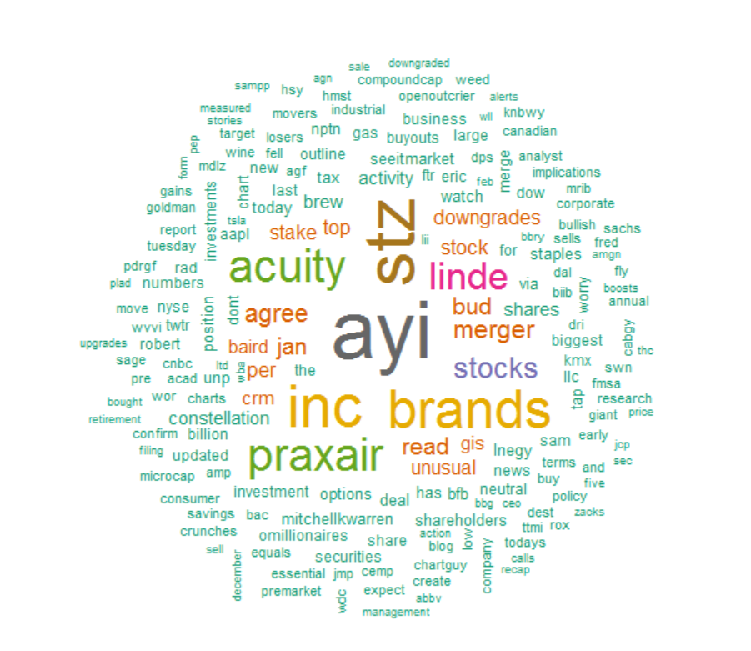

**Step 11:**

**Gain data frame-**

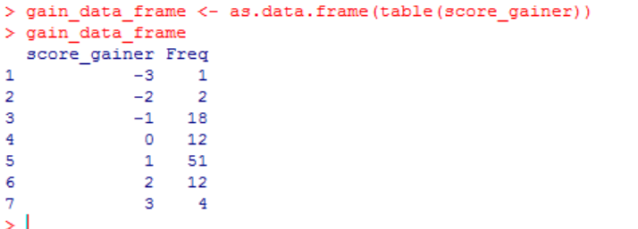

**Loser data frame-**

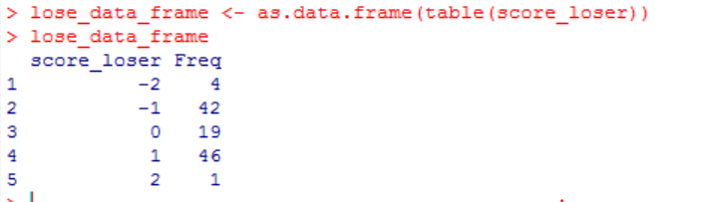

**Step 12:**

**Gain Plot-**

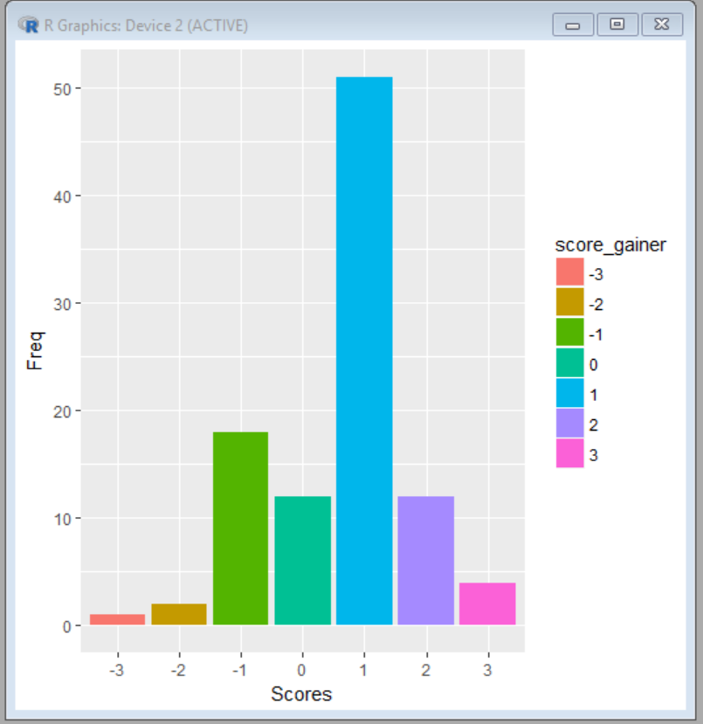

**Loser Plot-**

