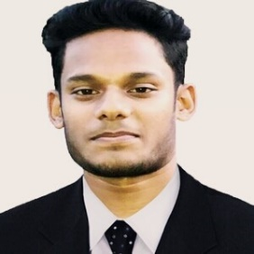**Anis Ahmmed**

**Address:**  Sector#10, Uttara, Dhaka-1230

**Contact:** 01636339310

**Email:** anisahmed450@gmail.com

**Objective**

To establish myself in a position with challenging opportunities from where I can exploit my personal skills, expertise and knowledge

**Experience**

**Web Development (Internship)**

**Company :** Sanaz Corporation

**Position :** Web Developer

**Duration :** 3 month

**Professional Certification/ Training**

1. **Professional Customer Service (Training)**

**Institute :** Xubisoft Ltd.

**Duration :** 2.5 month

1. **Apply Effective Communication in English (WASDA Session)**

**Duration: 5 Days**

I have completed 5 day’s workplace Communication in English Course under Workplace Skills Development Academy a New Zealand based educational Institute. I have secured (A) grade on that course.

**Skills**

* Have knowledge about Php Laravel framework, HTML5, CSS3, Bootstrap 4, have knowledge in WordPress, MySQL, Github.

Github Profile: <https://github.com/anisahmmed>

**Educational Qualification**

**IUBAT-International University of Business Agriculture and Technology (2016-2020)**

**Degree :** Bachelor of Computer Science and Engineering (BCSE)

**Passing Year :** 2020

**CGPA :** 3.49 (out of 4.00)

**Milestone College (2013-2015)**

**Degree :** Higher Secondary School Certificate (HSC)

**Passing year :** 2015

**GPA :** 4.67 (out of 5.00)

**Dhanua High School (2011-2013)**

**Degree :** Secondary School Certificate (SSC)

**Passing year :** 2013

**GPA :** 4.25 (out of 5.00)

**Language Proficiency**

* English and Bangla (native).

**Personal Information**

**Father’s Name :** Md. Shofiquel Islam

**Mother’s Name :** Shahera Khatun

**Date of Birth :** 01.09.1998

**Gender :** Male

**Marital Status :** Unmarried

**Religion :** Islam

**Permanent Address :** Nagor Houla, Sreepur, Gazipur

**National Id Number :** 19983318625000321

**References**

**Name :** Rubayea Ferdows

**Name** **:** Md Alomgir Hossain

**Designation** **:** Senior Lecturer

**Department** **:** CSE

**Organization** **:** IUBAT University

**Contact No.** **:** 01718735128

**Designation :** Senior Lecturer

**Department :** CSE

**Organization :** IUBAT University

**Contact No. :** 01677066697

I undersigned, hereby declare that I will be responsible for any wrong information providedhere.



…………………….

**Anis Ahmmed**

Date: 12.09.2020