SPRINT SARI 2023 Annual report

Table of Contents

Methods 2

*Ethics and consent* 2

*Participating centres* 2

*Data collection* 3

*Dataset analysed* 3

*Statistical analysis* 3

*Disclaimer* 4

Results 5

*Overall cohort* 5

*Adults* 13

*Pediatric* 21

Acknowledgements 30

*Participating sites* 30

*Management Committee* 33

*Statistical analysis and reporting team* 35

References 35

# Methods

### *Ethics and consent*

Human Research Ethics Committee (HREC) approval for data collection, with a waiver of informed consent, was granted via the National Mutual Acceptance (NMA) scheme, through the Alfred (HREC/16/Alfred/59), or by separate applications to individual sites. Research Governance approval was granted by the Chief Health Officer (CHO) in South Australia and Victoria, and supported by the CHO in Queensland, under legislated public health powers. Individual site Research Governance approvals were granted at all sites where it was required.

### *Participating centres*

Participating sites across Australia were identified following an expression of interest to ANZICS-CTG affiliated sites, or through previous affiliation with the SPRINT SARI AUS team. The ANZICS-CTG is a well-established research network with highly experienced research coordinators familiar with conducting high quality research studies. The initial case report form (CRF) had extensive development by local and international clinical experts, and includes standardized data fields that align with our international SPRINT-SARI collaborators.

### *Data collection*

Data in this report was entered by the research coordinator at the participating site. To support the rapid institution of data collection and reporting, SPRINT-SARI AUS hosts a data platform that includes an electronic data capture system, a secure repository and an analytic framework. Study data were collected and managed using REDCap electronic data capture tools hosted at Monash University2.REDCap (Research Electronic Data Capture) is a secure, web-based software platform designed to support data capture for research studies, providing 1) an intuitive interface for validated data capture; 2) audit trails for tracking data manipulation and export procedures; 3) automated export procedures for seamless data downloads to common statistical packages; and 4) procedures for data integration and interoperability with external sources.

### *Dataset analysed*

Data in this report was extracted on 2024-05-22 at 10:18h and pertains to ICU admissions in Australia reported to the SPRINT-SARI AUS ICU COVID-19 database until 2023-12-31.

### *Statistical analysis*

Descriptive statistics have been reported as mean and standard deviation (SD) or median and interquartile range (IQR) and frequencies and percentages for categorical variables. Differences between groups were assessed using the chi-square test for categorical variables and the Wilcoxon rank sum test for continuous variables. Kaplan Meier survival estimates were used to describe the 30-day in-hospital mortality according to relevant groups of interest. All analyses were performed using R version 4.4.0 (R Core Team, 2023)3 with pakages, “dplyr”4, “ggplot2”5, “ggpubr”6, “forcats”4, “gtsummary”7, “gt”8, “survival”9

### *Disclaimer*

This report is also descriptive and we urge caution in any inference particularly around causation.

The utmost effort has been made to ensure the highest quality data is being reported. However please note the following caveats:

* The population in this report reflect the sickest patients with SARI patients being managed in contributing ICUs, and do not reflect the overall population of SARI patients.
* Information is not complete for all patients.
* Whenever possible, transfers were aggregated into one record.

# Results

## *Overall cohort*

#### Figure 1. Annual number of SARI cases

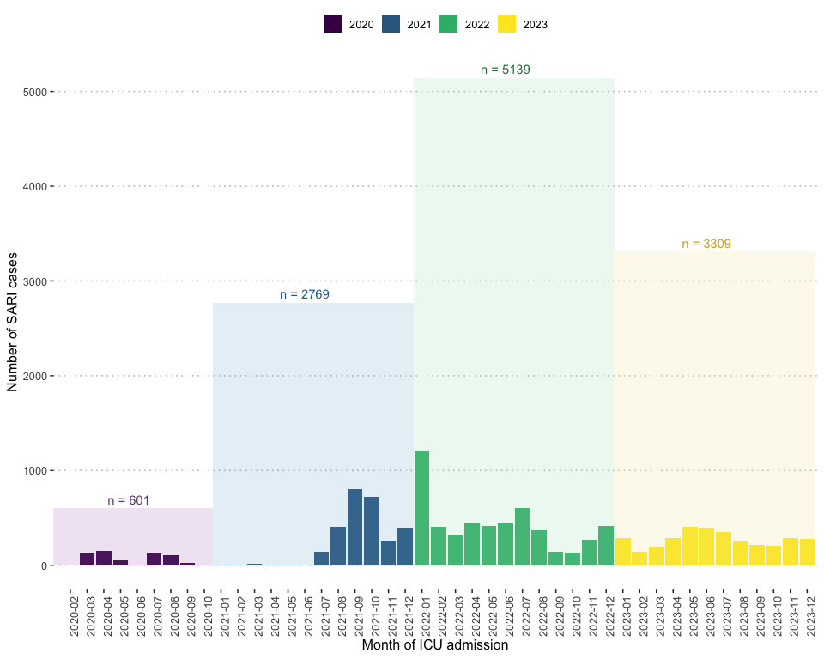

#### Figure 2. Pathogen proportion

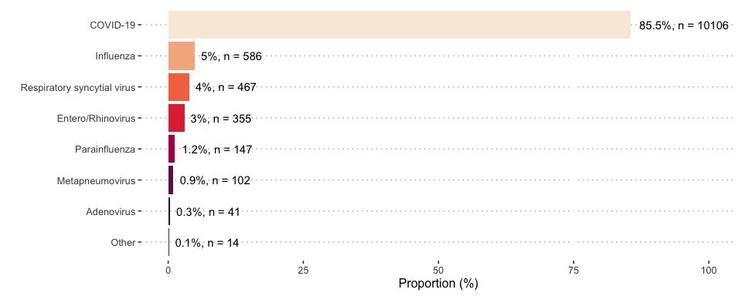

#### Figure 3. Pathogen proportion by year

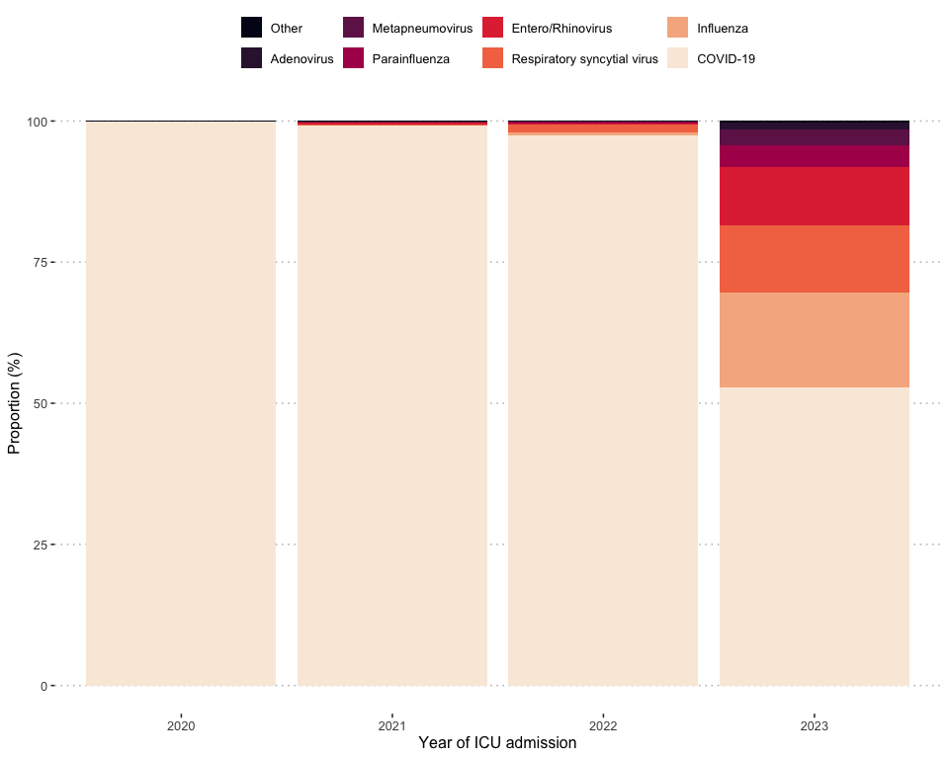

#### Table 1. Pathogen proportion by year

| **Variables** | **Overall**  (N = 11818) | **2020**  (N = 601) | **2021**  (N = 2769) | **2022**  (N = 5139) | **2023**  (N = 3309) |
| --- | --- | --- | --- | --- | --- |
| Pathogen, n (%) |  |  |  |  |  |
| COVID-19 | 10,106 (86) | 600 (100) | 2,749 (99) | 5,011 (98) | 1,746 (53) |
| Influenza | 586 (5.0) | 0 (0) | 0 (0) | 28 (0.5) | 558 (17) |
| Respiratory syncytial virus | 467 (4.0) | 0 (0) | 4 (0.1) | 72 (1.4) | 391 (12) |
| Entero/Rhinovirus | 355 (3.0) | 0 (0) | 9 (0.3) | 3 (<0.1) | 343 (10) |
| Parainfluenza | 147 (1.2) | 0 (0) | 1 (<0.1) | 20 (0.4) | 126 (3.8) |
| Metapneumovirus | 102 (0.9) | 0 (0) | 1 (<0.1) | 3 (<0.1) | 98 (3.0) |
| Adenovirus | 41 (0.3) | 0 (0) | 1 (<0.1) | 0 (0) | 40 (1.2) |
| Other | 14 (0.1) | 1 (0.2) | 4 (0.1) | 2 (<0.1) | 7 (0.2) |

#### Table 2. Baseline characteristics and treatments

|  |  |  |  |  |
| --- | --- | --- | --- | --- |
| **Variables***\** | **N** | **Overall***†* | (N = 11818)*†* | **2020-2022***†* |
| **Demographic** | | | | |
| Age, years | 11,815 | 59 (38 – 72) | 60 (45 – 72) | 50 (9 – 71) |
| Sex female | 11,810 | 4,727/11,810 (40) | 3,302/8,486 (39) | 1,425/3,324 (43) |
| Body mass index, kg/m2 | 7,353 | 28 (24 – 34) | 29 (25 – 35) | 26 (21 – 31) |
| Obesity | 9,950 | 1,951/9,950 (20) | 1,619/6,718 (24) | 332/3,232 (10) |
| Pregnancy | 3,617 | 155/3,617 (4.3) | 139/2,732 (5.1) | 16/885 (1.8) |
| **Infection type and prognostic score** | | | | |
| APACHE II score | 4,474 | 14 (10 – 19) | 14 (10 – 19) | NA (NA – NA) |
| Infection type | 11,818 |  |  |  |
| COVID-19 |  | 10,098/11,818 (85) | 8,345/8,493 (98) | 1,753/3,325 (53) |
| Non-COVID-19 |  | 1,720/11,818 (15) | 148/8,493 (1.7) | 1,572/3,325 (47) |
| **Comborbidities** | | | | |
| Chronic cardiac disease | 10,047 | 2,150/10,047 (21) | 1,455/6,802 (21) | 695/3,245 (21) |
| Chronic pulmonary disease | 10,037 | 1,425/10,037 (14) | 881/6,789 (13) | 544/3,248 (17) |
| Diabetes | 9,991 | 1,845/9,991 (18) | 1,458/6,749 (22) | 387/3,242 (12) |
| Diabetes with complications | 9,994 | 858/9,994 (8.6) | 615/6,750 (9.1) | 243/3,244 (7.5) |
| Asthma | 10,021 | 1,128/10,021 (11) | 766/6,771 (11) | 362/3,250 (11) |
| End stage kidney disease | 10,039 | 1,121/10,039 (11) | 794/6,792 (12) | 327/3,247 (10) |
| Rheumatological disease | 10,030 | 558/10,030 (5.6) | 394/6,785 (5.8) | 164/3,245 (5.1) |
| Mild/Moderate liver disease | 10,052 | 444/10,052 (4.4) | 317/6,794 (4.7) | 127/3,258 (3.9) |
| Dementia | 10,018 | 102/10,018 (1.0) | 67/6,759 (1.0) | 35/3,259 (1.1) |
| Malnutrition | 10,019 | 212/10,019 (2.1) | 113/6,775 (1.7) | 99/3,244 (3.1) |
| Chronic neurological disease | 10,042 | 754/10,042 (7.5) | 429/6,791 (6.3) | 325/3,251 (10.0) |
| Malignant neoplasm | 10,037 | 660/10,037 (6.6) | 400/6,791 (5.9) | 260/3,246 (8.0) |
| Chronic haematological disease | 10,039 | 548/10,039 (5.5) | 371/6,794 (5.5) | 177/3,245 (5.5) |
| HIV/AIDS | 9,975 | 44/9,975 (0.4) | 34/6,726 (0.5) | 10/3,249 (0.3) |
| Chronic immunosuppression | 9,988 | 1,177/9,988 (12) | 838/6,745 (12) | 339/3,243 (10) |
| **Treatement in ICU** | | | | |
| Invasive mechanical ventilation | 11,194 | 3,998/11,194 (36) | 2,930/7,877 (37) | 1,068/3,317 (32) |
| Duration of invasive mechanical ventilation, days | 3,838 | 5 (2 – 11) | 6 (2 – 12) | 4 (1 – 7) |
| ECMO | 11,178 | 220/11,178 (2.0) | 161/7,861 (2.0) | 59/3,317 (1.8) |
| Prone positioning | 6,760 | 776/6,760 (11) | 548/3,464 (16) | 228/3,296 (6.9) |
| Vasopressor or inotrope | 8,493 | 2,088/8,493 (25) | 2,088/8,493 (25) | 0/0 (NA) |
| Renal replacement therapy | 6,771 | 574/6,771 (8.5) | 321/3,453 (9.3) | 253/3,318 (7.6) |
| *\**Abbreviations: AIDS, Acquired Immunodeficiency Syndrome, APACHE II, Acute Physiology and Chronic Health Evaluation II; ECMO, Extra-Corporeal Membrane Oxygenation; HIV, Human Immunodeficiency Virus. | | | | |
| *†*Continous variables are presented as median (IQR). Categorical variables are presented as n/N (%). | | | | |

#### Table 3. Outcomes

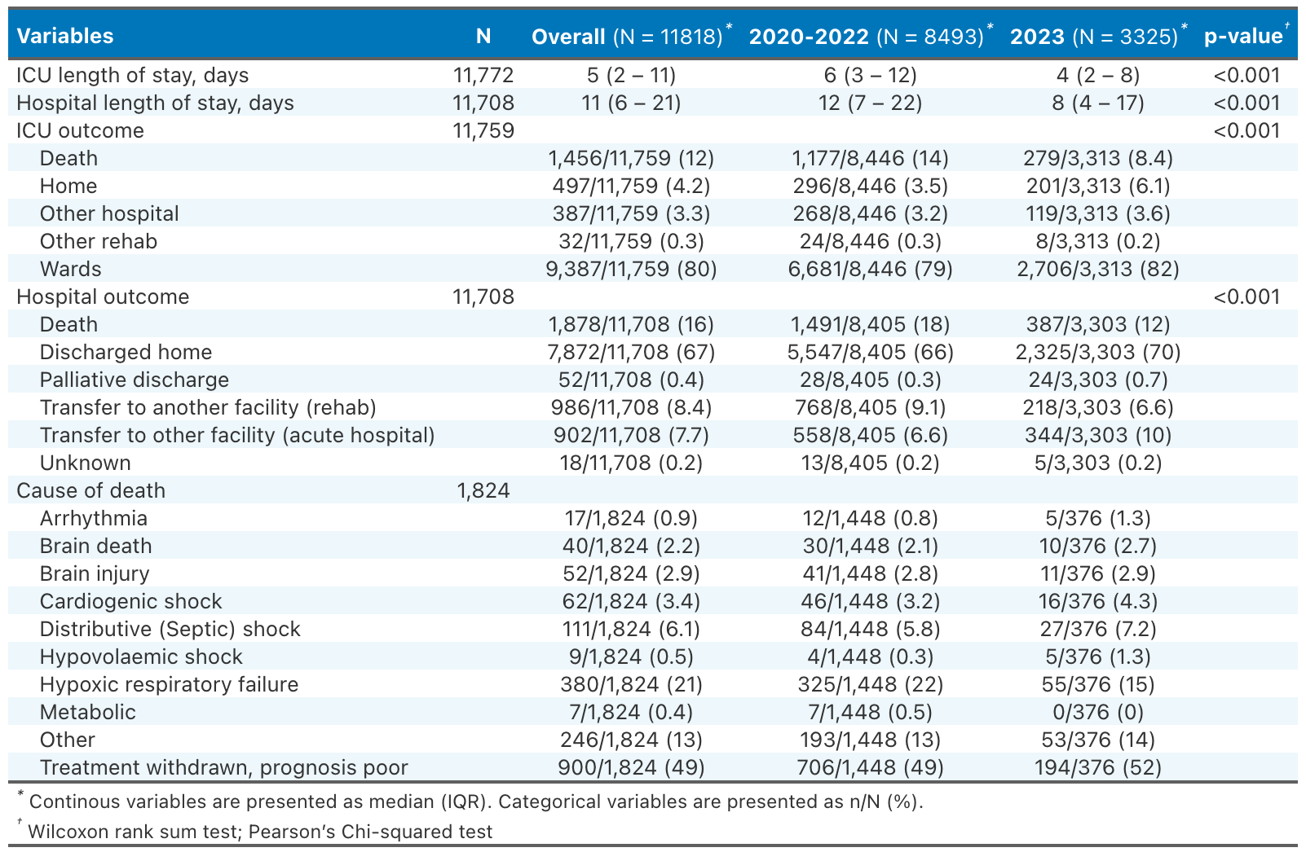

#### Figure 4. Kaplan Meier survival curves for 30-day in-hospital mortality according to the study period

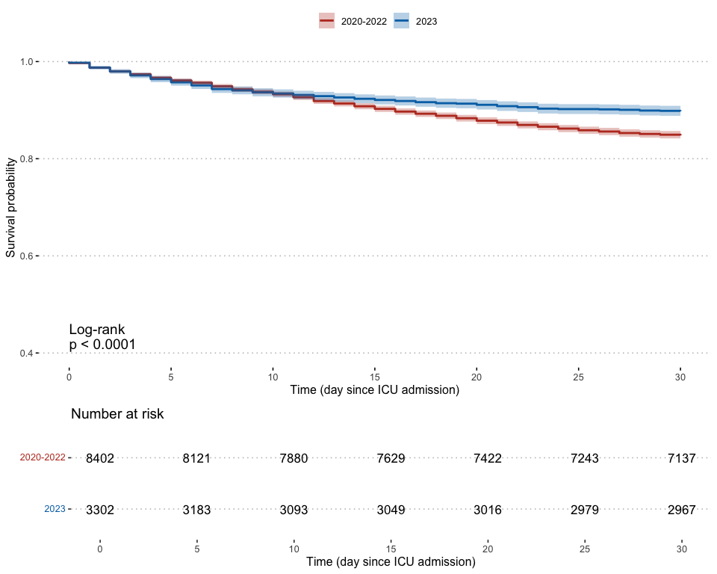

#### Figure 5. Kaplan Meier survival curves for 30-day in-hospital mortality in 2023 according to the infection type

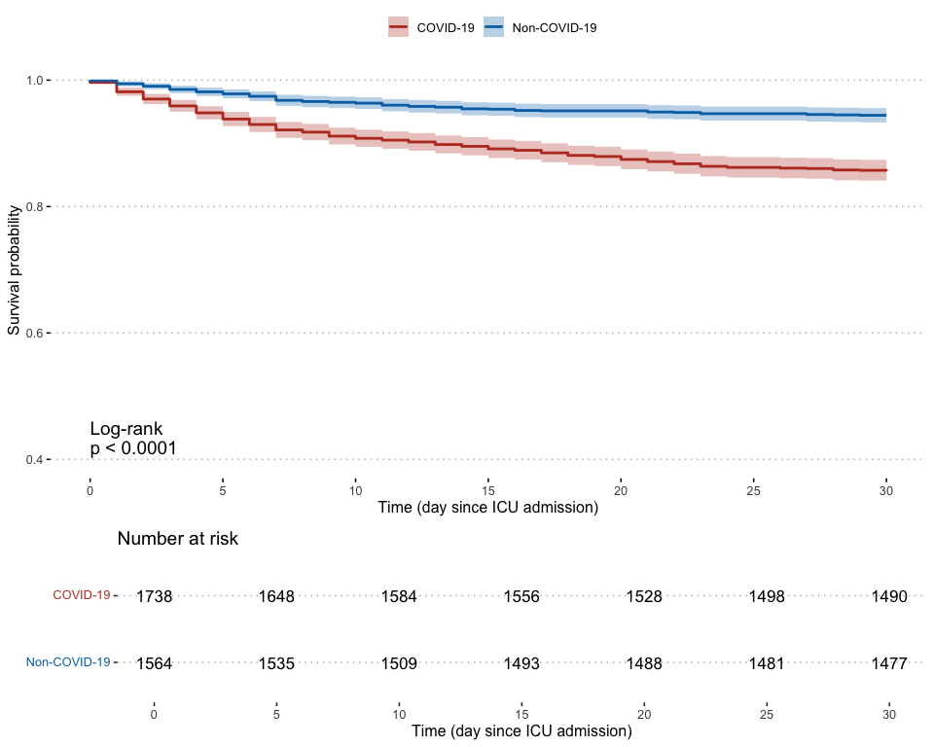

## *Adults*

#### Figure 6. Annual number of SARI cases

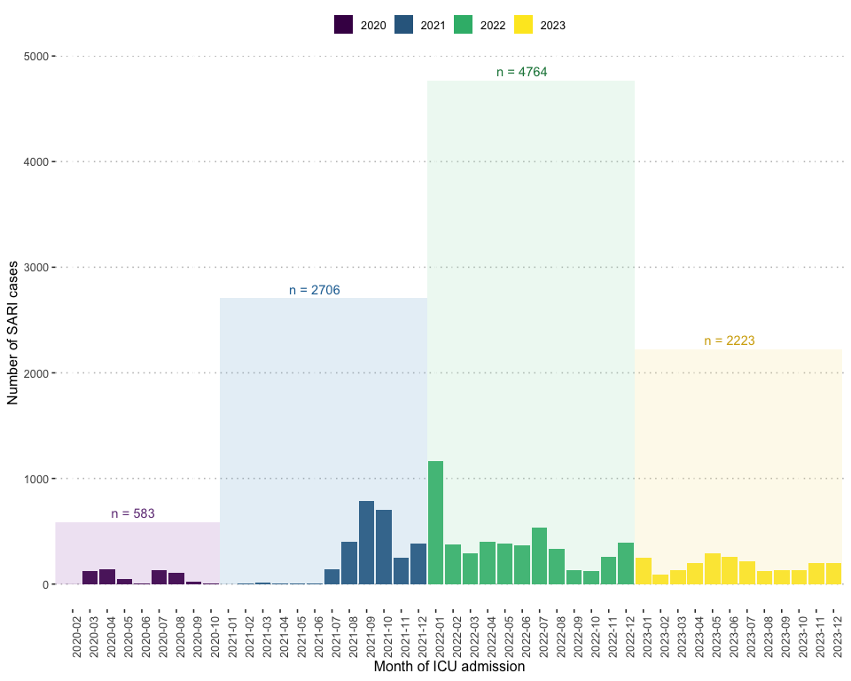

#### Figure 7. Pathogen proportion

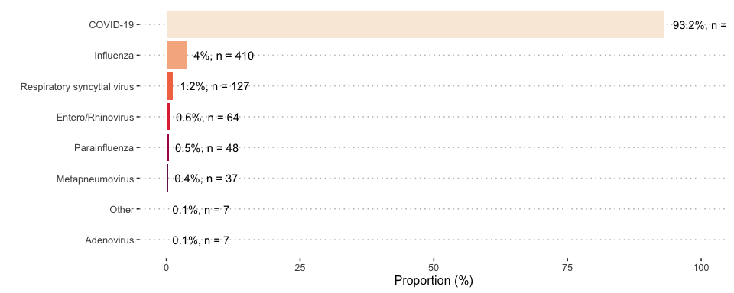

#### Figure 8. Pathogen proportion by year

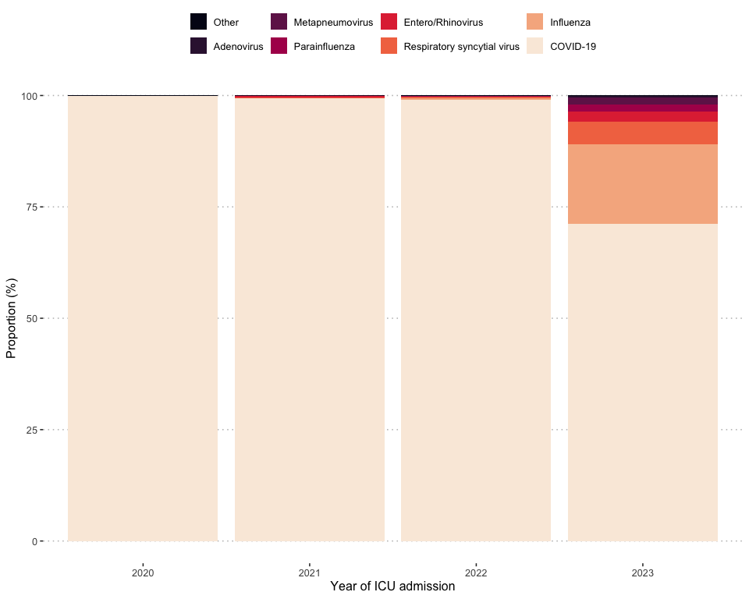

#### Table 4. Pathogen proportion by year

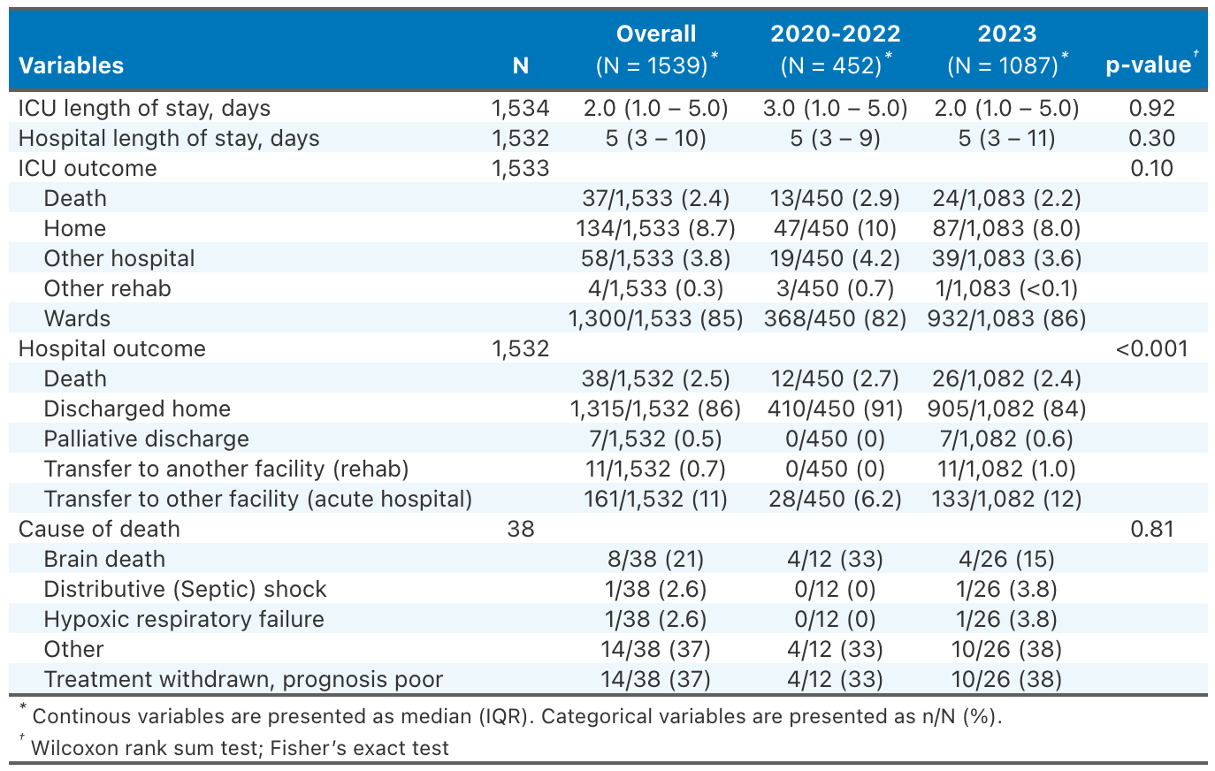

#### Table 5. Baseline characteristics and treatments

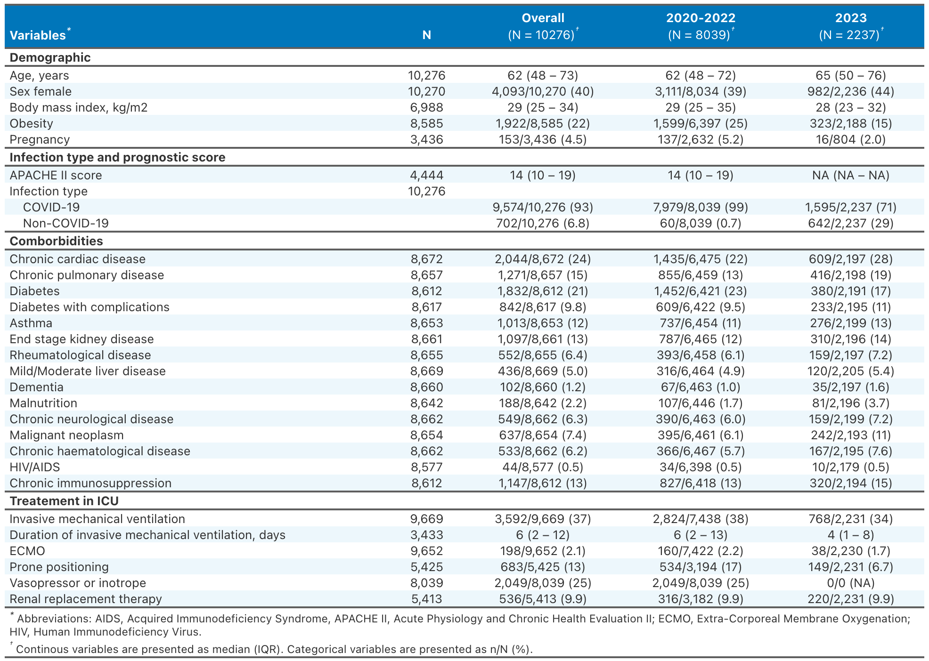

#### Table 6. Outcomes

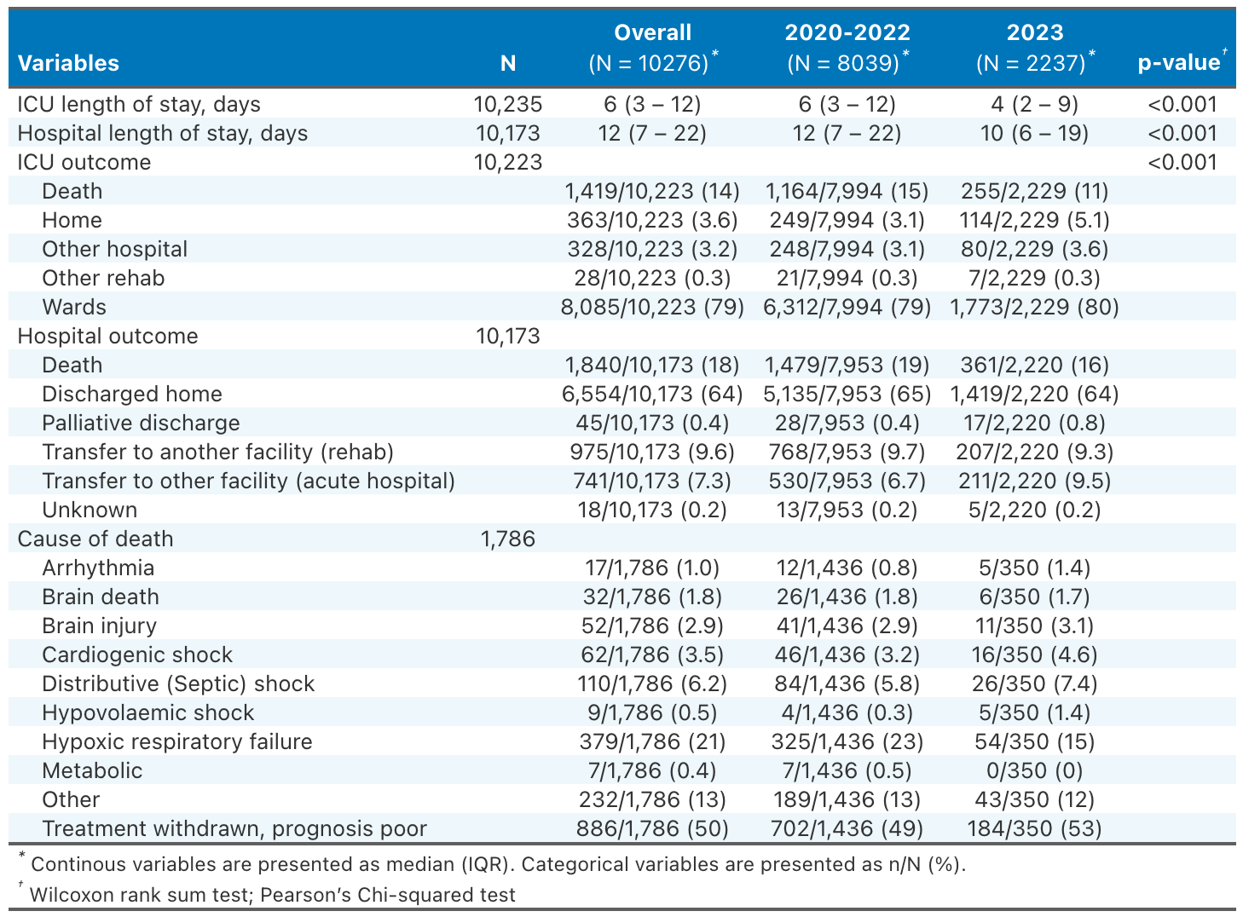

#### Figure 9. Kaplan Meier survival curves for 30-day in-hospital mortality according to the study period

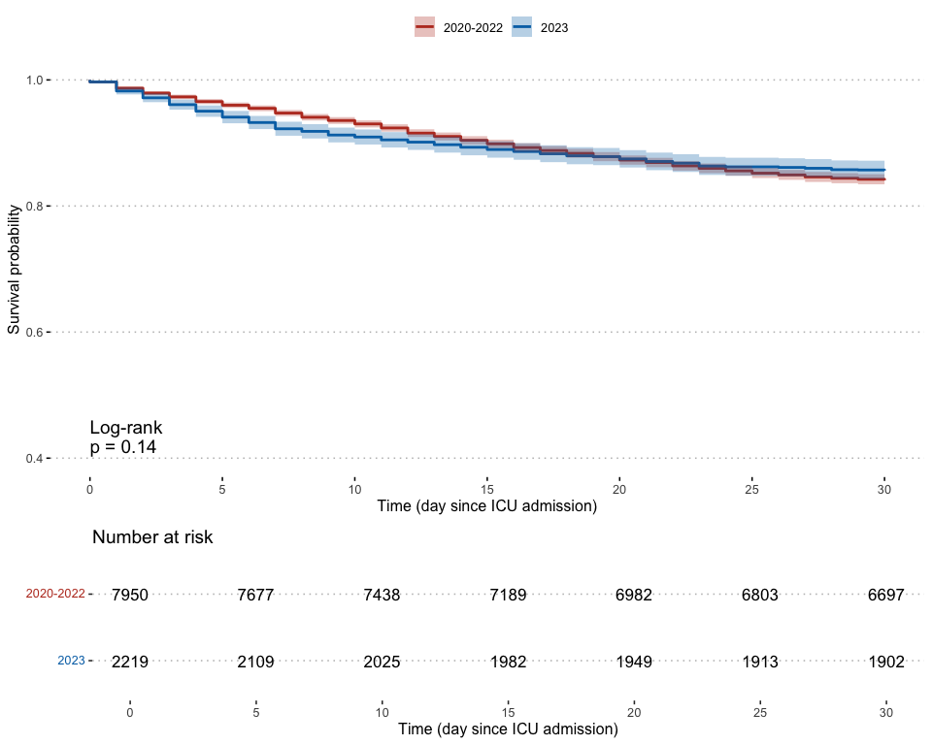

#### Figure 10. Kaplan Meier survival curves for 30-day in-hospital mortality in 2023 according to the infection type

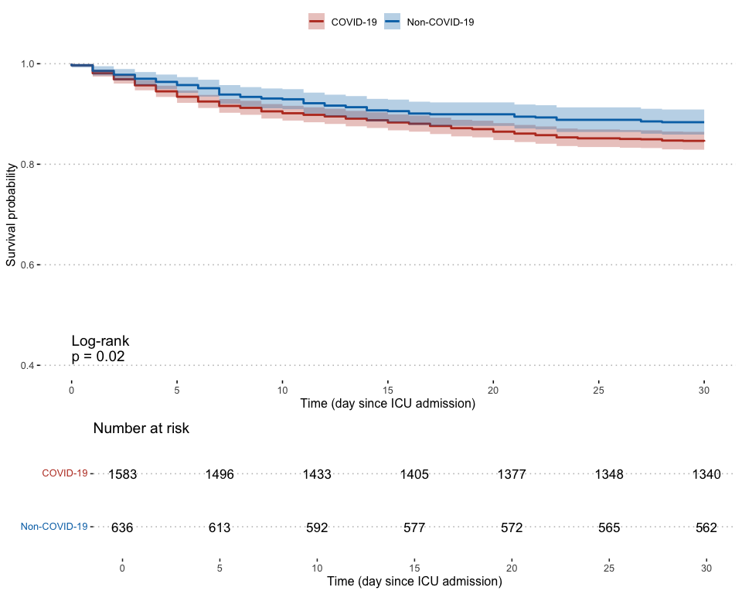

## *Pediatric*

#### Figure 11. Annual number of SARI cases

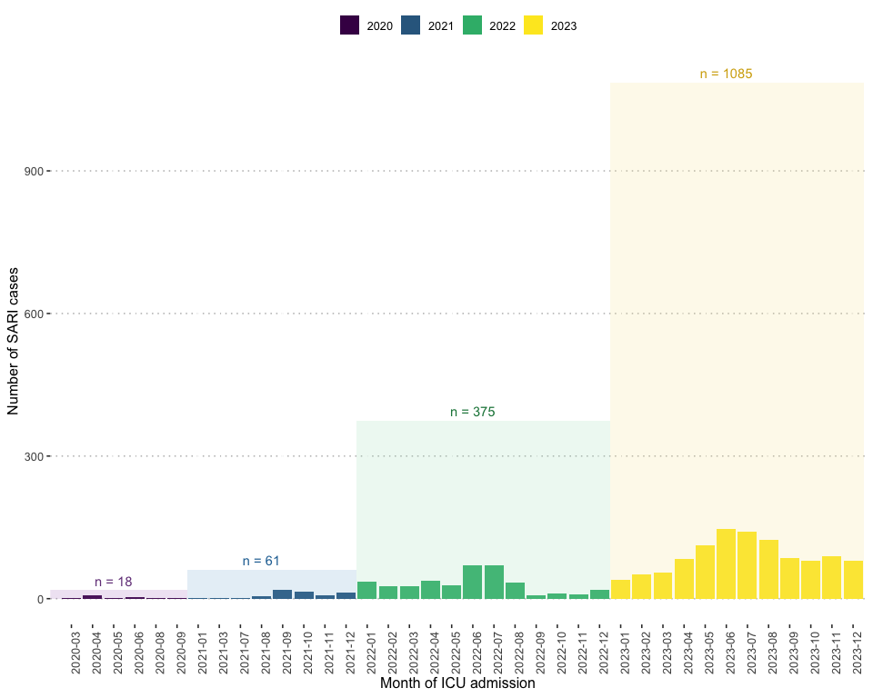

#### Figure 12. Pathogen proportion

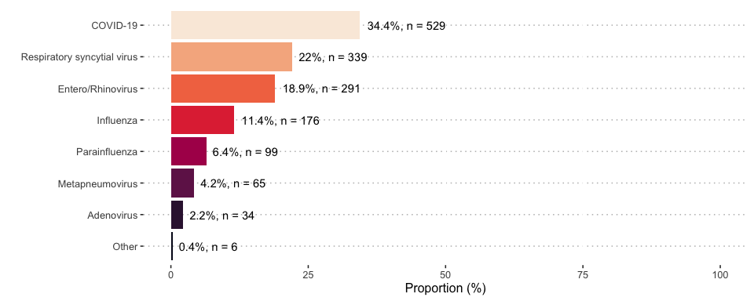

#### Figure 13. Pathogen proportion by year

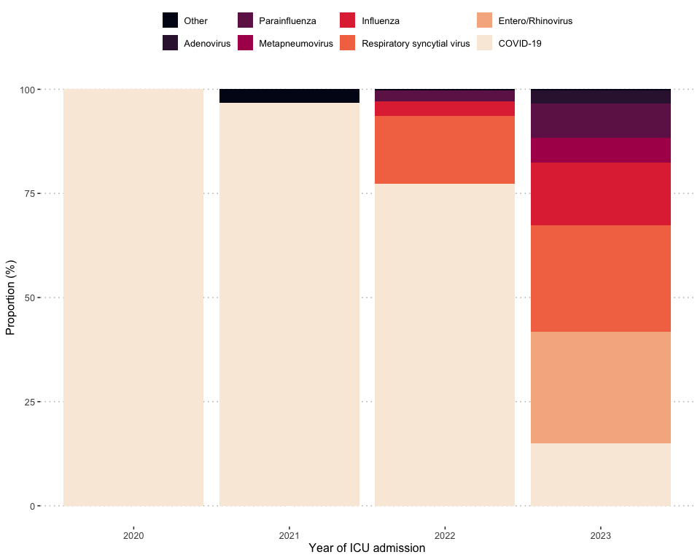

#### Table 7. Pathogen proportion by year

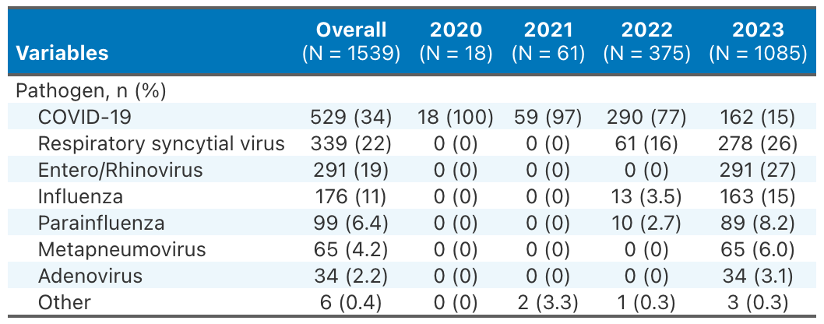

#### Table 8. Baseline characteristics and treatments

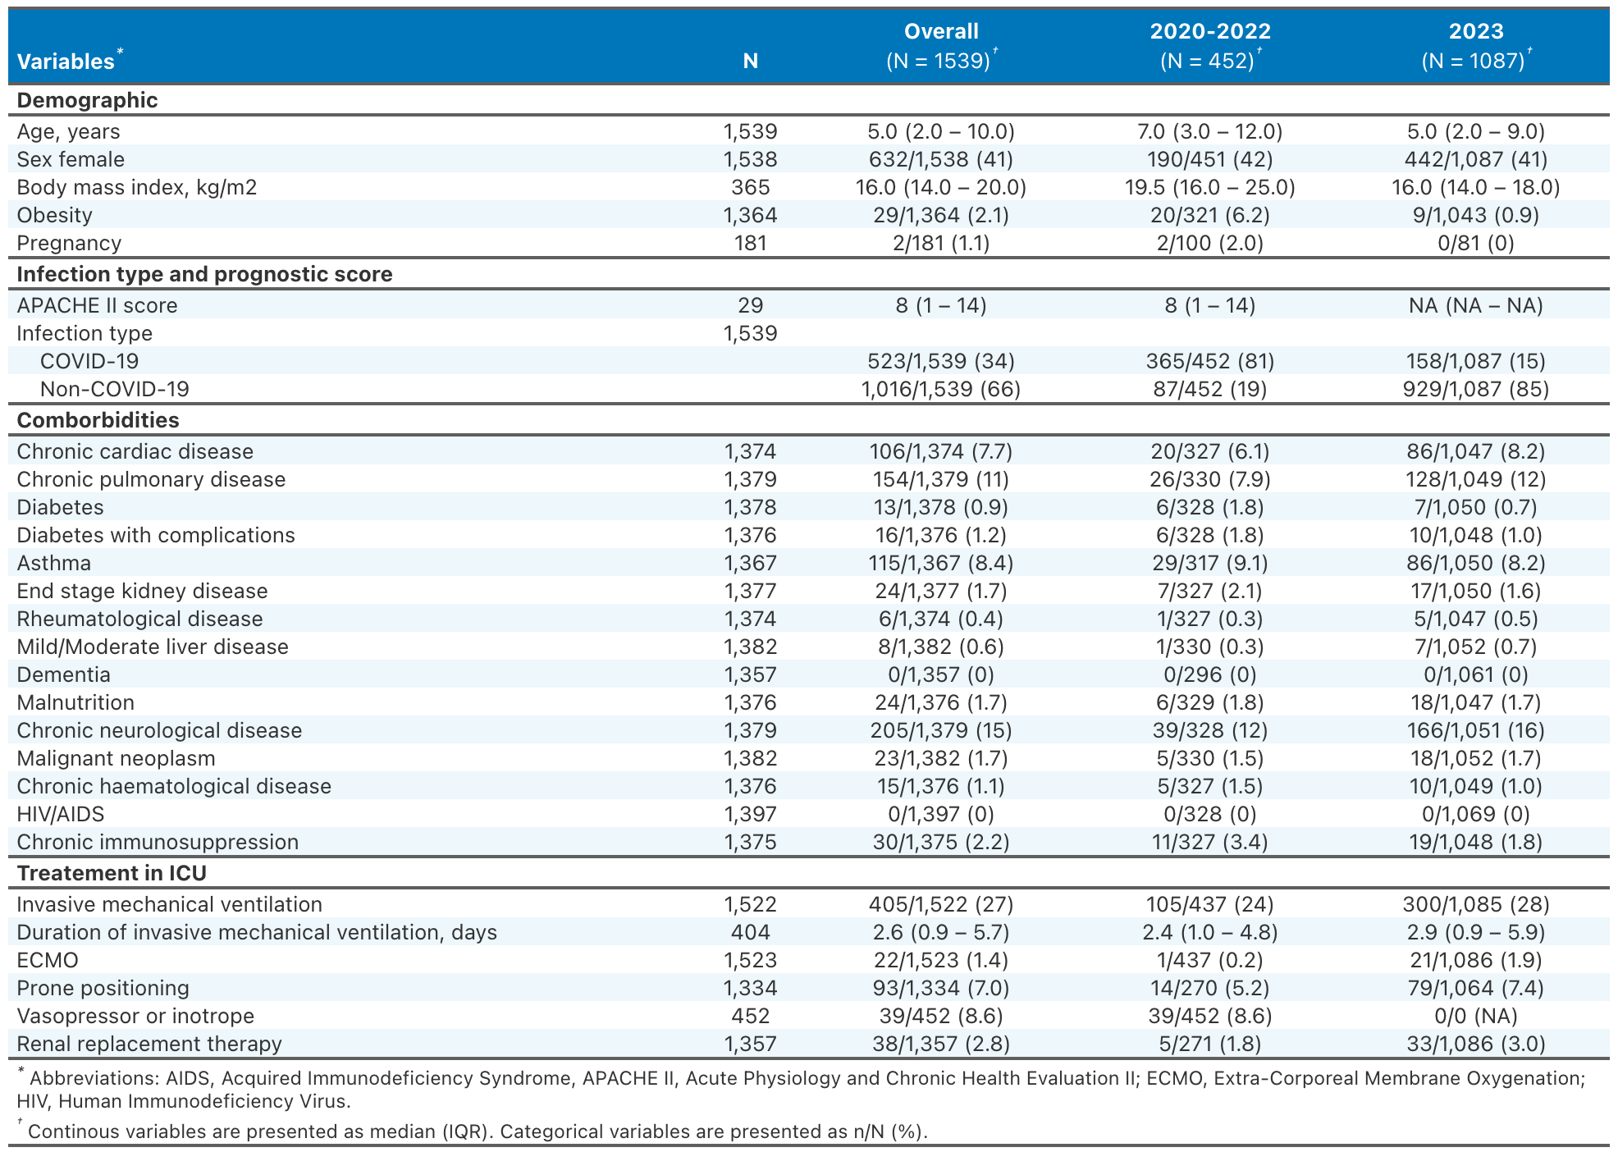

#### Table 9. Outcomes



#### Figure 14. Kaplan Meier survival curves for 30-day in-hospital mortality according to the study period

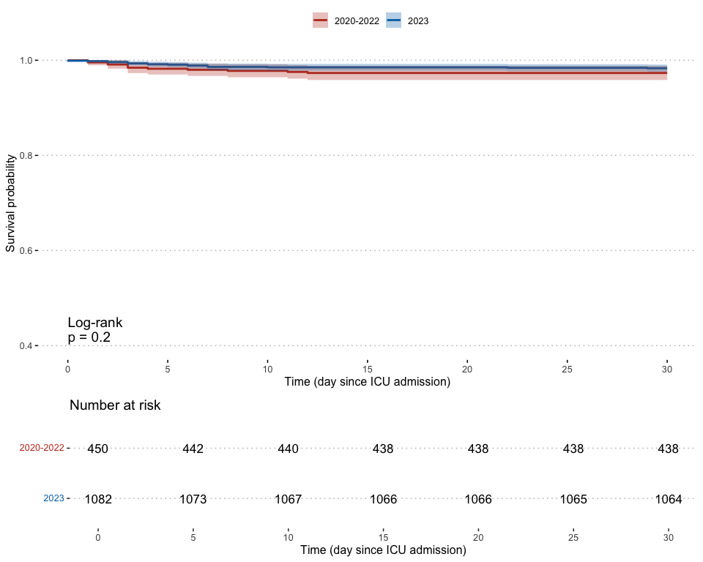

#### Figure 15. Kaplan Meier survival curves for 30-day in-hospital mortality in 2023 according to the infection type

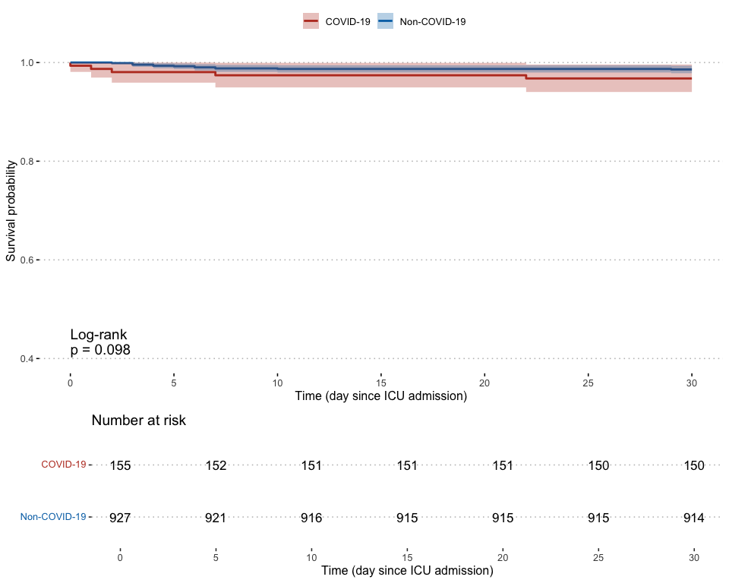

# Acknowledgements

## *Participating sites*

| State | Centre |
| --- | --- |
| ACT | Canberra Hospital |
| NSW | Bankstown-Lidcombe Hospital |
| NSW | Calvary Mater Newcastle |
| NSW | Campbelltown Hospital |
| NSW | Children’s Hospital at Westmead |
| NSW | Concord Hospital |
| NSW | John Hunter Hospital |
| NSW | Lismore Base Hospital |
| NSW | Liverpool Hospital |
| NSW | Nepean Hospital |
| NSW | Prince of Wales Hospital |
| NSW | Royal North Shore Hospital |
| NSW | Royal Prince Alfred Hospital |
| NSW | St George Hospital |
| NSW | St Vincent’s Hospital Sydney |
| NSW | Sydney Children’s Hospital, Randwick |
| NSW | Westmead Hospital |
| NSW | Wollongong Hospital |
| NT | Royal Darwin Hospital |
| NT | Alice Springs Hospital |
| QLD | Bundaberg Hospital |
| QLD | Caboolture Hospital |
| QLD | Cairns Hospital |
| QLD | Gold Coast University Hospital |
| QLD | Hervey Bay Hospital |
| QLD | Ipswich Hospital |
| QLD | Logan Hospital |
| QLD | Mater Misericordiae Limited |
| QLD | Princess Alexandra Hospital |
| QLD | Queensland Children’s Hospital |
| QLD | Redcliffe Hospital |
| QLD | Royal Brisbane and Women’s Hospital |
| QLD | Sunshine Coast University Hospital (ICU and PCCU) |
| QLD | The Prince Charles Hospital |
| QLD | Toowoomba Hospital |
| SA | The Queen Elizabeth Hospital |
| SA | Flinders Medical Centre |
| SA | Royal Adelaide Hospital |
| SA | Lyell McEwin |
| SA | Adelaide Women’s and Children’s Hospital |
| TAS | Launceston Hospital |
| TAS | Royal Hobart Hospital |
| VIC | Angliss Hospital |
| VIC | Austin Hospital |
| VIC | Barwon Health |
| VIC | Bendigo Hospital |
| VIC | Box Hill Hospital |
| VIC | Cabrini Hospital |
| VIC | Casey Hospital |
| VIC | Dandenong Hospital |
| VIC | Epworth Richmond |
| VIC | Footscray Hospital (Western Health) |
| VIC | Frankston Hospital |
| VIC | Grampians Health (Prev Ballarat Base Hospital ) |
| VIC | Maroondah Hospital |
| VIC | Mildura Base Hospital |
| VIC | Monash Children’s Hospital |
| VIC | Monash Medical Centre |
| VIC | Northeast Health Wangaratta |
| VIC | Royal Children’s Hospital |
| VIC | Royal Melbourne Hospital |
| VIC | St Vincent’s Hospital Melbourne |
| VIC | Sunshine Hospital (Western Health) |
| VIC | The Alfred Hospital |
| VIC | The Northern Hospital |
| VIC | Warrnambool Base Hospital |
| VIC | Werribee Mercy Hospital |
| WA | Bunbury Hospital |
| WA | Fiona Stanley Hospital |
| WA | Joondalup Health Campus |
| WA | Perth Children’s Hospital |
| WA | Royal Perth Hospital |
| WA | Rockingham General Hospital |
| WA | Sir Charles Gairdner Hospital |
| WA | St John of God Midland |
| WA | St John of God Murdoch |

## *Management Committee*

| Team |
| --- |
| Andrew Udy |
| Aidan Burrell |
| Allen Cheng |
| Patricia Alliegro |
| Tessa Broadley |
| Lewis Campbell |
| Winston Cheung |
| Jamie Cooper |
| Simon Erickson |
| Craig French |
| Ed Litton |
| Rick McAllister |
| Annamaria Palermo |
| Mark Plummer |
| Mahesh Ramanan |
| Ben Reddi |
| Claire Reynolds |
| Hannah Rotherham |
| Shweta Priyadarshini |
| Husna Begum |
| Tony Trapani |
| Vicki Papanikolaou |
| Aaliya Ibrahim |
| Peinan Zhao |
| Jodi Dumbrell |
| Nicole Ng |

## *Statistical analysis and reporting team*

| Team |
| --- |
| Anis Chaba |
| Ary Serpa Neto |
| Peinan Zhao |
| Aidan Burrell |
| Andrew Udy |
| Tony Trapani |
| Patricia V. Alliegro |
| Vicki Papanikolaou |
| Jodi Dumbrell |
| Nicole Ng |

# References

1. Harris PA, Taylor R, Thielke R, Payne J, Gonzalez N, Conde JG. Research electronic data capture (REDCap)a metadata-driven methodology and workflow process for providing translational research informatics support. Journal of Biomedical Informatics [Internet] 2009;42(2):377–81. Available from: <https://www.sciencedirect.com/science/article/pii/S1532046408001226>

2. Harris PA, Taylor R, Minor BL, et al. The REDCap consortium: Building an international community of software platform partners. Journal of Biomedical Informatics [Internet] 2019;95:103208. Available from: <https://www.sciencedirect.com/science/article/pii/S1532046419301261>

3. R Core Team. R: A language and environment for statistical computing [Internet]. Vienna, Austria: R Foundation for Statistical Computing; 2023. Available from: <https://www.R-project.org/>

4. Wickham H. Forcats: Tools for working with categorical variables (factors) [Internet]. 2023. Available from: <https://CRAN.R-project.org/package=forcats>

5. Wickham H. ggplot2: Elegant graphics for data analysis [Internet]. Springer-Verlag New York; 2016. Available from: <https://ggplot2.tidyverse.org>

6. Kassambara A. Ggpubr: ’ggplot2’ based publication ready plots [Internet]. 2023. Available from: <https://CRAN.R-project.org/package=ggpubr>

7. Sjoberg DD, Whiting K, Curry M, Lavery JA, Larmarange J. Reproducible summary tables with the gtsummary package. The R Journal [Internet] 2021;13(1):570–80. Available from: <https://doi.org/10.32614/RJ-2021-053>

8. Iannone R, Cheng J, Schloerke B, Hughes E, Lauer A, Seo J. Gt: Easily create presentation-ready display tables [Internet]. 2024. Available from: <https://CRAN.R-project.org/package=gt>

9. Therneau TM. A package for survival analysis in r [Internet]. 2024. Available from: <https://CRAN.R-project.org/package=survival>